NAME: EDEM ETORO-ABASI ANIEDI
MATRIC NUMBER: 19/sci03/ 009
DEPARTMENT: BIOCHEMISTRY
ASSIGNMENT
1.
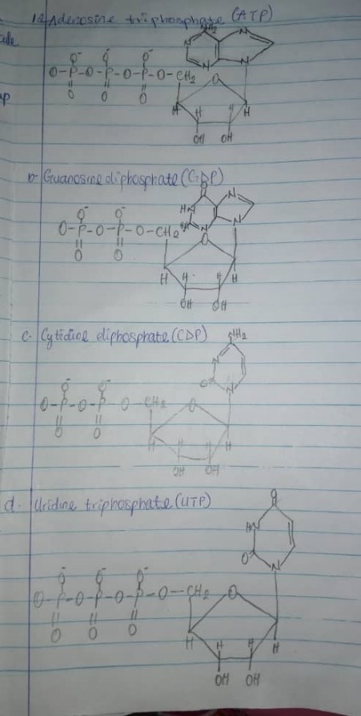
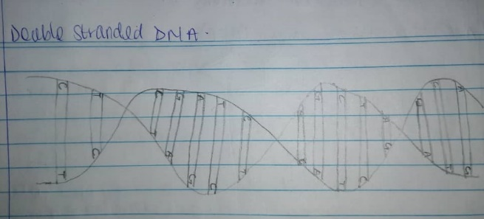
2.
Properties | DNA | RNA
Sugar moiety | Deoxyribose | Ribose
Nitrogenous Base | Adenine, Guanine, Cytosine, Thymine | Adenine, Guanine, Cytosine, Uracil
Pairing | Adenine pairs with Thymine | Adenine pairs with Uracil
Number of strands | Two strands | Single strand
Alkali action | Cannot be hydrolyzed by alkali | Can be hydrolyzed by alkali
Propagation | Self-replicating | Synthesized from DNA

3. Biosynthesis of Calcitriol: Cholecalciferol is hydrolyzed at the 25th position to 25-hydroxycholecalciferol(25-OHD3) by a specific hydroxylase present in the liver. 25-hydroxycholecalciferol is the major storage and circulatory form of vitamin D. The kidney possesses a specific enzyme (25-hydroxycholoecalciferol 1- hydroxylase) which hydrolyzes 25-hydrocholecalciferol at position -1- to form 1, 25-hydroxycholecalciferol(calcitriol)
4. Co-enzymes are small organic molecules that bind tightly (prosthetic groups) or loosely(co-substrates) to enzymes as they participate in catalysis. They can also be defined as essential organic compounds that attach to enzymes to aid catalyze reactions. They serve as recyclable shuttles or group transfer reagents that transport many substrates from their point of generation to their point of utilization. Due to their affinity with the enzyme, comparable with that of the substrate, they are regarded as co-substrates. They are derivatives of water-soluble B-complex vitamins.
Riboflavin (VitaminB₂) is a component of two co-enzymes; FMN and FAD (Flauinmononucleotide and Flavinadeninedinucleotide). They participate in many redox reactions responsible for enzyme production. FMN and FAD function as tightly bound prosthetic groups in a class of enzymes known as the flavoproteins. They are also associated with certain enzymes involved with carbohydrate, lipid and purine metabolism besides the electron transport chain. The co-enzymes contain riboflavin, adenine, ribose and phosphates.
5. Nucleotide unit: Adenylate, Guanylate (purines), Cytidylate, Uridylate (pyrimidines)
Nucleoside unit: Adenosine, Guanosine(purines), Cytidine, Uridine(pyrimidines)

6.
.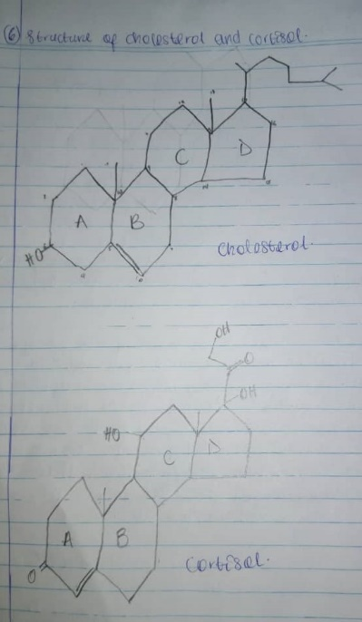
7. Vitamins are organic compounds required in the diet in small amounts to perform specific biological functions in an organism. There are 13 essential vitamins and they are classified into two broad groups based on their solubilities; fat soluble vitamins and water-soluble vitamins.
Fat soluble vitamins are apolar hydrophobic compounds that can only be absorbed sufficiently when there is normal fat absorption. They are soluble in fat are absorbed by the body via the intestinal tract. They are stored in body fats and cannot be readily excreted in urine. The fat-soluble vitamins include; Retinol, Tocopherol, Cholecalciferol, Phylloquinone and Menaquinone (vitamins A, E, D and K respectively).
Water soluble vitamins are polar hydrophilic compounds that are easily absorbed by the body. They cannot be stored in the body and are easily lost in urine so they must be continually supplied in the diet. They are non-toxic. The water-soluble vitamins include Thymine, Riboflavin, Niacin, Pantothenic acid, Pyridoxamine, Biotin, Folic acid, Cobalamin (these are the vitamin B complex; B₁, B₂, B₃, B₅, B₆, B₇, B₉, B₁₂ respectively) and Ascorbic acid (vitamin C).
Biosynthesis of Calcitriol: Cholecalciferol is hydrolyzed at the 25th position to 25-hydroxycholecalciferol(25-OHD3) by a specific hydroxylase present in the liver. 25-hydroxycholecalciferol is the major storage and circulatory form of vitamin D. The kidney possesses a specific enzyme (25-hydroxycholoecalciferol 1- hydroxylase) which hydrolyzes 25-hydrocholecalciferol at position -1- to form 1, 25-hydroxycholecalciferol(calcitriol). The hydroxylase enzymes of the liver and kidney require cytochrome P450, NADPH and molecular oxygen for the hydroxylation process.
8. (i) Cerebrosides: These are the simplest glycolipids with only one sugar residue (either glucose or galactose) linked to the ceramide. There are two types; glucocerebroside and galactocerebroside. Glucocerebrosides are the predominant glycolipid of extranuclear tissue while galactocerebrosides are found in nerve tissues membrane. 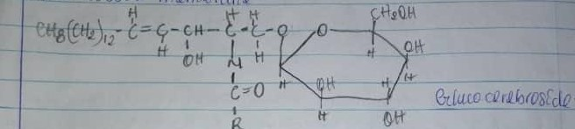
(ii) Sulfatides: These are cerebrosides in which the monosaccharide contains a sulphate ester.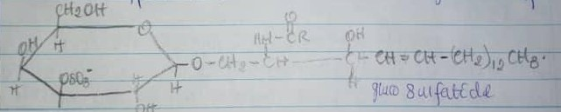
(iii) Globosides: These contain one or more sugar molecules attached to the ceramide. They are important components of the red blood cell membrane and are the determinants of the ABO blood group system.
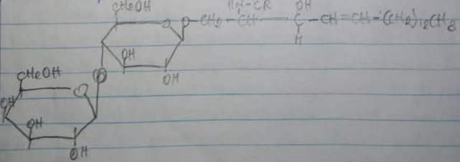
(iv) Gangliosides: These are complex glycolipids derived from glucocerebrosides. They contain oligosaccharides with one or more molecules of sialic acid (N- acetylneuraminic acid) attached to the ceramide.
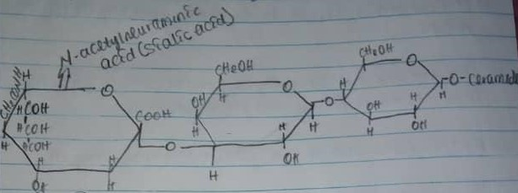
9. Cell and it’s Components
The cell is the smallest structural unit of living matter capable of functioning independently. It is classified into two types; prokaryotes and eukaryotes. Prokaryotic cells have no membrane bound nucleus and sub nuclear organelles e.g. are bacteria and blue green algae. Eukaryotic cells have true membrane bound nucleus and are larger than prokaryotic cells. Eukaryotes have a variety of other membrane bound organelles in their cytoplasm.
A cell has three major components; the cell membrane, the cytoplasm & its organelles and the nucleus.
Cell Membrane: This is a thin envelope that surrounds the cell. It consists of glycolipids, glycoproteins, phospholipids, lipids and proteins. It protects cell contents, acts as a semipermeable barrier allowing certain substances into and out of the cell and helps in the maintenance of the shape and size of the cell.
Cytoplasm: This consists of the clear fluid in the cell called cytosol and the organelles. These organelles include;
- Endoplasmic Reticulum: This is an interconnected network of tubular and flat vascular structures which form links between the nucleus and cell membrane. There are two types; the rough endoplasmic reticulum which has ribosomes and functions in protein synthesis and the smooth endoplasmic reticulum which has no ribosomes and functions in lipid synthesis.
- Golgi apparatus: This consists of a stack of several smooth, membranous sacs. It is present in all cells except the red blood cells. It is situated near the nucleus. The Golgi apparatus modifies proteins and lipids it receives from the endoplasmic reticulum.
- Lysosomes: This is produced in the Golgi apparatus. It contains enzymes called lysozymes. The lysosomes destroy bacteria and other foreign bodies, removes excess secretory products and removes unwanted cell in embryo.
- Peroxisomes: These look like lysosomes but are not made from Golgi apparatus. They are made of preexisting peroxisomes. Their major function is detoxification of peroxides.
- Mitochondria: This is the site of energy production in the cell in the form of ATP synthesis.
- Plastids: This is found in plants, algae. There are two types; leucoplasts which stores starch or proteins in storage organs and chromoplast that accumulate chloroplast.
- Chloroplast: These are a type of chromoplast specialized for photosynthesis.
- Cytoskeleton: This is found in eukaryotic cells and is a network of protein filaments that supports the plasma membrane. These protein filaments include; microtubules which are necessary for formation and functions of mitotic spindles that give stability to cell, microfilaments also known as cell cortex which help in muscle contraction and maintain shape & movements of the cell and intermediate filaments that provide strength and rigidity to axons.
- Ribosomes: These are RNA/protein complexes that function in protein biosynthesis.
Nucleus: This is a spherical organelle located close to the center of the cell. It is the sight of DNA replication and transcription. It also contains all the genetic information of the cell.

