NAME: obiekwe chinonso Emmanuel
MATRIC NUMBER: 17/sci01/056
COURSE CODE: CSC302

Q1

Modular programming is a software design technique that emphasis on separating the functionality of a program into independent, interchangable modules, each that it contains everything necessary to execute only one aspect of the desired programs functions. In modular programming procedures of a common functionality are grouped together into separate modules and the main program coordinates calls to procedures in separate modules and hands over data as parameters. The schema is shown below:
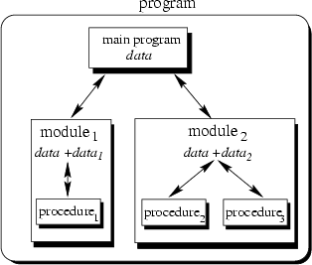
Fig 1: Schema of Modular programming
- Object Oriented programming(OOP) is a programming paradigm based on objects that aims to incorporate the advantages of modularity and re-usability of objects which are usually instances of classes used to interact with one another to design applications

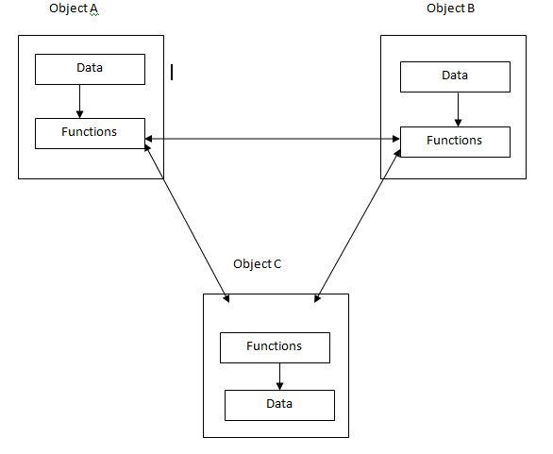
Fig 2 Schema of Object Oriented Programming
OOP is an approach to the overall organization of a program.
Unlike modular programming which gets more complex as the size of the program increases, OOP take s of that by the use of objects and their re-usability in various stages.
And as modular programming data can be easily altered, In OOP there is encapsulation meaning that the data needed by the object is within the object and can only be accessed by a function call from that object and not altered.

B
An online reservation program with varities of airline management takes and service customer needs from time of initial reservation to completion of the flight