MEE 510
PRODUCT DESIGN ASSIGNMENT
EVALUATION OF THE EFFECT OF CORROSION ON THE STRUCTURAL INTERGRITY OF MILD STEEL WELDMENY
BY
OPARA NDAMENUM
MECHANICAL ENGINEERING
15/ENG06/057

Corrosion of metals refers to the natural process wherein a refined metal is converted into its more chemically stable form such as metal oxides, metal hydroxides, and metal sulphides. In this case the metal to be considered is mild steel.
Carbon steel are used throughout the industrialized world in such diverse application as marine, nuclear/fossil fuel power plants, transportation etc. Carbon steel is cheap and widely available. It comes in different grades. High strength grades are used for high pressure service, to reduce the wall thickness. For very low temperature, such as depressurization lines and cryogenic service, alloy steels, such as stainless steel, are required.
Types of Corrosion of Metals
There are various types of corrosion such as:
Pitting Corrosion
Pitting corrosion is very unpredictable and therefore is difficult to detect. It is considered one of the most dangerous types of corrosion. It occurs at a local point and proceeds with the formation of a corrosion cell surrounded by the normal metallic surface. Once this ‘Pit’ is formed, it continues to grow and can take various shapes. The pit slowly penetrates metal from the surface in a vertical direction, eventually leading to structural failure if left unchecked.

Uniform Corrosion
This is considered the most common form of corrosion wherein an attack on the surface of the metal is executed by the atmosphere. The extent of the corrosion is easily discernible. This type of corrosion has a relatively low impact on the performance of the material.

Crevice Corrosion
Whenever there is a difference in ionic concentration between any two local areas of a metal, a localized form of corrosion known as crevice corrosion can occur. Examples of areas where crevice corrosion can occur are gaskets, the undersurface of washers, and bolt heads.

Stress Corrosion Cracking
Stress Corrosion Cracking can be abbreviated to ‘SCC’ and refers to the cracking of the metal as a result of the corrosive environment and the tensile stress placed on the metal. It often occurs at high temperatures.

Intergranular Corrosion
Intergranular corrosion occurs due to the presence of impurities in the grain boundaries that separate the grains that are formed during the solidification of the metal alloy. It can also occur via the depletion or enrichment of the alloy at these grain boundaries.

Galvanic Corrosion
When there exists an electric contact between two metals that are electrochemically dissimilar and are in an electrolytic environment, galvanic corrosion can arise. It refers to the degradation of one of these metals at a joint or at a junction. A good example of this type of corrosion would be the degradation that occurs when copper, in a salt-water environment, comes in contact with steel.

Statement of Problem
Corrosion failures of industrial components are commonly associated with welding. The reasons are many and varied. For example, welding may reduce the resistance to corrosion and environmentally assisted cracking by altering composition and microstructure, modifying mechanical properties, introducing residual stress, and creating physical defects.

Aim and Objectives
The aim of this project is to evaluate the effect of corrosion defect on the structural integrity of mild steel
The objectives of this work are to:
- Carry out tests on non-corroded mild steel weldment
- Carry out tests on corroded mild steel weldment
- Evaluate and compare test results of corroded and non-corroded mild steel to determine the effect of the corrosion

Scope
This project is limited to the study of the corroded weldment in carbon steel and how the corrosion affects the structural integrity of the weldment.

Methodology
- Destructive tests
- Non Destructive tests

SCANNING ELECTRON MICROSCOPY
The scanning electron microscope (SEM) uses a focused beam of high-energy electrons to generate a variety of signals at the surface of solid specimens. The signals that derive from electron-sample interactions reveal information about the sample including external morphology (texture), chemical composition, and crystalline structure and orientation of materials making up the sample. Performing a visual analysis of a surface using scanning electron microscopy contributes to the identification of contaminates or unknown particles, the cause of failure and interactions between materials. In addition to surface evaluation, SEM analysis is utilized for particle characterization, such as wear debris generated during mechanical wear testing. The high magnification, high-resolution imaging of our SEM analysis supports the determination of the number, size, and morphology of small particles, allowing clients to understand the wear properties of their material.

SPARK TEST
Spark testing involves the use of a field portable electronic instrument specifically designed to analyze metals and measure and quantify the chemical content. The instrument gives elemental content of metallic and non-metallic compounds which make up the material under analysis and will give the percentage content of the elements present.
Conventionally, spark test is made by holding a sample of the material against an abrasive wheel. By visually inspecting the spark stream, an experienced metalworker can identify the metals with considerable accuracy. This test is fast, economical, convenient, and easily accomplished, and there is no requirement for special equipment (Today spark testing is automated with improved reliability and more information about the metal provided). We can use this test for identifying metal salvaged from scrap. Identification of scrap is particularly important when selecting material for cast iron or cast steel heat treatment. When you hold a piece of iron or steel in contact with a high-speed abrasive wheel, small particles of the metal are torn loose so rapidly that they become red-hot. As these glowing bits of metal leave the wheel, they follow a path (trajectory) called the carrier line. This carrier line is easily followed with the eye, especially when observed against a dark background.
The sparks given off, or the lack of sparks, aid in the identification of the metal. The length of the spark stream, the color, and the form of the sparks are features you should look for.

ULTRASONIC TESTING (UT)
Ultrasonic nondestructive testing, also known as ultrasonic NDT or simply UT, is a method of characterizing the thickness or internal structure of a test piece through the use of high frequency sound waves. The frequencies, or pitch, used for ultrasonic testing are many times higher than the limit of human hearing, most commonly in the range from 500 KHz to 24 MHz. This method of testing makes use of mechanical vibrations similar to sound waves but of higher frequency. A beam of ultrasonic energy is directed into the object to be tested. This beam travels through the object with insignificant loss, except when it is intercepted and reflected by a discontinuity. The ultrasonic contact pulse reflection technique is used. This system uses a transducer that changes electrical energy into mechanical energy. The transducer is excited by a high-frequency voltage, which causes a crystal to vibrate mechanically. The crystal probe becomes the source of ultrasonic mechanical vibration. These vibrations are transmitted into the test piece through a coupling fluid, usually a film of oil, called a couplant. When the pulse of ultrasonic waves strikes a discontinuity in the test piece, it is reflected back to its point of origin. Thus the energy returns to the transducer. The transducer now serves as a receiver for the reflected energy. The initial signal or main bang, the returned echoes from the discontinuities, and the echo of the rear surface of the test piece are all displayed by a trace on the screen of a cathode-ray oscilloscope. The detection, location, and evaluation of discontinuities become possible because the velocity of sound through a given material is nearly constant, making distance measurement possible, and the relative amplitude of a reflected pulse is more or less proportional to the size of the reflector.
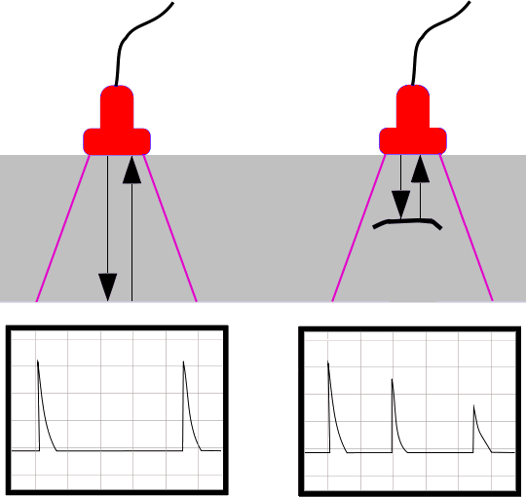

The principle of ultrasonic testing based on the fig above:
LEFT: A probe sends a sound wave into a test material. There are two indications, one from the initial pulse of the probe, and the second due to the back wall echo.
RIGHT: A defect creates a third indication and simultaneously reduces the amplitude of the back wall indication.
One of the most useful characteristics of ultrasonic testing is its ability to determine the exact position of a discontinuity in a weld. This testing method requires a high level of operator training and competence and is dependant on the establishment and application of suitable testing procedures. This testing method can be used on ferrous and nonferrous materials, is often suited for testing thicker sections accessible from one side only, and can often detect finer lines or plainer defects which may not be as readily detected by radiographic testing.
Ultrasonic flaw detection requires a trained operator who can set up a test with the aid of appropriate reference standards and properly interpret the results. Inspection of some complex geometries may be challenging. Ultrasonic thickness gages must be calibrated with respect to the material being measured, and applications requiring a wide range of thickness measurement or measurement of acoustically diverse materials may require multiple setups. Ultrasonic thickness gages are more expensive than mechanical measurement devices.

MAGNETIC TESTING (MT)
Magnetic particle inspection (often abbreviated MT or MPI) is a nondestructive inspection method that provides detection of linear flaws located at or near the surface of ferromagnetic materials. It is viewed primarily as a surface examination method. This technique is used to detect surface and slightly subsurface flaws in most ferromagnetic materials such as iron, nickel, and cobalt, and some of their alloys. This test shows defects and discontinuities invisible to the naked eye located on surfaces and in shallow sub surfaces up to 2 mm deep. Because it does not necessitate the degree of surface preparation required by other nondestructive test methods, conducting MPT is relatively fast and easy. This has made it one of the more commonly utilized NDT techniques.
In theory, magnetic particle inspection (MPI) is a relatively simple concept. It can be considered as a combination of two nondestructive testing methods: magnetic flux leakage testing and visual testing. Consider the case of a bar magnet. It has a magnetic field in and around the magnet. Any place that a magnetic line of force exits or enters the magnet is called a pole. A pole where a magnetic line of force exits the magnet is called a north pole and a pole where a line of force enters the magnet is called a south pole. When a bar magnet is broken in the center of its length, two complete bar magnets with magnetic poles on each end of each piece will result. If the magnet is just cracked but not broken completely in two, a north and south pole will form at each edge of the crack. The magnetic field exits the north pole and reenters at the south pole. The magnetic field spreads out when it encounters the small air gap created by the crack because the air cannot support as much magnetic field per unit volume as the magnet can. When the field spreads out, it appears to leak out of the material and thus is called a flux leakage field.
MPI is a simple process with two variations: Wet Magnetic Particle Testing (WMPT) and Dry Magnetic Particle Testing (DMPT). In either one, the process begins by running a magnetic current through the component. Any cracks or defects in the material will interrupt the flow of current and will cause magnetism to spread out from them. This will create a “flux leakage field” at the site of the damage.
The second step involves spreading metal particles over the component. If there are any flaws on or near the surface, the flux leakage field will draw the particles to the damage site. This provides a visible indication of the approximate size and shape of the flaw.

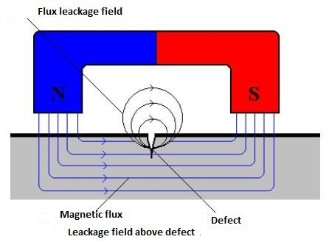

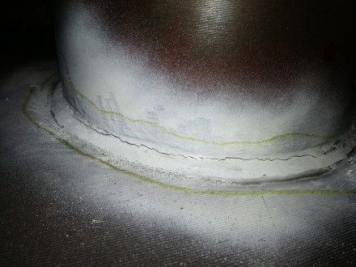
There are several benefits of MPI compared to other NDT methods. It is highly portable, generally inexpensive, and does not need a stringent pre-cleaning operation. MPI is also one of the best options for detecting fine, shallow surface cracks. It is fast, easy, and will work through thin coatings. Finally, there are few limitations regarding the size/shape of test specimens.
Despite its strengths, the method is not without limits. The material must be ferromagnetic. Likewise, the orientation and strength of the magnetic field is critical. The method only detects surface and near-to-surface defects. Those further down require alternative methods. Large currents are sometimes required to perform this method, thus “burning” of test parts is sometimes possible. In addition, once MPI has been completed, the component must be demagnetized, which can sometimes be difficult.

DESTRUCTIVE TEST (DT) OR MECHANICAL TEST
In destructive testing, the material is damaged and the component can usually no longer be used. In general, specially prepared and standardized samples are used for this type of testing. The destructive testing procedures provide important parameters in order to determine not only the proper material but also geometry of the component depending on the applied load. Destructive testing is undertaken in order to understand a specimen’s performance or material behaviour, these procedures are carried out to the test specimen’s failure. Destructive testing procedures can either follow specific standards or can be tailored to reproduce set service conditions.
A common application for materials testing is to look at the properties of welds. It is usually a requirement that welds have equal, or better, material properties that the pieces being joined. Destructive testing can be carried out on representative weld samples, known as coupons, to confirm the welds’ properties.

IMPACT TEST
An impact test signifies toughness of material which is the ability of material to absorb energy during plastic deformation. Static tension tests of unnotched specimens do not always reveal the capability of a metal to brittle fracture. This important factor is determined by impact test. Toughness takes into account both the strength and ductility of the material. Several engineering materials have to withstand impact or sudden loads while in service. Impact strengths are generally lower as compared to strengths achieved under slowly applied loads. Among all types of impact tests, the notched bar tests are most extensively used. Therefore, the impact test measures the energy necessary to fracture a standard notch bar by applying an impulse load. The test measures the notch toughness of material under shock loading. Values obtained from these tests are not of much utility to design problems directly and are highly arbitrary. Still it is important to note that it provides a good way of comparing toughness of various materials of toughness of the same material under different conditions. Impact testing most commonly consists of Charpy and Izod Specimen configurations.
Izod Impact Testing is a standard method of measuring the impact resistance of a material. In this, a striker or hammer attached to a pendulum is released from a height; which swings down and strikes at the upper tip and breaks the notched specimen (placed vertically) whose impact resistance is to be determined. In izod test only v notch is used. The dimension or size of the specimen used in the izod Test is 75mm x 10mm x 10mm. Also izod test is used for both metals and plastics.
Charpy Impact Testing is also a standard method of measuring the resistance of a material against sudden load or impact. In this, a striker or hammer attached to a pendulum is released from a height; which swings down and strikes at the center and breaks the notched specimen (placed horizontally) whose impact resistance is to be determined. Both v and u notch can be used in charpy testing. The dimension of the specimen used is 55mm x 10mm x 10mm. This testing method can be used for only metals.

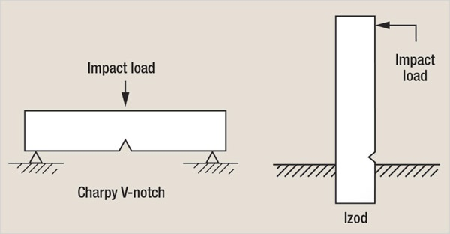

HARDNESS TEST
The hardness of a material is its resistance to penetration under a localized pressure or resistance to abrasion. Hardness tests provide an accurate, rapid, and economical way of determining the resistance of materials to deformation. There are three major types of hardness measurements depending upon the manner in which the test is conducted:
- Scratch hardness measurement
- Rebound hardness measurement
- Indentation hardness measurement
In scratch hardness method the materials are rated on their ability to scratch one another and is usually used by mineralogists only. In rebound hardness measurement, a standard body is usually dropped on to the material surface and the hardness is measured in terms of the height of its rebound. The general means of judging the hardness is measuring the resistance of a material to indentation. The indenter is usually a ball, cone or pyramid of a material much harder than that being used. Hardened steel, sintered tungsten carbide or diamond indenters are generally used. In indentation tests a load is applied by pressing the indenter at right angles to the surface being tested. The hardness of the material depends on the resistance which it exerts during a small amount of yielding or plastic straining. The resistance depends on friction, elasticity, viscosity and the intensity and distribution of plastic strain produced by a given tool during indentation. Some indentation tests include:
- Macro Hrdeness test (Loads > 1kg): Rockwell, Brinell, Vickers
- Micro Hardness Test (Loads < 1kg); knoop diamond, Vickers diamond.

TENSILE TEST
Tensile Testing, also known as tension testing, is a destructive engineering and materials science test whereby controlled tension is applied to a sample either as a load for proof testing or until it fully fails. This is one of the most common mechanical testing techniques. It is used to find out how strong a material is and also how much it can be stretched before it breaks. This test method is used to determine yield strength, ultimate tensile strength, ductility, strain hardening characteristics, Young's modulus and Poisson's ratio.
In this test ends of the test piece are fixed into grips connected to a straining device. If the applied load is small enough, the deformation of any solid is entirely elastic. An elastically deformed solid will return to its original form as soon as load is removed. However, if the load is too large, the material can be deformed permanently

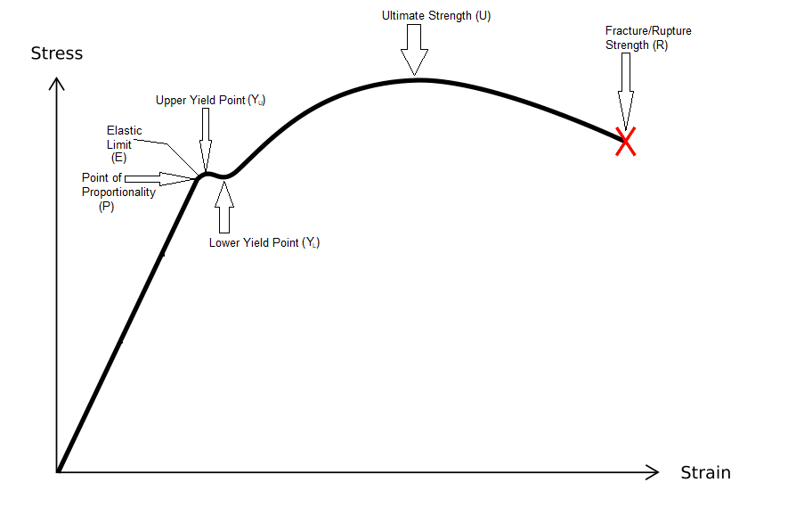
P, the point of proportionality is the point up to which the stress is directly proportional to strain during the testing process. E is the point up to which the material behaves as an elastic material. Up to this stage, if the load is removed, the specimen can regain its original shape and size. Y, the point at which the plastic deformation starts taking place in the material during the test is called the Yield Point. The value of the stress developed at this point is called the Yield Strength of the material. Different materials have a different value for the Yield Strength. U, the maximum amount of force that a material can withstand (before fracture) per unit cross-sectional area is called the Ultimate Strength of the material. You can also say that it is the maximum tensile stress developed in the material during the tensile testing. The value of the Ultimate Strength is different for different materials. R, the point at which the material breaks or fracture during the testing process is called the Rupture Point. And, the amount of stress at that point is called the Rupture Strength of the material.

