ASSIGNMENT

NAME ; OYENUGA MUSTAPHA OPEYEMI
MATRIC NO; 15/ENG06/061
DEPARTMENT; MECHANICAL ENGINEERING

CHAPTER 1

INTRODUCTION

Background to the Study
One of man’s greatest dreams is the actualization of winged flight. This has been expressed in Greek mythology of Daedalus (Greek Demigod engineer) and Icarus (Daedalus son) and seen in the works of great scholars of old most notable Leonardo Da Vinci’s design. Leonardo da Vinci began to study the flight of birds. He grasped that humans are too heavy, and not strong enough, to fly using wings simply attached to the arms. Therefore he sketched a device in which the aviator lies down on a plank and works two large, membranous wings using hand levers, foot pedals, and a system of pulleys.
A Flapping Wing Unmanned Aerial Vehicle is also known as an Ornithopter. Ornithopter is gotten from two Greek words, ‘Ornithos’ meaning bird and ‘pteron’ meaning wing.
An Ornithopter is a device that flies by flapping its wings. It imitates the flight of creatures in nature mainly birds and insects. Though these devices may differ in form, they are built on the same scale as the creatures they imitate. The wings generate the required lift and thrust required for flight via a flapping mechanism which converts the rotary motion of the motors through the gears into oscillating motion of the wings.
The principle of operation of the Ornithopter is same as the airplane; the forward motion through the air allows the wings to deflect air downward, producing lift. The flapping motion of the wings takes the place of rotating propeller. Engineers and researchers have experimented with wings that require carbon fiber, plywood, fabric, ribs, and the trailing edge to be stiff, strong, and for the mass to be as low as possible. Unlike airplanes and helicopters, the driving airfoils of the Ornithopter have a flapping or oscillating motion, instead of rotary motion. As with helicopters, the wings usually have a combined function of providing both lift and thrust. Theoretically, the flapping wing can be set to zero angle of attack on the upstroke, so it passes easily through the air. Since typically the flapping airfoils produce both lift and thrust, drag – inducing structures are minimized. These two advantages potentially allow a high degree of efficiency.

Statement of the Problem
Several attempts at building flapping robots or ornithopters have been made. While some were successful, many neither take off nor fly only for a short duration due to their higher complexity or poor design. Many designs still fail to fly despite the rapidly increasing population building electric ornithopters. A major problem in most designs is an inability to generate enough lift to take off in the first place. This precludes additional flight research, such as maneuverability, flight distance or time and this coupled with weight and cost constraints. In order to stay airborne, the wings must create lift equal to the weight of the Ornithopter. Thus, there arises the need for the design and selection of the components to meet the desired performance requirements of an Ornithopter which stems from the features of bird flight such as good maneuverability, low speed flight capability, agility and high propulsive efficiency.

Aims and Objectives of Study
Aim
The aim of this project is to design and construct a functional flapping wing unmannered aerial vehicle.

Objectives
- Build a functional flapping wing unmannered aerial vehicle (Ornithopter)
- To achieve short distance and sustained flight for a duration of at most 30 minutes
- To achieve durability enough to withstand impacts with minimum damage.

Justification of Study
The building of an Ornithopter is a great challenge in itself, apart from the fact that this area of UAVs is not as researched as fixed winged aircrafts. It has mainly been explored by Hobbyists and Enthusiasts and beset with cost and weight constraints until recent has seen the rise in research due to decrease in the weight of electric components. The design of flapping wing UAVs until now mainly progressed by means of trial-and-error. Automatic optimization is still very unreliable due to a lack of accurate theoretical models. Especially the design decisions concerning the shape, tension, and materials of the wings cannot be made purely on the basis of simulation due to a lack in knowledge on the aerodynamics around flexible airfoils. Looking into existing designs reveals some insights that help to understand the key challenges and tradeoffs involved in flapping wing design and giving credible feasibility to the design and implementation of functional Ornithopters.

Scope of Study
This study serves to provide insight to the basic principles involved in flapping wing design and creation of a functional ornithopter.

CHAPTER 2

LITERATURE REVIEW

Historical Background of Ornithopters
Although ornithopters had taken a back seat to hot air balloons in the 1800s and helicopters and fixed wing aircraft in the past century, nearly all earlier attempts at flight focused on imitating the flapping wings of birds. The ancient Greek myth of Daedalus and Icarus shows that the idea of humans taking to the air with the help of artificial wings is millennia old. The oldest recorded attempts date back to 60 CE, and portray enterprising individuals crafting wings from real feathers and leaping from tall buildings, with predictably disastrous results. The first reasonably successful of these tests occurred some thousand years later in 1060, when a monk managed to glide approximately 200 yards before his predictably destructive (though non-fatal) encounter with the ground (Sanderson et al 2016).
A notable step forward in ornithopter design came from Leonardo Da Vinci, although it was never properly investigated until the 19th century (Sanderson et al 2016). Leonardo da Vinci began to study the flight of birds. He grasped that humans are too heavy, and not strong enough, to fly using wings simply attached to the arms. Therefore he sketched a device in which the aviator lies down on a plank and works two large, membranous wings using hand levers, foot pedals, and a system of pulleys (Sail et al 2016).
The first ornithopters capable of flight were constructed in France Jobert in 1871 used a rubber band to power a small model bird. Alphonse Penaud, Abel Hureau de Villeneuve, and Victor Tatin, also made rubber-powered ornithopters during the 1870s. Tatin's ornithopter was perhaps the first to use active torsion of the wings, and apparently it served as the basis for a commercial toy offered by Pichancourt C. 1889. Gustave Trouve was the first to use internal combustion and his 1890 model flew a distance of 70 metres in a demonstration for the French Academy of Sciences. The wings were flapped by gunpower charges activating a bourbon tube (Wikipedia).
Further ornithopter experiments continued at sporadic intervals well into the early 20th century, although little progress was made in this time. Most prominent of these inventors was Otto Lilienthal, who while better known for his work with gliders was adamant about the potential of ornithopters. He designed and built two ornithopter models using a primitive combustion engine to power the wings, but was killed in a gliding accident before he could properly test his second attempt. Development of Ornithopters dropped off considerably following his death, mostly due to the success of fixed wing aircraft. In 1929, Alexander Lippisch designed a man-powered ornithopter that flew 250 to 300 meters after its launch. In 1942, Adalbert Schmid built a human-powered ornithopter that flew as many as 900 meters, while maintaining a distance of 20 meters off the ground for the majority of the flight. By adding an engine to the device, the ornithopter was able to fly for as long as 15 minutes in duration. A second aircraft built by Schmid was flown in 1947 and has 1 horsepower, more than three times greater than that of his first ornithopter. Many of which had to be towed by vehicle to be launched (Rawat et al 2013).
Manned ornithopters fall into two general categories: Those powered by the muscular effort of the pilot (human-powered ornithopters), and those powered by an engine (Wikipedia).
Percival Spencer constructed a series of engine driven ornithopters in the shape of a bird. They ranged in size from a small 0.02-engine-powered ornithopter to one with an eight-foot wingspan. Spencer is also noted as a pioneer pilot and the designer of the Republic Seabee amphibious airplane (K.P. Preethi, et al. 2016) In 1961, Percival Spencer and Jack Stephenson flew the first successful engine-powered, remotely piloted ornithopter, known as the Spencer Orniplane. The Orniplane had a 90.7-inch (2,300 mm) wingspan, weighed 7.5 pounds (3.4 kg), and was powered by a 0.35-cubic-inch (5.7 cm3 )-displacement two-stroke engine. It had a biplane configuration; to reduce oscillation of the fuselage (Wikipedia). He also designed a toy, called the Wham-O Bird, which introduced thousands of children to the idea of mechanized flapping-wing flight (K.P. Preethi, et al. 2016).
Sean Kinkade's Skybird, based somewhat on the Spencer Seagulls and using a 0.15 methanol-fueled engine, was an attempt at small-scale commercial production of an RC ornithopter. Smaller, electric versions were later offered. Unfortunately, many would-be enthusiasts paid their money and never received the product (Hasan, et al 2014).
The first successful electric ornithopters were the Caltech & Aerovironment microbats in 1998 (de Croon, et al 2016).
Robert Musters began a series of RC ornithopters with foam, actively twisted wings. The appearance of these ornithopters is close to that of a real bird and they are being offered for use in bird control at airports (Hasan, et al 2014).
Several other successful fabrications of flying birds including hovering bird with wing span of 30cm to 100cm have been made, some notable ones are the Cybird P1 remote controlled ornithopter, the H² bird made by students of University of California, Berkeley, and the Festo Smartbird etc.
Until recently, ornithopters represented a niche of flying vehicles. The development of lithium polymer batteries produced a light-weight high-power energy resource to power ornithopters.
Any design of an Ornithopter must take into account the same environments faced by medium to large sized birds i.e. unsteady, turbulent and incompressible flow field and Reynolds number >15000 (Rawat, et al 2013).
The main challenge is to ensure a light weight design having the Ornithopter equipped the required payload capability necessary to achieve flight and meet desired performance requirements.

Potential Challenges:
- Sourcing needed and appropriate materials in time and within budget
- Keeping overall weight to a minimum in other to achieve sustained flight
- Achieving appropriate stability and control, in order to minimize likely impacts on landing, as crashing could bring about damage or complete wreckage to the Ornithopter

Ornithopters Flight Dynamics

The Working Principle of an Ornithopter
The principle of operation of the ornithopter is same as the airplane; the forward motion through the air allows the wings to deflect air downward, producing lift. The flapping motion of the wings takes the place of rotating propeller.
As with helicopters, the wings usually have a combined function of providing both lift and thrust. Theoretically, the flapping wing can be set to zero angle of attack on the upstroke, so it passes easily through the air. Since typically the flapping airfoils produce both lift and thrust, drag-inducing structures are minimized. These two advantages potentially allow a high degree of efficiency (Bhargava, et al 2014)

Flapping Wing Aerodynamics
Flight is a phenomenon that has long been a part of the natural world. Birds’ fly not only by flapping their wings and gliding with their wings outstretched for long distances but based on principles of physical science. An Ornithopter as a man made, heavier than air, aircraft, rely on these same principles to overcome the force of gravity and achieve flight.
Heavier than air flight is made possible by the careful balance of the four fundamental forces: lift, thrust, drag and weight. These four forces act directly on the flying model.
Lift is the force that utilizes the fluid continuity and Newton’s Laws to create a force perpendicular to the flow of fluid. Lift is opposed by weight as it is the force that pulls things towards the ground. Thrust is the force that moves things through the air while drag is the aerodynamic force that reduces speed.
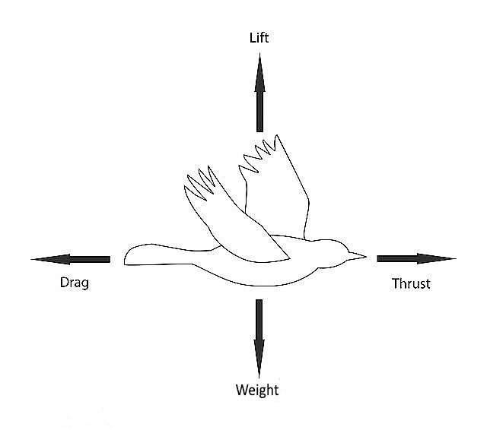
Figure 1: How Forces Act on a Bird

Thrust and drag cancels each other and same thing goes for lift and weight when the model is in cruising flight. Enough lift must be generated that must be equal to or higher than the weight of the flying model. Importantly the lift must be equal of more than the total weight of the bird.
Efficient lift generation mostly depends on the wing design. Wing is responsible for the maneuverability of the system. Its aspect ratio, angle of attack, wing loading all these terms are related to gain the efficiency in flight.
The wings of the ornithopter are attached to the body at slight angle, which is called the angle of attack; the downward stroke of the wing deflects air downward and backward, generating the lift and thrust. The surface of the wings is designed flexible which causes the wings to flex to required angle of attack in order to produce the forces essential for achieving flight (Srigrarom, et al 2015).

Flight Mechanism of an Ornithopter
Ornithopters cannot take-off from the ground directly, thus support is essential for this purpose. To fly an Ornithopter, its motion is triggered by providing it support through our hands, unlike the H² Bird which has a platform for landing and takeoff. For initiating the motion, the power supply for motor and servos is switched on and then the whole dynamics of the ornithopter is controlled by an RC Controller. Directions or throttle is controlled appropriately for smooth and stable flight. Servo motor are kept in different ways, one on the fuselage for upward and downward motion of the tail servo housing and the one attached to the servo holder carrying the tail for steering, this is so to change the direction and can be explained as follows: -
- If the fuselage servo is in upward direction then the Ornithopter deflects in downward direction.
- If the fuselage servo is in downward direction then the Ornithopter deflects in upward direction.
- If fuselage servo is in upward direction and tail servo is in leftward tilt then the ornithopter deflects in leftward direction.
- If fuselage servo is in downward direction and tail servo is in rightward tilt then the ornithopter deflects in rightward direction (Bhargava et al 2014).

Components of an Ornithopter

2.3.1. Mechanical Components:
- The Body/Frame: is the most crucial components hold all the as it holds all other components. Weight and strength are crucial in selection of the material of the frame, as this affects flight; cost is also taken into consideration during selection. Also considered in the design of the frame are the frontal area and the shape.

- The Gear System: this is the component of the Ornithopter that converts the electric power of the battery into the flapping motion of the wings. In ornithopter, gear mechanisms are used in order to provide sufficient torque to flap the wings Material most advisable to be used for this is plastics and for strut type gear box and plate type gear box are recommended for this construction.

- The Wings: Membrane Wings are the simplest wing design to construct and has a high success rate. This wing design consists of a single leading edge spar, bearing a thin sheet of wing material with additional supports where necessary. The wing material may be a plastic film, fabric or paper. For plastic film membranes, a crisp film should be used instead of a limp film.. It is important that the membrane takes a cambered shape under load. This can be achieved by ensuring that the red structure radiates outward from the front inside corner of the wing. A cambered shape ensures that the membrane is properly supported and eliminates the need for radial support, which reduces weight of the ornithopter. Micro air vehicles benefit from this design as the structure allows for the increase in wing area without increasing the wing span (Sanderson, et al 2016)

- The Flapping Mechanism: This mechanism converts rotary motion of the motor into reciprocating motion of the wings. The mechanism consists of a rotating crank shaft and connecting rods. The operating principle of the flapping mechanism is as follows:
- The motor drives a rotating crank
- The crank has a connecting rod attached to it and the other end of the connecting rod is attached to the wing
- As the crank goes around the connecting rods push the wing up and down (Dubey, et al 2017)

- Tail Wing: is responsible for both of the controllable degrees of freedom aside from the ability to throttle the drive motor. In order for an ornithopter to steer efficiently and perform turns easily, the necessary condition is the stabilization of a free flight ornithopter, which depends on its tail. The tail of an ornithopter is generally a V-shaped tail with an angle of 120 degrees.

- Other Attachments:
    - Wing Hinge: This is the point on the fuselage were the wing is hung. It contains bearings to ensure smooth and efficient flapping
    - Wing Housing: this holds the wings by and is what connects it to the hinge
    - Servo Tail Housing: This holds the Servo motor to which the tail is attached.
    - Gear plates: It covers both sides on the front of the fuselage. it essentially serves as protection for the gear system and provides support for the flapping mechanism

Electrical Components:
- Power Source:
- DC Brushless Motors: The electromagnets in a brush-less motor is switched on and off electronically by a brush-less motor controller. This improves the efficiency of the motor as without mechanical contacts, less power is require overcoming the friction at the mechanical contacts. The disadvantage of brushless motors is that they cost more than brushed motors.
For ornithopters, “outrunner” type brush-less motor is recommended. The electromagnets in these motors are stationary, while the motor outer casing rotates. These motors operate at low speed and high torque, which requires less gear reduction in the design of the ornithopter. The larger the wing, the slower the motor will run. Therefore, it is important to adjust the wing size to get the optimal loading on the motor such that the motor will not be excessively stressed. However, if it is impossible to change the wing size, the gear ratio or flapping amplitude can be adjusted.

- Batteries: The size and type of battery determines the power output and affects the duration of flight. Two common types of batteries used are the lithium-polymer battery and the lithium iron phosphate battery. Lithium iron phosphate batteries have a longer lifespan, better temperature tolerance and operate safer than lithium polymer batteries. However, lithium polymer batteries are lighter than lithium iron phosphate batteries. This is a major disadvantage for smaller ornithopters because as the battery weight increases, the weight of the ornithopter will also increase, which results in a higher demand of lift generated by the wings.

- Electronic Speed Controller: is a device that controls the speed of the motor by turning the motor on and off. To turn on the motor the switch is kept closed which allows current to flow to the motor. If switch is open then the flow of current is stopped and the motor will slow down and eventually stop turning. Proportional throttle control is achieved by varying the amount of time the switch is on relative to the amount of time it is off. For example, for 1/2 throttle, the switch is on half the time. In order to achieve smooth throttle response, this switching must occur several times per second. The motor operates safely with 13.5A so we must limit our maximum current output from the ESC to help the motor from burning out under critical load conditions.

- Communication:
- RC Transmitter and Receiver: RC means Radio Control. Radio Control is the use of radio signals to control a device. Radio control is commonly used for the control of model cars, airplanes and toys.
An RC Transmitter and Receiver are composed of a handheld device that consists of controls and a radio transmitter and a receiver module on the model and part of its electronic configuration.
The Transmitter provides control via signal transmission while the receiver receives the signal and via the onboard computer the instruction sent is executed.

- Tail Actuation:
- Servomotors: Two servos or steppers are mounted on the body frame to move the rudders attached to the tail, which are used to change the direction and pitch of the ornithopter

Ornithopter Applications
Ornithopters possess a number of features that make them ideal for use in various fields. Given their resemblance to insects and birds, ornithopters blend into the environment better than drones and other fixed wing aircraft and possess better maneuverability. They are also much quieter and less disruptive than drones, allowing for greater usage in areas such as reconnaissance. Ornithopters are used by the military and law enforcement agencies, as well as for aerial photography for either recreational or scientific purposes. They can be deployed to inspect power lines and fields, or to look for victims and assess damage after natural disasters or acts of terrorism and also in agriculture e.g. pollination (Gerszberg, et al 2019). Airports also make use of ornithopters to scare birds off the runway to allow planes to land. It’s also used in research work most especially in studies pertaining to their natural imitations e.g. The Colorado Division of Wildlife has used these machines to help save the endangered Gunnison sage grouse. An artificial hawk under the control of an operator causes the grouse to remain on the ground so they can be captured for study (Wikipedia)

CHAPTER 3

METHODOLOGY
This project will be executed using the following steps:
Material Selection

Working Drawing
Construction
Testing
Design Description

Mechanical Components and Material Selection
The materials selected for the Ornithopter fuselage, other mechanical components and its attachments to it were selected based on the following criteria according to Rawat et al:
  - Weight: In designing an aerial vehicle initial calculations for calculating the lift of the vehicle are directly related to the gross weight of the vehicle. So the frame must be designed for least weight possible without compromising on strength.

  - Strength: Frame must have adequate strength to support all the components and must fulfill its intended purpose.

  - Cost: Cost is one of the biggest deciding factors in selection of a material. The material used should therefore be cost effective and readily available.

  - Fuselage Frontal Area: Drag on an aerial vehicle is directly proportional to the frontal area. So, the frame for an aerial vehicle should be as streamlined as possible.

  - Shape: By designing an ornithopter what we are necessarily doing is imitating the flight of birds. Most applications of an ornithopter require an appearance resembling a bird. Therefore while designing the frame, it is almost mandatory to fabricate it in the shape of a bird

Table 1: Showing Materials Selected For Different Mechanical Components
S/N | COMPONENT | DESCRIPTION/DESIGN | MATERIAL SELECTED
 | Fuselage | It is the most crucial components hold all the as it holds all other components. It will be in the shape of a bird. | Fiberglass
 | Wings | This wing design consists of a single leading edge spar, bearing a thin sheet of wing material with additional supports where necessary | Polyester
 | Tail Wing | In order for an Ornithopter to steer efficiently and perform turns easily, the necessary condition is the stabilization of a free flight Ornithopter, which depends on its tail. The tail of an Ornithopter is generally a V-shaped tail with an angle of 120 degrees. | Polyester
 | Gear | This is the component of the Ornithopter that converts the electric power of the battery into the flapping motion of the wings. The gear setup is a staggered gear format consisting of a smaller gear attached to the motor which is the driver gear, a driven gear attached to the fuselage and the gear on the transverse transmission shaft with the last two being driven gears. | Plastic
 | Shaft | Transverse Transmission Shaft consisting of two cranks at either end and a driven gear at centered mainly on the left side linked by a cylindrical pipe that runs through the center of the driven gear. The crank has a connecting rod attached to it and the other end of the connecting rod is attached to the wing  As the crank goes around the connecting rods push the wing up and down | Hollow stainless steel rod, wood and plastic

Description of Other Attachment:
  - Wing Holder, Wing Hinge and Servo Tail Housing: These Components are to be done in aluminum and are to be strong enough to hold components as specified in the drawings i.e. ball bearings and tail servo respectively
  - Gear
  - Wing spars and struts:
P/S: Ball bearings will be used at certain points because of the scale of the bird at the point the tail servo holder is joined to fuselage, the wing holder and where the transmission shaft pass through the center of the fuselage.

Bird Design and Working
The design for the Ornithopter Fuselage is a bird inspired theme got from research into birds with large wingspans, academic works and popular enthusiasts and hobbyists’ works.
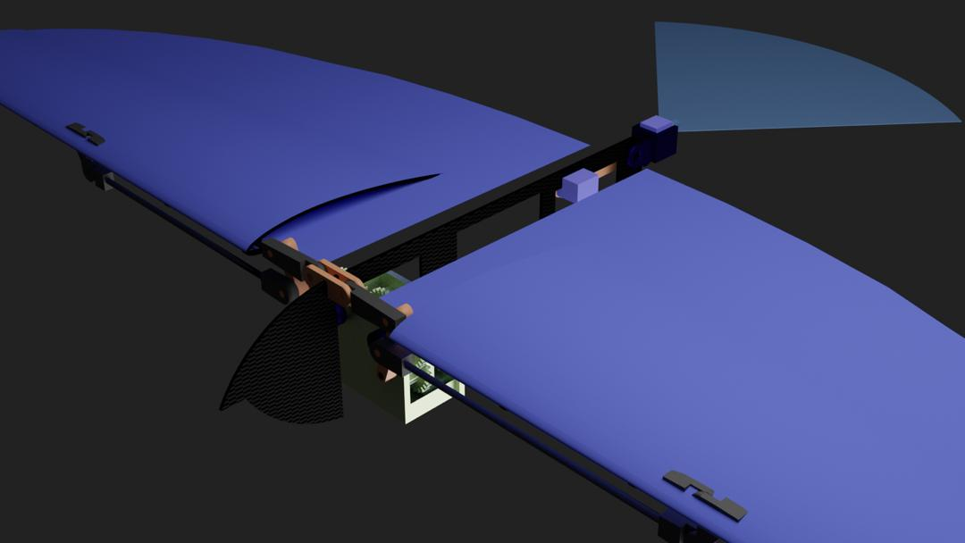
Isometric View of SolidWorks Model
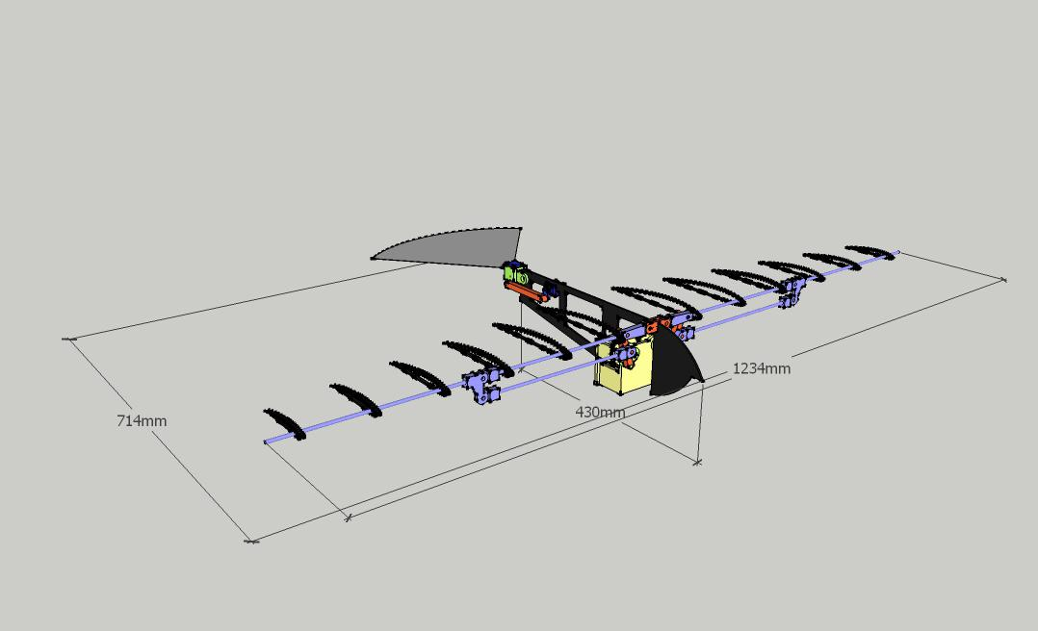
AIRFRAME STRUCTURE

Calculation of Dimension
Values were set for the following parameters:
- Wings: Wings are the most important parts of our model which can determine the flight characteristics of the Ornithopter. The sizes of a medium sized Ornithopter range between 30cm to 2m. The wing span (b) set for the ornithopter is 124cm and Chord length (c) is 21cm. The shape of the wing is elliptical and the wing area (S) is found using the formula below:
$Wing Area (S)= a×b×π$
Where,
$a=wing span ÷2=124÷2=62$
$b=root chord ÷2=21 ÷2=10.5$
$Wing Area (S)=62×10.5×π=2044.14 {cm}^{2}$

Aspect ratio and wing loading come here under careful considerations. Wing Aspect Ratio (AR) can tell the maneuverability of any bird. It is simply the ratio of the square of the wing span (b) to the wing area (S)
$AR={b^{2}}/S$
$= {{124}^{2}}/{2044.14}=7.5$

We can understand that higher the wing loading, faster the bird must fly to overcome its weight force (gravity). Wing Loading is simply the ratio of weight (W) to wing area (S)
Weight (W) in kilograms for which the intended model is set not to exceed 0.75kg (750g), this includes all electrical and mechanical components.
$Wing Loading=W/S$
$$={750}/{2044.14}$$
$$=0.387g/{cm}^{2}$$

Flapping Frequency to be generated for model is also set to be between 2-5 Hz.

First, the constants were set.
- Coefficient of Drag (C_{D}) = 2 (Based on airfoil type)
- Density of air (𝛒) = 1.225 kg/m³
- Acceleration due to gravity (G) = 9.81 m/s²
- Maximum angle wing makes with respect to body (𝛉) = 0.5236 radians

Finally, values were calculated
- Drag force (F_{d})
$F_{d} = ρ × C_{d} × c ×{b^{3}}/3$
$=1.225 ×2×0.21×{{1.24}^{3}}/3$
$=0.33 N$

- Angular Momentum (𝛚)
$$ω = {√M×G}/{F_{d}}$$
$$= {√0.75×9.81}/{0.33}$$
$$= 4.72 rad/s$$

- The time for the downstroke (T)
$$T = 1/{ {\left(ω×θ\right)}^{2}}$$
$$=1/{{(4.72×0.5236)}^{2}}$$
$$=0.16 s$$

- The torque (𝜏) of the wings
$$τ = ρ × ω^{2} × C_{d} × c × {b^{4}}/8$$
$$=1.225×{4.72}^{2}×2×0.21×{{1.24}^{2}}/8$$
$$=3.4 Nm$$

- Power ($P$) in watts
$P = τ * ω$
$=3.4×4.72$
$=16.04 W$

- Power ($P_{hp}$) in horsepower
$P_{hp} = P * 0.00134102$
$=16.04×0.00134102$
$=0.022$

Table 2: Table showing Calculated Values
b (m) | M (kg) | c (m) | F_{d} (N) | 𝛚 (rad/s) | T (s) | 𝛕 (Nm) | P (W) | P_{hp}
1.24 | 0.75 | 0.21 | 0.33 | 4.72 | 0.16 | 3.4 | 16.93 | 0.022
P/S: Calculations were done with using converted to standard form i.e. millimeter to meter, grams to kilograms etc.

Fabrication Process
The fabrication of the mechanical components of the Ornithopter was carried out in the following step:
- The Working drawings were generated using SolidWorks.
- Fabrication of mechanical parts was carried out as specified in the drawings with minor adjustments made to dimensions used in drawing.

Mechanical Components and Their Fabrication
- Fuselage and Gear Plates: The Fuselage and Gear plates were casted in acrylic and was done using the following steps:

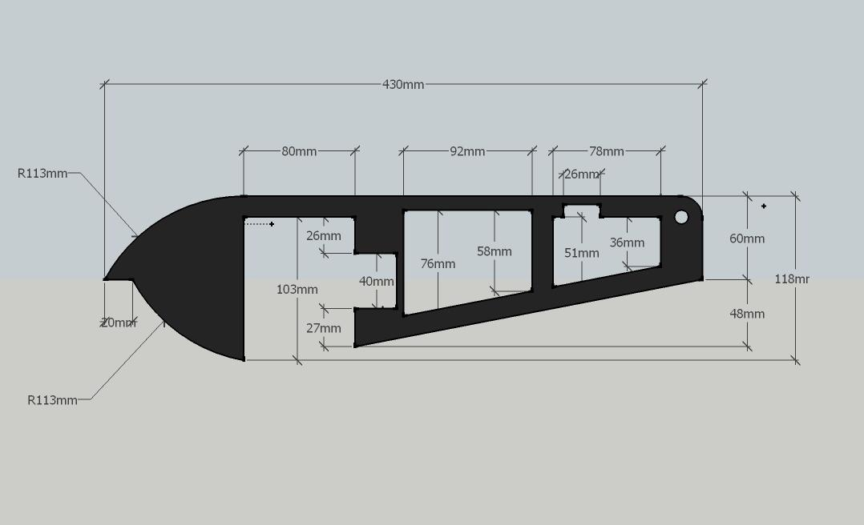
Figure 3: 2D Drawing of Fuselage with Dimensions

- Wings and Tail: The skeleton or frame of the wings and the tail was made using carbon fiber rods using a 3D printer and polyester to wrap it around

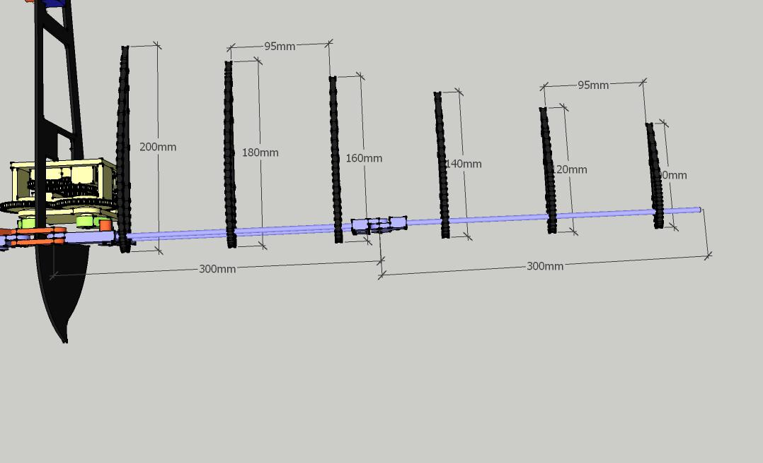

Figure 7: Finished wings and tail

- Flapping Mechanism: Shaft was fabricated using two circular wooden disks, a hollow aluminum rod and two cranks of length 8cm and a plastic gear. These where put on the bird individually during assembly process.
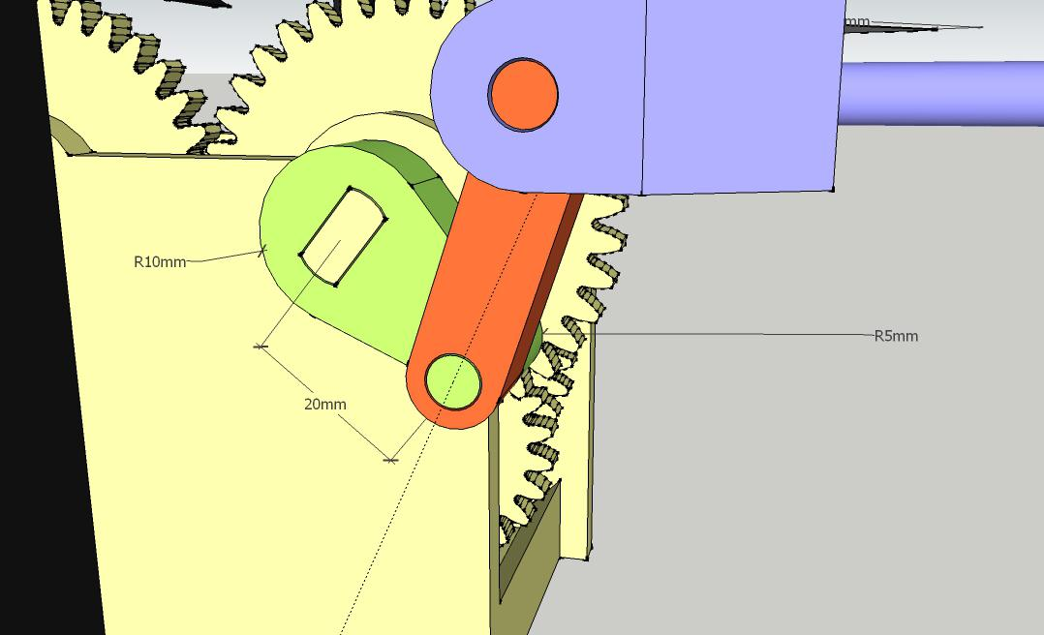
Figure 8: SolidWorks Isometric Rendering For Transverse Transmission Shaft

- Other Components
- Wing Holder:

- Wing Hinge:

- Servo Tail Housing:
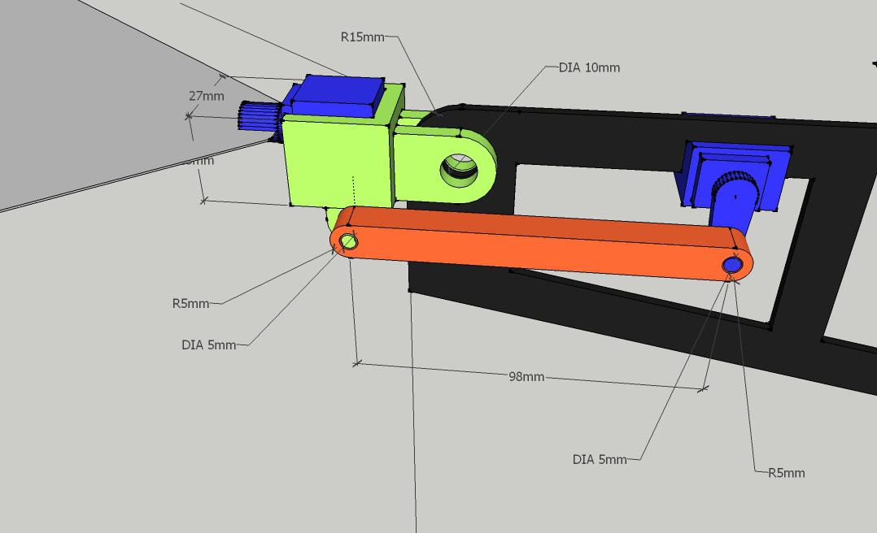
Figure 11: SolidWorks Drawing of Tail Servo mechanism

Electrical Components Selection
- Power Source:
- Motor: The model is powered by an A2212/13T Brushless Outrunner DC Motor. Brushless motors are typically 85-90% efficient whereas brushed DC motors are around 75-80% efficient. This difference in efficiency means that more of the total power used by the motor is being turned into rotational force and less is being lost as heat. This motor has a 2200KV (rpm/v) rpm rating and can pull max of 21.5A current at 11.1V. So it is capable to deliver 239W maximum power output under loaded condition and turns at a rate of 24,642rpm at no load at 100% throttle. The outer magnet can rotate and the coil remains stationary.
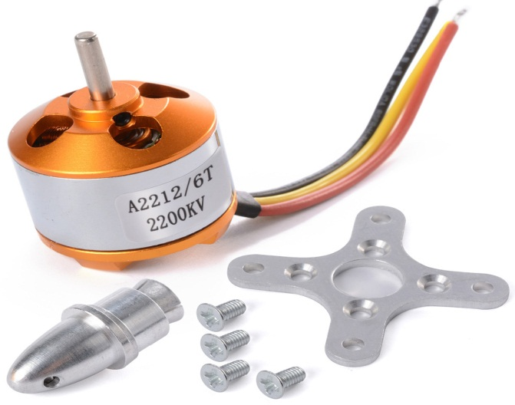
Figure 13: An A2212/13T Brushless Outrunner Motor

- ESC (Electronic Speed Control): This motor’s speed is controlled by a HK SS Series brushless 40A electronic speed controller. It gives a 40A burst for 10 seconds and 30A continuous.
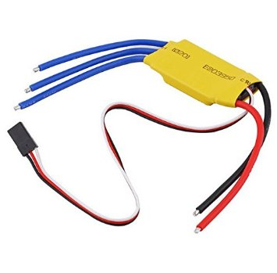
Figure 14: Electronic Speed Controller

- Battery LiPo or Lithium Polymer batteries have a much more even delivery of power during use, giving more consistent speed and punch throughout each cycle. They also have little or none of the memory effect that NiMH and NiCd battery packs suffer from. In short, LiPo’s provide high energy storage to weight ratios in an endless variety of shapes and sizes. For the past few years, NiMH stick and saddle packs have dominated the RC world, but now LiPo’s are fast becoming the norm for many RC enthusiasts. We are using a 25C 2200mAh 3S Lipo battery.
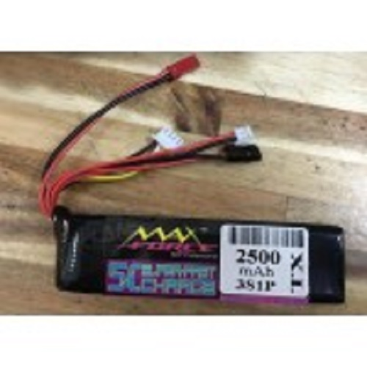
Figure 15: 25C 2200mAh 3S Lipo Battery

- Communication
- MC6 2.4GHz 6 channel transmitter and receiver control: A full function 6 Channel System with easy to set up servo reversing and model type right from the transmitter face using ‘Easy Switches’
The MC Series offers great performance, excellent range and reliability. The Microprocessor constantly scans for the best available channel to provide a care free flying experience without any transmission issues. It is not necessary to wait for other people while they are flying as the MC Series will always scan and choose the strongest signal channel for you automatically. One can fly with 1 or 50 people at the same time without any interference
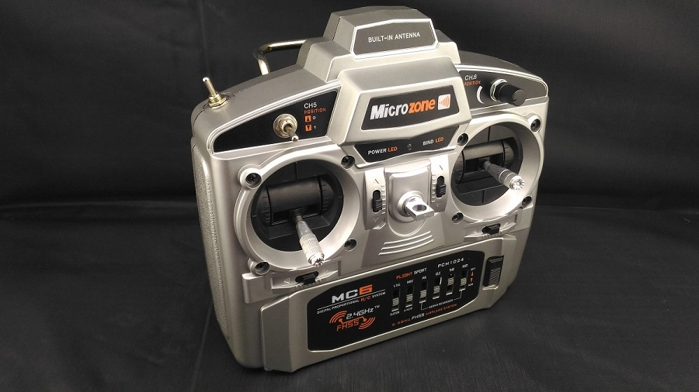
Figure 16: MC-6C 2.4GHz 6 channel transmitter and receiver

- Tail Actuation:
- Mg 90s Servo: it is small and light weight but boasts a high power output for its size. This is largely due to its metal gear and bearings. This makes it much more durable than other types of servo that feature plastic gears and bearings. The durability of the Mg 90s Servo Metal gear makes it the perfect for RC models such as airplanes and also robotic projects.

Electrical Configuration and Circuit
The goal is to ensure control of thrust, sideways, downward and upward movement of the model. The other electrical components (ESC, two servos) are connected to the RC receiver. In total 3 channels are needed to control our model bird. We simply connected the ESC which is connected to the motor to the thrust channel of the receiver and the two servos are connected to channels one and two of receiver module. As the frequency of the transmitter is very high, its antenna is small in contrast with the AM/FM transmitter and the antenna has a null region on the area pointed by the antenna tip. So for better controlling we need to take care that the antenna tip point is not directed to the model in flight time. The ESC itself has battery eliminating circuit to power up our receiver module, and in turn the servos, and also has a low voltage cut-off for Li-po to prevent a permanent damage of the Li-po battery that is used to power up the whole system.

BEME
Table 3: Bill of Engineering Materials and Evaluation

REFERENCES
- Dan Sanderson, Jourdan McKenna, Brian Baggaley, Frederick Wight (2016): Design and Implementation of an Ornithopter, Worcester Polytechnic Institute

- Ishant Dubey, Mohd.Amir, G. Sai Keerthana (2017): A Small Unmanned Flapping Air Vehicle “Ornithopter” International Journal of Scientific & Engineering Research Volume 8, Issue 9, ISSN 2229-5518.

- Umang Rawat, Amit Pawar, Shaswat Roy, Rajat Swami (2013): A designing approach for a flapping wing micro air vehicle, International Journal of Mechanical and Production Engineering, ISSN: 2320-2092, Volume- 1, Issue- 5

- Akshay Bhargava, Apoorv Bhargava, Saurabh Kr. Jangid (2014): Ornithopter design and operation , International Journal of Mechanical And Production Engineering, ISSN: 2320-2092, Volume- 2, Issue- 4

- K. P. Preethi Manohari Sail, K. Bharadwaj, K. Ravi Teja, Kalyan Dagamoori, Kasiraju Venkata Sai Tarun, Vishnu Vijayan (2016): Design, Fabrication and Testing Of Flapping Wing Micro Air Vehicle, K.P.Preethi et al. Int. Journal of Engineering Research and Applications ISSN: 2248-9622, Vol. 6, Issue 1, (Part – 3)

- Zachary John Jackowski (2009): Design and Construction of an Autonomous Ornithopter, Department of Mechanical Engineering, Massachusetts Institute of Technology.

- Nina Gerszberg, Kyra Mortensen, Akila Saravanan, Lev Stambler, Calvin Weaver, Amy Su (2018): Electronic Ornithopter Systems: Manual Navigation and Autonomous Hovering in Micro Air Vehicles, New Jersey’s Governor’s School of Engineering and Technology.

- Ornithopters - Sites.google.com/site/bath139409680/home

- Wei Shyy, Hikaru Aono, Chang-kwon Kan, Hao Liu (2013): An Introduction To Flapping Wing Aerodynamics, ISBN 978-1-107-64035-1 Paperback

- Ornithopter - Wikipedia: https://en.wikipedia.org/wiki/Ornithopter

- How Ornithopters Fly, Horst Radger: http://ornithopter.de/english/index_en.htm

- Sutthiphong Srigrarom, Woei-Leong Chan (2015): Ornithopter Type Flapping Wings for Autonomous Micro Air Vehicles, ISSN 2226-4310 www.mdpi.com/journal/aerospace.

- Imoleayo Abel: Design and Feasibility Study of Personal Ornithopters, Everbach. Department of Engineering, Swarthmore College.

- G. C. H. E. de Coon, M. Percin, B. D. W. Remes, R. Ruijsink, C. De Wagter (2016) : The DelFly: Design, Aerodynamics and Artificial Intelligence of a Flapping Wing Robot, ISBN: 978-94-017-9207-3: Hardcover – Chapter 2: Introduction to Flapping Wing Design

- Muhammad Ridhwan bin Jumat, Sutthiphong Srigrarom (2014): Design and development of UGS flapping wing MAVs, University of Glasgow Singapore.

- Nahid Hasan Adnan, Mohammad Talha Talkin Alam (2014): Designing a Radio Frequency Controlled Biomimetic Flying Bird, Department of Electrical and Electronic Engineering, BRAC University, Dhaka, Bangladesh.

- Balaji Kartikeyan Chandrasekaran (2017): Design Of An Adaptive Flight Controller For A Bird-Like Flapping Wing Aircraft, Department of Aerospace Engineering, Wichita State University.

APPENDIX
