DEPARTMENT OF HUMAN NUTRITION AND DIETETICS
ABBASS AISHAT MODUPEOLA
MATRICULATION NUMBER 19/MHS04/004
COURSE CODE : NTD 206

ASSIGNMENT
- Describe the glycolytic pathway

Glycolysis is the process in which one glucose molecule is broken down to form two molecules of pyruvic acid (also called pyruvate). The glycolysis process is a multi-step metabolic pathway that occurs in the cytoplasm of animal cells, plant cells, and the cells of microorganisms. At least six enzymes operate in the metabolic pathway. The glycolysis pathway can be separated into two phases
- The Preparatory (or Investment) Phase – wherein ATP is consumed.
- The Pay Off Phase – wherein ATP is produced.
In the preparatory phase, the energy of ATP is invested, raising the free-energy content of the intermediates, and the carbon chains of all the metabolized hexoses are converted into a common product, glyceraldehyde 3-phosphate. That is, Glucose is first phosphorylated at the hydroxyl group on C-6. The D-glucose 6-phosphate thus formed is converted to D-fructose 6-phosphate. (2) is again phosphorylated, this time at C-1, to yield D-fructose 1, 6-bisphosphate. For both phosphorylation, ATP is the phosphoryl group donor. Fructose 1,6-bisphosphate is split to yield two three-carbon molecules, dihydroxyacetone phosphate and glyceraldehyde 3-phosphate. The dihydroxyacetone phosphate is isomerized to a second molecule of glyceraldehyde 3-phosphate.

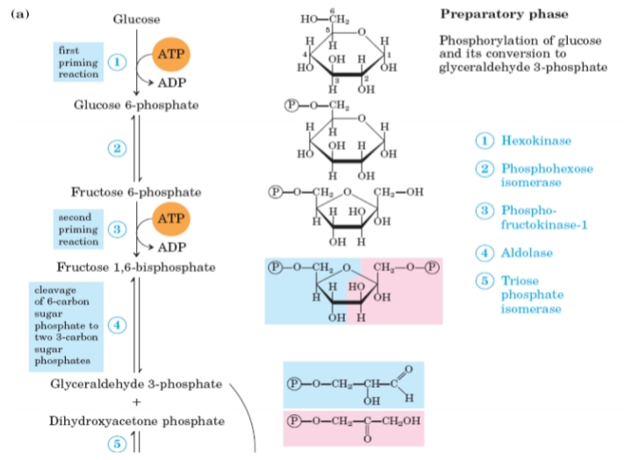
A Diagram of the preparatory phase: Phosphorylation of glucose and its conversion to glyceraldehyde-3-phosphate
In the pay-off phase, each molecule of glyceraldehyde 3-phosphate is oxidized and phosphorylated by inorganic phosphate (not by ATP) to form 1,3-bisphosphoglycerate. Energy is then released as the two molecules of 1,3-bisphosphoglycerate are converted to two molecules of pyruvate (steps 7 through 10). Much of this energy is conserved by the coupled phosphorylation of four molecules of ADP to ATP. The net yield is two molecules of ATP per molecule of glucose used, because two molecules of ATP were invested in the preparatory phase. Energy is also conserved in the payoff phase in the formation of two molecules of NADH per molecule of glucose.

A Diagram of the Pay-off phase:
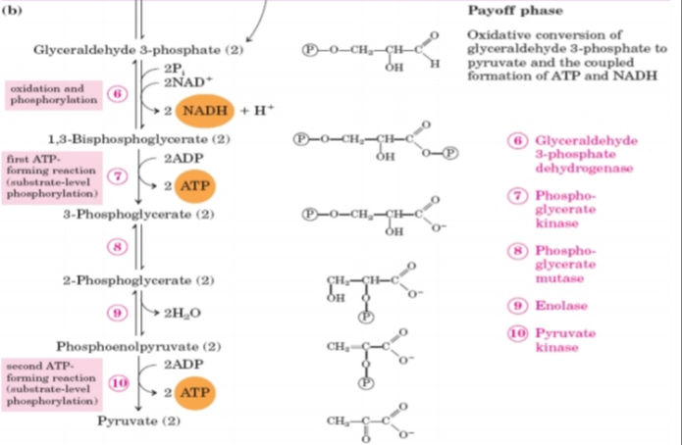
A Diagram of the Pay-off phase: Oxidative conversion of glyceraldehyde 3-phosphate to pyruvate and the coupled formation of ATP and NADH

- Compute the stoichiochemistry of coenzyme reduction and ATP formation in the aerobic oxidation of glucose via glycolysis, the pyruvate dehydrogenase complex reaction, the citric acid cycle and oxidative phosphorylation using 1 NADH = 3ATP and 1 FADH2 = 2ATP
Solution
Reaction No of ATP/ No of ATP
Red Coenz
Glucose glucose 6-phosphate -1 ATP -1
Fructose 6-phosphate ---- fructose 1,6-bisphosphate -1 ATP -1
2 Glyceraldehyde 3-phosphate
---------2 1,3-bisphosphoglycerate 2 NADH 5†
2 1,3-Bisphosphoglycerate ---- 2 3-phosphoglycerate 2 ATP 2
2 Phosphoenolpyruvate ---- 2 pyruvate 2 ATP 2
2 Pyruvate ---- 2 acetyl-CoA 2 NADH 5
2 Isocitrate ---- 2 a-ketoglutarate 2 NADH 5
2 α-Ketoglutarate ---- 2 succinyl-CoA 2 NADH 5
2 Succinyl-CoA ---- 2 succinate 2 ATP
(or 2 GTP) 2
2 Succinate ---- 2 fumarate 2 FADH2 3
2 Malate ---- 2 oxaloacetate 2 NADH 5
Total 32
Stoichiometry of Coenzyme Reduction and ATP Formation in the Aerobic
Oxidation of Glucose via Glycolysis, the Pyruvate Dehydrogenase Complex
Reaction, the Citric Acid Cycle, and Oxidative Phosphorylation
*This is calculated as 2.5 ATP per NADH and 1.5 ATP per FADH2. A negative value
indicates consumption

