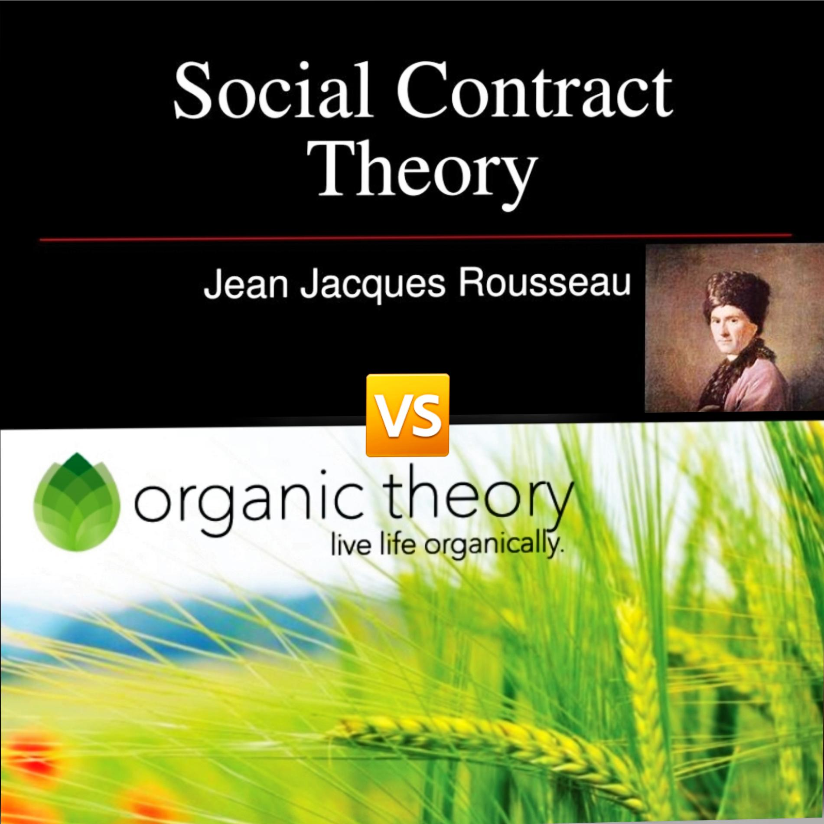

Political science

GROUP7

PAPER WORK PRESENTATION
  - GROUP STATUS &
  - PRECIS OF THE SEARCH RESULTS OF THE ORGANIC AND SOCIAL CONTRACT THEORY.
  - Date:19/3/2020.

Lecturer: MAITO YEKINI
PROJECT: ORGANIC THEORY VS SOCIAL CONTRACT THEORY OF A STATE.
Content outline:
- participant involved: Names and duties,
- Briefings of topics: critical view, comparison,
- Distinctive features between theories,
- Conclusions.
GROUP  MEMBERS |  | MATRICULATION  NUMBER | FUNCTION | ATTENDANCE
1 | NWOGBO MICHAEL | 19/LAW01/157 | PRESENTER | PRESENT
2 | NWOKORO CHINWENDU IFEOMA | 19/LAW01/158 | PRESENTER | PRESENT
3 | NWONU OGECHUKWU CALEB | 19/LAW01/159 | PRESENTER | PRESENT
4 | OBANIWA ABRAHAM KOLAWOLE | 19/LAW01/160 | PRESENTER | PRESENT
5 | OBIA AMAWUWA JENNIFER OBAECHI | 19/LAW01/161 | RESEARCHER | PRESENT
6 | OBILOM NMESOMA DEBORAH | 19/LAW01/162 | PRESENTER | PRESENT
7 | OBINNA-OGU ADAEZA BLOSSOM | 19/LAW01/163 | PRESENTER | PRESENT
8 | ODEDINA OLUWAJOBA BOLU | 19/LAW01/164 | PRESENTER | PRESENT
9 | ODEWOYE CECILIA OLUWATOYIN | 19/LAW01/165 | PRESENTER | PRESENT
10 | MARY ODEYEMI IYANUOLUWA | 19/LAW01/166 | PRESENTER | PRESENT
11 | ODIA OSAWUYAMEN VANESSA | 19/LAW01/167 | PRESENTER | PRESENT
12 | ODIASE STEPHEN JUSTICE EHI | 19/LAW01/168 | PRESENTER | PRESENT
13 | ODIBO OGHENEMARO BLESSING | 19/LAW01/169 | RESEARCHER | PRESENT
14 | ODJUGO OGHENEVWOGAGA BRODERICK | 19/LAW01/170 | PRESENTER | PRESENT
15 | ODOR EMEKA MARTINS | 19/LAW01/171 | RESEARCHER | PRESENT
16 | OFOKANSI ANTHONY NONSO | 19/LAW01/172 | MORALE SUPPORT | PRESENT
17 | OGBEBOR EHIZOGIE SUSSY | 19/LAW01/173 | PRESENTER | PRESENT
18 | OGBOSAIMUGHAN DIVINE | 19/LAW01/174 | RESEARCHER | PRESENT
19 | OGEDENGBE ABIMIFELUWA OLAYINKA | 19/LAW01/175 | PRESENTER | PRESENT
20 | OGUEJI HANNAH EBUBECHUKWU | 19/LAW01/176 | PRESENTER | PRESENT
21 | OFOKANSI ANTHONY NONSO | 19/LAW01/177 | MORALE SUPPORT | PRESENT
22 | OKUNGBADE THOMAS DANIEL | 19/LAW01/178 | PRESENTER | PRESENT
23 | OGUNMOSUNLE OLAMIPOSI AYOBAMI | 19/LAW01/179 | RESEARCHER | PRESENT
24 | OGUNMOYERO MOBOLAJI AYOMIPOSI | 19/LAW01/180 | RESEARCHER | PRESENT
25 | OHAERI UGOCHI CAROL | 19/LAW01/181 | PRESENTER | PRESENT
26 | OHWO FRANCES AGHOGHO | 19/LAW01/182 | RESEARCHER | PRESENT
27 | AKOMA BESIDONE DESTINY | 19/SMS08/001 | PRESENTER | PRESENT
28 | BARAWA-MOSES FOLEH | 19/SMS08/002 | RESEARCHER | PRESENT
29 | DUA-PHIMIA BARIMKARA | 19/SMS08/003 | RESEARCHER | PRESENT
30 | EKENIDO EFEMEZINE JOSHUA | 19/SMS08/004 | RESEARCHER | PRESENT
31 | EZEH STANLEY | 19/SMS08/005 | RESEARCHER | PRESENT
32 | FELIX BENEDICT KELECHI | 19/SMS08/006 | RESEARCHER | PRESENT
33 | LAARO IBRAHIM JIBOLO | 19/SMS08/007 | RESEARCHER | PRESENT
34 | MOHAMMED HAIDAR ALIYU | 19/SMS08/008 | RESEARCHER | PRESENT
35 | NTE ABRAHAM AWAJINWON | 19/SMS08/009 | RESEARCHER | PRESENT
36 | USMAN NAJEEM | 19/SMS08/010 | RESEARCHER | PRESENT

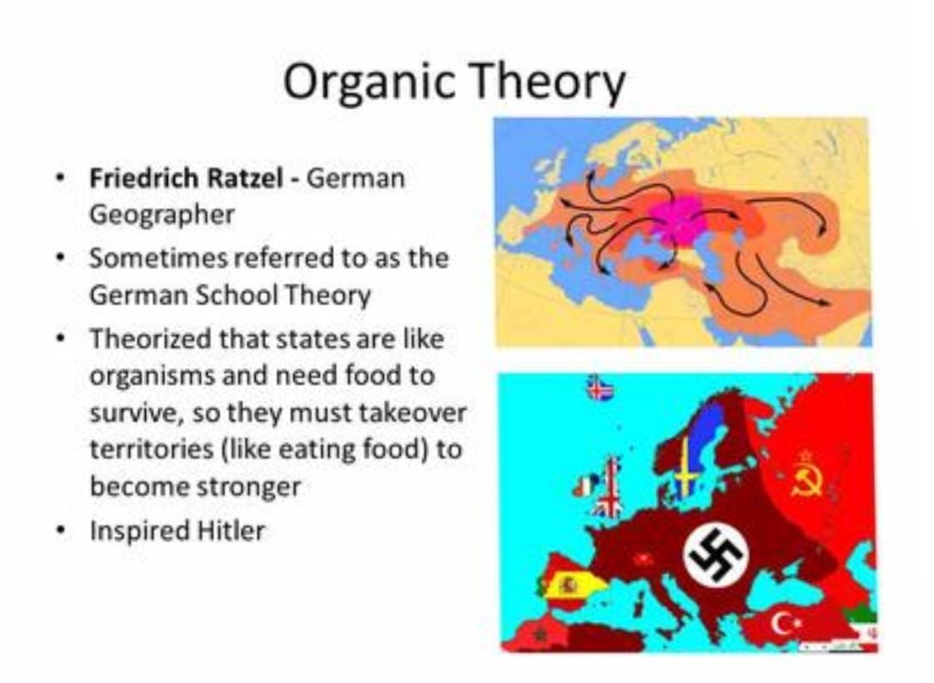
BRIEFINGS ON THE ORGANIC THEORY OF A STATE
The name “organic theory” comes from the assertion of Friedrich Ratzel (1840-1904) a German geographer and ethnographer, notable for first using the term lebensraum (living space) in the sense that the nation socialist later would. He believed that political entity such as country behaves in a way similar to living organisms. The union of individuals forming the state has been described as similar to the union between several parts of an animal body, where all parts are functionally related and none can act in isolation from the rest. Just as the body has a natural unity so has a social group. An arm lives and moves only as part of an organic whole. When amputated it dies. The organic theory is a biological conception which describes the state in terms of natural science. It views the individuals which compose it as analogous/correspondent to the cells of plants or animals, and postulates a relationship of interdependence/mutuality between them and society such as exists between the organs and parts of a biological organism and the whole structure. In conclusion with both state and living organisms, as the organisms comprises of cells so does the state comprise of individuals. As the relation of hand to the body and leaf to the tree, so is the relation of man to society.
The basic idea of the organic theory is to show that the state is, in its nature, like a biological organism or a living being and that the relation between the state and the individual is the same as between an organism and its cell. The organismic theory is essentially a biological concept which describes the phenomena of the state in biological terms. According to this theory, the state is not a mere aggregation of individuals, but an organism having parts and organs which arc related to one another in the same way as the different organs of an animal or a plant are related to one another. The theory is as old as political thought itself. Plato compared state to ‘A’ and man to ‘a’: it is an individual magnified. He compared the rulers, warriors and working classes to wisdom, courage, and appetite of the individual respectively. Aristotle drew a comparison between the symmetry of the state and symmetry of the body and believed that the individual is an intrinsic part of the society. Cicero, a Roman philosopher, also makes a passing reference to this theory. He likened the head of the state to the spirit that rules the body. Hobbes compared the state to a huge, imaginary monster called the Leviathan, which is but an artificial man, of great strength and stature. According to him the state could suffer from human ailments like pleurisy, scabies and boils etc. Rousseau, a French philosopher, too, compared the “body politic” to the “Human body”, both of which he said possessed the “motive power” of “force” and “will” (the legislative power and the executive power). The former was the “heart” of the state; the latter is the “brain”.
Bluntschli, a German philosopher, found a striking resemblance between the state and an organism. According to him the state is not a lifeless mechanism. It has life and spirit. It is not merely a collection of individuals just as an oil painting is not merely a collection of drops of oil-paint.
The state has its own personality independence as that of the individual comprising the state. Idealists described the state as a moral organism but according to Spencer the state is a living organism. He draws an elaborate analogy between the state and a living organism in the following manner:
Both state and an organism show a similar process of growth and evolution from simplicity to complexity. State in the beginning was just a tribal organization but it has developed from that primitive stage to the modern complex structure with a multiplicity of functions. An organism also exhibits similar process of growth. An embryo in the body of the mother is just a lump of flesh but slowly grows to a complete whole with various organs having variety of functions. Both grow from inside outwards. Each evolves by adjustment and response to environments. In process of growth each undergoes individualization, specialization and differentiation of both organs and functions.
Both state and organism have three main systems; a sustaining system; a distributor system; a regulating system. Sustaining system of an organism consists of digestive system by which food is digested and life of an organism is sustained. In the case of the state there is a corresponding sustaining system which consists of agriculture and industries by virtue of which the State is sustained. The distributing system in an organism consists of circulatory system by which blood is distributed to various parts of the body. In the case of the state, the distributing system consists of transport and communication. The regulating system of an organism consists of brain and nerves. Governmental and Military system constitute the regulating system in the State. There is thus a parallelism between the ways in which animal and social life is preserved.
As an organism is composed of cells, so the state is composed of individuals. In both cases, the component units contribute to the life of the whole.
An organism is constantly subjected to the process of constant wear and tear. Old and worn out cells die out and their place is taken by the fresh cells formed by the blood. In the case of social organism as well old and decrepit individuals die out and their place is taken by the newborns. Health of an organism depends upon the health of the cells organs. In case they get diseased, the whole organism suffers. In the similar way, health of the state depends upon the moral and physical health of the individuals, and associations of individuals. In case they do not work properly the efficiency and performance of the state is bound to suffer. There is thus a complete interdependence of the parts and the whole in both cases.
Both organism and state exhibit a “similar cycle of birth, growth, decay and death. From these points of agreement, the conclusion is drawn that state is an organism and there is a lot of identity between the two. The state lives, grows and develops much as an individual does.

FEATURES:
- Both state and organism have three main systems; a sustaining system; a distributor system; a regulating system. Sustaining system of an organism consists of digestive system by which food is digested and life of an organism is sustained. In the case of the state there is a corresponding sustaining system which consists of agriculture and industries by virtue of which the State is sustained. The distributing system in an organism consists of circulatory system by which blood is distributed to various parts of the body. In the case of the state, the distributing system consists of transport and communication. The regulating system of an organism consists of brain and nerves. Governmental and Military system constitute the regulating system in the State. There is thus a parallelism between the ways in which animal and social life is preserved.
- As an organism is composed of cells, so the state is composed of individuals. In both cases, the component units contribute to the life of the whole.
- An organism is constantly subjected to the process of constant wear and tear. Old and worn out cells die out and their place is taken by the fresh cells formed by the blood. In the case of social organism as well old and decrepit individuals die out and their place is taken by the new-borns.
- Health of an organism depends upon the health of the cells organs. In case they get diseased, the whole organism suffers. In the similar way, health of the state depends upon the moral and physical health of the individuals, and associations of individuals. In case they do not work properly the efficiency and performance of the state is bound to suffer. There is thus a complete interdependence of the parts and the whole in both cases.
- Both organism and state exhibit a “similar cycle of birth, growth, decay and death. From these points of agreement, the conclusion is drawn that state is an organism and there is a lot of identity between the two. The state lives, grows and develops much as an individual does. Within the organic theory we have features which may be varying from within and some are more precise than others in its descriptive characteristics which it compromises of and they are listed below as the:
MAIN FEATURES OF THE ORGANIC THEORY
Some of the characteristics that best describes. The organic theory are:
- Society is a living organism with special characteristics that obeys, as a living organism, the laws of biology.
- The main mission of the rulers is to preserve the unity of the whole. This unit is only possible with concord.
- As a consequence of the above, discord is the worst evil of a society.
- The emergence or development of factions that could weaken the State should be avoided at all costs.
- The government has, in the political field, the same function that the heart has in the human body.
- A model of organic society par excellence is the family.
- Monarchical regimes serve this conception of society.
CONCLUSIONS: Now according to me, my own approach to the organic theory would be that: The organic theory is a social biological convergence of independent functional units of individuals that come together interpedently to synergies together as a whole functional system which would form a social body of an organic structure. Therefore the distinct functional units of individuals working as a whole can now be precisely referred to as a living organisms. The theory inevitably leads to the assumption that the individuals comprising the state are completely subordinated to the state just as the cells of the body depend for their life and existence on the organism. Chop off a part of the skin, it ceases to exist. This theory leads us, therefore, to the conclusion that an individual cannot exist outside the state. The theory thus hits at individual freedom and inevitably leads to the idea of the establishment of totalitarian state or fascism.

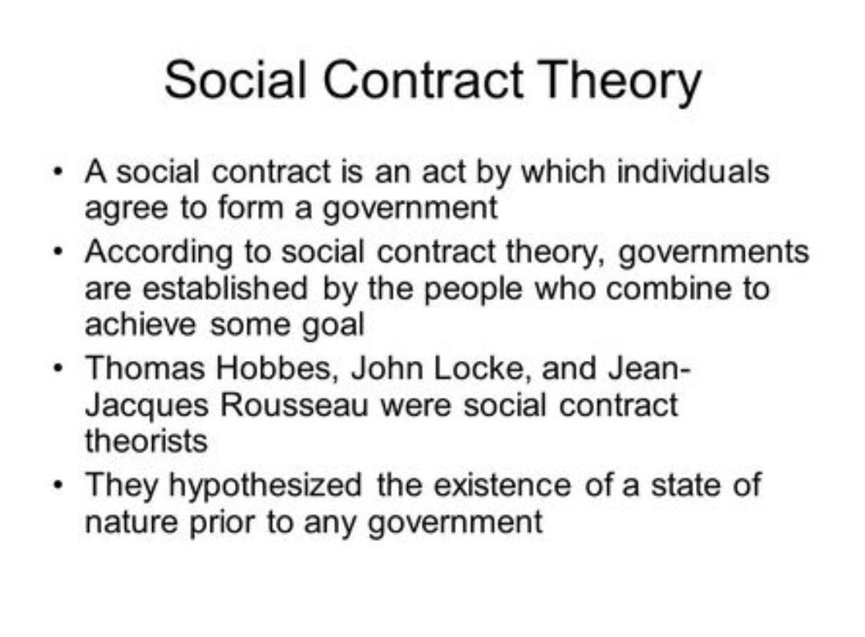
THE SOCIAL CONTRACT THEORY
This part provides a small summary of Social Contract Theory by Hobbes, Locke and Rousseau. It discusses what is the social contract theory and the reason. Then the paper points out the State of Nature according to Hobbes, Locke and Rousseau. It also put forth the differences of opinion of these jurists of the State of Nature with regard to social contract and lastly the critical apprehension of the theory of social contract given by Hobbes, Locke and Rousseau.
WHAT IS SOCIAL CONTRACT THEORY?
The concept of social contract theory is that in the beginning man lived in the state of nature. They had no government and there was no law to regulate them. There were hardships and oppression on the sections of the society. To overcome from these hardships they entered into two agreements which are:- Unionist, ; and Pactum Subjectionis. By the first pact of unionist, people sought protection of their lives and property. As, a result of it a society was formed where people undertook to respect each other and live in peace and harmony. By the second pact of subjectionis, people united together and pledged to obey an authority and surrendered the whole or part of their freedom and rights to an authority. The authority guaranteed everyone protection of life, property and to a certain extent liberty. Thus, they must agree to establish society by collectively and reciprocally renouncing the rights they had against one another in the State of Nature and they must imbue some one person or assembly of persons with the authority and power to enforce the initial contract. In other words, to ensure their escape from the State of Nature, they must both agree to live together under common laws, and create an enforcement mechanism for the social contract and the laws that constitute it. Thus, the authority or the government or the sovereign or the state came into being because of the two agreements. Analysis of the theory of Social Contract by Thomas Hobbes Thomas Hobbes theory of Social Contract appeared for the first time in Leviathan published in the year 1651 during the Civil War in Britain. Thomas Hobbes legal theory is based on social contract. According to him, prior to Social Contract, man lived in the State of Nature. Man’s life in the State of NATURE was one of fear and selfishness. Man lived in chaotic condition of constant fear. Life in the State of Nature was solitary, poor, nasty, brutish, and short. Man has a natural desire for security and order. In order to secure self-protection and self-preservation, and to avoid misery and pain, man entered into a contract. This idea of self-preservation and self-protection are inherent in man’s nature and in order to achieve this, they voluntarily surrendered all their rights and freedoms to some authority by this contract who must command obedience. As a result of this contract, the mightiest authority is to protect and preserve their lives and property. This led to the emergence of the institution of the ruler or monarch, who shall be the absolute head. Subjects had no rights against the absolute authority or the sovereign and he is to be obeyed in all situations however bad or unworthy he might be. However, Hobbes placed moral obligations on the sovereign who shall be bound by natural law. Hence, it can be deduced that, Hobbes was the supporter of absolutism. In the opinion of Hobbes, law is dependent upon the sanction of the sovereign and the Government without sword are but words and of no strength to secure a man at all. He therefore, reiterated that civil law is the real law because it is commanded and enforced by the sovereign. Thus, he upheld the principle of Might is always Right. Hobbes thus infers from his mechanistic theory of human nature that humans are necessarily and exclusively self-interested. All men pursue only what they perceive to be in their own individually considered best interests. They respond mechanistically by being drawn to that which they desire and repelled by that to which they are averse. In addition to being exclusively self-interested, Hobbes also argues that human beings are reasonable. They have in them the rational capacity to pursue their desires as efficiently and maximally as possible. From these premises of human nature, Hobbes goes on to construct a provocative and compelling argument for which they ought to be willing to submit themselves to political authority. He did this by imagining persons in a situation prior to the establishment of society, the State of Nature. Hobbes impels subjects to surrender all their rights and vest all liberties in the sovereign for preservation of peace, life and prosperity of the subjects. It is in this way the natural law became a moral guide or directive to the sovereign for preservation of the natural rights of the subjects. For Hobbes all law is dependent upon the sanction of the sovereign. All real law is civil law, the law commanded and enforced by the sovereign and are brought into the world for nothing else but to limit the natural liberty of particular men, in such a manner, as they might not hurt but to assist one another and join together against a common enemy. He advocated for an established order. Hence, Individualism, materialism, utilitarianism and absolutions are inter-woven in the theory of Hobbes. Analysis of the theory of Social Contract by John Locke, John Locke’s theory of Social Contract is different than that of Hobbes. According to him, man lived in the State of Nature, but his concept of the State of Nature is different as contemplated by Hobbesian theory. Locke’s view about the state of nature is not as miserable as that of Hobbes. It was reasonably good and enjoyable, but the property was not secure. He considered State of Nature as a Golden Age. It was a state of peace, goodwill, mutual assistance, and preservation. In that state of nature, men had all the rights which nature could give them. Locke justifies this by saying that in the State of Nature, the natural condition of mankind was a state of perfect and complete liberty to conduct one’s life as one best sees fit. It was free from the interference of others. In that state of nature, all were equal and independent. This does not mean, however, that it was a state of license. It was one not free to do anything at all one pleases, or even anything that one judges to be in one’s interest. The State of Nature, although a state wherein there was no civil authority or government to punish people for transgressions against laws, was not a state without morality. The State of Nature was pre-political, but it was not pre-moral. Persons are assumed to be equal to one another in such a state, and therefore equally capable of discovering and being bound by the Law of Nature. So, the State of Nature was a state of liberty, where persons are free to pursue their own interests and plans, free from interference and, because of the Law of Nature and the restrictions that it imposes upon persons, it is relatively peaceful. Property plays an essential role in Locke’s argument for civil government and the contract that establishes it. According to Locke, private property is created when a person mixes his labor with the raw materials of nature. Given the implications of the Law of Nature, there are limits as to how much property one can own: one is not allowed to take so more from nature than oneself can use, thereby leaving others without enough for themselves, because nature is given to all of mankind for its common subsistence. One cannot take more than his own fair share. Property is the linchpin of Locke’s argument for the social contract and civil government because it is the protection of their property, including their property in their own bodies, that men seek when they decide to abandon the State of Nature. John Locke considered property in the State of Nature as insecure because of three conditions; they are:-
1. Absence of established law;
2. Absence of impartial Judge; and
3. Absence of natural power to execute natural laws.  Thus, man in the State of Nature felt need to protect their property and for the purpose of protection of their property, men entered into the Social Contract. Under the contract, man did not surrender all their rights to one single individual, but they surrendered only the right to preserve/maintain order and enforce the law of nature. The individual retained with them the other rights, i.e., right to life, liberty and estate because these rights were considered natural and inalienable rights of men. Having created a political society and government through their consent, men then gained three things which they lacked in the State of Nature: laws, judges to adjudicate laws, and the executive power necessary to enforce these laws. Each man therefore gives over the power to protect himself and punish transgressors of the Law of Nature to the government that he has created through the compact. According to Locke, the purpose of the Government and law is to uphold and protect the natural rights of men. So long as the Government fulfils this purpose, the laws given by it are valid and binding but, when it ceases to fulfill it, then the laws would have no validity and the Government can be thrown out of power. In Locke’s view, unlimited sovereignty is contrary to natural law. Hence, John Locke advocated the principle of a state of liberty; not of license. Locke advocated a state for the general good of people. He pleaded for a constitutionally limited government.
Locke, in fact made life, liberty and property, his three cardinal rights, which greatly dominated and influenced the Declaration of American Independence, 1776.
Analysis of the theory of Social Contract by Jean Jacques Rousseau Jean Jacques Rousseau was a French philosopher who gave a new interpretation to the theory of Social Contract in his work “The Social Contract” and “Emile”. According to him, social contract is not a historical fact but a hypothetical construction of reason. Prior to the Social Contract, the life in the State of Nature was happy and there was equality among men. As time passed, however, humanity faced certain changes. As the overall population increased, the means by which people could satisfy their needs had to change. People slowly began to live together in small families, and then in small communities. Divisions of labor were introduced, both within and between families, and discoveries and inventions made life easier, giving rise to leisure time. Such leisure time inevitably led people to make comparisons between themselves and others, resulting in public values, leading to shame and envy, pride and contempt. Most importantly however, according to Rousseau, was the invention of private property, which constituted the pivotal moment in humanity’s evolution out of a simple, pure state into one, characterized by greed, competition, vanity, inequality, and vice. For Rousseau the invention of property constitutes humanities fall from grace out of the State of Nature. For this purpose, they surrendered their rights not to a single individual but to the community as a whole which Rousseau termed as general will. According to Rousseau, the original freedom, happiness, equality and liberty which existed in primitive societies prior to the social contract was lost in the modern civilization. Through Social Contract, a new form of social organization- the state was formed to assure and guarantee rights, liberties freedom and equality. The essence of the Rousseau’s theory of General Will is that State and Law were the product of General Will of the people. State and the Laws are made by it and if the government and laws do not conform to general will, they would be discarded. While the individual parts with his natural rights, in return he gets civil liberties such as freedom of speech, equality, assembly, etc. The General Will, therefore, for all purposes, was the will of majority citizens to which blind obedience was to be given. The majority was accepted on the belief that majority view is right than minority view. Each individual is not subject to any other individual but to the general will and to obey this is to obey himself. His sovereignty is infallible, indivisible, unpreventable and illimitable. Thus, Rousseau favored people’s sovereignty. His natural law theory is confined to the freedom and liberty of the individual. For him, State, law, sovereignty, general will, etc. are interchangeable terms. Rousseau’s theory inspired French and American. revolutions and given impetus to nationalism. He based his theory of social contract on the principle of Man is born free, but everywhere he is in chains.
COMPARISION OF THE THEORY OF SOCIAL CONTRACT OF THOMAS HOBBES, JOHN LOCKE AND JEAN JACQUES ROUSSEAU.
- Hobbes asserts that without subjection to a common power of their rights and freedoms, men are necessarily at war. Locke and Rousseau, on the contrary, set forth the view that the state exists to preserve and protect the natural rights of its citizens. When governments fail in that task, citizens have the right and sometimes the duty to withdraw their support and even to rebel.
- Hobbes view was that whatever the state does is just. All of society is a direct creation of the state, and a reflection of the will of the ruler. According to Locke, the only important role of the state is to ensure that justice is seen to be done. While Rousseau view is that the State must in all circumstance ensure freedom and liberty of individuals.
- Hobbes theory of Social Contract supports absolute sovereign without giving any value to individuals, while Locke and Rousseau supports individual than the state or the government.
- To Hobbes, the sovereign and the government are identical but Rousseau makes a distinction between the two. He rules out a representative form of government. But, Locke does not make any such distinction.
- Rousseau’sview of sovereignty was a compromise between the constitutionalism of Locke and absolutism of Hobbes.

  - CRITICAL APPREHENTION
- Rousseau propounded that state, law and the government are interchangeable, but this in present scenario is different. Even though government can be overthrown but not the state. A state exists even there is no government.
- Hobbes concept of absolutism is totally a vague concept in present scenario. Democracy is the need and examples may be taken from Burma and other nations.
- According to Hobbes, the sovereign should have absolute authority. This is against the rule of law because absolute power in one authority brings arbitrariness.
- Locke concept of State of nature is vague as any conflict with regard to property always leads to havoc in any society. Hence, there cannot be a society in peace if they have been conflict with regard to property.
- Locke concept of laissez-faire is not of welfare oriented. Now in present scenario, every state undertake steps to form a social contract governs relations in a society, between the people and between the people and their government and other institutions. Portions of a social contract may be formal, such as a constitution, laws, and regulations, while many aspects of a social contract may be more informal such as social norms, conventions, expectations, and religious practices.
- The theory is that without a social contract life in a state of nature would be as Thomas Hobbes put it solitary, poor, nasty, brutish and short.

SOME FEATURES OF THE SOCIAL CONTRACT THEORY
- Social contracts are the origin of society. Without a firm social contract, society as we know it would not be possible.
- A social contract is only possible with the consent of the people.
- It is a social contract that establishes the legitimacy of authority and the state over the people.
- A social contract establishes the political community.
- A social contract establishes civil society.
- With a social contract the people trade personal freedom for social and political order.
- The people do surrender some freedoms to authority, but they do so voluntarily in exchange for protection of their remaining freedoms as well as the promise of services from government.
- A social contract expresses the general will of a people, their collective interests, and provides the basis for ensuring the general welfare of the people.
- A social contract offers the promise of personal protection and the rule of law in exchange for giving up the natural right of personal retaliation.
- A social contract defines what is expected from government by the people.

Conclusion
So basically, the social contract theory says that people live together in society in accordance with an agreement that establishes moral and political rules of behavior. Some people believe that if we live according to a social contract, we can live morally by our own choice and not because a divine being requires it. Over the centuries, philosophers as far back as Socrates have tried to describe the ideal social contract, and to explain how existing social contracts have evolved. Philosopher Stuart Rachel’s suggests that morality is the set of rules governing behavior that rational people accept, on the condition that others accept them too. Social contracts can be explicit, such as laws, or implicit, such as raising one’s hand in class to speak. The U.S. Constitution is often cited as an explicit example of part of America’s social contract. It sets out what the government can and cannot do. People who choose to live in America agree to be governed by the moral and political obligations outlined in the Constitution’s social contract. Indeed, regardless of whether social contracts are explicit or implicit, they provide a valuable framework for harmony in society.

