NAME:SHADE OF GOD MARTINS-ETENG ISU
MATRIC NO:17/MHS03/023
ANATOMY (C.O)
MEDICAL BIOCHEMISTRY

DNA REPLICATION STEPS
There are three main steps to DNA replication: initiation, elongation, and termination.

In order to fit within a cell’s nucleus, DNA is packed into tightly coiled structures called chromatin, which loosens prior to replication, allowing the cell replication machinery to access the DNA strands.Before DNA replication can begin, the double helix structure of the DNA molecules has to be ‘unzipped.’ Helicase, an enzyme, is integral to this process, breaking the hydrogen bonds that hold the complementary bases of DNA together (A with T and C with G). The separation creates a ‘Y’ shape called a replication fork and the two single strands of DNA now act as templates for making new strands of DNA. Next, the Single-Stranded DNA Binding Protein (SSB Protein) binds to the now single-stranded DNA, preventing the separating strands from joining again.

The two strands of the double-helix DNA are joined together by cross-bars, twisted around. For this to work, each DNA strand runs in opposite direction.
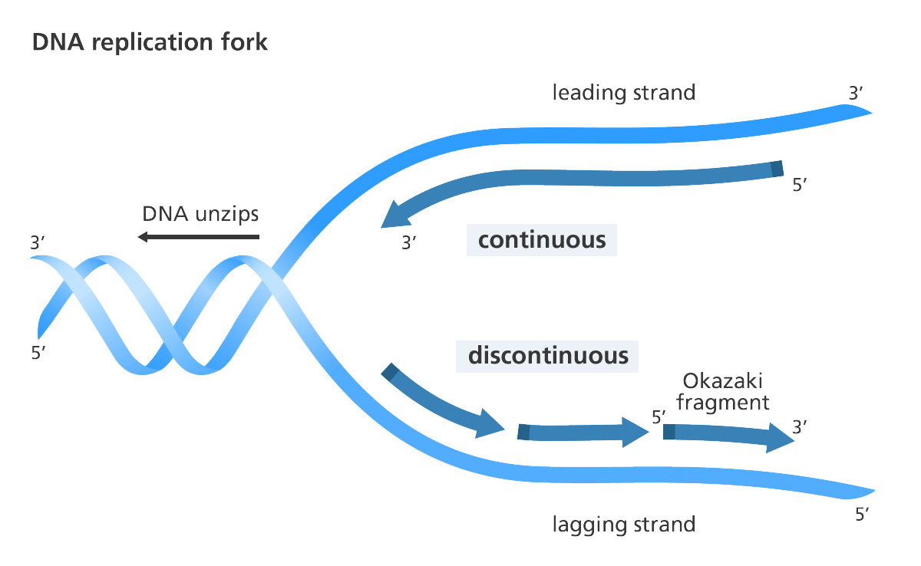
One of the strands is oriented in the 3’ to 5’ direction (towards the replication fork), this is the leading strand. The other strand is oriented in the 5’ to 3’ direction (away from the replication fork), this is the lagging strand.

Because the enzyme that carries out the replication, DNA polymerase, only functions in the 5′ to 3′ direction, this means that the daughter strands synthesize through different methods, one adding nucleotides one by one in the direction of the replication fork, the other able to add nucleotides only in chunks. The first strand, which replicates nucleotides one by one is the leading strand; the other strand, which replicates in chunks, is the lagging strand. The notations 5′ and 3′ mean “five prime” and “three prime,” which indicate the carbon numbers in the DNA’s sugar backbone. These numbers indicate end-to-end chemical orientation, with the numbers 5 and 3 representing the fifth and third carbon atom of the sugar ring respectively. The 5′ carbon has a phosphate group attached to it and the 3′ carbon a hydroxyl (-OH) group. It’s this asymmetry that gives a DNA strand a “direction,” allowing for easy binding between nucleotides of the opposite strands.
LEADING STRAND
A short piece of RNA called a primer, which is produced by an enzyme called primase, binds to the end of the leading strand in the 5’ to 3’ direction. The primer acts as the starting point for DNA synthesis.
Enzymes called DNA polymerases generate new complementary nucleotide bases (the A,C, G, and T) and are responsible for creating the new strand by a process called elongation. In eukaryotic cells, polymerases alpha, delta, and epsilon are the primary polymerases involved in DNA replication. This sort of replication is called ‘continuous.’

LAGGING STRANDS
The lagging strand begins the replication process by binding with multiple RNA primers,tgenerated by the primase enzyme, at various points along the lagging strand.Chunks of DNA, called Okazaki fragments, are added to the lagging strand between the primers, also in the 5’ to 3’ direction.
This type of replication is called ‘discontinuous’, as the Okazaki fragments will need to be joined up later.

After the formation of both the continuous and discontinuous strands, an enzyme called exonuclease removes all RNA primers from the original strands. The gaps where the primer(s) had been are then filled by yet more complementary nucleotides.Another enzyme “proofreads” the newly formed strands in order to make sure there are no errors.The enzyme DNA ligase then joins Okazaki fragments together, forming a single unified strand.
A special type of DNA polymerase enzyme called telomerase catalyzes the synthesis of telomere sequences at the ends of the DNA.
FINALLY, the parent strand and its complementary DNA strand coils into the familiar double helix shape. The result is two DNA molecules consisting of one new and one old chain of nucleotides. Each of these two daughter helices is a nearly exact copy of the parental helix (it is not 100% the same due to mutations).

2.) Functions of DNA Replication enzymes

Enzyme Function
Topoisomerase Relaxes the super-coiled DNA
DNA helicase Unwinds the double helix at
the replication fork.
Primase. Provides the starting point for
DNA polymerase to begin
synthesis of the new strand.
DNA polymerase Synthesizes the new DNA
strand; also proofreads and
corrects some errors.
DNA ligase Re-joins the two DNA strands
into a double helix and joins
Okazaki fragments of the
lagging strand.

