AFE BABALOLA UNIVERSITY, ADO EKITI
COLLEGE OF MEDICINE AND HEALTH SCIENCES
DEPARTMEMT OF HUMAN NUTRITION AND DIETETICS
ABBASS AISHAT MODUPEOLA
MATRICULATION NUMBER 19/MHS04/004
COURSE CODE: PHS 204

ASSIGNMENT

PHYSIOLOGY OF LACTATION
Lactation describes the secretion of milk from the mammary glands and the period of time that a mother lactates to feed her young. The process occurs in all female mammals, although it predates the origin of mammals.

Preparation for Lactation
By the fifth or sixth month of pregnancy, the breasts are ready to produce milk. During the latter part of pregnancy, the woman’s breasts enter into the lactogenesis I stage. This is when the breasts make colostrum, a thick, sometimes yellowish fluid.
At this stage, high levels of progesterone inhibit most milk production. It is not a medical concern if a pregnant woman leaks any colostrum before her baby’s birth, nor is it an indication of future milk production.
At birth, prolactin levels remain high, while the delivery of the placenta results in a sudden drop in progesterone, estrogen, and human placental lactogen levels. This abrupt withdrawal of progesterone in the presence of high prolactin levels stimulates the copious milk production of the lactogenesis II stage.
When the breast is stimulated, prolactin levels in the blood rise and peak in about 45 minutes, then return to the pre-breastfeeding state about three hours later. The release of prolactin triggers the cells in the alveoli to make milk.

COLOSTRUM
Colostrum is the first milk a breastfed baby receives. It contains higher amounts of white blood cells and antibodies than mature milk, and is especially high in immunoglobulin A (IgA), which coats the lining of the baby’s immature intestines, and helps to prevent pathogens from invading the baby’s system. Secretory IgA also helps prevent food allergies. Over the first two weeks after the birth, colostrum production slowly gives way to mature breast milk.

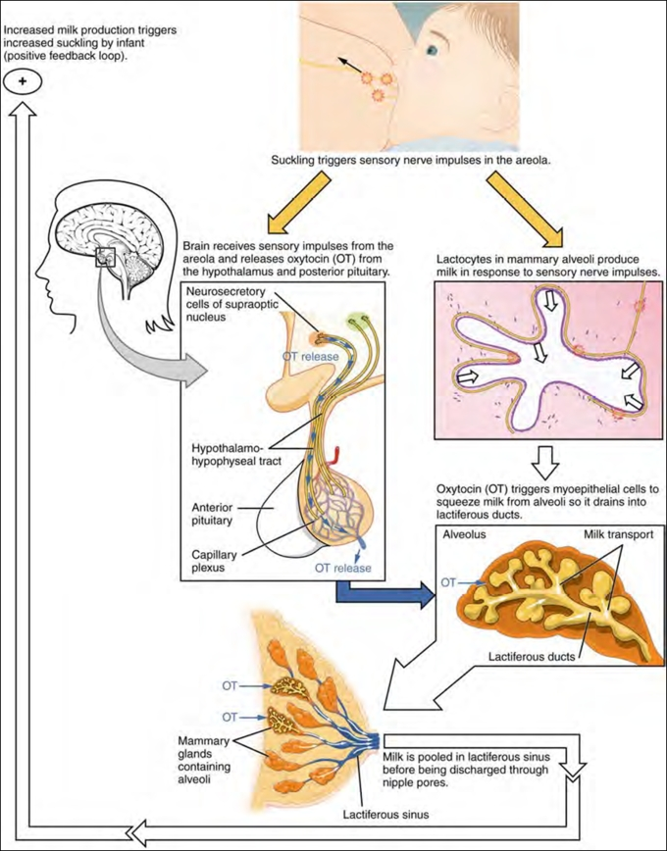

The physiology of pregnancy in a normal woman

PREGNANCY
Pregnancy is the time from fertilization of an egg, also known as conception, to birth. Getting pregnant and growing a human from scratch is a very complicated biological process that takes a lot of resources. As a result, pregnancy can have a wide range of effects on the mother, both physically and emotionally.
Each egg that is released during a menstrual cycle travels to your uterus. However, unlike unfertilized eggs that proceed unaltered and then disintegrate when they get there, a fertilized egg develops into a tiny human embryo on the way. On reaching the uterus, the embryo implants itself in the uterine wall, develops into a foetus, and steadily grows, until about nine months later it is ready to emerge into the outside world as a newborn baby.

Signs and symptoms
If you are fertile, sexually active, and become pregnant, the first thing you are likely to notice is a late or missing menstrual period. Fertilization of an egg triggers changes in the production of various hormones almost immediately, and hormone changes evolve and persist throughout your pregnancy to help you grow a healthy baby. Unfortunately, these changes may also cause unpleasant side effects. As a result, in addition to a missed period, many women experience tender, swollen breasts, fatigue, nausea and vomiting, or morning sickness during the first few weeks of becoming pregnant.

Physiological changes that occur during pregnancy
Hormonal: The menstrual cycle refers to the normal changes in your ovaries and uterus that make an egg accessible for fertilization and prepare your uterus for pregnancy. It typically occurs once every 28 days. If you are ovulating normally, an egg, or ovum emerges from one or other of your ovaries, leaving behind a structure called the corpus luteum. This structure produces large amounts of progesterone and estrogen, hormones that help prepare your uterus for implantation of a fertilized egg. If the egg is not fertilized, the corpus luteum degenerates, causing progesterone and estrogen levels to drop, and menstruation to begin. If the ovum is fertilized, on the other hand, the corpus luteum remains intact and continues to maintain the hormone levels you need to keep your uterus baby-friendly. Eventually, the placenta develops the ability to secrete the necessary hormones itself, and the corpus luteum typically disappears after 3 to 4 months.
In addition to progesterone and estrogen, human chorionic gonadotropin also spikes in early pregnancy. The levels of this hormone double every two days in the first 10 weeks of pregnancy. Its primary role is to prevent any further menstruation, and to prepare the placenta - the organ that connects the foetus to the uterus. The placenta allows the foetus to be supplied with nutrients and oxygen, as well as providing a route for the removal of toxic waste products.
Although many signs and symptoms of pregnancy are related to hormonal changes, there are also many that occur due to the growing foetus invading the spaces that were previously occupied by your other organs.
Immune tolerance: Your growing foetus is a foreign object, something that your immune system is normally programmed to attack and reject. In order to prevent this from happening, as soon as the embryo becomes implanted in the uterine wall, a key pathway that usually triggers the launch of an immune attack is turned off, making this part of your immune system dormant, and preventing immune cells from targeting the foetus or placenta. In addition to making it possible for you to grow your baby, there can be secondary benefits of pregnancy-related changes in immune function. In particular, women suffering from diseases caused by immune disorders, such as rheumatoid arthritis, multiple sclerosis, and psoriasis, may find relief from disease symptoms during pregnancy due to increased levels of anti-inflammatory steroids that occur naturally.
During pregnancy, your cardiac output - the amount of blood your heart pumps around your body per minute - increases to meet the needs of the developing foetus, and to provide the volume of blood necessary to fill the uteroplacental circulation.
This is achieved by increasing the stroke volume, which is the amount of blood pumped out of your heart with each heartbeat. Your cardiac output peaks around week 24 of your pregnancy, when it is 30%-40% higher than normal. As the foetus grows, your uterus begins to crowd your aorta, the major artery that carries oxygenated blood to your tissues and organs and vena cava, the major vein that carries deoxygenated blood back to your heart. Sometimes, certain positions, such as lying on your back, puts excess pressure on these vessels, which can lead to a drop in blood pressure causing dizziness, fainting, and in some cases, even damage to the foetus. In addition, exercise or activities that change heart rate tend to put a greater demand on your cardiovascular system when you are pregnant than they normally would, and the large changes in cardiac output associated with pregnancy may add additional strain for women with pre-existing heart conditions, such as valvular heart disease, or coronary heart disease. One other relatively common cardiovascular complication of pregnancy is varicose veins, which are enlarged, swollen veins that typically develop in the legs. During pregnancy, your growing uterus puts pressure on your veins making it harder for the blood to flow back to your heart. This causes the blood to pool in the veins making them swell.
Hematologic: As cardiac output increases, blood volume increases to match. This is due to a 50% increase in the volume of your plasma (the clear, yellowish fluid of your blood), and a 20% increase in the number of red and white blood cells. Overall, this has the effect of diluting the blood, often resulting in “physiological anaemia of pregnancy” (a relative deficiency of red blood cells). Iron requirements increase during pregnancy as the foetus and placenta grow, and as the red blood cell numbers rise. Iron is essential for red blood cell production, and supplements are often needed as the amount of iron absorbed from the diet and recruited from iron stores is often not enough. Several hormones are thought to play a role in changing blood composition to support pregnancy including the renin-angiotensin-aldosterone hormonal system, atrial natriuretic peptide, estrogen, and progesterone, although exactly how they do this is not clear. Whatever the mechanism, the increased blood volume is very important as it ensures that the extra blood needed to supply the growing uterus and placenta is available, and can help protect the mother against normal blood loss that occurs while giving birth.
Renal: Your kidneys are responsible for filtering waste products from your blood, and regulating blood pressure and electrolytes; for example, sodium (Na^++start superscript, plus, end superscript), potassium (K^++start superscript, plus, end superscript) and calcium (Ca2^++start superscript, plus, end superscript). During pregnancy, changes in kidney function approximately follow changes in cardiac function - both organs work considerably harder. By around the 20th week, and sometimes as early as the 8th to 10th week of pregnancy, your kidneys are filtering 30% to 50% more blood than before you were pregnant. The effects of this are greater reabsorption of sodium, and increased elimination of sugars (glycosuria), amino acids (aminoaciduria), and creatinine in your urine (creatinine clearance tests are often used by doctors as a measure of how well your kidneys are working). After about the 12th week of pregnancy, progesterone, a smooth muscle relaxant, causes the tubes that transport urine from the kidneys to the bladder, called the ureters, to dilate. As your uterus expands, it may compress the dilated ureters, obstructing the flow of urine to your bladder, and increasing the chances that you get a urinary tract, or kidney infection while you are pregnant. Laying down on your side can help relieve the pressure on your major blood vessels letting your kidneys work more effectively. However, this can make for a lot of urine production and toilet breaks during the night when you are trying to sleep.
Respiratory: Breathing exercises are often practised by expectant mothers to use during labour and birth, but this isn’t the only way changes in respiration are helpful. As with your other organs, the growing uterus begins to invade the space normally reserved for your lungs, which restricts their expansion during normal breathing. Once again, progesterone, the multi-talented pregnancy hormone gets to work, triggering your lungs to increase the amount of air inhaled with each breath - the tidal volume - as well as the number of breaths per minute - the respiratory rate. This increases the oxygen supply required to meet the metabolic needs of the foetus, placenta and other organs.
Metabolic: Changes in metabolism during pregnancy alter the distribution of body fat, as well as how you digest and process food. While accumulating fats and nutrients is necessary for the healthy growth of your baby, metabolic changes can also affect the way in which medications are processed. As such, it is important to know how your pregnant body may respond to any drugs or homeopathic remedies you may be taking, and whether or not this could have an effect on your growing baby.
Body weight: Supporting the growth of a developing foetus takes a lot of energy, so it’s not surprising that more calories are required during pregnancy. In fact, after the first three months (trimester) your appetite generally increases so that you are consuming about 300 extra calories a day. Although in the first trimester you can expect to gain just a few pounds, it’s normal to gain about a pound per week for the rest of your pregnancy. In addition to weighing more, you can expect your breasts to grow around 1 to 2 cup sizes in preparation for breastfeeding.
Gastrointestinal: As your uterus grows, it puts pressure on your digestive organs including your colon, gallbladder, liver, and stomach. This can impair their function, and lead to constipation, gallstones, reduced bile transport, as well as a general slowing of the digestive process that is related to lower levels of the hormone gastrin. Gastrin stimulates the secretion of stomach acid, which in turn leads to the production of pepsin, an enzyme that digests proteins in your food - less gastrin leads to slower digestion. In addition to this, elevated progesterone levels during pregnancy slacken the cardiac sphincter, the “door” between your oesophagus and stomach, making it open more easily. It is very common to experience heartburn due to acid reflux into your oesophagus during the third trimester, as the cardiac sphincter cannot withstand the pressure that builds up in your stomach as your uterus grows. Its also worth noting that taking analgesics during pregnancy may not be for the best, as they can slow down gastric emptying even more, creating an even higher pressure that the cardiac sphincter must withstand.
Integumentary: The integumentary system consists of your skin, hair and nails, as well as underlying connective tissue that attaches your skin to your body and various glands including sweat and oil producing glands, and your mammary glands. As your pregnancy proceeds, your skin stretches to accommodate your growing uterus and breast tissue. Sometimes the stretching can tear the underlying connective tissue causing red or purple marks to appear on your abdomen, commonly known as stretch marks. In addition, increased estrogen levels during pregnancy increases the production of melanin, the pigment that gives human skin and hair its color. This often causes the ring of colour around your nipples (areolae) to darken, and may create a line of pigment that typically runs from your navel to your pubic bone. Its also possible you may develop patchy discoloration of your face and darkening of any moles and freckles. Other integumentary changes that may occur during pregnancy include accelerated nail growth and excessive hair growth in unusual places, while increased blood supply to your skin often leads to increased perspiration. Finally, while it’s commonly said that pregnancy makes your skin clear and radiant, it’s also possible for it to become oily and acne prone.
Your body undergoes massive changes to support and nourish a baby, and after giving birth, it generally takes some time for you to feel like yourself again. Some body changes that persist may take you by surprise, but are all linked to the physiological changes that were necessary to grow your baby. These are some of the most common ones:
- Low sex drive - this is linked to the abrupt drop in estrogen levels after you give birth. Your sex drive will come back, but don’t be surprised if sex stays a low priority for you for the better part of a year.
- Tummy bulge - it takes 6-8 weeks for your uterus to shrink back to your pre-pregnancy size, meaning the tummy bulge may stick around for a while.
- Shoe size - you may notice that your feet swell during pregnancy, but for some women carrying the extra weight around permanently alters their shoe size. This is likely related to the effects of relaxin, which loosens the ligaments throughout your body including your feet. The extra weight during pregnancy can flatten your arches, making your feet grow.
- Breast size - although your breasts will grow during pregnancy and remain larger during breast feeding, it’s not uncommon for them to shrink to a slightly smaller size than they were before you were pregnant. This is usually related to your body weight, as the size of your breasts depends on the amount of body fat you have.
- Hair loss - you may find your hair starts falling out faster than ever before during the months following childbirth. Estrogen slows the rate of hair loss during pregnancy, which means lots of hair is ready to drop when estrogen levels return to pre-pregnancy levels.
- Menstruation - if you decide not to breastfeed your baby, you are likely to start menstruating (and ovulating) again about 10 weeks after giving birth, as your hormones return to their pre-pregnancy levels. However, it’s worth noting that your period may return the very next month after giving birth. Breastfeeding generally delays ovulation, so if you decide to breastfeed you may not have a period for up to 20 weeks or more, although it's also not uncommon for it to restart earlier than this.

