IBEKWE GIVENS
HUMAN NUTRITION AND DIETETICS
15/MHS02/052
BIO 102 Assignment

- How are fungi important to mankind?
- Fungi are responsible for the mediation of decay of organic matter.
- Yeast is important in food industries like bakeries.
- Some species of mushroom serve as food for man.
- Some fungi are parasites to some certain obnoxious pests of man e.g. houseflies, grasshoppers etc and therefore serve as important biological control method for such pests.
- Illustrate the cell structure of a unicellular fungus with a well labeled diagram.
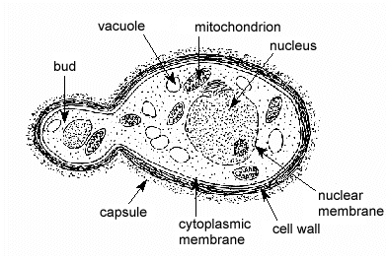 Diagram of a yeast cell
- Outline the sexual reproduction in a typical filamentous form of fungi.
Sexual reproduction in Rhizopus stolonifer
- Firstly, this occurs when two mating types of hyphae grow in the same medium.
- Then, A chemical interaction between the two mating types of hyphae causes a growth perpendicular to the hyphae in opposite directions.
- The growths are delimited by a wall such that many nuclei are isolated in differentiated sex organs called gametangia (plural).
- The gametangia fuse through a process called plasmogamy and together they form a zygote which may undergo prolonged dormancy or a resting stage.
- The nuclei in the zygote fuse in twos and undergo meiosis independently; the zygote then germinates under favourable conditions to produce a fruiting which at maturity liberates the haploid spores.
- How do Bryophytes adapt to their environment?
- They possess definite structures for water and nutrient absorption from the soil; therefore the body is divided into aerial portion and subterranean portion (the rhizoid).
- They also possess a waxy cuticle that keeps the aerial portion (that is exposed to the atmosphere) from drying out through the process of desiccation.
- Some other modifications that permit elimination of excess water from the plant body and not only exchange of gases between the internal parts of the plant and the atmosphere therefore openings are available on the aerial parts of the plant.
- Describe with illustration the following terminologies: (a) eusteles (b) atactostele (c) siphonostele (d) dictyostele.
i. Eusteles: is a type of stele in which the vascular bundles are discrete, concentric collateral bundles of xylem and phloem. It is found in herbaceous dicotyledonous plants.
ii. Atactostele: is a type of stele in which the vascular bundles are scattered. It is found in grasses and many monocotyledonous plants.
iii. Siphonostele: is a type of stele in which the stele is a cylinder enclosing a parenchymatous pith. It is found advanced vascular systems e.g. the stems of ferns and higher vascular plants.

iv. Dictyostele: a type of stele in which the vascular supply to leaves have leaf gaps and vascular cylinders are dissected.
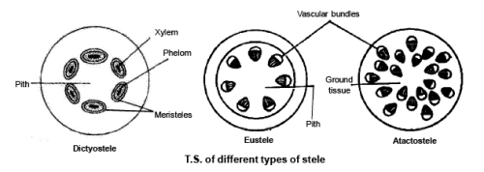
Types of Siphonostele
- Illustrate the life cycle of a primitive vascular plant.

