NAME: Ibezim Emily Chika
MATRIC NUMBER: 17/mhs01/143
COURSE: Neurophysiology (PHS 305)

QUESTION
1. Discuss the physiology of sleep
2. Discuss the role of basal ganglia in coordinating movement

PHYSIOLOGY OF SLEEP
What is sleep?
Sleep is a state of reduced awareness and responsiveness. In humans, sleep is also associated with reduced movement. Sleep is a natural, periodic and reversible behavioral state of perceptual disengagement from and unresponsiveness to the environment.
Sleep consists of two different phases:
Rapid eye movement (REM) sleep; and
Non-REM sleep or slow wave sleep.

REM sleep
Sleep physiologyREM sleep is characterised by the presence of rapid eye movements during sleep. This type of sleep is less restful than slow-wave sleep and is associated with dreaming and bodily muscle movements. During REM sleep a person’s threshold to be aroused by external stimuli is higher than during slow-wave sleep. Heart rate and breathing become irregular during REM sleep, a feature of the dream state.
The brain is extremely active during REM sleep. The electroencephalogram shows patterns of brain wave activity similar to those that occur during the waking hours. Due to this feature of REM sleep, it is often also referred to as paradoxical sleep as it is a paradox that one can be asleep and yet the brain is incredibly active.

Non-REM sleep
In contrast, non-REM sleep is characterised by deep sleep. The duration of REM sleep episodes is longer earlier in the night when one is most tired. As one becomes more rested during the night, the duration of REM sleep episodes decreases.
During non-REM sleep the blood pressure, breathing and metabolic rate are all depressed significantly. Bodily movements do not occur during non-REM sleep.
Non-REM sleep is also referred to as slow wave sleep as during this period the brain waves are very strong and of a very low frequency (i.e. slow).
While non-REM sleep is sometimes referred to as dreamless sleep, dreams and even nightmares can occur during non-REM sleep. These are not associated with movement and are not remembered as they are not consolidated to memory during this sleep phase.

Sleep cycles
REM sleep occurs at about 90 minute intervals. There are usually 4 to 6 cycles of REM and non-REM sleep each night. Later into the night, the REM episodes become longer and non-REM sleep becomes shorter and lighter.
Non-REM sleep can be defined as stage 1, 2, 3 or 4. Stages 1 and 2 are often referred to as light sleep and stages 3 and 4 as deep sleep, slow wave sleep or delta sleep.
Brain wave activity (EEG) during wakefulness and sleepBrain wave activity (EEG) during wakefulness and sleepBrain wave activity (EEG) during wakefulness and sleep.

Brain wave activity (EEG) during wakefulness and sleep

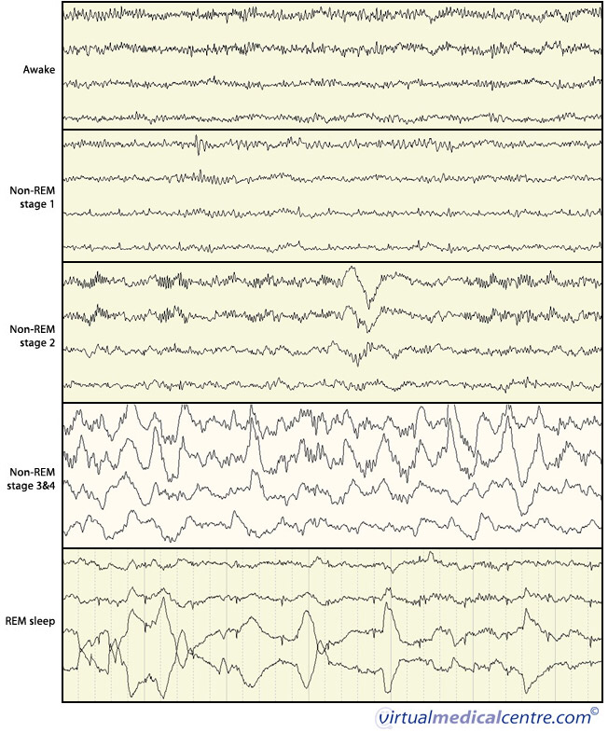

What drives sleep?

Homeostatic drive
Sleep physiologyThe drive to fall asleep increases as the time since the previous episode of non-REM sleep increases (homeostatic drive). This drive reinforces the cyclic nature of sleep and wakefulness and is similar to other physiological needs. For example, the increased need to sleep with sleep deprivation is similar to increased hunger that occurs with increased lengths of food deprivation.

Adaptive drive
This includes a number of mechanisms which effect but are independent of the duration of wakefulness and the circadian rhythm.
Mental stimulation prior to bedtime can make falling asleep difficult, particularly if there are worries or anxieties that cannot be resolved. The ability to relax the body (mentally and physically) affects whether one is able to initiate sleep.
The level or lack of sensory inputs also influences our ability to fall asleep. A number of these sensory inputs include:

Pain and discomfort: Awakening during the night is more common in individuals with chronic disease such as rheumatoid arthritis or multiple sclerosis. Pain is also associated with increased tossing and turnings that also result with increased awakenings during the night;
Temperature: An ambient temperature of 18 °C is ideal for falling asleep and staying asleep. Increased and decreased temperatures result in disrupted sleep;
Physical activity: Exercise promotes wakefulness during the activity and also for 3 hours after the activity. Exercise close to the time of going to bed can delay and decrease melatonin secretion. This is important as melatonin is a hormone produced by the pineal gland which promotes sleep;
Sexual activity: Unlike other forms of activity, sexual intercourse usually promotes falling asleep;
Noise: A noisy environment can impair sleep and increase arousal from sleep. The noise level that causes an individual to wake varies between people and also changes with age. A person is also more likely to wake up if the noise is significant to the person, the crying of an infant to its parents;
Hunger: Hunger is associated with wakefulness. Carbohydrates and milky drinks that contain tryptophan, a compound which is broken down in the body to produce melatonin, are excellent at promoting sleep. Bananas, peanuts and figs are also rich sources of tryptophans. High protein foods are rich in tyrosine (a hormone which promotes wakefulness) and can lead to wakefulness. Large meals can cause reflux and heartburn and also drive wakefulness; and
Light exposure: Seasonal changes in the duration of daylight affect the sleep-wakefulness cycle. During sleep, 5-10% of light reaches the retina and light exposure can result in arousal from non-REM sleep. Light exposure during the day also increases alertness, motor function and mood, elevates body temperature and heart rate.
A separate effect of light is on the circadian rhythm. This effect is mediated at a specific region in the brain called the suprachiasmatic nuclei (SCN) and suppresses melatonin levels.

Circadian rhythm
Sleep physiologyCircadian rhythms occur in 24 hour cycles. The circadian rhythm prompts sleep at night and also to small extent between 2 and 4 pm. Usually the sleep, temperature and hormonal circadian rhythms are synchronised so that all of these factors act together to drive a state of sleep or wakefulness.
The circadian rhythm is generated by a “biological clock” whose activity is modulated by various external stimuli. These external cues ensure that the internal clock is in sync with the external environment.
Special cells within the retina of the eye provide the input to the SCN. The SCN in turn influences melatonin secretion from the pineal gland. Melatonin is synthesised from tryptophan. Melatonin production can be increased by an increased oral intake of tryptophan and vitamin B6 (a co-enzyme in tryptophan metabolism) such as by consuming carbohydrates, milk, bananas, figs and peanuts, so consuming these can help an individual to fall asleep. Melatonin secretion is increased by selective serotonin reuptake inhibitors (anti-depressants) and antipsychotics. Melatonin release is inhibited by caffeine, beta-blockers, benzodiazepines and non-steroidal anti-inflammatories, and their consumption can make it more difficult to sleep.
Regimented times for going to bed, going to sleep, waking and getting up are important for reinforcing circadian rhythm. The most important of these is the time of waking because it helps to ensure that the homeostatic drive to sleep is strong.

Importance of Sleep
In neurophysiology, Sleep may have some role in development of brain cells and connections between brain cells during development. The ability to form new neurons (neurogenesis) slows early in life and it is the development of new neuronal networks that is responsible for new behaviours.
Synchronisation of cortical activity during non-REM sleep may in some way coordinate cortical connections. The prefrontal cortex is inactive during all phases of sleep (this may also confer some benefit). During REM sleep the cerebral cortex is open to sensory inputs and forms loose associations that cannot be formed during wakefulness.
Also,
Sleep has been considered a restorative or a recovery phase that prepares the body for the next episode of wakefulness. Cell division is more rapid during non-REM sleep and sleep has an important function on the immune system.

How much sleep is normal and how much do I need?
Sleep physiologyAbout 60% of the adult population sleep for between 7 and 8 hours per night, 8% sleep for less than 5 hours per night and ~2% sleep for 10 hours or more. Loss of non-REM sleep, especially stages 3 and 4, are thought to cause more daytime tiredness than loss of REM sleep. Both short and long sleepers experience the same length of stage 3 and 4 non-REM sleep; short sleepers have less stage 2 non-REM sleep and shorter time to fall asleep.
The daily sleep requirements decline steadily as we age, from 16 hours a day in infants to 7.5-8,5 hours in young adults. It then levels off before decreasing further in the elderly.
Less than 5-6 hours of sleep in a night is usually associated with symptoms of sleep deprivation.

BASAL GANGLIA
The basal ganglia are responsible for voluntary motor control, procedural learning, and eye movement, as well as cognitive and emotional functions.

Location of the Basal Ganglia
The basal ganglia (or basal nuclei) are a group of nuclei of varied origin in the brains of vertebrates that act as a cohesive functional unit. They are situated at the base of the forebrain and are strongly connected with the cerebral cortex, thalamus, and other brain areas.
The basal ganglia are associated with a variety of functions, including voluntary motor control, procedural learning relating to routine behaviors or habits such as bruxism and eye movements, as well as cognitive and emotional functions.

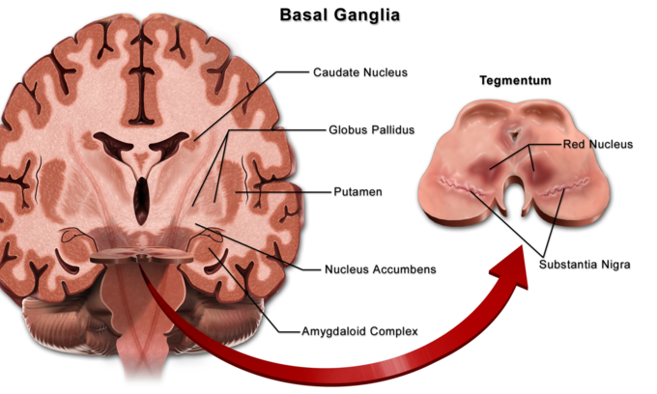
Basal Ganglia: Locations of Basal Ganglia

Role of Basal Ganglia in Movement
The greatest source of insight into the functions of the basal ganglia has come from the study of two neurological disorders, Parkinson’s disease and Huntington’s disease. For both of these disorders, the nature of the neural damage is well-understood and can be correlated with the resulting symptoms.
Parkinson’s disease involves the major loss of dopaminergic cells in the substantia nigra. Huntington’s disease involves the massive loss of medium spiny neurons in the striatum.
The symptoms of the two diseases are virtually opposite: Parkinson’s disease is characterized by a gradual loss of the ability to initiate movement, whereas Huntington’s disease is characterized by an inability to prevent parts of the body from moving unintentionally.
It is noteworthy that, although both diseases have cognitive symptoms, especially in their advanced stages, the most salient symptoms relate to the ability to initiate and control movement. Thus, both are classified primarily as movement disorders.
A different movement disorder, called hemiballismus, may result from damage restricted to the subthalamic nucleus. Hemiballismus is characterized by violent and uncontrollable flinging movements of the arms and legs.

Function in Eye Movement
One of the most intensively studied functions of the basal ganglia is their role in controlling eye movements. Eye movement is influenced by an extensive network of brain regions that converge on a midbrain area called the superior colliculus (SC).
The SC is a layered structure whose layers form two-dimensional retinotopic maps of visual space. A bump of neural activity in the deep layers of the SC drives eye movement toward the corresponding point in space.

Motivation
Although the role of the basal ganglia in motor control is clear, there are also many indications that it is involved in the control of behavior in a more fundamental way, at the level of motivation. In Parkinson’s disease, the ability to execute the components of movement is not greatly affected, but motivational factors such as hunger fail to cause movements to be initiated or switched at the proper times.
The immobility of patients with Parkingson’s disease has sometimes been described as a paralysis of the will. These patients have occasionally been observed to show a phenomenon called kinesia paradoxica, in which a person who is otherwise immobile responds to an emergency in a coordinated and energetic way, then lapses back into immobility once the emergency has passed.
The role in motivation of the limbic part of the basal ganglia—the nucleus accumbens (NA), ventral pallidum, and ventral tegmental area (VTA)—is particularly well established. Thousands of experimental studies combine to demonstrate that the dopaminergic projection from the VTA to the NA plays a central role in the brain’s reward system.
Numerous things that people find rewarding, including addictive drugs, good-tasting food, and sex, have been shown to elicit activation of the VTA dopamine system. Damage to the NA or VTA can produce a state of profound torpor.

