Odukoya Treasure
18/MHS05/010
Physiology
ANA 212 Gross anatomy of the pelvic and perineum

Question
With the aid of diagram discuss the anatomy of the female external genitalia.
Answer
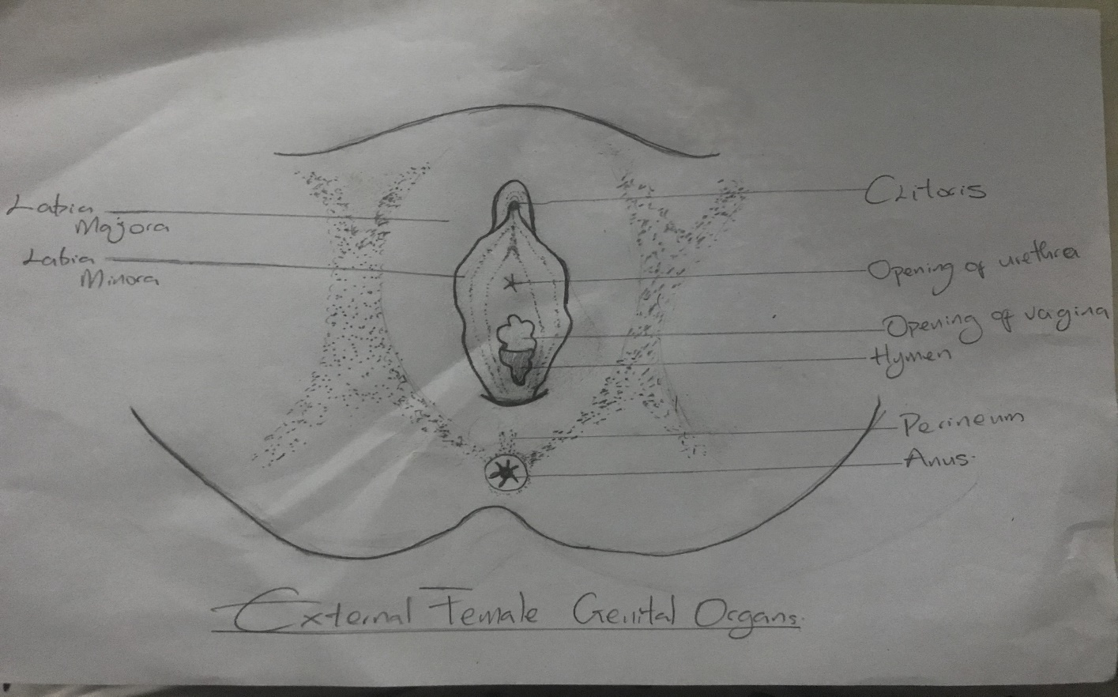
The vulva, also known as the pudendum, is a term used to describe those external organs that may be visible in the perineal area. The vulva consists of the following organs: mons pubis, labia minora and majora, hymen, clitoris, vestibule, urethra, Skene glands, greater vestibular (Bartholin) glands, and vestibular bulbs. The boundaries include the mons pubis anteriorly, the rectum posteriorly, and the genitocrural folds (thigh folds) laterally.
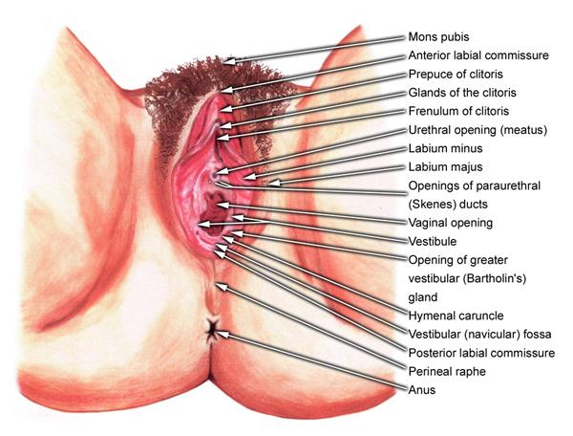
A detailed labeled diagram of the external genitalia
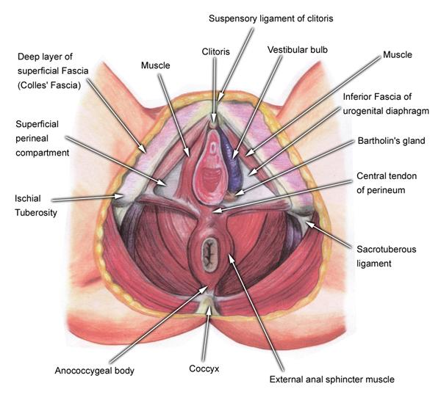
Deeper view of the external features
Mons pubis: The mons pubis is the rounded portion of the vulva where sexual hair development occurs at the time of puberty. This area may be described as directly anterosuperior to the pubic symphysis.
Labia: The labia majora are 2 large, longitudinal folds of adipose and fibrous tissue. They vary in size and distribution from female to female, and the size is dependent upon adipose content. They extend from the mons anteriorly to the perineal body posteriorly. The labia majora have hair follicles.
The labia minora, also known as nymphae, are 2 small cutaneous folds that are found between the labia majora and the introitus or vaginal vestibule. Anteriorly, the labia minora join to form the frenulum of the clitoris.
Hymen: The hymen is a thin membrane found at the entrance to the vaginal orifice. Often, this membrane is perforated before the onset of menstruation, allowing flow of menses. The hymen varies greatly in shape.
Clitoris: The clitoris is an erectile structure found beneath the anterior joining of the labia minora. Its width in an adult female is approximately 1 cm, with an average length of 1.5–2.0 cm. The clitoris is made up of 2 crura, which attach to the periosteum of the ischiopubic rami. It is a very sensitive structure, analogous to the male penis. It is innervated by the dorsal nerve of the clitoris, a terminal branch of the pudendal nerve.
Vestibule and urethra: Between the clitoris and the vaginal introitus (opening) is a triangular area known as the vestibule, which extends to the posterior fourchette. The vestibule is where the urethral (urinary) meatus is found, approximately 1 cm anterior to the vaginal orifice, and it also gives rise to the opening of the Skene glands bilaterally. The urethra is composed of membranous connective tissue and links the urinary bladder to the vestibule externally. A female urethra ranges in length from 3.5 to 5.0 cm.
Skene and Bartholin glands: The Skene glands secrete lubrication at the opening of the urethra. The greater vestibular (Bartholin) glands are also responsible for secreting lubrication to the vagina, with openings just outside the hymen, bilaterally, at the posterior aspect of the vagina. Each gland is small, similar in shape to a kidney bean.
Vestibular bulbs: Finally, the vestibular bulbs are 2 masses of erectile tissue that lie deep to the bulbocavernosus muscles bilaterally.

