**NAME:**  ESSIEN, ABASIODIONG EFFIONG

**MATRIC NUMBER:** 18/SCI 14/010

**COURSE:** GST 212

**DEPARTMENT:** GEOLOGY

Perfect Fit

No. 10 Walls Street, Osongoma Estate, Uyo, Akwa Ibom State.

08127610940/08038263505

Prepared by:

Essien, Abasiodiong Effiong

C. E. O.

odyyessien@gmail.com

**Table** of **Contents**

1. Executive Summary
2. Description of the Business
3. Positioning
4. Business Concept
5. Business Goals
6. Services
7. Operations Plan
8. Market Research
9. Competition
10. Marketing Plan
11. Labor
12. Organizational Plan
13. Management Team
14. SWOT Analysis
15. Administrative Plans
16. Risks
17. Capital Requirements
18. Appendix: Financial Projections

**1.0 Executive Summary**

This is the plan for a new business, Perfect Fit, by Essien, Abasiodiong Effiong, to be started locally at Osongoma Estate and then expanded to other estates in Uyo. The mission of Perfect Fit is to offer affordable, convenient fitness training services to mostly women and male in the estate. In order to offer clients, the most affordable service, Perfect Fit will utilize professional fitness Trainers who are certified as personal trainers, are in excellent physical condition and have the  personal experience and knowledge to provide the service. They will have the personal  background that will enable them to help the customers and enable them achieve their own fitness goals. Fitness training center will be offered at the Amela shopping mall and will  be open from 8:am in the morning to 8:00pm at night. By providing a low-cost, flexible alternative to expensive, off-site facilities, we expect to attract a large health conscious, fitness-oriented demographic and residents who are ready to work hard on their personal health. To reach clients, we will use limited advertising, primarily utilizing social media and word of mouth methods Perfect Fit will be unique not only in its approach towards using certified professional trainers who will also offer personal training to customers who prefer such service. Perfect Fit will be structured as a  partnership between Mr. Abasiodiong Essien and Mr. David Etukudo. This means that Perfect Fit will be a very low-cost, simple company, allowing it to grow quickly and inexpensively. The objective is to become profitable within the first three months and to grow at a quick but manageable pace.

**1.2 Goals**

Our primary goal is to create a community committed to elite functional fitness. Our monthly objective is to generate at least 20 new members. This will allow us to become a  profitable fitness business. We aim to open and run a facility at full capacity within the first two years with 150 to 200 members.

**1.3** **Objectives**

* The main objective of Perfect Fit is to develop a product and service  based company

whose goal is to exceed customer’s expectations and increase

 production.

* Provide initial consultation and screening, enable to know what the health position of the clients.
* Private or group personal training sessions offered at the Facility.
* Health and lifestyle advising for the clients
* To fully exploit the sector in terms of quality provided and ensuring all the clients enjoy what they are offered.
* To reduce cost while improving quality and hygiene.
* To create employment for youths in Osongoma estate whose youth face difficulty in accessing employment hence perish in poverty
* To impact entrepreneurial skills on the youth of Osongoma estate, Uyo and encourage them to make use of the Youth Empowerment Fund offered by the Akwa Ibom State government to generate income thereby improving the standard of living.

**1.4** **Vision**

Perfect Fit intends to be the largest fitness center in Uyo, attracting at least 20 to 30 new customers each day and later expand to the other neighboring states in the country.

**1.5** **Mission**

 Our main focus will be giving quality service at a great value. Customer satisfaction is paramount. When approached by a customer with a request, our motto will be “No gimmicks, no excuse just results" We will strive for broad appeal.

 Employee welfare will be equally important to our success. All will be treated fairly with the utmost respect.

**1.6** **Keys to Success**

The keys to the success of Perfect Fit are:

1.The creation of a unique, innovative, mid-scale atmosphere that will differentiate us from other competitors.

2.Ensuring costs are low at all time.

3.Making use the residents of Osongoma estate by employing them as employees.

**2.0 INTRODUCTION**

**2.2 Description of the Business**

Perfect Fit is a unique fitness capacity with a strong focus on providing  practical lifestyle enhancement to its members in an upbeat, yet adult oriented atmosphere. As a first class exercise facility, the company promises to deliver the highest level personal service and attention to its members. Therefore, training of customers will be the key and the option of personal trainers will be available for the customers who prefer to do so. Most personal trainers will charge at least ₦1000 per session. Noting that personal training industry is growing as more and more people take an interest in their fitness and wellbeing,

most of this growth is occurring in the higher income ranges. Perfect Fit’s goal is to change that, bringing the personal training revolution to the estate at low charge. Perfect Fit will be based at Osongoma estate and will operate a both personal training business and general training for the residents. The following will be the address;

  **Cell phone**

-08127610940/08038263505

**Email address**

- [Perfectfit@gmail.com](mailto:Perfectfit@gmail.com)

Perfect Fit is a partnership and with 4 employees, 2 permanent and 2 casuals.

The  permanent employees are:

i.Emmanuel Jacob

ii. James Anselem

While the temporary employees are:

iii.Mercy Etim

iv.Steve Ekpe

**2.3 Positioning** Perfect Fit will position itself as a "no gimmicks, no excuses, just results" fitness training company. Trainers will be professionals who are certified to offer both general training and personal training. The no frills approach will allow Perfect Fit to keep costs low, allowing the service to stay affordable to our student clientele.

**2.3.1 Business Location**

The business shall be located at Osongoma Estate. Osongoma Estate is an ideal place for the business since it is easily accessible from either of the regions ( Shelter afrique, Ewet housing, Nwaniba and Udo Udoma), it is surrounded by residential apartments, it is a relatively secure environment, it is made up of most middle class or working people who in most occasions are cautious about their weight and general fitness among other favorables. Also the Osongoma estate where the business is to be located has only one complete functional fitness gym but it charges relatively high rates; leaving Perfect Fit with much benefits.

**3.0 PERFECT FIT SERVICES.**

Perfect Fit service is simple, yet versatile. Clients may purchase personal training sessions. Each session is ₦1000 and lasts half an hour. During this half hour, the client and trainer are free to use the time as they see fit. For example, an introductory session may be spent mostly discussing fitness goals and composing a plan for reaching these goals whereas later sessions may be spent entirely on exercising. Perfect Fit’s personal trainers are selected from professional trainers who are already rolled in other fitness centers and consist of women and men that are in excellent shape and have extensive experience in exercising. These trainers have certification or experience in professional public training, they have the knowledge to help their customers get in better shape. The women trainers will work with the women, coaching them on various ways of exercising at the facility. The unusual service approach will result in a uniquely low  price that Osongoma residents can afford.

**4.0** **MARKETING STRATEGY** The company shall carry out market research that is inclined to:

**4.1 Customer Services and Retention.**

**Honesty and courtesy to customers.**

 Use of proper language to all types of customers when serving them, this include customers who pay in advance and loyal.

**Online Survey**

Perfect Fit will be marketed to all residents at Osongoma estate that have access to our promotional tools. A marketing research survey will be conducted online, asking questions about their exercise habits and attitudes surrounding personal fitness training.

**4.1.1 Marketing Activities**

Our marketing activities include the following:

* Constant internet support and blogging
* Email advertising to current members and potential leads
* Sponsorship of local athletes and students in sporting events



**4.1.2 Positioning:**

For the gym goers that aren't satisfied with their fitness routine, Perfect Fit provides high intensity exercise that WORKS! Unlike 24 Hour Fitness or Bally's Total Fitness, Perfect Fit is fast, fun and extremely effective.

**4.1.3 Promotions:**

Perfect Fit’s promotion strategy consists of word of mouth, email promotions and local advertising (newspaper, school flyers and non-profit organizations).

**4.2 Marketing Plan**

In order for Perfect Fit to succeed, the company will need to keep costs low and so that so many residents will be attracted. As a business that is targeting members of the residents, it's essential that the company build a strong reputation. Perfect Fit will be marketed both physically and online. Initially the business will be marketed via Facebook and also advertising using flyers. This will help create an initial interest in the new company. Perfect Fit trainers will also be required to wear their Perfect Fit shirts  during their training sessions, which will hopefully arouse curiosity from fellow gym goers to be attracted to the facility. These inexpensive means of advertising will minimize costs while creating exposure for the new company.

**4.3 Strategic Alliances and Competitiveness**

The company shall get linked to other small fitness gyms in the Osongoma region; it shall callable with the clinics, hospitals and nutritionists in the Osongoma area who are addressing the lifestyle diseases. While there are many small fitness alternatives, such as gyms, biking, hiking, organized sports and personal trainers, Perfit Fit has no direct competitors. We will offer the benefits of private training at a cost comparable to gym memberships. The company will also be open its doors close to a 24 Hour. Fitness location with the intention of attracting some of its customers.

**4.3 Labor**

Perfect Fit will begin by hiring five personal trainers, recruiting them from the residents. These hires will be made by the owner who will select the trainers based on their exercise experience, their athleticism, and their performance in a "try-out" staged as an actual personal training session. Some would call our trainers "jocks" endearingly. They have extensive knowledge of fitness training, have free time, need money, and would love to get paid to spend time at the gym.



**4.4 Organizational Plan**

The company will begin with Abasiodiong and David as the owners, and 4 employees who are knowledgeable in fitness training and available as-needed for part-time work. The owners will manage the  business. As the company grows, it will hire more trainers. Perfect Fit will be able to manage a maximum of 4 trainers. If sufficient demand should require more trainers, the company will hire an assistant to direct scheduling, billing, and other administrative concerns. Aden will contract with an accountant for accounting services.

Top Management Trainers Office manage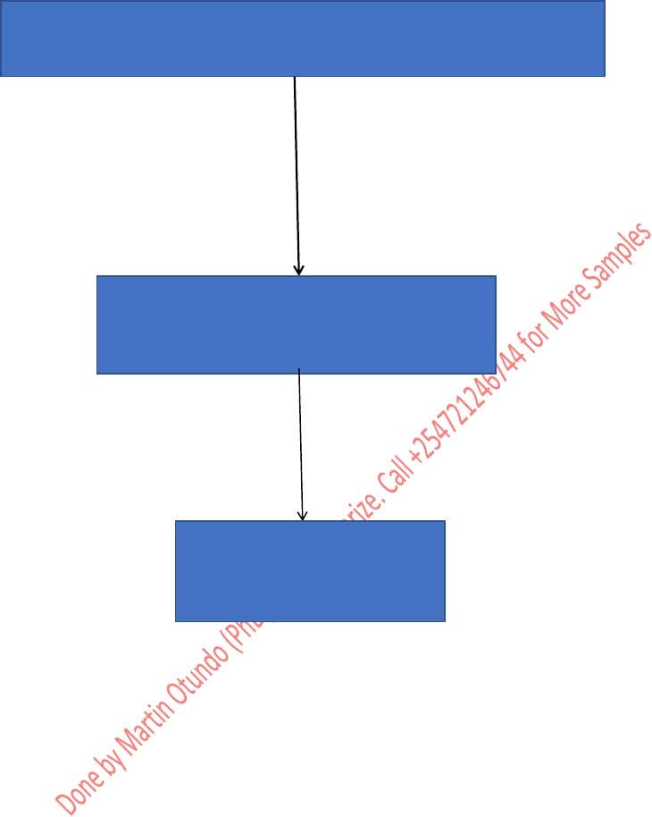  **4.5 Management Team**

Essien, Abasiodiong, will be the sole manager of the company. He does have an education in business management, he has significant business experience that is directly applicable to Perfect Fit and will qualify him to launch and operate this business.

**5.1** **Administrative Plan** Essien, Abasiodiong and David Etukudo will be the managers. They will be in charge of all managerial aspects of the company. They will employ as many personal trainers as is necessary to fill the demand.



**5.3 Risks**

There is a risk that not enough residents are interested in personal training. This is why marketing and advertising will be essential during the beginning stages of the company as Perfect Fit builds a name for itself. Once the company is established, the largest risk it faces is litigation. Physical exercise can easily lead to injury. There is the risk that a personal trainer suggests something to a client that results in the client becoming injured. Perfect Fit will require a general waiver of liability from both the trainers and the clients. Even with the waiver though, Perfect Fit may incur legal fees if the client still decides to litigate.

**6.0 Financial Plan**

**6.1 Capital Requirements**

It is estimated that in order to open for business, Perfect Fit would require Three Million Six Hundred and Seventy Thousand(₦3,670,000) of start-up capital. Essien, Abasiodiong and David Etukudo are the owners and will provide all the capital required to start.

**6.2 Financial Assumptions**

Perfect Fit estimates that in its first week of business it might begin with only five sessions occurring. By months end, this number will accumulate to 50 for the month. The following month, Perfect Fit hopes to perform 100 personal training sessions.



**Appendix**

* **Financial Projections**

YEAR 1

|  |  |  |  |  |
| --- | --- | --- | --- | --- |
| Category | Description | Units | Cost(₦) | Total(₦) |
| Revenues |  | 000” |  |  |
| Personal Training Services | Estimated 5 in week 1,  10 in week 2,  15 in week 3  20 in week 4 | 5  10  15  20 | 250  250  250  250 | 1250  2500  3750  5000 |
| **Expenses** |  |  |  |  |
|  | Flyers | 1000 | 5 | 5000 |
|  | Miscellaneous startup fees |  |  | 4000 |
|  | Trainers T shirts | 10 | 500 | 5000 |
|  | Website creation |  |  | 32000 |
|  | Monthly website fees |  |  | 6500 |
| Trainer’s fees |  | 50 | 100 | 5000 |
| **Total expenses** |  |  |  | **57000** |
| Net gain/loss |  |  |  | -45000 |

YEAR 2

|  |  |  |  |  |
| --- | --- | --- | --- | --- |
| Category | Description | Units | Cost(₦) | Total(₦) |
| **Revenues** |  |  |  |  |
| Personal Training Services | Estimated 50 to be trained in 100 sessions | 5000 | 100 | 500,000 |
|  |  |  |  |  |
|  | Flyers | 1000 | 5 | 5000 |
|  | Monthly website fees |  |  | 24,000 |
|  | Miscellaneous |  |  | 50,000 |
| Total Expenses  **Net Gain/Loss** | | | | 7900 |
| **421,000** |