FALEYE CALEB
16/MHS03/023
ANA 402
ELECTRON MICROSCOPIC TECHNIQUE AND ULTRASTRUCTURE

AN ASSIGNMENT SUBMITTED TO THE
DEPARTMENT OF ANATOMY,
FACULTY OF BASIC MEDICAL SCIENCES,
COLLEGE OF MEDICINE AND HEALTH SCIENCES,
AFE BABALOLA UNIVERSITY,ADO-EKITI,
EKITI STATE,NIGERIA

IN PARTIAL FULFILMENT OF THE REQUIREMENTS FOR
THE AWARD OF THE DEGREE OF
BACHELOR OF SCIENCE (B.Sc)
IN ANATOMY

- Write an essay on the history of microscopy?
What is a microscope?
There is so many little objects that human eyes can’t be able to see these objects are tagged as microscopic. The microscope is a instrument to see minute objects consisting of lens or combination of lenses. Due to their highly-improved lenses, we can view high-quality images and these days this images can be transferred to computers. Today’s microscopes are so advanced that they can show objects which are sized of the millionth part of a meter called micron.
The science of searching small objects with microscopes is called microscopy. Microscopic means that impossible to see, without a help of a microscope, with a naked eye.
History of Microscope
After the glass is first made in the first century, Roman’s was trying to make objects to be seen bigger. The first and simple forms were called flea glasses and they were able to show 6 times bigger.
The microscope is developed in Netherlands at the 1590s but its inventor is not easy to identify. Some proofs are leading to Cornelis Drebbel. But others insist that Zacharias Jansen and his father Hans were working with lenses, they combined some lenses and put them into a tube and invented the microscope. Few others believed that Galileo Galilei was the first discoverer of microscope.
First microscopes were not good enough to use at researches because it can only enlarge by 9 times bigger.First, the real microscope was used by Anton van Leeuwenhoek in the late 17th century which was made by pipes, simple lens, plate and screw.

Unlike the others, his microscope could show objects one-millionth of a meter bigger of its sizes(270x). Others best achievement was 50x magnification. With this microscope, he saw and identified bacteria, erythrocyte, and sperm cells. He published their drawings on Philosophical Transactions of the Royal Society of London at 1674.These drawings were forgotten until there were huge developments in science.
In 1665 Van Leeuwenhoek’s work was a guide to Robert Hooke and he wrote Micrographia. It is the first book that provides microscopic pictures of insects, plant.
Types of microscopes
Stereoscope
Dissection microscope is used with visible light. It is used to see dissection better.
It has 3-dimensional images and it has low magnification.

Confocal Microscope
Confocal laser scanning microscopy (CLSM) plays the most significant role on imaging tiny samples in three-dimensional form. CLSM works like an optical microscope with some differences. It uses monochromatic laser light instead of visible light.CLSM has widely used from cell biology, genetics, microbiology and development biology to quantum optics, nanocrystal imaging and spectroscopy.
History of Confocal Microscope
Early in 1940, Hans Goldmann from Switzerland invented a slit lamp to make documentation of eye examinations. Some researchers believe it might be first confocal optical system.
Marvin Minsky invented first confocal scanning microscope in 1955 and in 1957 got its patent
In 1969 M. David Egger and Paul Davidovits described the first CLSM in two pages and published. Only one illumination spot generated with this point scanner. It was used for the imaging of the nerve tissue.
In 1983 confocal microscope was first used and controlled by a computer after the publication of first work by I. J. Cox and C. Sheppard from Oxford University. Based on Oxford group’s designs, first CLSM was offered from 1982.
At the Laboratory of Molecular Biology in Cambridge, William Bradshaw Amos and John Graham White and colleagues invented the first confocal beam scanning microscope in the middle of 1980s.This time the illumination spot was moving but not the stage. This technique allowed faster image acquisition, four images per second.
Working Principle of Confocal Microscope
For getting higher magnitude a laser is used. The laser light reflects from the dichroic mirror. After that it hits mirrors on motors and across the sample lasers get scanned by these mirrors. And emitted light passes through the dichroic mirror and gets focused onto pinhole. Finally, the sensor measures that light. As it appears the complete image of the sample cannot be observed just one point can be observed. The photomultiplier detector is connected to a computer and one pixel at a time it constructs an image.
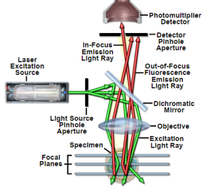
Principal Light Pathways in Confocal Microscopy
What is the advantage of using a confocal microscope?
By scanning lots of thin parts of a sample, it is easy to build a very good three-dimensional image. Confocal microscope has better resolution horizontally and vertically. The best resolution can be obtained at 0.2 microns for horizontal and 0.5 microns for vertical
Scanning Electron Microscope (SEM)
SEM is an electron microscope that uses the focused beam of electrons to images of the sample. Electrons interact with atoms in the sample and gives information about external morphology (texture), chemical composition, and crystalline structure and orientation of materials making up the sample.A beam of electrons uses raster scan pattern which is a rectangular pattern of an image and reconstruction in the screen. Most computers use bitmap image systems to store the image.
The image is created by matching the position with the perceived signal. SEM can get better than 1 nm resolution. Standard SEM microscopes are generally suitable for dry and conductive surfaces in high vacuum. Also, there are specialized machines that work under changeable conditions from low temperature to high temperature and in low vacuum. There is environmental SEM for wet conditions.McMullan presented the history of SEM. Manfred von Ardenne invented SEM in 1937. In the early 1960s, Cambridge groups marketed as Stereoscan in 1965.After interaction of high energized beam of electrons and outer orbit electrons of sample’s atoms Auger electrons which have low electrons will be formed. These electrons carry information about sample surface.After interactions, there will be electron beams which have lower energy, move to the surface of the sample and will gather there.These electrons called as secondary electrons. For imaging for SEM, mostly secondary electrons are being used. Change of secondary electrons numbers depends on the topography of surface and angle of the point where the beam hits the surface
Transmission Electron Microscope
High energized electrons pass through the very thin sample. After interaction of electrons, images are enlarged and focused on fluorescence screen, photographic film layer or CCD camera.In 1930 Max Knoll and Ernst Ruska invented TEM [33]. It allows us to see smaller objects than the optical microscope.TEM is used in cancer research, virology, materials science, nanotechnology, and semiconductor.
TEM’s contrast depends on absorption of electrons, thickness, and composition of the sample. Complex wave interactions at higher magnifications modulate the intensity of the image with analysis of an expert for the image. The resolution limit is up to 0.2 nm for TEM.Compared to SEM, TEM has troublesome work to get the sample ready and the user must have a very good background about it.

Compound Light Microscopes
Compound microscopes are 2-dimensional light microscopes and they are most used microscopes. Even though it has low resolution it has high magnification.
Parts of Optical Microscope
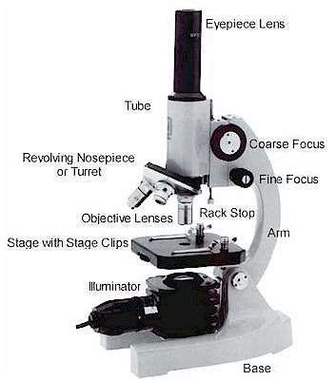
- Eyepiece Lens: The lens that allows us to see through.
- Tubes: It helps eyepiece to connect to lenses.
- Arm: Holds the tube.
- Base: Supports the microscope at the bottom.
- Illuminator: Light source or a mirror that helps us to see a sample from the tube. If it is a mirror it can reflect outer light to use.
- Stage: This platform is used to put samples and it has clips to prevent the sample from moving.
- Revolving Nosepiece or Turret: This part is for holding lenses together and it can rotate to switch between lenses.
- Objective Lenses: These lenses are most commonly can be put three or four lenses on the microscope. They have 4,10,40 or 100 times bigger magnification. They are color coded and should build to DIN standards.
- Rack Stop: It is used to protect the objective lens from breaking

DIN Standards
The real image is formed 160mm away from the objective lens.
Parfocal distance should be 45 mm.
Eyepiece lens should be 170mm[40].
Working Principle of Optical Microscope
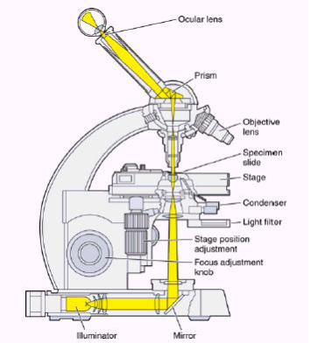

- Differentiate between the light microscope and electron microscope?
Differences Between Electron and Light Microscope
- Light microscopes techniques are simple but for electron microscope high-level technical skill needed.
- Preparation time of the sample is few minutes to few hours for light microscopes but several days for electron microscopes.
- Live or dead samples can be seen in light microscopes but for electron microscopes only dead and dried samples can be seen.
- Light microscopes have low resolution than electron microscope and the resolution limit for the light microscope is 200 nm but for SEM 1nm and for TEM 0.2 nm.
- Light rays are used to illuminate for light microscope but for electron microscope electrons are being used.
- Lenses are made of glass for light microscope but for electron microscope all lenses are electromagnets.
- Magnification of light microscope is 500x to 1500x but for EM 160,000x and photographic magnification is 1000,000x or more.
- Light microscopes are cheap but electron microscopes are expensive

- Differentiate between the SEM and TEM?
 | SEM | TEM
Type of electrons | Scattered, scanning electrons | Transmitted electrons
High tension | ~1 – 30 kV | ~60 – 300 kV
Specimen thickness | Any | Typically <150 nm
Type of info | 3D image of surface | 2D projection image of inner structure
Max. magnification | Up to ~1 – 2 million times | More than 50 million times
Max. FOV | Large | Limited
Optimal spatial resolution | ~0.5 nm | < 50 pm
Image formation | Electrons are captured and counted by detectors, image on PC screen | Direct imaging on fluorescent screen or PC screen with CCD
Operation | Little or no sample preparation, easy to use | Laborious sample preparation, trained users required

