MUHAMMED AHMED SHARAFADEEN
16/MHS01/145
400L, ANATOMY

1. PROCEDURE INVOLVED IN MAKING GLASS OF KNIFE FOR CUTTING IN ULTRATHIN SECTIONS
A small sample is taken from the specimen to be investigated. Specimens may be from biological matter, like animal or plant tissue, or from inorganic material such as rock, metal, magnetic tape, plastic, film, etc. The sample block is first trimmed to create a block face 1 mm by 1 mm in size. "Thick" sections (1 μm) are taken to be looked at on an optical microscope. An area is chosen to be sectioned for TEM and the block face is re-trimmed to a size no larger than 0.7 mm on a side. Block faces usually have a square, trapezoidal, rectangular, or triangular shape. Finally, thin sections are cut with a glass or diamond knife using an ultramicrotome and the sections are left floating on water that is held in a boat or trough. The sections are then retrieved from the water surface and mounted on a copper, nickel, gold, or other metal grid. Ideal section thickness for transmission electron microscopy with accelerating voltages between 50kV and 120kV is about 30–100 nm.

Instrumentation
Depending on the section thickness and sectioning temperature, the following instruments are necessary

Microtomes
One generally prepares thin (>5 μm) and semi-thin (0.5–5μm) sections at room temperature with the aid of a microtome. The sections and the flat surfaces of the blocks where the sections were cut can be inspected by means of SEM, AFM and HVTEM.

Ultramicrotomes
Using ultramicrotomes, semi-thin (thickness 0.2–3 μm) as well as ultrathin (thickness <0.2 μm) sections can be prepared for inspection by TEM and AFM. Depending on the mechanical properties of the materials (e.g. hardness), the sectioning can take place at room temperature without any sample preparation (in the case of hard materials), after chemical fixation, or under cryogenic conditions (see below). It should be noted that the semi-thin sections, after deformation outside or inside a microscope, are also used for the detailed study of the deformation mechanisms of the materials. As in the previous case, the flat surfaces remaining after ultramicrotomy can be studied by means of AFM and SEM.

Cryomicrotomes and Cryoultramicrotomes
Cryo devices are ideal equipment for sectioning soft materials without fixation or staining. Both the knife and the specimen are cooled by liquid nitrogen, whereby the sectioning temperature can be adjusted down to −185 C. These sections are mainly studied by means of TEM, while the flat surfaces can be scanned by AFM.

Knives
The knives used for sectioning are made of glass or diamond. Using a special glassbreaking device and good-quality glass strips, an expert can easily manufacture glass knives for broad application. Both types of knives have advantages and disadvantages. The selection of the type of the knife is determined by the price and also by the nature of material to be sectioned. For wet sectioning it is necessary to mount a truf or collecting tray onto the glass knife, or to use a diamond knife with a truf.

2. KNIFE

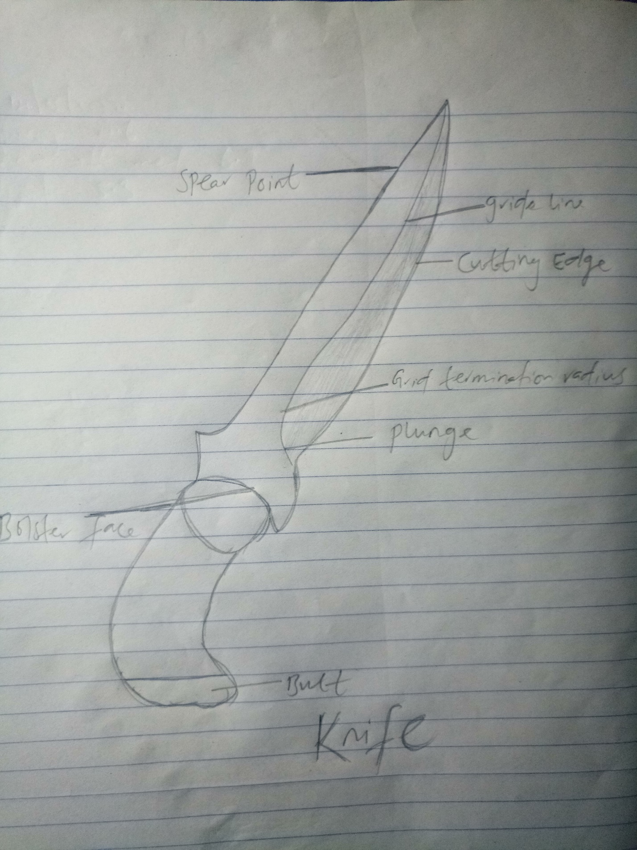

REFERENCE
- Electron Microscopy", chapter 4, by John J. Bozzola and Lonnie Dee Russell
- Kempf, Eugen Karl (1976). "Low magnifications: A marginal area of electron microscopy" (PDF). ZEISS Information. 21 (83): 57–60. ISSN 0174-5581.
- Micro Star Technologies, diamond knives

