NAME: OKON SEUBONG-ABASI
MATRIC NO.:17/MHS01/245
COURSE: RENAL PHYSIOLOGY
- Discuss the pathophysiological process involved in renal failure
Renal failure refers to failure of excretory functions of kidney. It is usually characterized by a decrease in glomerular filtration rate (GFR). Decreased renal function interferes with the kidneys' ability to maintain fluid and electrolyte homeostasis. The ability to concentrate urine declines early and is followed by decreases in ability to excrete excess phosphate, acid, and potassium. It may be either acute or chronic.
Chronic kidney disease (CKD) is initially described as diminished renal reserve or renal insufficiency, which may progress to renal failure (end-stage renal disease). Decreased renal function interferes with the kidneys' ability to maintain fluid and electrolyte homeostasis.
Five Stages of Kidney Disease
Stage 1 with normal or high GFR (GFR > 90 mL/min)
Stage 2 Mild CKD (GFR = 60-89 mL/min)
Stage 3A Moderate CKD (GFR = 45-59 mL/min)
Stage 3B Moderate CKD (GFR = 30-44 mL/min.
Stage 4 Severe CKD (GFR = 15-29 mL/min)
Stage 5 End Stage CKD (GFR <15 mL/min)
Acute Renal Failure
It is the abrupt stoppage of renal functions. It is usually reversible but may result in sudden life-threatening reactions in the body with the need of emergency treatment. It is characterized by tubular dysfunction with impaired sodium and water reabsorption and is associated with the shedding and excretion of proximal tubule brush border membranes and epithelial tubule cells into the urine.
Causes
- Acute nephritis
- Damage of renal tissues by poisons such as lead, mercury, etc.
- Renal ischemia
- Acute tubular necrosis which could be caused by burns, hemorrhage, snake bit, toxins and drugs
- Severe transfusion reactions
Features
- Oliguria: Decreased urinary output
- Anuria: Cessation of urine formation
- Proteinuria: Appearance of protein in urine
- Hematuria: presence of blood in urine
- Edema: Due to increased volume of ECF caused by retention of sodium and water.
- Hypertension within a few days because of the increase in ECF volume.
- Acidosis due to retention of metabolic end products
Chronic Renal Failure
It is the progressive, long standing and irreversible impairment of renal functions. Causes
- Chronic nephritis: refers to the inflammations that occur in the kidneys. It is a complex kidney disease.
- Polycystic kidney disease: Polycystic kidney disease (PKD or PCKD, also known as polycystic kidney syndrome) is a genetic disorder in which the renal tubules become structurally abnormal, resulting in the development and growth of multiple cysts within the kidney.
- Renal calculi: Kidney stones, or renal calculi, are solid masses made of crystals. Kidney stones usually originate in your kidneys. However, they can develop anywhere along the urinary tract.
- Urethral constriction: It involves scarring that narrows the urethra.
- Hypertension
- Atherosclerosis
- Tuberculosis
- Slow poisoning by drugs or metals
Features
- Uremia: It is characterized by excess accumulation of end products of protein metabolism such as urea, nitrogen and creatine in blood.
- Acidosis: Uremia results in acidosis
- Edema: Failure of kidney to excrete sodium and electrolytes causes increase in extracellular fluid volume resulting in development of edema.
- Blood loss: Gastrointestinal bleeding accompanied by platelet dysfunction leads to heavy blood loss.
- Anemia: Since, erythropoietin is not secreted in the kidney during renal failure, the production of RBC decreases resulting in normocytic normochromic anemia.
- Hyperparathyroidism: Secondary hyperparathyroidism is developed due to the deficiency of calcitriol (1,25dihydroxycholecalciferol). It increases the removal of calcium from bones resulting in osteomalacia.

- With the aid of suitable diagrams discuss the types of dialysis you know?
Dialysis is a way of cleaning your blood when your kidneys can no longer do the job. It gets rid of your body's wastes, extra salt and water, and helps to control your blood pressure.
Types of dialysis
There are two kinds of dialysis.
- Hemodialysis: In hemodialysis, blood is pumped out of your body to an artificial kidney machine, and returned to your body by tubes that connect you to the machine. Artificial kidney is the machine that is used to carry out dialysis during renal failure. It is used to treat the patients suffering from both acute renal failure and chronic renal failure.
Diagram
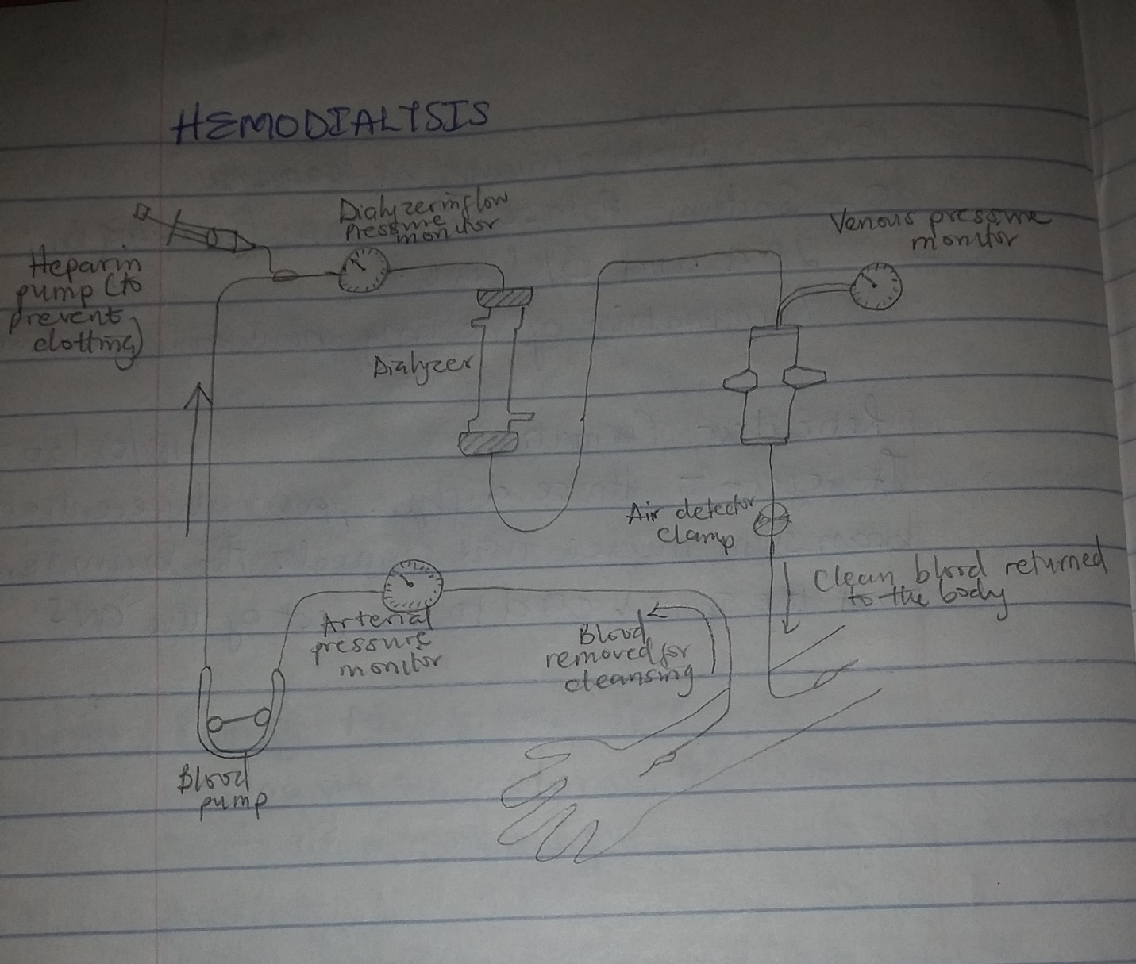

Mechanism of action
Patient’s arterial blood is passed continuously or intermittently through the artificial kidney and then back to the body through the vein. Heparin is used as an anticoagulant while passing the blood through the machine. Inside the artificial kidney, the blood passes through a dialyzer called hemofilter, which contains minute channels interposed between two cellophane membranes. The outer surface of these membranes is bathed in the dialyzing fluid called dialysate. The used dialysate in the artificial kidney is constantly replaced by fresh dialysate.
Urea, creatinine, phosphate and other unwanted substances from the blood pass into the dialysate by concentration gradient. The essential substances required by the body diffuse from dialysate into blood. Almost all the substances, except plasma proteins are exchanged between the blood and dialysate through the cellophane membranes. In addition to the dialyzer, the dialysis machine has several blood pumps with pressure monitors, which enable easy flow of blood from the patient to the machine and back to the patient. It also has pumps for flow of fresh dialysate and for drainage of used dialysate.
- Peritoneal dialysis: In peritoneal dialysis, the inside lining of your own belly acts as a natural filter.
Diagram
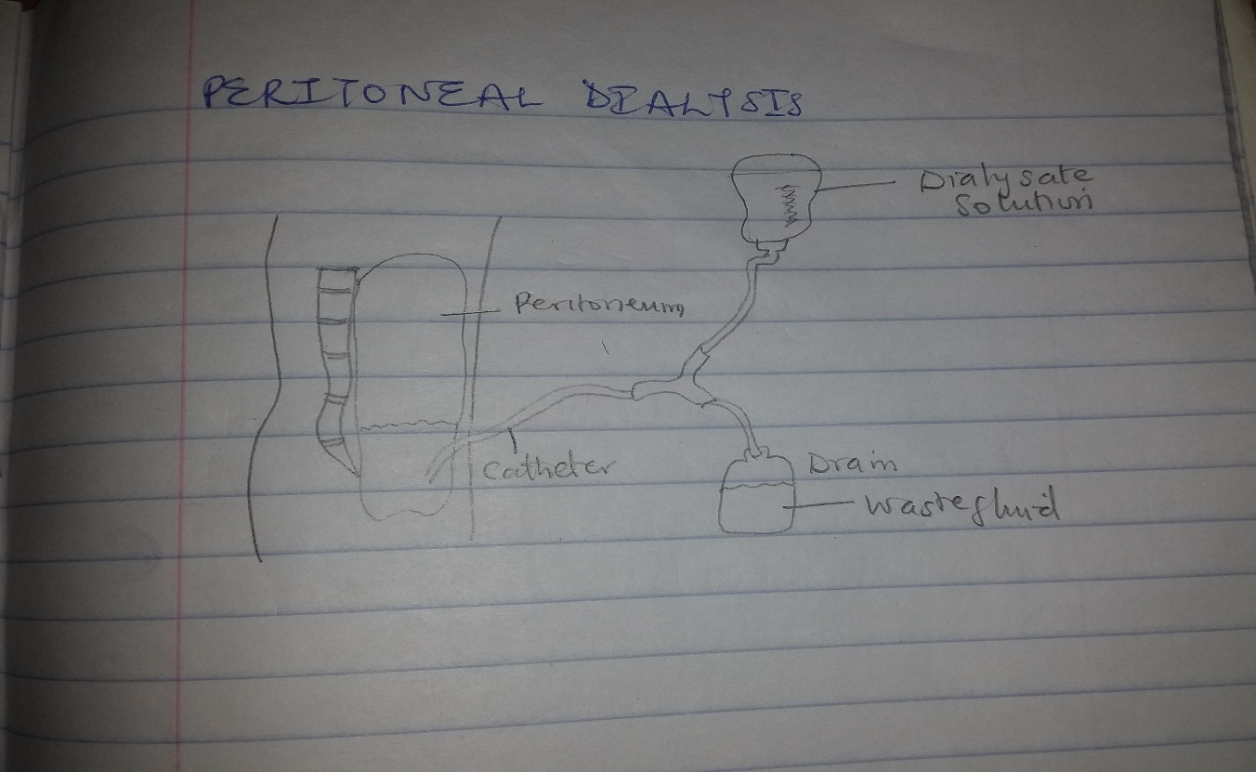

Mechanism of action
How does peritoneal dialysis work?
A soft plastic tube (catheter) is placed in the belly by surgery. A sterile cleansing fluid is put into your belly through this catheter. After the filtering process is finished, the fluid leaves your body through the catheter.
There are two kinds of peritoneal dialysis:
- Continuous Ambulatory Peritoneal Dialysis (CAPD)
- Automated Peritoneal Dialysis (APD)
The basic treatment is the same for each. However, the number of treatments and the way the treatments are done make each method different. CAPD is "continuous," machine-free and done while you go about your normal activities such as work or school. You do the treatment by placing about two quarts of cleansing fluid into your belly and later draining it. This is done by hooking up a plastic bag of cleansing fluid to the tube in your belly. Raising the plastic bag to shoulder level causes gravity to pull the fluid into your belly. When empty, the plastic bag is removed and thrown away.
When an exchange (putting in and taking out the fluid) is finished, the fluid (which now has wastes removed from your blood) is drained from your belly and thrown away. This process usually is done three, four or five times in a 24-hour period while you are awake during normal activities. Each exchange takes about 30 to 40 minutes. Some patients like to do their exchanges at mealtimes and at bedtime.
APD differs from CAPD in that a machine (cycler) delivers and then drains the cleansing fluid for you. The treatment usually is done at night while you sleep.
Complications of Dialysis
Complications of dialysis depend upon the patient’s condition, age, existence of diseases other than renal failure and many other factors. Common complications of dialysis in individuals having only renal dysfunction are:
1. Sleep disorders
2. Anxiety
3. Depression.

