NAME: NWOKPOR NNAEMEKA COLLINS
MAT NO: 17/MHS01/211
300LVL MBBS
PHYSIOLOGY ASSIGNMENT

1. DISCUSS THE PHYSIOLOGY OF SLEEP

SLEEP ARCHITECTURE
Sleep architecture refers to the basic structural organization of normal sleep. There are two types of sleep, non-rapid eye-movement (NREM) sleep and rapid eye-movement (REM) sleep. NREM sleep is divided into stages 1, 2, 3, and 4, representing a continuum of relative depth. Each has unique characteristics including variations in brain wave patterns, eye movements, and muscle tone. Sleep cycles and stages were uncovered with the use of electroencephalographic (EEG) recordings that trace the electrical patterns of brain activity

Two Types of Sleep
Over the course of a period of sleep, NREM and REM sleep alternate cyclically. The function of alternations between these two types of sleep is not yet understood, but irregular cycling and/or absent sleep stages are associated with sleep disorders. For example, instead of entering sleep through NREM, as is typical, individuals with narcolepsy enter sleep directly into REM sleep.

NREM and REM Sleep Cycles
A sleep episode begins with a short period of NREM stage 1 progressing through stage 2, followed by stages 3 and 4 and finally to REM. However, individuals do not remain in REM sleep the remainder of the night but, rather, cycle between stages of NREM and REM throughout the night. NREM sleep constitutes about 75 to 80 percent of total time spent in sleep, and REM sleep constitutes the remaining 20 to 25 percent. The average length of the first NREM-REM sleep cycle is 70 to 100 minutes. The second, and later, cycles are longer lasting—approximately 90 to 120 minute. In normal adults, REM sleep increases as the night progresses and is longest in the last one-third of the sleep episode. As the sleep episode progresses, stage 2 begins to account for the majority of NREM sleep, and stages 3 and 4 may sometimes altogether disappear.

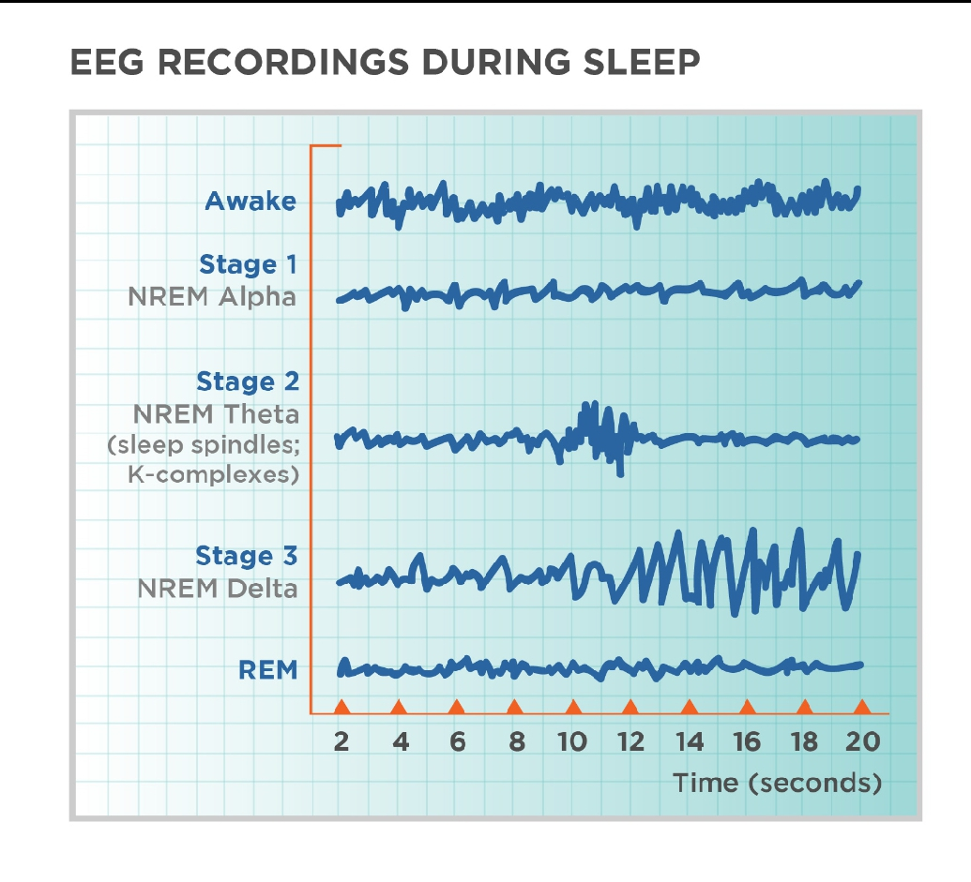
Four Stages of NREM Sleep
The four stages of NREM sleep are each associated with distinct brain activity and physiology. shows the EEG patterns characteristic of the four NREM stages. Other instruments are used to track characteristic changes in eye movement and muscle tone.

Stage 1 Sleep
NREM stage 1 sleep serves a transitional role in sleep-stage cycling. Aside from newborns and those with narcolepsy and other specific neurological disorders, the average individual’s sleep episode begins in NREM stage 1. This stage usually lasts 1 to 7 minutes in the initial cycle, constituting 2 to 5 percent of total sleep, and is easily interrupted by a disruptive noise. Brain activity on the EEG in stage 1 transitions from wakefulness (marked by rhythmic alpha waves) to low-voltage, mixed-frequency waves. Alpha waves are associated with a wakeful relaxation state and are characterized by a frequency of 8 to 13 cycles per second.

Stage 2 Sleep
Stage 2 sleep lasts approximately 10 to 25 minutes in the initial cycle and lengthens with each successive cycle, eventually constituting between 45 to 55 percent of the total sleep episode. An individual in stage 2 sleep requires more intense stimuli than in stage 1 to awaken. Brain activity on an EEG shows relatively low-voltage, mixed-frequency activity characterized by the presence of sleep spindles and K-complexes ). It is hypothesized that sleep spindles are important for memory consolidation. Individuals who learn a new task have a significantly higher density of sleep spindles than those in a control group.

Stages 3 and 4, Slow-Wave Sleep
Sleep stages 3 and 4 are collectively referred to as slow-wave sleep (SWS), most of which occurs during the first third of the night. Each has distinguishing characteristics. Stage 3 lasts only a few minutes and constitutes about 3 to 8 percent of sleep. The EEG shows increased high-voltage, slow-wave activity.

The last NREM stage is stage 4, which lasts approximately 20 to 40 minutes in the first cycle and makes up about 10 to 15 percent of sleep. The arousal threshold is highest for all NREM stages in stage 4. This stage is characterized by increased amounts of high-voltage, slow-wave activity on the EEG.

REM Sleep
REM sleep is defined by the presence of desynchronized (low-voltage, mixed-frequency) brain wave activity, muscle atonia, and bursts of rapid eye movements. “Sawtooth” wave forms, theta activity (3 to 7 counts per second), and slow alpha activity also characterize REM sleep. During the initial cycle, the REM period may last only 1 to 5 minutes; however, it becomes progressively prolonged as the sleep episode progresses (). There are numerous physiological differences between NREM and REM sleep

Dreaming is most often associated with REM sleep. Loss of muscle tone and reflexes likely serves an important function because it prevents an individual from “acting out” their dreams or nightmares while sleeping . Approximately 80 percent of vivid dream recall results after arousal from this stage of sleep. REM sleep may also be important for memory consolidation.

Physiology During Sleep
In addition to the physiological changes listed in, there are other body system changes that occur during sleep. Generally, these changes are well tolerated in healthy individuals, but they may compromise the sometimes fragile balance of individuals with vulnerable systems, such as those with cardiovascular diseases. Physiological changes also occur in the following systems:

Cardiovascular: Changes in blood pressure and heart rate occur during sleep and are primarily determined by autonomic nervous system activity. For instance, brief increases in blood pressure and heart rate occur with K-complexes, arousals, and large body movements (). Further, there is an increased risk of myocardial infarction in the morning due to the sharp increases in heart rate and blood pressure that accompany awakening
Sympathetic-nerve activity: Sympathetic-nerve activity decreases as NREM sleep deepens; however, there is a burst of sympathetic-nerve activity during NREM sleep due to the brief increase in blood pressure and heart rate that follows K-complexes. Compared to wakefulness, there is a rise in activity during REM sleep.
Respiratory: Ventilation and respiratory flow change during sleep and become increasingly faster and more erratic, specifically during REM sleep.
Ventilation data during REM sleep are somewhat unclear, but they suggest that hypoventilation (deficient ventilation of the lungs that results in reduction in the oxygen content or increase in the carbon dioxide content of the blood or both) occurs in a similar way as during NREM sleep . Several factors contribute to hypoventilation during NREM, and possibly REM, sleep such as reduced pharyngeal muscle tone (). Further, during REM sleep, there is reduced rib cage movement and increased upper airway resistance due to the loss of tone in the intercostals and upper airway muscles . More generally, ventilation and respiratory flow show less effective adaptive responses dur ing sleep. The cough reflex, which normally reacts to irritants in the airway, is suppressed during REM and NREM sleep. The hypoxic ventilatory response is also lower in NREM sleep than during wakefulness and decreases further during REM sleep. Similarly, the arousal response to respiratory resistance (for example, resistance in breathing in or out) is lowest in stage 3 and stage 4 slee.
Cerebral blood flow: NREM sleep is associated with significant reductions in blood flow and metabolism, while total blood flow and metabolism in REM sleep is comparable to wakefulnes. However, metabolism and blood flow increase in certain brain regions during REM sleep, compared to wakefulness, such as the limbic system (which is involved with emotions), and visual association area.
Renal: There is a decreased excretion of sodium, potassium, chloride, and calcium during sleep that allows for more concentrated and reduced urine flow. The changes that occur during sleep in renal function are complex and include changes in renal blood flow, glomerular filtration, hormone secretion, and sympathetic neural stimulation.
Endocrine: Endocrine functions such as growth hormone, thyroid hormone, and melatonin secretion are influenced by sleep. Growth hormone secretion typically takes place during the first few hours after sleep onset and generally occurs during SWS, while thyroid hormone secretion takes place in the late evening. Melatonin, which induces sleepiness, likely by reducing an alerting effect from the suprachiasmatic nucleus, is influenced by the light-dark cycle and is suppressed by light.
SLEEP-WAKE REGULATION
The Two-Process Model
The sleep-wake system is thought to be regulated by the interplay of two major processes, one that promotes sleep (process S) and one that maintains wakefulness (process C) ). Process S is the homeostatic drive for sleep. The need for sleep (process S) accumulates across the day, peaks just before bedtime at night and dissipates throughout the night.

Process C is wake promoting and is regulated by the circadian system. Process C builds across the day, serving to counteract process S and promote wakefulness and alertness. However, this wake-promoting system begins to decline at bedtime, serving to enhance sleep consolidation as the need for sleep dissipates across the night. With an adequate night’s rest, the homeostatic drive for sleep is reduced, the circadian waking drive begins to increase, and the cycle starts over. In the absence of process C, total sleep time remains the same, but it is randomly distributed over the day and night; therefore, process C also works to consolidate sleep and wake into fairly distinct episodes (). Importantly, through synchronization of the circadian system, process C assists in keeping sleep-wakefulness cycles coordinated with environmental light-dark cycles.

Sleep-Generating Systems in the Brainstem
Sleep process S is regulated by neurons that shut down the arousal systems, thus allowing the brain to fall asleep. Many of these neurons are found in the preoptic area of the hypothalamus (). These neurons, containing molecules that inhibit neuronal communication, turn off the arousal systems during sleep. Loss of these nerve cells causes profound insomnia. Inputs from other regions of the brain also greatly influence the sleep system. These include inputs from the lower brainstem that relay information about the state of the body (e.g., a full stomach is conducive to falling asleep), as well as from emotional and cognitive areas of the forebrain. In addition, as described further in the next section, there are inputs from the circadian system that allow the wake-sleep system to synchronize with the external day-night cycle, but also to override this cycle when it is necessitated by environmental needs.

The sleep-generating system also includes neurons in the pons that intermittently switch from NREM to REM sleep over the course of the night. These neurons send outputs to the lower brainstem and spinal cord that cause muscle atonia, REMs, and chaotic autonomic activity that characterize REM sleep. Other outputs are sent to the forebrain, including activation of the cholinergic pathways to the thalamus to activate the EEG.

Wake-Generating Systems in the Brainstem
Wakefulness is generated by an ascending arousal system from the brainstem that activates forebrain structures to maintain wakefulness . The main source for the ascending arousal influence includes two major pathways that originate in the upper brainstem. The first pathway, which takes origin from cholinergic neurons in the upper pons, activates parts of the thalamus that are responsible for maintaining transmission of sensory information to the cerebral cortex. The second pathway, which originates in cell groups in the upper brainstem that contain the monoamine neurotransmitters (norepinephrine, serotonin, dopamine, and histamine), enters the hypothalamus, rather than the thalamus, where it picks up inputs from nerve cells that contain peptides (orexin or hypocretin and melanin-concentrating hormone). These inputs then traverse the basal forebrain, where they pick up additional inputs from cells containing acetylcholine and gamma-aminobutyric acid. Ultimately, all of these inputs enter the cerebral cortex, where they diffusely activate the nerve cells and prepare them for the interpretation and analysis of incoming sensory information.

CIRCADIAN RHYTHMS, THE 24-HOUR CLOCK
Circadian rhythms refer, collectively, to the daily rhythms in physiology and behavior. They control the sleep-wake cycle, modulate physical activity and food consumption, and over the course of the day regulate body temperature, heart rate, muscle tone, and hormone secretion. The rhythms are generated by neural structures in the hypothalamus that function as a biological clock (). Animals and plants possess endogenous clocks to organize daily behavioral and physiological rhythms in accord with the external day-night cycle ). The basis for these clocks is believed to be a series of molecular pathways involving “clock” genes that are expressed in a nearly 24-hour rhythm ().

In mammals, two proteins, Clock and Bmal1, bind together and move into the nucleus of the cell, where they bind to specific sites in the DNA that activate specific genes . Among the genes that they activate are Period and Cryptochrome. The products of these genes also move back into the nucleus, where they disrupt the binding of Clock and Bmal1 to the DNA, thus inhibiting their own synthesis. This results in a rising and falling pattern of expression of the Period and Cryptochrome gene products with a periodicity that is very close

Many other genes are also regulated by Clock and Bmal1, and these genes cycle in this way in many tissues in the body, giving rise to daily patterns of activity. These rhythmically expressed genes contribute to many aspects of cellular function, including glucose and lipid metabolism, signal transduction, secretion, oxidative metabolism, and many others, suggesting the importance of the circadian system in many central aspects of life.

The Suprachiasmatic Nucleus
The suprachiasmatic nucleus (SCN) is responsible for regulating circadian rhythms in all organs. It receives direct inputs from a class of nerve cells in the retina that act as brightness detectors, which can reset the clock genes in the SCN on a daily basis. The SCN then transmits to the rest of the brain and body signals that bring all of the daily cycles in synchrony with the external day-night cycle.

The main influence of the SCN on sleep is due to a series of relays through the dorsomedial nucleus of the hypothalamus, which signals to the wake-sleep systems to coordinate their activity with the day-night cycles. The SCN also coordinates cycles of feeding, locomotor activity, and hormones, such as corticosteroids. Under some conditions (e.g., limited food availability) when there are changes in the external temperature, or even under conditions of behavioral stress (e.g., the need to avoid a predator), animals must shift their daily cycles to survive. In such circumstances, the dorsomedial nucleus may shift to a new daily cycle, which can be completely out of phase with the SCN and the light-dark cycle, and its signals also shift the daily cycles of sleep, activity, feeding, and corticosteroid hormone secretion.

Another major output of the SCN is to a pathway that controls the secretion of melatonin, a hormone produced by the pineal gland. Melatonin, which is mainly secreted at night, acts to further consolidate the circadian rhythms but has only limited effects directly on sleep.

Sleep and Thermoregulation
Body temperature regulation is subject to circadian system influence. An individual’s body temperature is higher during the day than at night (). At night there is a gradual decline in body temperature, a decrease in heat production (called the falling phase of the body temperature rhythm), and an increase in heat loss, all which promote sleep onset and maintenance, as well as EEG slow-wave activity. Conversely, there is a gradual increase in body temperature several hours before waking. The brain sends signals to other parts of the body that increase heat production and conservation in order to disrupt sleep and promote waking.

SLEEP PATTERNS CHANGE WITH AGE
Sleep architecture changes continuously and considerably with age. From infancy to adulthood, there are marked changes in how sleep is initiated and maintained, the percentage of time spent in each stage of sleep, and overall sleep efficiency (i.e., how successfully sleep is initiated and maintained). A general trend is that sleep efficiency declines with age . Although the consequences of decreased sleep efficiency are relatively well documented, the reasons are complex and poorly understood. Exami nation of sleep characteristics by age, however, allows a closer understanding of the function of sleep for human development and successful aging.

2. DISCUSS THE ROLE OF BASAL GANGLIA IN CONTROLLING MOVEMENT.

The basal ganglia are responsible for voluntary motor control, procedural learning, and eye movement, as well as cognitive and emotional functions.
Location of the Basal Ganglia
The basal ganglia (or basal nuclei) are a group of nuclei of varied origin in the brains of vertebrates that act as a cohesive functional unit. They are situated at the base of the forebrain and are strongly connected with the cerebral cortex, thalamus, and other brain areas.

The basal ganglia are associated with a variety of functions, including voluntary motor control, procedural learning relating to routine behaviors or habits such as bruxism and eye movements, as well as cognitive and emotional functions.

Action Selection
Currently popular theories hold that the basal ganglia play a primary role in action selection. Action selection is the decision of which of several possible behaviors to execute at a given time.

Experimental studies show that the basal ganglia exert an inhibitory influence on a number of motor systems, and that a release of this inhibition permits a motor system to become active. The behavior switching that takes place within the basal ganglia is influenced by signals from many parts of the brain, including the prefrontal cortex, which plays a key role in executive functions.

Movement
The basal nuclei is involved in the control of movement and learning
Coordinating motivation with body movement. Specifically, the basal ganglia inhibits individual behavior in a complex social interaction and also inhibits small voluntary movement
The greatest source of insight into the functions of the basal ganglia has come from the study of two neurological disorders, Parkinson’s disease and Huntington’s disease. For both of these disorders, the nature of the neural damage is well-understood and can be correlated with the resulting symptoms.

Parkinson’s disease involves the major loss of dopaminergic cells in the substantia nigra. Huntington’s disease involves the massive loss of medium spiny neurons in the striatum.

The symptoms of the two diseases are virtually opposite: Parkinson’s disease is characterized by a gradual loss of the ability to initiate movement, whereas Huntington’s disease is characterized by an inability to prevent parts of the body from moving unintentionally.

It is noteworthy that, although both diseases have cognitive symptoms, especially in their advanced stages, the most salient symptoms relate to the ability to initiate and control movement. Thus, both are classified primarily as movement disorders.

A different movement disorder, called hemiballismus, may result from damage restricted to the subthalamic nucleus. Hemiballismus is characterized by violent and uncontrollable flinging movements of the arms and legs.

Function in Eye Movement
One of the most intensively studied functions of the basal ganglia is their role in controlling eye movements. Eye movement is influenced by an extensive network of brain regions that converge on a midbrain area called the superior colliculus (SC).

The SC is a layered structure whose layers form two-dimensional retinotopic maps of visual space. A bump of neural activity in the deep layers of the SC drives eye movement toward the corresponding point in space.

Motivation
Although the role of the basal ganglia in motor control is clear, there are also many indications that it is involved in the control of behavior in a more fundamental way, at the level of motivation. In Parkinson’s disease, the ability to execute the components of movement is not greatly affected, but motivational factors such as hunger fail to cause movements to be initiated or switched at the proper times.

The immobility of patients with Parkingson’s disease has sometimes been described as a paralysis of the will. These patients have occasionally been observed to show a phenomenon called kinesia paradoxica, in which a person who is otherwise immobile responds to an emergency in a coordinated and energetic way, then lapses back into immobility once the emergency has passed.

The role in motivation of the limbic part of the basal ganglia—the nucleus accumbens (NA), ventral pallidum, and ventral tegmental area (VTA)—is particularly well established. Thousands of experimental studies combine to demonstrate that the dopaminergic projection from the VTA to the NA plays a central role in the brain’s reward system.

Numerous things that people find rewarding, including addictive drugs, good-tasting food, and sex, have been shown to elicit activation of the VTA dopamine system. Damage to the NA or VTA can produce a state of profound torpor.

Neurotransmitters
In most regions of the brain, the predominant classes of neurons use glutamate as the neurotransmitter and have excitatory effects on their targets. In the basal ganglia, however, the great majority of neurons uses gamma-aminobutyric acid (GABA) as the neurotransmitter and have inhibitory effects on their targets.

The inputs from the cortex and thalamus to the striatum and subthalamic nucleus are glutamatergic, but the outputs from the striatum, pallidum, and substantia nigra pars reticulata all use GABA. Thus, following the initial excitation of the striatum, the internal dynamics of the basal ganglia are dominated by inhibition and disinhibition.

Other neurotransmitters have important modulatory effects. Dopamine is used by the projection from the substantia nigra pars compacta to the dorsal striatum and also in the analogous projection from the ventral tegmental area to the ventral striatum (nucleus accumbens).

Acetylcholine also plays an important role, as it is used both by several external inputs to the striatum and by a group of striatal interneurons. Although cholinergic cells make up only a small fraction of the total population, the striatum has one of the highest acetylcholine concentrations of any brain structure.

