Name: Ugorji Nkemjika Jane
Matric Number: 18/MHS05/012
Department: Physiology
College: Medicine And Health Sciences
Course Code: PHS 204
Question: Discuss lactation and gestation period in a normal female
Lactation
The mammary epithelium remains a presecretory tissue until the abrupt diminution in plasma estrogen and progesterone concentration that occurs at the time delivery. Without the inhibitory influence of progesterone on mammary epithelium, prolactin and the other hormones active in the initiation of milk production can exert their effects on acinar cells. By 4-5 days postpartum, estrogen and progesterone concentrations in the plasma are less than normal follicular phase levels and the transition in the acing epithelium from a presecretory to a secretory state is complete. The ovaries apparently are not necessary for the initiation or maintenance of lactation, because oophorectomy has no effect on this process.
The initiation of milk production (lactogenesis) requires 2-5 days in the human being. Prolactin and cortisol are essential for lactogenesis, and growth hormone, insulin, and thyroxin play facultative roles. Prolactin and cortisol are essential for lactogenesis, and growth hormone, insulin, and thyroxine play facultative roles.
The success of a purpose suppression of lactation depends in inhibiting the process of lactogenesis. Because lactogenesis does not begin in the human being until the rapid decrease in oestrogen and progesterone that occurs at delivery and because it requires 2-3 days to be completed, it is possible to inhibit lactogenesis through the use of exogenous steroids to maintain relatively high circulating levels during this critical period after delivery.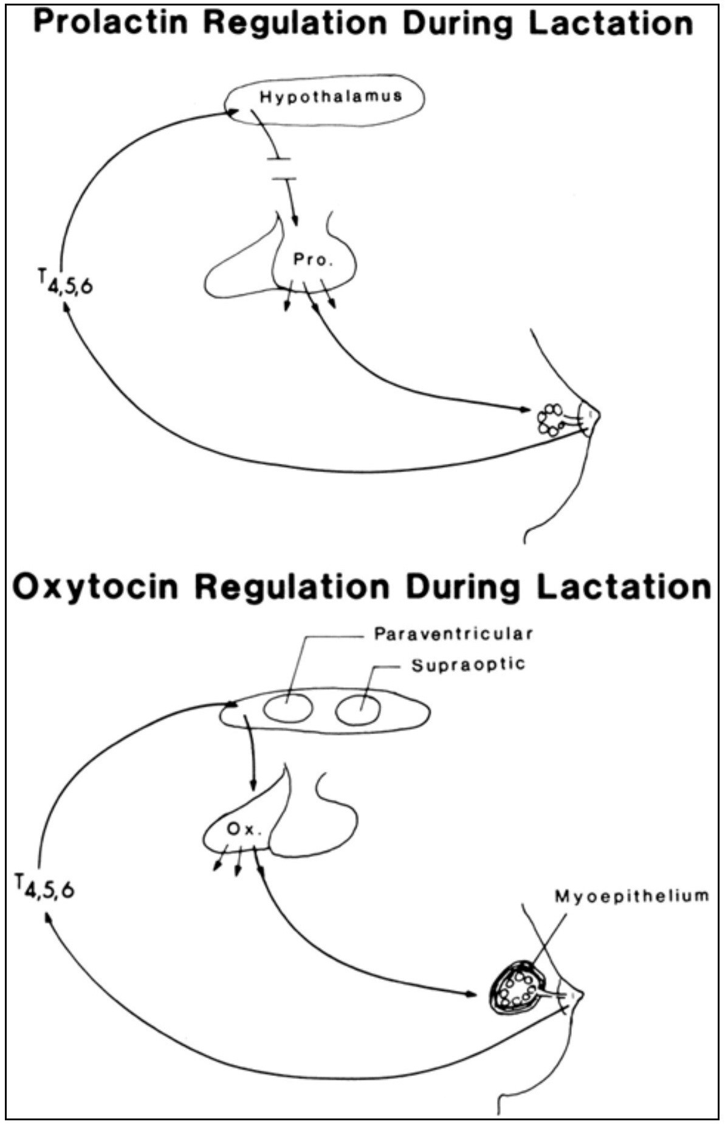
Gestation Period
The average length of human gestation is 280 days or 40 weeks, from the first day of the woman’s last menstrual period. The medical term for the due date is estimated date of confinement (EDC).
However, only about four percent of women actually give birth on their EDC.
The unborn baby spends around 37 weeks in the uterus (womb). pregnancy is counted from the first day of the woman's last menstrual period, not the date of conception which generally occurs two weeks later, followed by five to seven days before it settles in the uterus. Since some women are unsure of the date of their last menstruation (perhaps due to period irregularities), a pregnancy is considered full term if birth falls between 37 to 42 weeks of the estimated due date.
A baby born to prior to week 37 is considered premature, while a baby that still hasn’t been born by week 42 is said to be overdue. In many cases, labour will be induced in the cases of an overdue baby.
A simple method to calculate the due date is to add seven days to the date of the first day of your last period, then add nine months. Irregular menstrual cycles can mean that some women aren't sure of when they conceived. Some clues to the length of gestations include:
i. Ultrasound examination (especially when performed between six and 12 weeks) ii. Size of uterus on vaginal or abdominal examination iii. The time fatal movements are first felt.

