NAME: ADEBARA FAITH INUMIDUN
MATRIC NO.: 17/SCI05/001
COLLEGE: MEDICAL AND HEALTH SCIENCES
DEPARTMENT: MEDICINE AND SURGERY
LEVEL: 300

ASSIGNMENT
Assignment title: Neurophysiology
Course title: Neurophysiology
Course code: PHS 305

Question assignment
- Discuss the physiology of sleep.
- Discuss the role of basal ganglia in coordinating movement.

QUESTION ONE
THE PHYSIOLOGY OF SLEEP
Sleep is defined as unconsciousness from which the person can be aroused by sensory or other stimuli. It is to be distinguished from coma, which is unconsciousness from which the person cannot be aroused.
It is the natural periodic state of rest for mind and body with closed eyes characterized by partial or complete loss of consciousness. Loss of consciousness leads to decreased response to external stimuli and decreased body movements.
There are multiple stages of sleep, from very light sleep to very deep sleep; the depth of sleep is not constant throughout the sleeping period but varies in different stages of sleep.
- TYPES OF SLEEP
Sleep researchers divide sleep into two entirely different types of sleep that have different qualities, as follows:
- Non-rapid eye movement sleep, NREM sleep or non-REM sleep or slow-wave sleep, in which the brain waves are strong and of low frequency
- Rapid eye movement sleep or REM sleep, in which the eyes undergo rapid movements despite the fact that the person is still asleep
During each night, a person goes through stages of two types of sleep that alternate with each other. Most sleep during each night is of the slow-wave variety; this is the deep, restful sleep that the person experiences during the first hour of sleep after having been awake for many hours. REM sleep, on the other hand, occurs in episodes that occupy about 25 percent of the sleep time in young adults; each episode normally recurs about every 90 minutes. This type of sleep is not so restful, and it is usually associated with vivid dreaming.
- NON-RAPID EYE MOVEMENT SLEEP – NREM OR NON-REM SLEEP
Non-rapid eye movement (NREM) sleep is the type of sleep without the movements of eyeballs. It is also called slow-wave sleep.
Dreams do not usually occur in this type of sleep and it occupies about 70% to 80% of total sleeping period. Although slow-wave sleep is frequently called "dreamless sleep," dreams and sometimes even nightmares do occur during slow-wave sleep. The difference between the dreams that occur in slow wave sleep and those that occur in REM sleep is that those of REM sleep are associated with more bodily muscle activity. Also, the dreams of slow-wave sleep are usually not remembered because consolidation of the dreams in memory does not occur.
Non-REM sleep is followed by REM sleep.

- RAPID EYE MOVEMENT SLEEP – REM SLEEP
Rapid eye movement sleep is the type of sleep associated with rapid conjugate movements of the eyeballs, which occurs frequently. Though the eyeballs move, the sleep is deep. So, it is also called paradoxical sleep or desynchronized sleep. It occupies about 20% to 30% of sleeping period.
Functionally, REM sleep is very important because, it plays an important role in consolidation of memory. Dreams occur during this period.
In a normal night of sleep, bouts of REM sleep lasting 5 to 30 minutes usually appear on the average every 90 minutes. When the person is extremely sleepy, each bout of REM sleep is short and may even be absent. Conversely, as the person becomes more rested through the night, the durations of the REM bouts increase.
REM sleep has several important characteristics:
- It is an active form of sleep usually associated with dreaming and active bodily muscle movements.
- The person is even more difficult to arouse by sensory stimuli than during deep slow-wave sleep, and yet people usually awaken spontaneously in the morning during an episode of REM sleep.
- Muscle tone throughout the body is exceedingly depressed, indicating strong inhibition of the spinal muscle control areas.
- Heart rate and respiratory rate usually become irregular, which is characteristic of the dream state.
- Despite the extreme inhibition of the peripheral muscles, irregular muscle movements do occur. These are in addition to the rapid movements of the eyes.
- The brain is highly active in REM sleep, and overall brain metabolism may be increased as much as 20 percent. The electroencephalogram (EEG) shows a pattern of brain waves similar to those that occur during wakefulness. This type of sleep is also called paradoxical sleep because it is a paradox that a person can still be asleep despite marked activity in the brain.
In summary, REM sleep is a type of sleep in which the brain is quite active. However, the brain activity is not channelled in the proper direction for the person to be fully aware of his or her surroundings, and therefore the person is truly asleep.
Differences Between REM Sleep and Non-REM Sleep
Characteristics | REM sleep | Non-REM sleep
Rapid eye movement (REM) | Present | Absent
Dreams | Present | Absent
Muscle twitching | Present | Absent
Heart rate | Fluctuating | Stable
Blood pressure | Fluctuating | Stable
Respiration | Fluctuating | Stable
Body temperature | Fluctuating | Stable
Neurotransmitter | Noradrenaline | Serotonin

- STAGES OF SLEEP AND EEG PATTERN
- RAPID EYE MOVEMENT SLEEP
During REM sleep, electroencephalogram (EEG) shows irregular waves with high frequency and low amplitude. These waves are desynchronized waves.
- NON-RAPID EYE MOVEMENT SLEEP
The NREM sleep is divided into four stages, based on the EEG pattern. During the stage of wakefulness, i.e. while lying down with closed eyes and relaxed mind, the alpha waves of EEG appear. When the person proceeds to drowsy state, the alpha waves diminish
Stage I: Stage of Drowsiness
Alpha waves are diminished and abolished. EEG shows only low voltage fluctuations and infrequent delta waves.
Stage II: Stage of Light Sleep
Stage II is characterized by spindle bursts at a frequency of 14 per second, superimposed by low voltage delta waves.
Stage III: Stage of Medium Sleep
During this stage, the spindle bursts disappear. Frequency of delta waves decreases to 1 or 2 per second and amplitude increases to about 100 µV.
State IV: Stage of Deep Sleep
Delta waves become more prominent with low frequency and high amplitude.
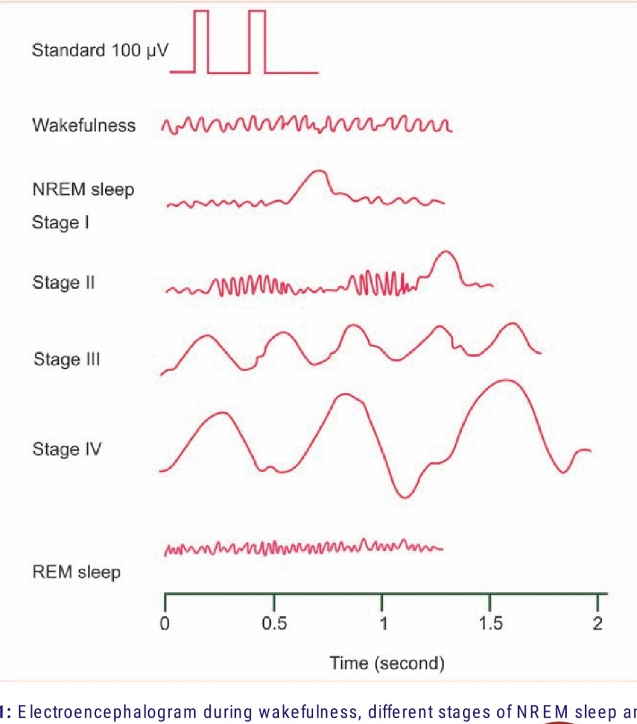
Electroencephalogram during wakefulness, different stages of NREM sleep and REM sleep. NREM = Non-rapid eye movement, REM = Rapid eye movement

- BASIC THEORIES OF SLEEP
Sleep is believed to be caused by an active inhibitory process
An earlier theory of sleep was that the excitatory areas of the upper brain stem, the reticular activating system, simply fatigued during the waking day and became inactive as a result. This was called the passive theory of sleep. An important experiment changed this view to the current belief that sleep is caused by an active inhibitory process: it was discovered that transecting the brain stem at the level of the midpons creates a brain whose cortex never goes to sleep. In other words, a centre located below the midpontile level of the brain stem appears to be required to cause sleep by inhibiting other parts of the brain.
Ascending reticular activating system (ARAS) is responsible for wakefulness because of its afferent and efferent connections with cerebral cortex. Inhibition of ARAS induces sleep. Lesion of ARAS leads to permanent somnolence, i.e. coma.
Neuronal Centres, Neurohumoral Substances, and Mechanisms That Can Cause Sleep
Sleep occurs due to the activity of some sleep-inducing centres in brain. Stimulation of these centres induces sleep. Damage of sleep centres results in sleeplessness or persistent wakefulness called insomnia.
SLEEP CENTERS
Complex pathways between the reticular formation of brainstem, diencephalon and cerebral cortex are involved in the onset and maintenance of sleep. However, two centres which induce sleep are located in brainstem:
- Raphe nucleus
- Locus coeruleus of pons
Recently, many more areas that induce sleep are identified in the brain of animals. Inhibition of ascending reticular activating system also results in sleep.
- Role of Raphe Nucleus
Raphe nucleus is situated in lower pons and medulla. Activation of this nucleus results in non-REM sleep. It is due to release of serotonin by the nerve fibers arising from this nucleus. Serotonin induces non-REM sleep.

- Role of Locus Coeruleus of Pons
Activation of this centre produces REM sleep. Noradrenaline released by the nerve fibers arising from locus coeruleus induces REM sleep.

- APPLIED PHYSIOLOGY – SLEEP DISORDERS
- INSOMNIA
Insomnia is the inability to sleep or abnormal wakefulness. It is the most common sleep disorder. It occurs due to systemic illness or mental conditions such as psychiatric problems, alcoholic addiction and drug addiction.
- HYPERSOMNIA
Hypersomnia is the excess sleep or excess need to sleep. It occurs because of lesion in the floor of the third ventricle, brain tumours, encephalitis, chronic bronchitis and disease of muscles. Hypersomnia also occurs in endocrine disorders such as myxedema and diabetes insipidus.
- NARCOLEPSY AND CATAPLEXY
Narcolepsy is a hypothalamic disorder with abnormal sleep pattern. It is a disorder characterized by sudden and uncontrollable attacks of deep sleep, often brief, sometimes accompanied by paralysis and hallucinations. There is a sudden attack of uncontrollable desire for sleep and the person suddenly falls asleep. It occurs in the daytime. The sleep may resemble the normal sleep. The duration of sleep is very short. It may be from few seconds to 20 minutes. In night, sleep may be normal but is often disturbed or there may be insomnia (loss of sleep).
Cataplexy is a sudden and abrupt loss of muscle tone, sometimes associated with narcolepsy. Cataplexy is the sudden uncontrolled outbursts of emotion associated with narcolepsy. Due to emotional outburst like anger, fear or excitement, the person becomes completely exhausted with muscular weakness. The attack is brief and last for few seconds to a few minutes. Consciousness is not lost.
Both the diseases are due to hypothalamic disorders.
- SLEEP APNEA SYNDROME
Sleep apnea is the temporary stoppage of breathing repeatedly during sleep. Sleep apnea syndrome is the disorder that involves fluctuations in the rate and force of respiration during REM sleep with short apneic episode. Apnea is due to decreased stimulation of respiratory centers, arrest of diaphragmatic movements, airway obstruction or the combination of all these factors. When breathing stops, the resultant hypercapnia and hypoxia stimulate respiration. Sleep apnea syndrome occurs in obesity, myxedema, enlargement of tonsil and lesion in brainstem. Common features of this syndrome are loud snoring, restless movements, nocturnal insomnia, daytime sleepiness, morning headache and fatigue. In severe conditions, hypertension, right heart failure and stroke occur.
- NIGHTMARE
Nightmare is a condition during sleep that is characterized by a sense of extreme uneasiness or discomfort or by frightful dreams. Discomfort is felt as of some heavy weight on the stomach or chest or as uncontrolled movement of the body. After a period of extreme anxiety, the subject wakes with a troubled state of mind. It occurs mostly during REM sleep. Nightmare occurs due to improper food intake, digestive disorders or nervous disorders. It also occurs during drug withdrawal or alcohol withdrawal.
- NIGHT TERROR
Night terror is a disorder similar to nightmare. It is common in children. It is also called pavor nocturnus or sleep terror. The child awakes screaming in a state of fright and semi-consciousness. The child cannot recollect the attack in the morning. Nightmare occurs shortly after falling asleep and during non-REM sleep. There is no psychological disturbance.
- SOMNAMBULISM
Somnambulism is getting up from bed and walking in the state of sleep. It is also called walking during sleep or sleep walking (somnus = sleep; ambulare = to walk). It varies from just sitting up in the bed to walking around with eyes open and performing some major complex task. The episode lasts for few minutes to half an hour. It occurs during non-REM sleep. In children, it is associated with bedwetting or night terror without any psychological disturbance. However, in adults it is associated with psychoneurosis.
- NOCTURNAL ENURESIS
Nocturnal enuresis is the involuntary voiding of urine at bed during night. It is also called bedwetting or nocturnal micturition. It occurs due to the absence of voluntary control of micturition. It is a common and normal process in infants and children below 3 years. It is because of incomplete myelination of motor nerve fibers of the bladder. When myelination is complete, voluntary control of micturition develops and bedwetting stops.
If nocturnal micturition occurs after 3 years of age it is considered abnormal. It occurs due to neurological disorders like lumbosacral vertebral defects. It can also occur due to psychological factors. Loss of voluntary control of micturition occurs even during the impairment of motor area of cerebral cortex.
- MOVEMENT DISORDERS DURING SLEEP
Movement disorders occur immediately after falling asleep. Sleep start or hypnic jerk is the common movement disorder during sleep. It is characterized by sudden jerks of arms or legs. Sleep start is a physiological form of clonus. Other movement disorders are teeth grinding (bruxism), banging the head and restless moment of arms or legs.

QUESTION TWO
ROLES OF BASAL GANGLIA IN COORDINATING MOVEMENT
Basal ganglia are the scattered masses of gray matter submerged in subcortical substance of cerebral hemisphere. They form the part of extra pyramidal system, which is concerned with motor activities.
BASAL GANGLIA
- COMPONENTS OF BASAL GANGLIA
Basal ganglia include three primary components:
- Corpus striatum
- Substantia nigra
- Subthalamic nucleus of Luys

- CORPUS STRIATUM
Corpus striatum is a mass of gray matter situated at the base of cerebral hemispheres in close relation to thalamus. Corpus striatum is incompletely divided into two parts by internal capsule:
- Caudate nucleus: this is an elongated arched gray mass, lying medial to internal capsule. It has a head portion and a tail portion. The head is bulged into lateral ventricle and situated rostral to thalamus, the tail is long and arched and extends along the dorsolateral surface of thalamus and ends in amygdaloid nucleus.
- Lenticular nucleus: Lenticular nucleus is a wedge-shaped gray mass, situated lateral to internal capsule. A vertical plate of white matter called external medullary lamina, divides lenticular nucleus into two portions – Outer Putamen and Inner Globus pallidus.
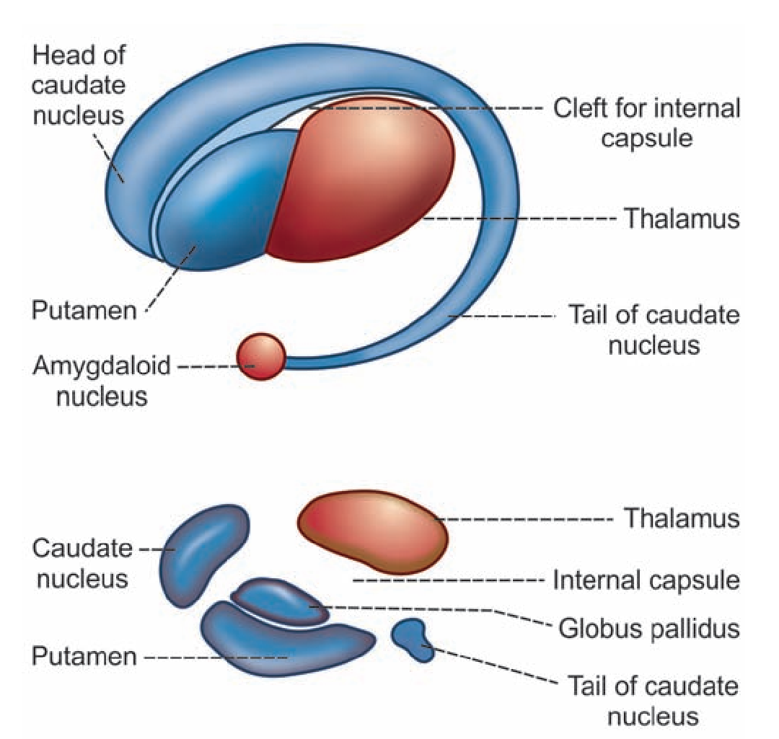
CORPUS STRIATUM
- SUBSTANTIA NIGRA
Substantia nigra is situated below red nucleus. It is made up of large pigmented and small non­pigmented cells. The pigment contains high quantity of iron.
- SUBTHALAMIC NUCLEUS OF LUYS
Subthalamic nucleus is situated lateral to red nucleus and dorsal to substantia nigra.
- FUNCTIONS OF BASAL GANGLIA
Basal ganglia form the part of extrapyramidal system, which is concerned with integration and regulation motor activities. Various functions of basal ganglia are:
- Control of muscle tone
- Control and coordination of motor activity
- Control of reflex muscular activity
- Control of automatic associated movements
- Globus pallidus and red nucleus are involved in arousal mechanism because of their connections with reticular formation

- ROLE OF BASAL GANGLIA IN COORDINATING MOVEMENTS
Aside from the areas in the cerebral cortex that stimulate muscle contraction, two other brain structures are also essential for normal motor function. They are the cerebellum and the basal ganglia. Yet neither of these two can control muscle function by themselves. Instead, they always function in association with other systems of motor control.
The cerebellum plays major roles in the timing of motor activities and in rapid, smooth progression from one muscle movement to the next. It also helps to control the intensity of muscle contraction when the muscle load changes and controls the necessary instantaneous interplay between agonist and antagonist muscle groups.
The basal ganglia, which are in close association with cerebral cortex, help to plan and control complex patterns of muscle movement, controlling relative intensities of the separate movements, directions of movements, and sequencing of multiple successive and parallel movements for achieving specific complicated motor goals.

- REGULATION OF VOLUNTARY MOVEMENTS – THE PUTAMEN CIRCUIT
Movements during voluntary motor activity are initiated by cerebral cortex. However, these movements are controlled by basal ganglia, which are in close association with cerebral cortex. During lesions of basal ganglia, the control mechanism is lost and so the movements become inaccurate and awkward.
Basal ganglia control the motor activities because of the nervous (neuronal) circuits between basal ganglia and other parts of the brain involved in motor activity. The anatomical connections between the basal ganglia and the other brain elements that provide motor control are complex (as shown in the diagram below). To the left is shown the motor cortex, thalamus, and associated brain stem and cerebellar circuitry. To the right is the major circuitry of the basal ganglia system, showing the tremendous interconnections among the basal ganglia themselves plus extensive input and output pathways between the other motor regions of the brain and the basal ganglia.
THE PUTAMEN CIRCUIT
Neuronal circuits arise from three areas of the cerebral cortex:
- Premotor area
- Primary motor area
- Supplementary motor area
All these nerve fibers from cerebral cortex reaches the caudate nucleus. From here, the fibers go to putamen. Some of the fibers from cerebral cortex go directly to putamen also. Putamen sends fibers to globus pallidus. Fibers from here run towards the thalamus, subthalamic nucleus of Luys and substantia nigra. Subthalamic nucleus and substantia nigra are in turn, projected into thalamus. Now, the fibers from thalamus are projected back into primary motor area and other two motor areas, i.e. premotor area and supplementary motor area.
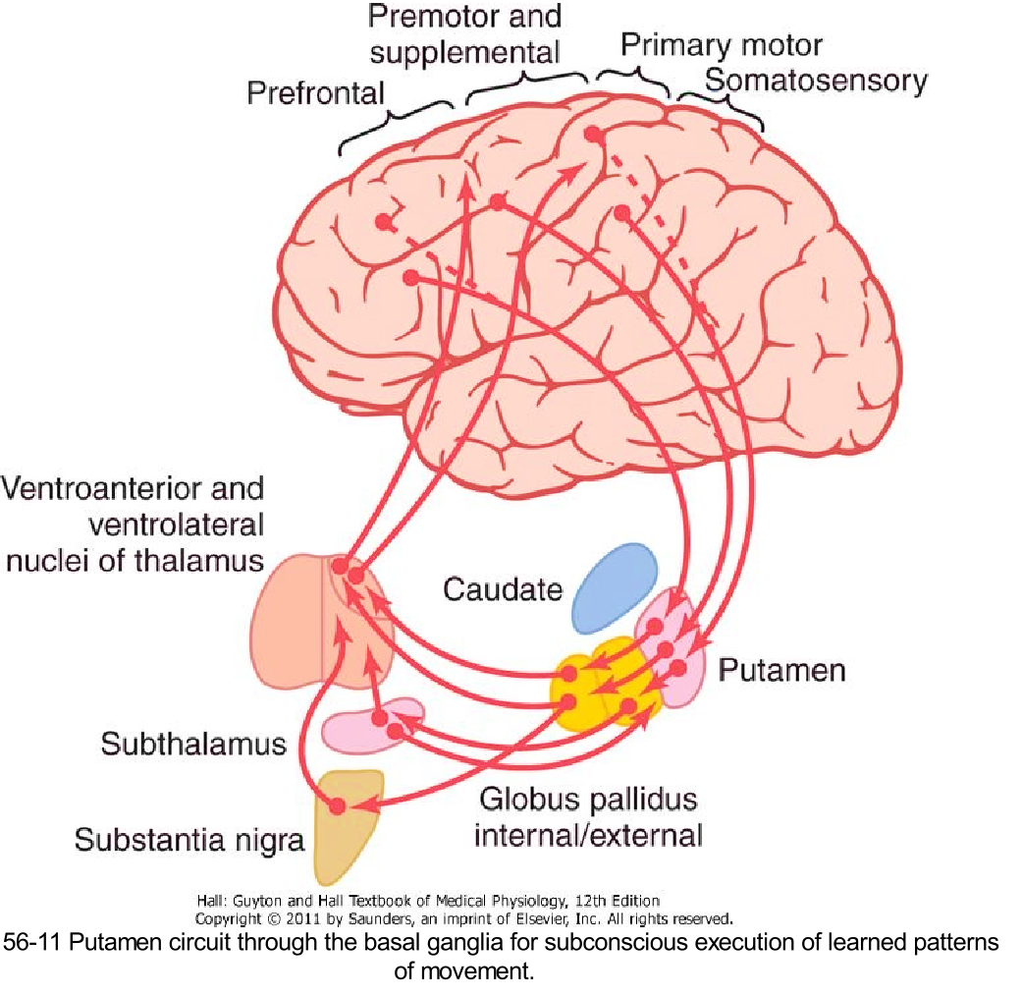

- REGULATION OF CONSCIOUS MOVEMENTS – THE CAUDATE CIRCUIT
Fibers between cerebral cortex and caudate nucleus are concerned with regulation of conscious movements. This function of basal ganglia is also known as the cognitive control of activity.
The term ‘cognition’ means the thinking processes of the brain, using both sensory input to the brain plus information already stored in memory. Most of our motor actions occur as a consequence of thoughts generated in the mind, a process called cognitive control of motor activity. The caudate nucleus plays a major role in this cognitive control of motor activity. For example, when a stray dog barks at a man, immediately the person, understands the situation, turns away and starts running.
THE CAUDATE CIRCUIT
The neural connections between the caudate nucleus and the corticospinal motor control system (as shown in the diagram below) are somewhat different from those of the putamen circuit. Part of the reason for this is that the caudate nucleus extends into all lobes of the cerebrum, beginning anteriorly in the frontal lobes, then passing posteriorly through the parietal and occipital lobes, and finally curving forward again like the letter "C" into the temporal lobes. Furthermore, the caudate nucleus receives large amounts of its input from the association areas of the cerebral cortex overlying the caudate nucleus, mainly areas that also integrate the different types of sensory and motor information into usable thought patterns.
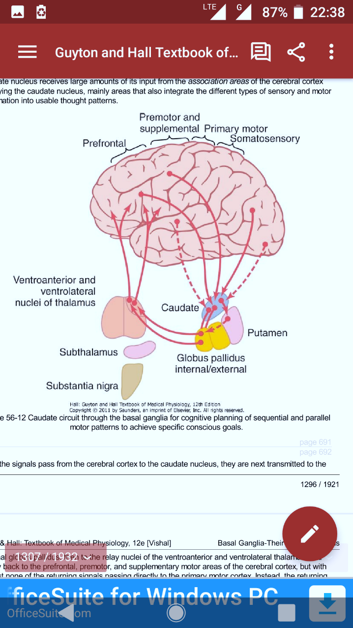
After the signals pass from the cerebral cortex to the caudate nucleus, they are next transmitted to the internal globus pallidus, then to the relay nuclei of the ventroanterior and ventrolateral thalamus, and finally back to the prefrontal, premotor, and supplementary motor areas of the cerebral cortex, but with almost none of the returning signals passing directly to the primary motor cortex. Instead, the returning signals go to those accessory motor regions in the premotor and supplementary motor areas that are concerned with putting together sequential patterns of movement lasting 5 or more seconds instead of exciting individual muscle movements.
A good example of this would be a person seeing a tiger approach and then responding instantaneously and automatically by (1) turning away from the tiger, (2) beginning to run, and (3) even attempting to climb a tree. Without the cognitive functions, the person might not have the instinctive knowledge, without thinking for too long a time, to respond quickly and appropriately. Thus, cognitive control of motor activity determines subconsciously, and within seconds, which patterns of movement will be used together to achieve a complex goal that might itself last for many seconds.
- REGULATION OF SUBCONSCIOUS MOVEMENTS
Cortical fibers reaching putamen are directly concerned with regulation of some subconscious movements, which take place during trained motor activities. Skilled activities such as writing the learnt alphabet, paper cutting with scissors, nail hammering, shooting a basketball through a hoop, passing a football, throwing a baseball, the movements of shoveling dirt, most aspects of vocalization, controlled movements of the eyes, and virtually any other of our skilled movements are performed subconsciously and would require the basal ganglia.

ROLE OF NEUROTRANSMITTERS IN THE FUNCTIONS OF BASAL GANGLIA
Functions of basal ganglia on motor activities are executed by some neurotransmitters released by nerve endings within basal ganglia. Following neurotransmitters are released in basal ganglia: -
Neurotransmitter | Released by | Action
Dopamine | Fibers from substantia nigra to corpus striatum | Inhibition
Gamma aminobutyric acid | Intrinsic fibers of corpus striatum and substantia nigra | Inhibition
Acetylcholine | Fibers from cerebral cortex to caudate nucleus and putamen | Excitation
Substance P | Fibers from globus pallidus reaching substantia nigra | Excitation
Enkephalins | Fibers from globus pallidus reaching substantia nigra | Excitation
Noradrenaline | Fibers between basal ganglia and reticular formation | Excitation
Glutamic acid | Fibers from subthalamic nucleus to globus pallidus and substantia nigra | Excitation

APPLIED PHYSIOLOGY
- ATHETOSIS
It is a type of abnormal involuntary movement, which refers to slow rhythmic and twisting movements. It is caused by lesions in the globus pallidus, caudate nucleus and putamen, which lead to spontaneous and often continuous writhing movements of a hand, an arm, the neck, or the face-movements.
- HEMIBALLISMUS
A lesion or degeneration in the subthalamus often leads to sudden flailing movements of an entire limb, a condition called hemiballismus. Hemiballismus is a disorder characterized by violent involuntary abnormal movements on one side of the body involving mostly the arm. While walking, the arm swings widely. These movements are called the flinging movements. These movements are due to the release phenomenon because of the absence of inhibitory influence on movements.
- CHOREA
Multiple small lesions in the putamen and caudate nucleus lead to flicking movements in the hands, face, and other parts of the body, called chorea. Chorea is an abnormal involuntary movement. Chorea means rapid jerky movements. It mostly involves the limbs.
- PARKINSON DISEASE
Parkinson's disease, known also as paralysis agitans or parkinsonism, is a slowly progressive degenerative disease of the nervous system. It results from widespread destruction of that portion of the substantia nigra (the pars compacta) that sends dopamine-secreting nerve fibers to the caudate nucleus and putamen.
It is named after the discoverer James Parkinson.
Damage of basal ganglia usually occurs because of the following causes:
- Viral infection of brain like encephalitis
- Cerebral arteriosclerosis
- Injury to basal ganglia
- Destruction or removal of dopamine in basal ganglia. It occurs mostly due to long-term treatment with antihypertensive drugs like reserpine. Parkinsonism due to the drugs is known as drug-induced parkinsonism.
- Unknown causes: Parkinsonism can occur because of the destruction of basal ganglia due to some unknown causes. This type of parkinsonism is called idiopathic parkinsonism.
Signs and Symptoms of Parkinson Disease
Parkinson disease develops very slowly and the early signs and symptoms may be unnoticed for months or even for years. Often the symptoms start with a mild noticeable tremor in just one hand. When the tremor becomes remarkable the disease causes slowing or freezing of movements followed by rigidity. Following are the common signs and symptoms of Parkinson disease:
- Tremor at rest
In Parkinson disease, the tremor occurs during rest. But it disappears while doing any work. So, it is called static tremor or resting tremor. It is also called drum-beating tremor, as the movements are similar to beating a drum. Thumb moves rhythmically over the index and middle fingers. These movements are called pill-rolling movements.
- Rigidity
There is rigidity of much of the musculature of the body due to stiffness of muscles. The muscular stiffness occurs because of increased muscle tone which is due to the removal of inhibitory influence on gamma motor neurons. It affects both flexor and extensor muscles equally. So, the limbs become more rigid like pillars. The condition is called lead-pipe rigidity. In later stages the rigidity extends to neck and trunk.
- Slowness of movements
Over the time, movements start slowing down (bradykinesia) and it takes a long time even to perform a simple task. Gradually the patient becomes unable to initiate the voluntary activity (akinesia) or the voluntary movements are reduced (hypokinesia). It is because of hypertonicity of the muscles.
- Postural instability
This is caused by impaired postural reflexes, leading to poor balance and falls.
- Festinant gait
Gait in Parkinson disease is called festinant gait. The patient walks quickly in short steps by bending forward as if he is going to catch up the center of gravity.
- Other motor symptoms
Other motor symptoms including dysphagia (impaired ability to swallow), speech disorders, gait disturbances, and fatigue.

The causes of these abnormal motor effects are unknown. However, the dopamine secreted in the caudate nucleus and putamen is an inhibitory transmitter; therefore, destruction of the dopaminergic neurons in the substantia nigra of the parkinsonian patient theoretically would allow the caudate nucleus and putamen to become overly active and possibly cause continuous output of excitatory signals to the corticospinal motor control system. These signals could overly excite many or all of the muscles of the body, thus leading to rigidity.
Some of the feedback circuits might easily oscillate because of high feedback gains after loss of their inhibition, leading to the tremor of Parkinson's disease. This tremor is quite different from that of cerebellar disease because it occurs during all waking hours and therefore is an involuntary tremor, in contradistinction to cerebellar tremor, which occurs only when the person performs intentionally initiated movements and therefore is called intention tremor.
The akinesia that occurs in Parkinson's disease is often much more distressing to the patient than are the symptoms of muscle rigidity and tremor, because to perform even the simplest movement in severe parkinsonism, the person must exert the highest degree of concentration. The mental effort, even mental anguish, that is necessary to make the desired movements is often at the limit of the patient's willpower. Then, when the movements do occur, they are usually stiff and staccato in character instead of smooth. The cause of this akinesia is still speculative. However, dopamine secretion in the limbic system, especially in the nucleus accumbens, is often decreased along with its decrease in the basal ganglia. It has been suggested that this might reduce the psychic drive for motor activity so greatly that akinesia results.

Treatment for Parkinson Disease
- Treatment with L-Dopa
As Parkinson disease is due to lack of dopamine caused by damage of dopaminergic fibers, it is treated by dopamine injection.
Dopamine does not cross the blood brain barrier. So, another substance called levodopa (L-dopa) which crosses the blood brain barrier is injected. L-dopa moves into the brain and there it is converted into dopamine. Since, L-dopa can be converted into dopamine in liver, some side effects occur due to excess dopamine content in liver and blood. So, along with L-dopa, another substance called carbidopa is administered. Carbidopa prevents the conversion of L-dopa into dopamine and carbidopa cannot pass through blood brain barrier. Thus, L-dopa moves into the brain tissues and is converted into dopamine.
- Treatment with L-Deprenyl
Another treatment for Parkinson's disease is the drug L-deprenyl. This drug inhibits monoamine oxidase, which is responsible for destruction of most of the dopamine after it has been secreted. Therefore, any dopamine that is released remains in the basal ganglia tissues for a longer time. In addition, for reasons not understood, this treatment helps to slow destruction of the dopamine secreting neurons in the substantia nigra. Therefore, appropriate combinations of L-dopa therapy along with L-deprenyl therapy usually provide much better treatment than use of one of these drugs alone.
- Treatment with Transplanted Fetal Dopamine Cells
Transplantation of dopamine-secreting cells (cells obtained from the brains of aborted fetuses) into the caudate nuclei and putamen has been used with some short-term success to treat Parkinson's disease. However, the cells do not live for more than a few months. If persistence could be achieved, perhaps this would become the treatment of the future.
- Treatment by Destroying Part of the Feedback Circuitry in the Basal Ganglia
Some of the symptoms of Parkinson disease such as tremor are abolished by surgical destruction of basal ganglia or thalamic nuclei.
Because abnormal signals from the basal ganglia to the motor cortex cause most of the abnormalities in Parkinson's disease, multiple attempts have been made to treat these patients by blocking these signals surgically. For a number of years, surgical lesions were made in the ventrolateral and ventroanterior nuclei of the thalamus, which blocked part of the feedback circuit from the basal ganglia to the cortex; variable degrees of success were achieved, as well as sometimes serious neurological damage. In monkeys with Parkinson's disease, lesions placed in the subthalamus have been used, sometimes with surprisingly good results.

- HUNTINGTON CHOREA
Huntington disease is an inherited progressive neural disorder due to the degeneration of neurons secreting GABA in corpus striatum and substantia nigra. This disease starts mostly in middle age. It is characterized by chorea, hypotonia and dementia. In severe cases bilateral wasting of muscles occurs. It is otherwise called Huntington disease, chronic progressive chorea, degenerative chorea or hereditary chorea.
- WILSON DISEASE
Wilson disease is an inherited disorder characterized by excess of copper in the body tissues. It is also known as progressive hepatolenticular degeneration. This disease develops due to damage of the lenticular nucleus particularly, putamen.
In Wilson disease, copper is deposited in the liver, brain, kidneys and eyes. Copper deposits cause damage of tissues. And the affected organs stop functioning.
In addition to symptoms of Parkinson disease, liver failure and damage to the central nervous system are the most predominant effects of this disorder. Wilson disease is fatal if not treated early.
- KERNICTERUS
Kernicterus is a form of brain damage in infants caused by severe jaundice. Basal ganglia are the mainly affected parts of brain.

