NAME: OBUNADIKE CHINENYE BLESSING
MATRIC NUMBER : 17/MHS01/225
COURSE TITLE: NEUROPHYSIOLOGY
COURSE CODE: PHS 305
ASSIGNMENT
1) DISCUSS THE PHYSIOLOGY OF SLEEP
2) DISCUSS THE ROLE OF BASAL GANGLIA IN COORDINATING MOVEMENT.

PHYSIOLOGY OF SLEEP

INTRODUCTION
Sleep refers to a state of unconsciousness from which the individual can be aroused by sensory or other stimuli. When asleep, an individual is not aware of the environment and is unable to perform activities that require consciousness. During sleep, the stimulus pulse transfer becomes less frequent between the reticular formation and cerebral cortex. Sleep is a naturally recurring state of mind and body, characterized by altered consciousness, relatively inhibited sensory activity, reduced muscle activity and inhibition of nearly all voluntary muscles during rapid eye movement (REM) sleep, and reduced interactions with surroundings. It is distinguished from wakefulness by a decreased ability to react to stimuli, but more reactive than a coma or disorders of consciousness, with sleep displaying very different and active brain patterns.

SLEEP-WAKE CYCLE AND FACTORS AFFECTING SLEEP
Sleep and wakefulness, like many of the body’s regulatory mechanisms, have circadian rhythm of about 24 h. A newborn infant has many cycles of sleep and wakefulness in 24 h, but after the age of 2 years a single sleep-wake cycle is established. In a normal adult, the sleep-wake cycle consists of 7–8 h of sleep and 16–17 h of wakefulness.
Control of sleep-wake cycle
Sleep-wake cycle, like other circadian rhythms, is endogenous. The biological clock controlling the circadian rhythms is suprachiasmatic nucleus of the anterior hypothalamus. The circadian rhythms are endogenous and can persist without environmental cues; however, under normal circumstances the rhythms are modulated by external timing cues called zeitgebers (time givers) that adapt the rhythm to the environment. Sunlight is a powerful timing cue. Light entrains this rhythm by means of retinohypothalamic tract. Although the suprachiasmatic nucleus regulates the timing of sleep, it is not responsible for sleep itself.
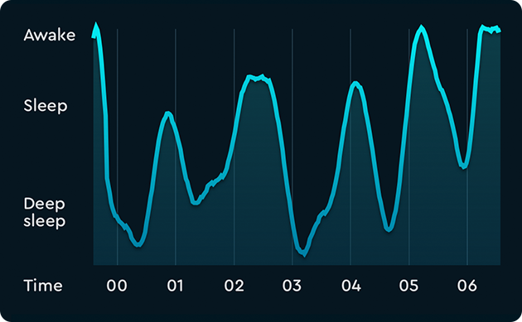
Diagram showing sleep cycle.
Factors affecting sleep
Sleep time remains fairly stable from day to day even under widely varying conditions and is only modestly affected by variations in activity and sensory stimulation. However, the factors which minimize sensory stimulation and favour the onset of natural sleep are:
- Darkened room
- Comfortable surrounding temperature
- Silence
- Physical and mental relaxation
- Consumption of a basic urge, such as hunger or sex and
- Low-frequency stimulation, such as by patting or knocking in a cradle or sitting in a moving vehicle.
The above described factors have only a modest effect if any. The only behavioural factor that reliably and substantially increases sleep is prior sleeplessness. On the other hand, anxiety and emotional stimuli by release of epinephrine cause activation of RAS and make sleep more difficult.

TYPES AND STAGES OF SLEEP
Sleep is of two types:
- non-REM sleep
- REM sleep
They which alternate in a sleep cycle.
Non-REM sleep
Non-REM sleep, i.e. non-rapid eye movement sleep is also known as slow wave sleep (SWS), because in this type of sleep brain waves are very slow. In normal adults, sleep mostly begins with non-REM sleep. It is rest type of sleep which a person experiences during first hour of sleep after having been kept awake for many hours. The non-REM sleep alternates with REM sleep during the sleep cycle.
The non-REM sleep is discussed under following headings:
- Stages and EEG patterns of non-REM sleep
- Physiological changes during non-REM sleep
- Behavioural changes during non-REM sleep
- Intellectual changes during non-REM sleep.

Stages and EEG patterns of non-REM sleep
Stage of wakefulness.
As described above, the state of wakefulness and consciousness results due to stimulatory impulses from RAS to cerebral cortex. EEG pattern during wakefulness is characterized by asynchronous and low-amplitude brain waves called β waves (Fig. 10.11-9A). State of quiet, awake rest with eyes closed. State of quiet, awake rest with eyes closed is the period in between the stage of wakefulness and stage of sleep. EEG pattern during quiet awake resting stage, as described earlier (page 861), is characterized by α waves which are highly synchronized, large waves having a frequency of 8–13 cycles/s.
State of non-REM sleep. When an individual from the state of quiet rest with eyes closed enters the state of non-REM sleep the consciousness is reduced. The non-REM sleep also known as slow-wave sleep progresses in an orderly way from light to deep sleep in four stages as:
- Stage 1 of non-REM sleep (stage of very light sleep). EEG pattern in this stage is characterized by low amplitude mixed frequency activity (Fig. 10.11-9C). There is still considerable sensitivity to sensory stimuli. However, the mild to moderate stimuli are often unable to produce a full arousal.
- Stage 2 of non-REM sleep, also called stage of light sleep, is characterized by the appearance of sleep spindles. These are bursts of α-like 10–14 Hz, 50 μV waves, which periodically interrupt the α rhythm (Fig. 10.11-9D).
_ Auditory stimuli during this phase readily evoke the K-complexes in the EEG. They also occur spontaneously during this stage. The K-complex consists of one or two high-voltage waves followed by a brief 14 Hz activity (Fig. 10.11-9D).
- Stage 3 of non-REM sleep or stage of moderate deep sleep in characterized by an EEG that display high amplitude slow (0.5–2 Hz) waves called δ waves (Fig. 10.11-9E).
- Stage 4 of non-REM sleep or stage of deep sleep produces EEG pattern dome-like very slow, large waves called δ waves (Fig. 10.11-9F). Thus, the characteristic of deep sleep is a pattern of rhythmic slow waves, indicating marked synchronization.

Physiological changes during non-REM sleep
- Muscle tone decreases progressively.
- Heart rate and blood pressure are decreased.
- Respiration rate is also decreased.
- Eyes begin slow, rolling movement until they finally stop in stage 4 (deep sleep) with eyes turned upwards.
- Body metabolism is lowered.
- Pituitary shows pulsatile release of growth hormone and gonadotropin.
Behavioural changes during non-REM sleep
Behaviourally, the non-REM sleep is characterized by:
- Progressive reduction in consciousness.
- An increasing resistance to being awakened, it is more difficult to wake up a person from stage 3 and 4 than from stage 1 and 2 of non-REM sleep.
- It is more difficult to wake up a young person than elderly from sleep because elderly person spends very little time in stage 3 and 4 of non-REM stage.
- When awaken person does not report dreaming.
- There is some response to meaningful stimuli even in sleep, which indicates that sensory processing continues at some level after the onset of sleep. This is apparent from the discriminate responses during sleep to meaningful versus non-meaningful stimuli. Examples of discriminate responses are:
_ Lower arousal threshold for one’s own name versus someone else’s name
– A sleeping mother is more likely to hear her own baby’s cry than the cry of an unrelated infant.
– A captain wakes up to the cry of ‘iceberg’ in the midst of the din and bustle of a ship.
Intellectual functions during non-REM sleep
- Thoughts become illogical and incoherent towards the onset of sleep.
- Retrograde amnesia occurs during transition from wakefulness to sleep. This is because sleep inactivates the consolidation of short-term into long-term memory.
Examples of retrograde amnesia include:
– Inability to grasp the instant of sleep onset in memory,
– Not remembering the ringing of alarm clock

REM sleep
REM sleep, i.e. ‘rapid eye movement’ sleep is also called ‘fast wave (desynchronized) sleep, or ‘paradoxical sleep’ or ‘dream sleep’ or ‘deepest sleep’ (as explained below). In adults, the REM sleep follows non-REM sleep, while in adults entry into sleep occurs via REM sleep.
EEG pattern of REM sleep
During REM sleep, EEG is characterized by a high-frequency and low-amplitude pattern (β rhythm), i.e. some desynchronized pattern that is seen in the waking state (Fig. 10.11-9G). Hence REM sleep is also called ‘fast wave sleep’ or ‘desynchronized sleep’. However, the individual clearly is unresponsive to environment stimuli and thus is asleep. Further, it is usually more difficult to awake in REM sleep than in non-REM sleep. Because of EEG pattern of wakefulness, the REM is also called ‘paradoxical sleep’. In cats, REM sleep is also associated with ponto-geniculooccipital (PGO) waves. The PGO waves are not detectablein humans by scalp EEG, but are recordable by depth EEG recordings. These waves originate in pons and pass rapidly to lateral geniculate body and then to cerebral cortex and hence the name PGO. These waves activate the reticular inhibiting area in the medulla producing hypotonia.
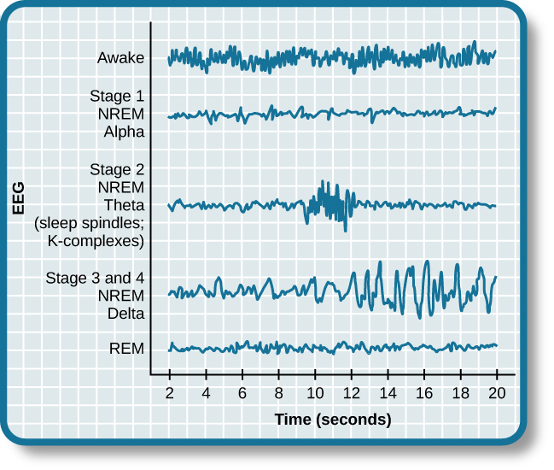
Diagram showing brainwave activity changes dramatically across the different stages of sleep.
Behavioural changes during REM sleep
Arousal.
As mentioned above, it is difficult to arouse an individual from REM sleep as it is from deep sleep. However, when awakened from REM sleep, the individual is immediately alert and aware of the environment. Dreaming occurs during REM sleep, so it is also called ‘dream sleep’. There is vivid dream recall from approximately 80% of arousals from REM sleep.
Physiological changes during REM sleep
- Rapid eye movements are the hallmark of this state of sleep and that is why the name REM sleep. Rapid eye movements (saccadic eye movements) are bursts of small jerky movements that bring the eye from one fixation point to another to allow a sweeping of visual images of dreams.
- Heart rate and respiration rate become irregular
- Muscle tone is reduced due to inhibition of spinal motor neurons via brain stem mechanisms. Snoring during sleep results from partial obstruction of airways caused by relaxed tongue (due to muscular atonia) in supine position.
- Twitching of limb musculature occurs occasionally. Because muscle tone is reduced tremendously during REM sleep, frequency and intensity of muscle twitching do not produce injuries or awaken the individual.
- Middle ear muscles are also active during REM sleep.
- Penile erection in males and engorgement of clitoris in females may occur during REM sleep.
- Impaired thermoregulation. Sweating or shivering during sleep in response to ambient temperature occurs in non-REM sleep and ceases in REM sleep.
- Teeth grinding (bruxism) may be seen in children.

SLEEP CYCLE
In a normal adult individual, the average sleep period of about 7–8 h is divided into about 5 cycles during which non-REM sleep and REM sleep alternate with each other. There is an orderly progression of sleep states and stages during a typical sleep cycle.
Duration of sleep cycles and sleep stages
The average duration of each sleep cycle is about 90 min (range 70–120 min). Duration of different sleep stages are different in different cycles:
- Duration of non-REM sleep which is about 85 min (out of total 90 min) in first cycle decreases progressively in the next sleep cycles.
- About 25% of entire sleep period is passed in REM sleep.
- Duration of REM sleep, which is about 5 min (out of total 90 min) in first cycle increases progressively in the next cycle.
- Duration of deeper stages (3 and 4) of non-REM sleep is maximum during first cycle and then decreases progressively and may even disappear altogether from the later cycles.
- Duration of second stage of non-REM sleep increases progressively from first cycle onwards and may even occupy most of the non-REM portion of the later cycles.
About 50% of the entire sleep period is spent in second stage of non-REM sleep.
- As morning approaches, the individual may be periodically awaken during later sleep cycles.
- The approximate duration (%) of different stages of sleep during first cycle and during the entire sleep
Variations in sleep cycles
Variations in sleep cycle, from the typical adult pattern depicted in Fig. 10.11-10, occur under certain circumstances. In adults, onset of sleep with REM sleep occurs under special circumstances, such as in jet lag, chronic sleep deprivation, narcolepsy, acute withdrawal of REM suppressing drugs and endogenous depressions.
Variations in total sleep duration
Average sleep time per day differs according to the age:
_ During infancy: 16 h,
_ During childhood: 10 h,
_ During adulthood: 7–8 h and
_ During old age: <8 h.
Genesis of REM sleep
Rapid eye movement sleep is generated by the interaction of neurons in the caudal mid brain and pons with the neurons in the medulla and forebrain.
REM sleep as described earlier is characterized by:
- Blockage of EEG spindles and slow waves,
- Occurrence of PGO waves,
- Muscle atonia
- Phasic motor action.
Role of cholinergic neurons of mid brain and the adjacent dorsal pons
These cells form an important component of the mid-brain arousal system and are maximally active during waking and REM sleep. Their activity contributes to the blocking of the slow waves of EEG.
Role of nucleus reticularis pontis oralis
The nucleus RPO forms another important neuronal
machinery for genesis of REM sleep. Three classes of neurons
in the RPO of particular interest are:
- Cholinergic PGO-on cells. The discharge of these neurons
produces the so-called PGO spikes that are characteristic
of REM sleep
- REM-waking-on-cells of RPO fire at high rate during active waking as well as during REM sleep. Some of these cells project to the motor neurons in the spinal cord and others project to the motor neurons that drive the extraocular muscles.
_ Burst firing of REM-waking-on cells during REM sleep produces rapid eye movements and muscle twitches.
3. REM-on-cells. REM-on-cells of RPO show high level of activity during REM sleep but have a very little or no activity during waking and non-REM sleep.
Although few in number, these cells play a key role in REM
sleep.
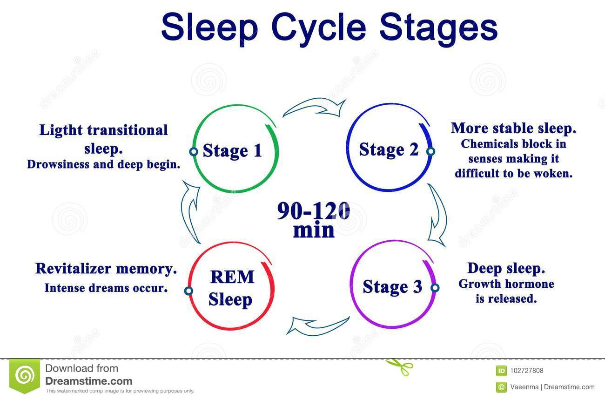
Chemical mediators of sleep
Neurotransmitters employed by the neurons forming the neural substrate of sleep as discussed above include:
- Serotonin,
- Acetylcholine
- Noradrenaline.
The substances that have been identified by an experiment on sleep-deprived animals as sleep-producing substances (S/S) are:
- Muramyl dipeptide ;a chemical related to substances found in the bacterial cell walls,
- Interleukin-1, a cytokine that may mediate the effects of muramyl dipeptides as well as immune response
- Adenosine
- Delta sleep-inducing peptide, a substance isolated from the blood of sleeping rabbits,
- Prostaglandin D2 and
- Arginine vasotoxin.
PHYSIOLOGICAL SIGNIFICANCE OF SLEEP
Sleep is an indispensable phenomenon. Its physiological significance is highlighted.
- Sleep may serve as a period of body’s rest and metabolic restoration as evidenced by following physiological changes during non-REM sleep:
_ Pulsatile release of growth hormone and gonadotropins from the pituitary and
_ Decrease in blood pressure, heart rate and respiration.
- Sleep is necessary for certain forms of learning. In experimental animals, learning sessions do not improve performance until a period of SWS or SWS plus REM sleep has occurred. However, it is not known why sleep is necessary and there is as yet no clinical correlate to this experimental observation.
- REM sleep is necessary for mental well-being. The correlation between dreaming and REM sleep indicates that the brain is highly active at this time. This may allow for the expression, through dreams, of concern in the subconscious and for long-term chemical and structural changes that brain must undergo to make learning and memory possible.
- REM sleep plays an important role in homeostatic mechanism. It is evident from the observation that when the experimental animals are completely deprived of REM sleep for long periods, they loose weight in spite of increased caloric intake and finally die.

SLEEP DISORDERS

- Insomnia refers to an inability to have sufficient or restful sleep despite an adequate opportunity for sleep. It is a subjective problem that occurs at one time or another in almost all adults. Insomnia can be relieved temporarily by sleeping pills, especially benzodiazepines. Prolonged use of these drugs can be habit-forming and can compromise day time performance.
- Fatal familial insomnia is a serious disorder characterized by worsening insomnia, impaired autonomic and motor functions, dementia and eventually death. It is a progressive disease that occurs in both an inherited and a sporadic form.
- Narcolepsy refers to an irresistible urge to sleep. As mentioned in the sleep cycle, in adults the sleep onset occurswith non-REM sleep, which is followed by REM sleep. However, in narcolepsy, REM sleep is entered directly from the waking states.

QUESTION 2

INTRODUCTION
According to anatomic definition, basal ganglia are subcortical nuclear masses which include corpus striatum (amygdaloid body, and claustrum). They are so named, as they develop in the basal part of cerebral hemisphere. However from the physiological viewpoint, the term basal ganglia
include:
- corpus striatum,
- subthalamic nucleus (body of Luys) and
- substantia nigra
Structure
The basal ganglia are a cluster of subcortical nuclei deep to cerebral hemispheres. The largest component of the basal ganglia is the corpus striatum which contains the caudate and lenticular nuclei (the putamen, globus pallidus externus, and internus), the subthalamic nucleus (STN), and the substantia nigra (SN). These structures intricately synapse onto one another to promote or antagonize movement.[2]
Divisions of the Basal Ganglia ie subcortical nuclei.
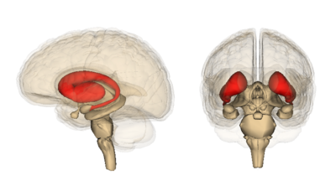
Corpus Striatum- (The largest subcortical brain structure of the basal ganglia is the striatum with a volume of approximately 10 cm). It is a heterogeneous structure that receives afferents from several cortical and subcortical structures and projects to various basal ganglia nuclei.[1] Within the striatum, there are two main divisions
- Dorsal striatum (DS) see image, shown in red. Primarily involved in control over conscious motor movements and executive functions. The dorsal striatum consists of the caudate nucleus and the putamen. A white matter, nerve tract (the internal capsule) in the dorsal striatum separates the caudate nucleus and the putamen.
- Ventral striatum, responsible for limbic functions of reward and aversion. Consists of nucleus accumbens and the olfactory tubercle.
Internal and External segments of Globus Pallidus (NB until the first half of the 19th century the globus pallidus and putamen were considered one structure, collectively referred to as the lentiform or lenticular nucleus)
Subthalamic Nucleus (STN) - a lens-shaped cell group that makes up the largest part of the subthalamus
Substantia Nigra (SN) - (“black substance” in Latin) is a long nucleus located in the midbrain but considered functionally a part of the basal ganglia because of its reciprocal connections with other brainstem nuclei. It consists of two components, the pars compacta and the pars reticulata, which have different connections and use different neurotransmitters.

Role of basal ganglia in movement
Basal ganglia control the voluntary movement which are initiated by the motor cortex. Role of basal ganglia in control of voluntary motor activity includes:
- Cognitive control of motor activity
- Timing and scaling of intensity of movement
- Subconscious execution of some movement.
Cognitive control of motor activity
Physiological studies have shown that neural discharge in basal ganglia ,like cerebellum, begins well before the movement begin. Thereforeit is believed that basal ganglia , like cerebellum are involved in the planning and programming of the movement. Most of the motor actions occur as a consequences of thoughts generated in mind. This process is known as COGNITIVE CONTROL OF MOTOR ACTIVITY.
Pathway
The cognitive control of motor activity is executed by the basal ganglia through the feedback loops(functional neuronal circuit). As described above , the caudate loop is primarily involved in the cognitive control of motor activity.
Timing and scaling of the intensity of movement
Two important capabilities of brain in controlling the movement are:
- Timing of the movement i.e how rapidly the movement should be performed and
- Scaling of the intensity of movements, i.e. how large the
movement should be. In higher animals, the basal ganglia act as an important co-ordinating centre of extrapyramidal system. In the absence of basal ganglia, the timing and scaling function becomes very poor
Subconscious execution of some movements.
Basal ganglia subconsciously execute some movements during the performance of trained motor activities, i.e. skilled activities. Examples of movements executed sub-consciously at the level of basal ganglia are:
- Swinging of arm while walking,
- Crude movement of facial expression that accompany emotions,
- Movements of limbs while swimming.
Control of clutch and brake while driving (constant attention is required during initial stages; however, they are carried out subconsciously by basal ganglia as they become routine).
Importance.
By subconscious control of activities, the basal ganglia relieve cortex from routine acts so that cortex can be free to plan its actions.

Control of reflex muscular activity
The basal ganglia exert inhibitory effect on spinal reflexes and regulate activity of muscles which maintain posture. Visual and labyrinthine reflexes are important in the maintenance of posture. The co-ordination and integration of impulses for these activities depend upon basal ganglia

Control of muscle tone
Muscle spindles and the gamma motor neurons of spinal cord (which are responsible for maintaining the tone of the muscles) are controlled by basal ganglia, especially substantia nigra.
Pathway includes projection from cortical inhibitory areastriatum- pallidum-substantia nigra-reticular formationspinal cord.
Proof. In lesion of basal ganglia muscle tone increases. Rigidity (lead-pipe type) is a characteristic feature of Parkinson’s disease
DISORDERS OF BASAL GANGLIA
PARKINSON’S DISEASE
Parkinson’s disease, also called paralysis agitans or shaking palsy, was first described by James Parkinson in 1817.
Aetiopathogenesis
Primary idiopathic condition. Parkinson’s disease occurs in elderly people due to idiopathic degeneration of nigrostriatal system of dopaminergic neurons. There is a steady loss of dopamine and dopamine receptors with age in the basal ganglia in normal individuals; however, it is markedly precipitated in individuals developing Parkinson’s disease. Secondary causes. In addition to the primary idiopathic degeneration of substantia nigra, features similar to Parkinson’s disease can occur in some other conditions. The term Parkinsonism nigra is used to denote such a condition, which may occur due to following causes:
- Viral encephalitis,
- Cerebral arteriosclerosis,
- Complication of certain drugs (e.g. phenothiazine) which block dopamine (D2) receptor
- Experimentally, parkinsonism can be produced acutely by injection of the drug MPTP (methyl-phenyltetrahydro- pyridine).

Pathogenesis.
A current view of the pathogenesis of Parkinson’s disease is that there is an imbalance between excitation and inhibition in the basal ganglia created by the loss of the dopaminergic inhibition of the putamen (Fig. 10.2-15). The resulting increase in inhibitory output to the external segment of the globus pallidus decreases inhibitory output from the subthalamic nucleus, and this increases the excitatory output from this nucleus to the internal segment of globus pallidus. This in turn increases the inhibitory output from this segment to the thalamus, causing a reduction in excitatory drive to the cerebral cortex.
Clinical features
Parkinson’s disease has both hypokinetic and hyperkinetic features. Its cardinal features are a triad of akinesia, rigidity and tremor; of which akinesia is a hypokinetic feature while rigidity and tremors are hyperkinetic features.

