SHINKU WILLIAMS
19/ENG05/059
MECHATRONICS
Question 1
Using the concept of Newton’s second of motion, describe the magnitude and direction of the acceleration of an electron being shot horizontally into a closed space with a uniform field being directed upward.
Answer

Since the electron is negatively charged, and unlike charges attracts so that it will move to the direction of the positive terminal of the electric field.
Therefore, the electron will be acted upon by a force that will be directed opposite to the electric field i.e. force is downward direction
For Newton 2nd law, force =Mass x Acceleration
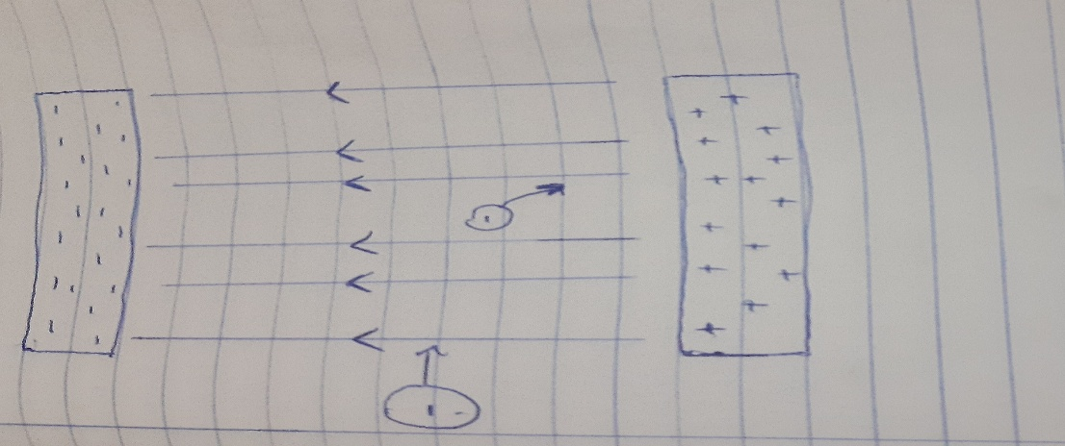
F=q . E f=m x a F=eE F=ma

eE=ma a=e x E/m Since the electric field is uniform, therefore the magnitude and direction of the electric field will be constant. The force will be constant and the magnitude of the acceleration will be constant while the direction of acceleration will be in the opposite direction as shown above.

Question 2
Describe electric field, magnetic field and electric current with respect to charges Electric field
An electric filed is said to exist at a point in space if a charged particle placed at that point experiences a force that would not be felt by an uncharged particle. A charged particle creates an electric field. The field acts on another charged object to produce a force.
The direction of the field is taken to be the direction of the force it would exert on a positive test charge. The electric field is radially outward from a positive charge and radially in toward a negative point charge
Magnetic field
A charge that is moving in a magnetic field experiences a force perpendicular to its own velocity and to the magnetic field. Magnetic fields are produced by moving electric charges and intrinsic magnetic moments of elementary particles. A stationary charged particle does not interact with a static magnetic field. A charge placed in a magnetic field experiences a magnetic force., the charge must be moving, for no magnetic force acts on a stationary charge and must have the same quality and quantity as the field it originally left.
Electric current
An electric current is a stream of charged particles such as electrons or ions moving through an electrical conductor or space.
If a neutral object loses electrons, it becomes more positively charged. If a neutral object gains electrons or charges, it becomes negatively charged. Current is the rate of flow of electron charges. Current can be caused by the flow of electron, ions.

