Assignment Title: Assignment 1
Course Title: Basic Electrical Engineering I
Course Code: ENG 221

Question 1
Using the concept of Newton’s second law of motion, describe the magnitude and direction of the acceleration of an electron being shot horizontally into a closed space with a uniform field being directed upward.
Answer:
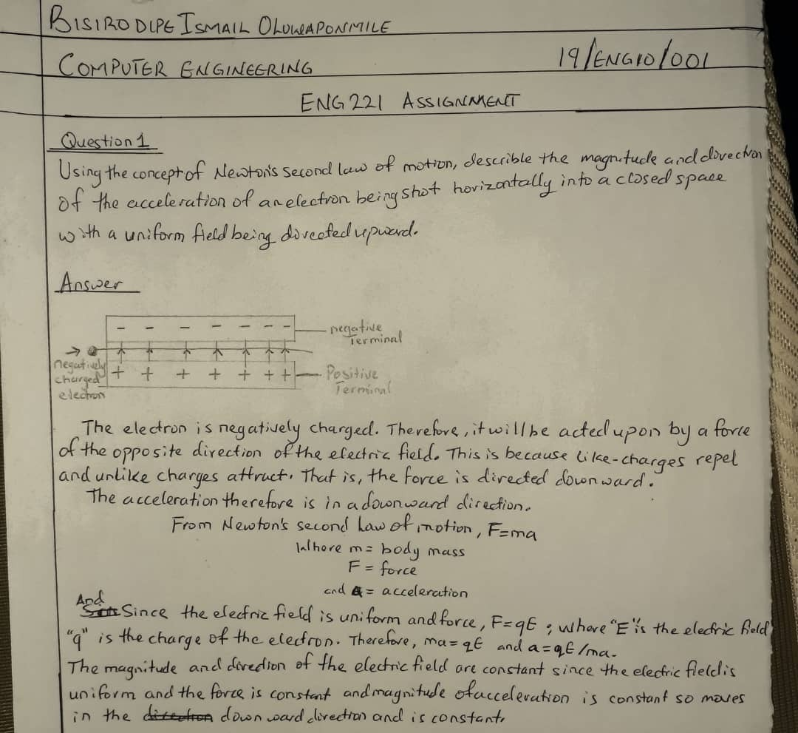

Question 2:
Describe electric field, magnetic field and electric current with respect to charges

ANSWERS

ELECTRIC FIELD:
Electric field is defined as the electric force per unit charge or a region around a charge particle within a force would be exerted on other charged particles or objects.

“E=F/q”

The direction of the field is taken to be the direction of the force it would exert on a positive test charges. The electric field goes the opposite direction if the charge is negative. Therefore, the electric field is radially outward from a positive charge and radially in toward a negative point charge.

MAGNETIC FIELD:
A magnetic field is a vector field that describes the magnetic influence on moving electric charges. A charge that is moving in a magnetic field experiences a force perpendicular to its own velocity and to the magnetic field. Electric current flowing through a long straight wire is a simple example of magnetic field.

F= q[E + (v×B)]
Where:
q= charge
E= Electric field
V= velocity
B= magnetic field.

ELECTRIC CURRENT:
Electric current is a stream of charged particles, such as electrons moving through space or an electric conductor. It is measured as the net rate flow of electric charge past a region.
I=V/R ; I=Q/t

