NAME: Opoola Daniel Oluwaseyi
MATRIC NO: 19/ENG/056
DEPT: MECHATRONICS
ENG 221

1. 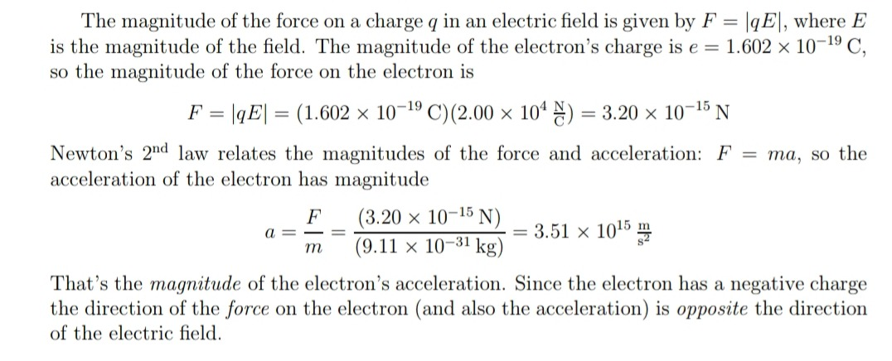

2.
a) An electric field (sometimes E-field]) is the physical field that surrounds each electric charge and exerts force on all other charges in the field, either attracting or repelling them. Electric fields originate from electric charges, or from time-varying magnetic fields. Electric fields and magnetic fields are both manifestations of the electromagnetic force, one of the four fundamental forces (or interactions) of nature.
F / q
Electric fields are important in many areas of physics, and are exploited practically in electrical technology. In atomic physics and chemistry, for instance, the electric field is used to model the attractive force holding the atomic nucleus and electrons together in atoms. It also models the forces in chemical bonding between atoms that result in molecules.
The electric field is defined mathematically as a vector field that associates to each point in space the (electrostatic or Coulomb) force per unit of charge exerted on an infinitesimal positive test charge at rest at that point. The derived SI units for the electric field are volts per meter (V/m), exactly equivalent to newtons per coulomb (N/C).

b) A magnetic field is a vector field that describes the magnetic influence on moving electric charges, electric currents, and magnetized materials. A charge that is moving in a magnetic field experiences a force perpendicular to its own velocity and to the magnetic field. The effects of magnetic fields are commonly seen in permanent magnets, which pull on magnetic materials such as iron, and attract or repel other magnets. In addition, a magnetic field that varies with location will exert a force on a range of non-magnetic materials by affecting the motion of their outer atomic electrons. Magnetic fields surround magnetized materials, and are created by electric currents such as those used in electromagnets, and by electric fields varying in time.

The force on an electric charge depends on its location, speed and direction; two vector fields are used to describe this force. The first is the electric field, which describes the force acting on a stationary charge and gives the component of the force that is independent of motion. The magnetic field, in contrast, describes the component of the force that is proportional to both the speed and direction of charged particles. The field is defined by the Lorentz force law and is, at each instant, perpendicular to both the motion of the charge and the force it experiences.

c) An electric current is a stream of charged particles, such as electrons or ions, moving through an electrical conductor or space. It is measured as the net rate of flow of electric charge past a region. The moving particles are called charge carriers, which may be one of several types of particles, depending on the conductor. In electric circuits the charge carriers are often electrons moving through a wire. In semiconductors they can be electrons or holes. In an electrolyte the charge carriers are ions, while in plasma, an ionized gas, electric current is formed by both electrons and ions.
The SI unit of electric current is the ampere, or amp, which is the flow of electric charge across a surface at the rate of one coulomb per second. The ampere (symbol: A) is an SI base unit. Electric current is measured using a device called an ammeter.

