NAME: Aina Oluwasemilore Emmanuel
MATRIC NO: 17/ENG04/005
DEPARTMENT: ELECT/ELECT ENGINEERING
COURSE: EEE471
1. Signal processing techniques
I. Time Domain: Time domain refers to the analysis of mathematical functions, physical signals or time series of economic or environmental data, with respect to time. In the time domain, the signal or function's value is known for all real numbers, for the case of continuous time, or at various separate instants in the case of discrete time. An oscilloscope is a tool commonly used to visualize real-world signals in the time domain. A time-domain graph shows how a signal changes with time, whereas a frequency-domain graph shows how much of the signal lies within each given frequency band over a range of frequencies.
II. Frequency Domain: The frequency domain refers to the analysis of mathematical functions or signals with respect to frequency, rather than time.[1] Put simply, a time-domain graph shows how a signal changes over time, whereas a frequency-domain graph shows how much of the signal lies within each given frequency band over a range of frequencies. A frequency-domain representation can also include information on the phase shift that must be applied to each sinusoid in order to be able to recombine the frequency components to recover the original time signal.
III. Complex Frequency Domain (s-plane): the s-plane is the complex plane on which Laplace transforms are graphed. It is a mathematical domain where, instead of viewing processes in the time domain modeled with time-based functions, they are viewed as equations in the frequency domain. It is used as a graphical analysis tool in engineering and physics.
A real function f in time t is translated into the s-plane by taking the integral of the function multiplied by e^{-st}from 0 to ♾ where s is a complex number with the form s=sigma +i*omega.
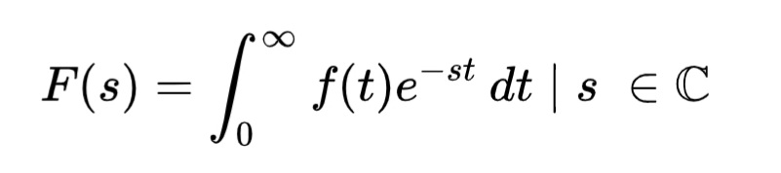
This transformation from the t-domain into the s-domain is known as a Laplace transform and the function F(s) is called the Laplace transform of f. One way to understand what this equation is doing is to remember how Fourier analysis works. In Fourier analysis, harmonic sine and cosine waves are multiplied into the signal, and the resultant integration provides indication of a signal present at that frequency (i.e. the signal's energy at a point in the frequency domain). The Laplace transform does the same thing, but more generally. The e^{-st} not only captures the frequency response via its imaginary e^{-i\omega t} component, but also decay effects via its real e^{-\sigma t} component. For instance, a damped sine wave can be modeled correctly using Laplace transforms.
A function in the s-plane can be translated back into a function of time using the inverse Laplace transform
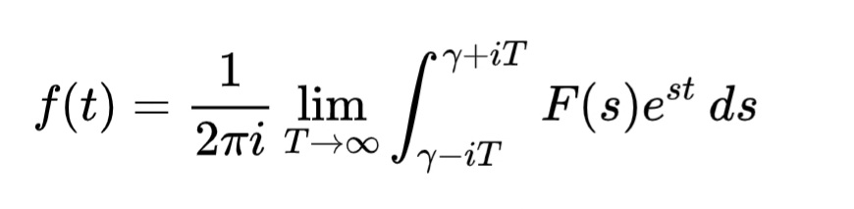
where the real number gamma is chosen so the integration path is within the region of convergence F(s). However rather than use this complicated integral, most functions of interest are translated using tables of Laplace transform pairs, and the Cauchy residue theorem.
Analysing the complex roots of an s-plane equation and plotting them on an Argand diagram can reveal information about the frequency response and stability of a real time system. This process is called root locus analysis.
2. Expert System Instrumentation: An expert system is a computer system emulating the decision-making ability of a human expert. Expert systems are designed to solve complex problems by reasoning through bodies of knowledge, represented mainly as if–then rules rather than through conventional procedural code.The first expert systems were created in the 1970s and then proliferated in the 1980s. Expert systems were among the first truly successful forms of artificial intelligence (AI) software. An expert system is divided into two subsystems: the inference engine and the knowledge base. The knowledge base represents facts and rules. The inference engine applies the rules to the known facts to deduce new facts. Inference engines can also include explanation and debugging abilities.

