1
Signal Processing and interfacing Techniques
Signal processing involves techniques that improve our understanding of information contained in received data. Normally, when a signal is measured with an oscilloscope, it is viewed in the time domain (vertical axis is amplitude or voltage and the horizontal axis is time). For many signals, this is the most logical and intuitive way to view them. Simple signal processing often involves the use of gates to isolate the signal of interest or frequency filters to smooth or reject unwanted frequencies.
When the frequency content of the signal is of interest, it makes sense to view the signal graph in the frequency domain. In the frequency domain, the vertical axis is still voltage but the horizontal axis is frequency.
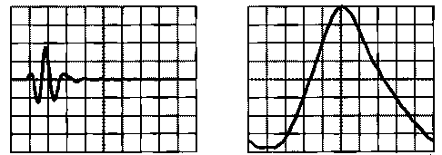
-----------Time Domain --------------------Frequency Domain (Magnitude)
The frequency domain display shows how much of the signal's energy is present as a function of frequency. For a simple signal such as a sine wave, the frequency domain representation does not usually show us much additional information. However, with more complex signals, such as the response of a broad bandwidth transducer, the frequency domain gives a more useful view of the signal.
Interfacing can be defined as transferring data between measurement devices and interfacing peripherals such as sensors, keypads, microprocessors, analog to digital converters or ADC, LCD displays, motors, external memories, even with other measurement devices, some other interfacing peripheral devices and so on or input.

2
An expert system is a computer program that uses artificial intelligence (AI) technologies to simulate the judgment and behavior of a human or an organization that has expert knowledge and experience in a particular field.
Typically, an expert system incorporates a knowledge base containing accumulated experience and an inference or rules engine -- a set of rules for applying the knowledge base to each particular situation that is described to the program. The system's capabilities can be enhanced with additions to the knowledge base or to the set of rules. Current systems may include machine learning capabilities that allow them to improve their performance based on experience, just as humans do.

