NAME: ADAMU ABDULQUDDUS

MATRIC NO: 17/ENG02/004
DEPT: COMPUTER ENGINEERING

EEE471

- Explain briefly the Signal processing and interfacing techniques in measuring instruments

Signal processing is an electrical engineering subfield that focuses on analysing, modifying, and synthesizing signals such as sound, images, and scientific measurements.
CATEGORIES OF SIGNAL PROCESSING
- ANALOG.
- CONTINOUS AND DISCRETE TIME.
- DIGITAL.
- NON LINEAR.
An interface electronics or read out is a detection electronic circuit, which is designed and realized according to the type and the output of a primary sensing element. Sensors and the detection electronics are the most important parts of a measurement system. Performance of a measurement system is generally specified by;
- Accuracy
- Repeatability
- Sensitivity
- Resolution
- Linearity
- Response and recovery times
- Hysteresis
The functional units of a sensor are based on measurement system in general, and can be represented by the following block diagram.
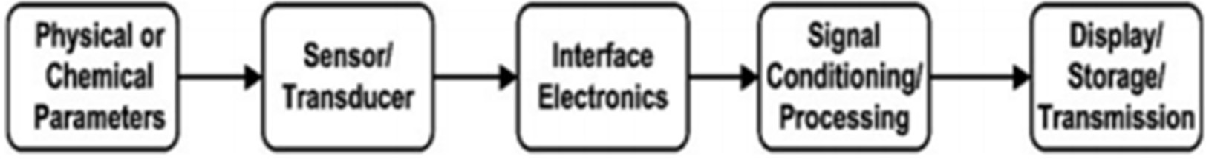

A general block diagram of a measurement system

The primary sensor/the transducer senses the presence of the desired physical or chemical parameter to be measured but the output of the sensor may or may not be in a suitable form for further processing. The sensor may be either the resistive or the inductive or the capacitive type. Most often, the desirable output of the electronic circuit is to be in the form of voltage, current or frequency (time period). However, the digital output of the sensor is desirable for easy interfacing, noise immunity, storing and communication with a digital system. The parameters of the sensor can be measured by a LCR meter
(An LCR meter is a type of electronic test equipment used to measure the inductance (L), capacitance (C), and resistance (R) of an electronic component), but for a low cost electronic test system, the interface electronic circuit is needed.
The interface circuit provides an easy manipulation and the conditioning of the electrical signal such as amplification, filtration, minimization of loading effects, etc. When, the sensor is remotely placed to monitor the measurand, it is necessary to transmit data.
Finally, the data should be represented in the form, which can be easily displayed either in analogous form or digital form, then recorded and stored. The signal conditioning unit is another important unit in the measurement system.

2. Explain briefly the expert system instrumentation

An EXPERT SYSTEM is an interactive and reliable computer-based decision-making system which uses both facts and heuristics to solve complex decision-making problems. It is considered at the highest level of human intelligence and expertise. The purpose of an expert system is to solve the most complex issues in a specific domain. An expert system is also a knowledge-based system that employs knowledge about its application domain and uses an inferencing (reason) procedure to solve problems that would otherwise require human competence or expertise.

An important thing to keep in mind when selecting ES tools is that, the tool selected for the project has to match the capability and sophistication of the projected ES, in particular, the need to integrate it with other subsystems such as databases and other components of a larger information system.

Components of Expert Systems

- Knowledge Base: Knowledge is required to exhibit intelligence. The success of any ES majorly depends upon the collection of highly accurate and precise knowledge

- Inference Engine: Use of efficient procedures and rules by the Inference Engine is essential in deducting a correct, flawless solution. In case of knowledge-based ES, the Inference Engine acquires and manipulates the knowledge from the knowledge base to arrive at a particular solution.

- User Interface: User interface provides interaction between user of the ES and the ES itself. It is generally Natural Language Processing so as to be used by the user who is well-versed in the task domain. The user of the ES need not be necessarily an expert in Artificial Intelligence.

PROCESS OF ES DEVELOPMENT AND MAINTENANCE

    - Problem Identification and Feasibility
    - Analysis
    - System Design and ES Technology
    - Identification
    - Development of Prototype
    - Testing and Refinement of Prototype
    - Complete and Field the ES
    - Maintain the System

ORGANIZATIONAL BENEFITS OF EXPERT SYSTEMS

- An Es can complete its part of the tasks much faster than a human expert.
- The error rate of successful systems is low, sometimes much lower than the human error rate for the same task.
- ESs make consistent recommendations
- ESs are a convenient vehicle for bringing to the point of application difficult-to- use sources of knowledge.

