ASSIGNMENT

COURSE CODE: CVE 505
COURSE TITLE: WATER RESOURCES ENGINEERING

PREPARED BY
JASPER VICTORY UGOCHI
(16/ENG03/033)

SUBMITTED TO
ENGR. ADEBANJO

THE DEPARTMENT OF CIVIL ENGINEERING
AFE BABALOLA UIVERSITY, ADO-EKITI,
EKITI STATE

DATE: 18/01/2021

- How a productive borehole can be sited and developed in fractured basement complex regions:-
Groundwater occurs in the weathered basement and in jointed/fractured/sheared/faulted basement columns. The weathered basement aquifer is porous but usually of low permeability because of its clayey nature while the storage capacity could be significantly high due to relatively high porosity.
The secondary porosities arising from fractures create significantly large storage capacity in fractured basement aquifers. The connectivity of these geological features enhances the groundwater yielding capacity of the fractured basement aquifers. Where both the weathered and fractured basement aquifers exist, the groundwater yield is high. Aquifers (weathered and fractured basement) in the basement complex environment are discontinuous and most times limited in lateral and depth extent. Abortive and productive boreholes could be drilled within the same premises when such abortive boreholes are not properly cited to exploit existing aquifers.
The electrical resistivity method involving 1D Vertical Electrical Sounding (VES) is commonly used to identify aquifers in basement complex environment. At times, the VES techniques is preceded by horizontal profiling or electromagnetic profiling as a reconnaissance technique to map areas with thick weathered layer (overburden) and or discontinuities created by faults and fractured zones while the VES is adopted as a confirmatory technique.

The design of a borehole must be proceeded by well executed pre-drilling feasibility studies which most of the time rely on geophysical studies of the subsurface geology. The design of a water well depends on the type of aquifer system to be exploited and the discharge rate required (or supply demand) must be decided before a borehole can be properly designed (Anderson, 1973). It will determine the size of pump to be installed, which, in tum, will govern the minimum internal diameter (lD) of the pump-chamber casing. The cardinal rule of well design is that the ID of pump chamber must be large enough to accommodate the pump-shroud. Cable and risers. An average design will incorporate the following features: total drill depth (TDD), drilled diameter. Casing selection, screen selection, casing screening installation and gravel pack design. A rotary rig comprises of a floor on which is mounted a diesel engine power unit, a mud pump for circulating the fluid, a winch for raising or lowering the drill string and a mast from which the drill string is suspended. The drill string is made up of lengths of heavy-duty steel tubing or drill pipe, with the drill-bit assembly attached to the bottom. The drilling fluid or mud is mixed in a mud pit and is pumped by mud pump through the kelly hose to a water swivel at the top.
This swivel is the unit from which the entire drilling string is suspended and allows the mud to pass while the drill string rotates. The mud passes down the drill string to the bit which it leaves by ports in the bit faces, and then returns up the annulus around the drill string to the mud pits. The mud pit has two chambers: the first and the smaller all of cuttings to settle from the mud (settlement pit) before it passes to the second chamber which acts as a sump for the mud pump (Driscoll, 1986). The mud removes cuttings from the bit, carries the mud into the mud pits. It cleans, cools and lubricates the drill-bit and drill-strinup. It exerts a supportive mud cake on the borehole walls to prevent caving of the formation. It also retains cuttings in suspension while the drilling stops to add extra lengths of drill-pipe. The rate of penetration (ROP) is a function of lithology. It is faster in sandy formation than in clayey formation. Similarly, the colour of the mud is a reflection of the immediate drilling environment. Drilling mud appears dark in lignite formation and reddish in lateritic formation. After drilling has been completed, the drill-strings are carefully pulled out of the borehole; this is followed by casing of the borehole which consists of blind casings and screens, back-flushing and gravel-packing (British Standard). After 24hours, a compressor is used to flush the well in order to clean the borehole annulus before the installation of submersible pump.

- Disadvantages of large dam projects
- Negative impact on aquatic life: There are many harmful effects on the aquatic life. Since dams block up flowing bodies of water such as rivers, any animal that depends on the flow to reproduce or as part of their cycle are put in danger. Migratory fish that mate in completely different location than they live the rest of their lives, for instance, are unable to mate and may decline in population.
- Impact on the Waterbody: The beneficial sediment, which is usually washed down by the water, is diverted, thereby reducing the fertility of the soil downriver. Changes in flow and sediment transport downstream of a dam often have significant environmental impacts (changes in temperature, chemical composition, and shoreline stability). If the watercourse is devoid of water, so the burden of sediments is rising, it tends to recollect it by eroding the river bed, and banks, which can destroy bridges and alternate banks and river forests.
- Impact on the overall Aquatic Ecosystem: Another effect is the upstream shifts to an artificial slack-water reservoir living area from the free-flowing river ecosystem. Changes in temperature, chemical composition, dissolved element levels and therefore physical properties of a reservoir are typically not ideal for the aquatic plants and animals that evolved with a green water system. Extinction of the many fish and alternative aquatic species, huge losses of forest, the disappearance of birds in floodplains, erosion of deltas, wetland and farmland occurs.
- Impact on the groundwater table: This problem produces a lower groundwater table along the river as riverbeds are deepened. This means that it is more difficult for plant roots to obtain what is needed to survive. Homeowners in the region often have to dig deeper wells for their homes to draw water. The mineral content and salts present in the fluid can also be altered due to this problem and cause soil structures damages along the way.
- Dams can block water progression to different states, provinces, and countries: When a dam gets built at or near a border between two states, provinces, or countries, it could block water progress in one region. It means that in the neighbouring country the supply from the same river is no longer regulated directly. This drawback can lead to serious problems among neighbours, which can sometimes even lead to war.

- Effects of water pollution on the environment
Water Pollutants | General effect on the environment
Organic (biodegradable wastes) | Eutrophication is an enrichment of water by nutrient salts that causes structural changes to the ecosystem such as: increased production of algae and aquatic plants, depletion of fish species, general deterioration of water quality and other effects that reduce and preclude use; food provided for organisms lower down in food chain
Toxic chemicals (e.g. heavy metals, pesticides, phenols, PCBs) | Abundance of organic substances that give the water disagreeable odours or tastes, barely masked by chlorination in the case of drinking water. These substances, moreover, form complex chemical compounds that prevent normal purification processes and are deposited on the walls of the water purifier inlet tubes, accelerating corrosion and limiting the flow rate;
Endocrine disruptors | Alteration of ecology
Acids/alkalis | Lowering/raising of pH; Only narrow range of pH tolerable for most plants and animals; heavy metals are toxic
Suspended solids | Reduction in light penetration (increased turbidity), blanketing, introduction of colour; Photosynthesis reduced; blanketing of benthic plants and animals; obstruction of gills of fish
Immiscible liquids | Formation of a layer at the water surface that could prevent O²/CO2 interchange
Heat | Decrease in dissolved oxygen (DO); increase in metabolic rate of aquatic organisms
Taste-, odour- and colour-forming compounds | The water acquires disagreeable odours or tastes (of earth, of rotten fish, of cloves, of water plants, etc.) due to the presence of particular algae
Microorganisms | Abundance of micro-organisms (phytoplankton, zooplankton, bacteria, fungi and debris) affect the turbidity and colouration of the water; Pathogenic to humans

- Suitable Approach to decontaminate river water such as the Ureje River in Ado-Ekiti, which gets polluted daily by domestic and agricultural effluent:
Introduction of Floating wetlands into the waterbody
- Definition of Floating Wetlands:
Floating wetlands consist of a suspended matrix planted with wetland plants. This facilitates microbiological and plant processing of nutrients.
It basically operates by biological treatment. Biological treatment is possible, however, by harnessing the natural ability of plants and microbes to absorb nutrients (such as phosphorus and nitrogen) and break down contaminants through biological processes known as bioremediation.
- How Floating Treatment Wetland (FTWs) work:
FTWs are small artificial platforms allowing these new emerging aquatic plants to develop in waters usually too deep for them. Their roots spread through the floating islands and down into water, which create dense, surface-area columns of roots.
The plant not only uses nutrients and pollutants but also provides extensive surfaces to microbes through plant roots and floating Island material—forming a slimy layer of biofilm. The biofilm is where an FTW system takes the majority of nutrient uptake and degradation.
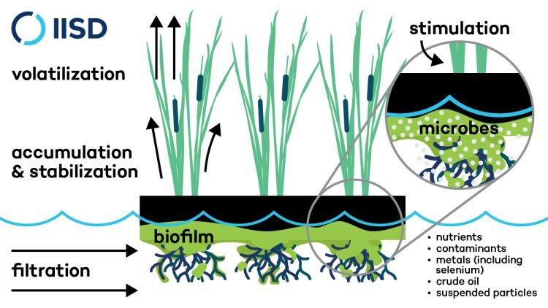
Figure 1: The processes that make the Floating Wetlands effective for cleaning water bodies

The specific creation of the ecosystem provides the ability to accumulate nutrients and turn common contaminants into harmless by-products of our lakes.
- Functions of floating wetlands:
Floating wetlands encourage settling of sediments contained in the water and also remove nutrients due to plants roots.
Plant roots are believed to play a major role in treatment processes within floating wetland systems as the water passes directly through the extensive root system hanging beneath the floating mat. The roots release enzymes, develop extensive biofilms and promote flocculation of suspended matter, at the surface of the submerged plant organs.
Other processes that may be important include plant uptake of nutrients and metals if harvested, enhancement of anoxic conditions in the water column beneath the floating mat, which promote microbial processes such as de-nitrification, and promotion of settling and binding of contaminants in the sediment pool.

