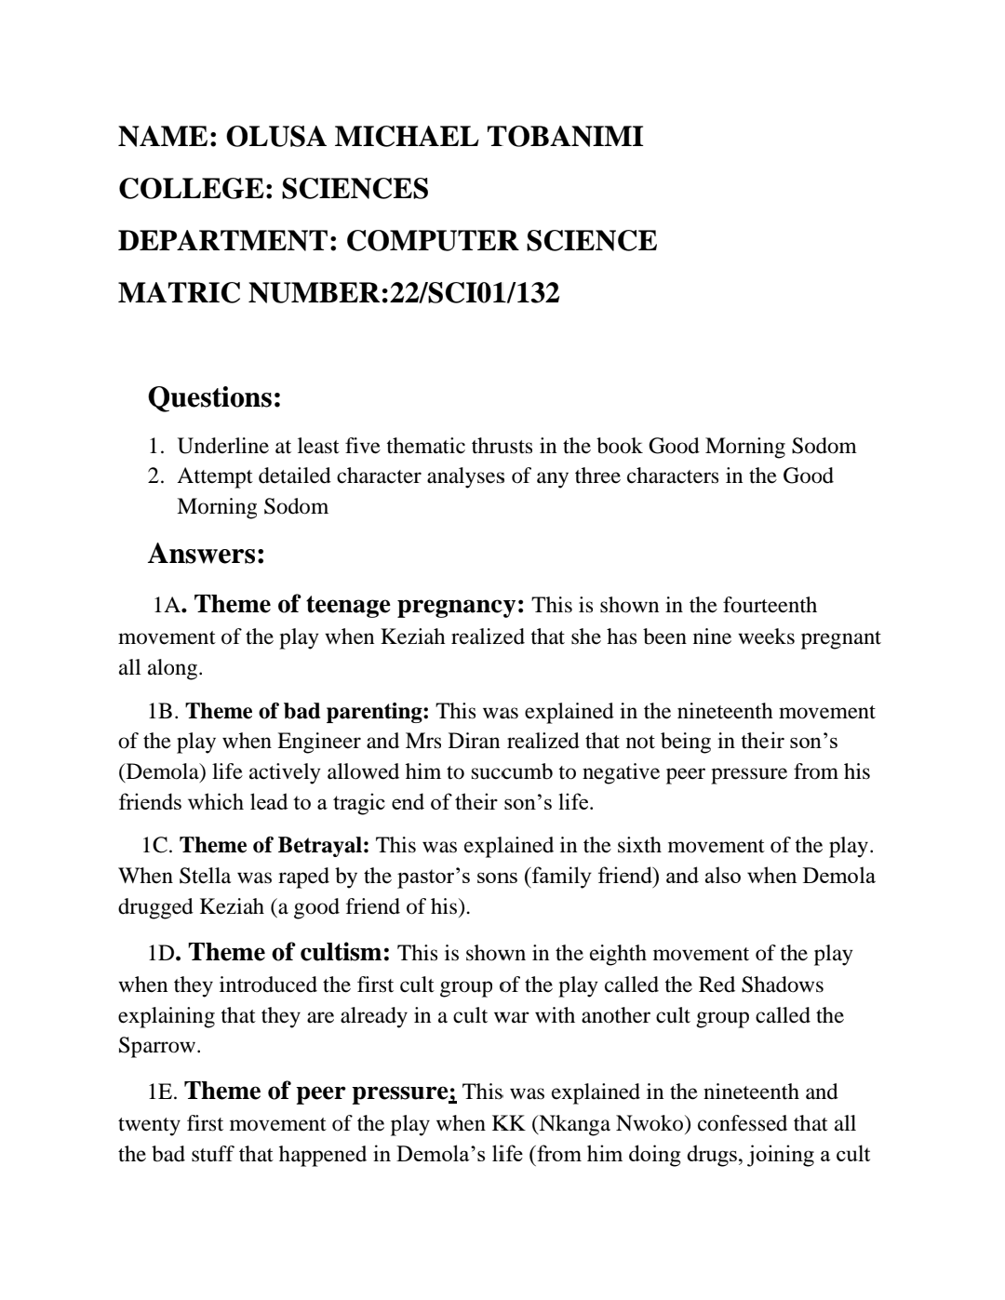

Name:OBOLO-BUBOU OBOLO

Department:POLITICAL SCIENCE

College: SOCIAL AND MANAGEMENT SCIENCE

* Magic no: 22/sms08/005

