TESTING OF DRILLING FLUIDS

Drilling fluids are said to be the “blood” of drilling operations mainly because of the functions they provide by the reason of their properties. It is essential that these properties be monitored to (i)detect deterioration and identify need for treatment (ii) to improve on drilling fluids design base on changing drilling conditions. Frequent tests are carried out by the mud engineer for these purposes and all tests/measurements are performed using standard procedures specified by API recommended practice. The tests can be carried on the field or in the laboratory. The common tests are:

Mud Density
It is important that the density of the drilling mud be known throughout most of the drilling operation. Frequent density tests aid in preserving a safety factor by disclosing any changes taking place in the unit weight of the mud. A MUD BALANCE provides a simple method for the accurate determination of mud density. Its construction makes it ideal for both laboratory and field use, and temperature does not affect the accuracy of readings.

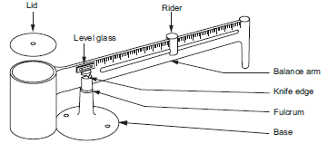
Figure 1: Mud Balance

Test/measurement procedure;

Step 1 – Remove lid & fill cup to the top with sample to be tested. If air bubbles have been trapped in the mud tap briskly until they breakout.
Step 2 – Replace lid and rotate until firmly seated, making sure some mud squeezes out the vent hole
Step 3 – Wipe mud from exterior of balance

Step 4 – Place balance on base with knife edge on fulcrum rest.

Step 5 – Move rider until instrument is in balance as determined by spirit leve l.

Step 6 – Read mud weight & hydrostatic pressure or gradient at edge of rider nearest fulcrum.

Mud densities are usually reported to the nearest 0.1 ppg (Ibs per gallon). Other units in common are Ibs/cuft, psi/ft, psi/1000ft, kg/l and specific gravity (S.G.).

Mud Viscosity
It is a measure of internal resistance of drilling mud to flow. Factors like hole size, hole condition, pumping rate, drilling rate, cutting size, mud weight, design of pit system and gel characteristics influence the specification of the viscosity of a given mud. The MARSH FUNNEL VISCOMETER is used to make quick tests of drilling fluids and it is almost on every drilling rig, however, this device only gives an indication of changes in viscosity and cannot be used to quantify the rheological properties of mud such as the yield point or plastic viscosity unlike other devices like ROTARY VISCOMETER, SHEAROMETER or RHEOMETER. This being that non-Newtonian fluids exhibit different viscosities at different flow rates.

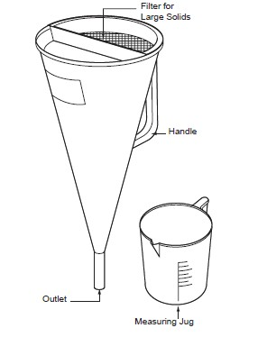
Figure 2: Marsh funnel & graduated cup

Procedure for Marsh funnel viscometer;

Step 1 – Hold funnel in upright position with index finger over outlet

Step 2 – Pour the test sample freshly taken from the mud system through the screen on top of funnel until mud level just reaches the under side of the screen.
Step 3 – Immediately remove finger from outlet tube and measure number of seconds for a quart of the sample to run out.
Step 4 – Report funnel viscosity in seconds

Note that time of efflux for a quart of clean fresh water at 70^{O}F is 26 seconds.
The RHEOMETER, a rotational viscometer is used to quantify the rheological properties of drilling mud. The assessment is made by shearing a sample of the mud at a series of prescribed rates and measuring the shear stress on the fluid at these rates.

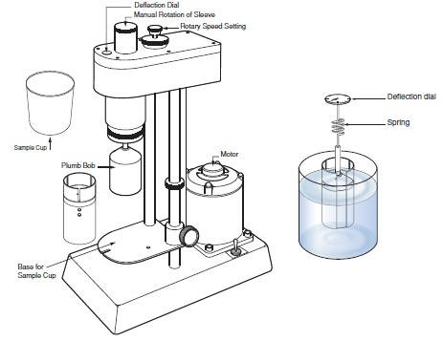
Figure 3: Multi-rate viscometer (i.e. rheometer) Procedure for rheometer;
Step 1 – Suspend the plumb bob inside the cylinder
Step 2 – Immerse both the plumb bob & cylinder in a sample of drilling mud and start shearing

Step 3 – Take the readings of the deflection of the plumb bob which is a measure of the viscosity of drilling fluid at that shear rate.
Step 4 – Plot shear rate versus deflection

Step 5 – Calculate the following parameters from the graph; Plastic viscosity (µ_{p} ) = θ₆₀₀ – θ₃₀₀ (centipoise)
Yield point (τ_{y}) = θ₃₀₀ ₋ µ_{p} (Ib/100 sq.ft)
Note that θ₆₀₀ & θ₃₀₀ are deflections readings at 600 RPM & 300 RPM rotor speed of the rheometer. Also, step 5 is only applicable to Bingham plastic (there is a linear relationship between shear stress and shear rate. Plastic viscosity can be thought of as part of the flow resistance caused by mechanical friction (i.e. solids content). Yield point is that component of resistance caused by electrochemical attraction within the mud while it is flowing. The apparent viscosity is determined by
θ₆₀₀/2 = apparent viscosity (µ_{a}) in centipoise
For a true or Newtonian fluid characterized by a straight line flow curve that passes through the origin, the apparent viscosity is equal to the plastic viscosity.

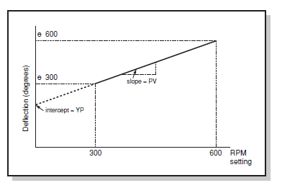

Figure 4: Typical graph drawn from viscometer results

Gel Strength or Mud Shear
The gel strength of the drilling mud can be thought of as the strength of any internal structures which are formed in the mud when it is static. The gel strength of the mud will provide an indication of the pressure required to initiate flow after the mud has been static for some time. It also provide an indication of the suspension properties of the mud hence its ability to suspend cuttings when the mud is stationary. The gel strength can be measured with either a rheometer or rotary viscometer. After the mud has remained static for sometime (10 secs) the rotor is set at a low speed (3 rpm) and the deflection noted. This is reported as the initial or 10 sec. gel. The same procedure is repeated after the mud remains static for 10 minutes, to determine the 10 minute gel. Both gels are measured in the same units as yield point (Ib/100 sq.ft). The gel strength usually appears on the mud report as two figures (e.g. 17/25). The first being the initial gel and the second the 10 minute gel.

Filtration
The filtration properties of drilling muds are a measure of the ability of the solid components of the muds to form a thin, low-permeability filter cake. The lower the permeability, the thinner the filter cake and the lower the volume of filtrate from muds of comparable solids concentration. This property is dependent upon the amount and physical state of the colloidal material in the mud. The filter cake building property of a mud can be measured using a FILTER PRESS.

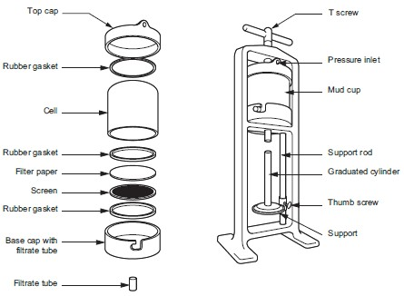
Figure 5: Filter press apparatus

During the test, the rate at which fluid from a mud sample is forced through a filter under specified temperature & pressure is evaluated. Also, the thickness of the solid residue deposited on the filter paper caused by the loss of fluid is measured. Note that this type of test does not accurately simulate downhole conditions in that only static filtration is being measured. In the wellbore, filtration is occurring under dynamic conditions with the mud flowing past the wall of the hole.
Procedure;

Step 1 – Assemble the filter press apparatus in the order according to the diagram. Secure the cell to the base cap
Step 2 – Fill the cell with the sample to be tested. Set the unit in place in the filter press frame.

Step 3 – Check the top cap to make sure the gasket is in place. Place the top cap on the cell and secure the unit in place with the T-screw
Step 4 – Place a dry graduated cylinder under the filtrate tube

Step 5 – With the regulator T-screw in its maximum outward position, open the valve to the cell. Apply 100 psi pressure to the filter cell by rapidly screwing the T-screw into the regulator. Timing of the test should begin now.
Step 6 – At the end of 30 minutes, close the valve to the cell rapidly and open the safety-bleeder valve. This releases the pressure on the entire system. Return the regulator T-screw to its maximum outward position.
Step 7 – Read the volume of filtrate collected in the graduated cylinder

Step 8 – Report the filtrate loss in ml as the API filtration loss of the mud. The filter cake thickness is measured and reported as thirty-seconds of an inch

Sand Content
A high proportion of sand in the mud is undesirable because it can damage the mud pumps, settle in the hole about the tools when circulation is stopped and may also cause a thick filter cake on the wall of the hole. It is essential to regularly measure the sand percentage in the mud. Sand content can be determined by elutriation, settling or sieve analysis. Of the three methods, sieve analysis is the most preferred because of reliability of test & simplicity of equipment. The sand content set consists of a 200- mesh sieve, funnel and a glass measuring tube calibrated from 0 to 20% to read directly the percentage sand by volume.
Procedure;

Step 1 – Fill the glass measuring tube with mud up to the scribe line

Step 2 – Add water to the next scribe line

Step 3 – Mix the fluids by shaking and then pour through the sieve

Step 4 – Wash the retained sand on the sieve through the funnel into the glass tube by a fine spray of water.
Step 5 – Allow the sand to settle and read-off the percentage directly.

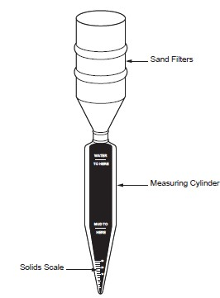
Figure 6: Sand content apparatus

Liquid and Solid Content
Knowledge of the liquid and solids content of a drilling mud is essential for good control of the mud properties. Such information will often explain poor performance of the mud and indicate whether the mud can best be condition by addition of water or chemical thinner. Also, proper control of oil emulsion mud depends upon knowledge of the oil content. The apparatus to determine liquid and solids content of the mud is included in the oil & water retort kit.
Procedure;

Step 1 – Heat a measured sample of mud in a retort until the liquid components are vaporized Step 2 – Channel the vapor through a condenser and collect it in a measuring glass

Step 3 – Read the volume of liquid (oil & water) directly as a percentage Step 4 – Subtract this value from 100% to obtain the volume of solids.

PH Determination
The PH test is a measure of the concentration of ions in an aqueous solution. It helps to indicate the degree of acidity or alkalinity of drilling mud. A perfectly neut ral solution has a PH 7.0 . Alkaline solutions have PH readings ranging from just above 7 to 14 while acid ranges from just below 7 to 0. The PH of mud can influence the reaction of various chemicals, hence, this test will aid in determining the need for chemical control as well as indicating the presence of contaminants such as cement, gypsum e.t.c. The test can be carried out using either PHydrion paper or by a special PH meter. The PH paper will turn different colours depending on the concentration of hydrogen ions while for a PH meter, a probe is simply placed in the mud sample and readings are taken after the needle stabilizes. The meter gives more accurate results to 0.1 of a unit.

Chloride Content
The amount of chloride in the mud is a measure of salt contamination from the formation. Procedure;
Step 1 – Take a small sample (measured) of mud filtrate and add phenolphthalein Step 2 – Titrate with acid until the colour changes
Step 3 – Measure 25 – 50ml of distilled water and a small amount of potassium chromate solution, add both to the titrated solution.
Step 4 – Stir solution continuously while adding silver nitrate drop by drop until colour changes, that is, the end point.

Cl content (ppm) = ml of silver nitrate * 100

Ml of filtrate sample

Cation Exchange Capacity
The molecular structure of bentonite is made up of silica & alumina chains with sodium and/or calcium ions loosely held, thus, they are readily exchanged for other ions & certain organic compounds. Methylene blue is an organic dye which will replace the exchangeable cations in the bentonite (sodium montmorillonite) and certain other mud additives. Base on this principle, the cation exchange capacity test using methylene blue will give an approximate measure of bentonite content in the mud. The technique involves putting a small mud sample in a flask

where it is first treated with hydrogen peroxide to remove most of the organic content. Methylene blue solution is then added in increments of 0.5 ml. After each increment the flask is well shaken and while the solids are still suspended one drop is placed on filter paper. The end point is reached when the dye appear as a greenish-blue ring around the solids on the filter paper.
Methylene blue capacity = ml of methylene blue (meq of methylene blue/100 grams of clay) ml of mud sample
Bentonite content (Ib/bbl) = 5 * methylene blue capacity
The methylene blue dye test can also be applied to aqueous dispersions of powdered clay, cores and drilled cuttings. It measures the total exchange capacity of the clay system and is dependent upon the type and content of clay mineral present.

