SYNTHESIS OF ANTIBIOTICS AND OTHER ANTIMICROBIAL AGENTS.
Sources: There are three major sources from which antibiotics are obtained;
A. Microorganisms. Bacitracin and polymyxin are obtained from some Bacillus species; streptomycin, tetracyclines, etc. from Streptomyces species; gentamicin from Micromonospora purpurea; griseofulvin and some penicillins and cephalosporins from certain genera (Penicillium, Acremonium) of the family Aspergillaceae; and monobactams from Pseudomonas acidophila and Gluconobacter species. Most antibiotics in current use have been produced from Streptomyces spp.
B. Synthesis. This process is purely by chemical combinations (synthesis) which involves the linking of side chains with functional groups. Chloramphenicol is now usually produced by a synthetic process.
C. Semisynthesis. Part of the molecule is produced by a fermentation process using the appropriate microorganism and the product is then further modified by a chemical process. Many penicillins and cephalosporins are produced in this way.
Other probable source identified are (a) some bacteriophages which may have an important role in the chemotherapy of bacterial infections, (b) plant products have proven to be a potentially fruitful source of new antimicrobial agents.
SOME ANTIBIOTIC GROUPS
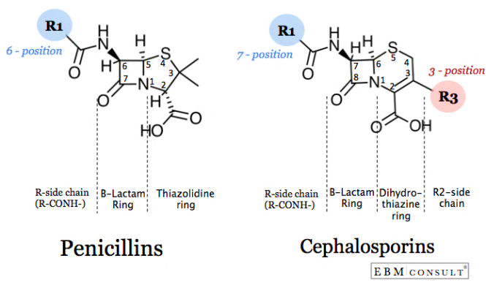
1. beta-lactam antibiotics: The beta-lactam antibiotics are so-called because they have in their structure the four membered lactam ring. There are several different types of b-lactam antibiotics that are valuable or potentially important antibacterial compounds. The Beta-lactam antibiotics include the well- established and clinically important penicillins and cephalosphorins as well as some relatively newer members: cephamycins, nocardicins, thienamycins, and clavulanic acid. Except in the case of nocardicins these antibiotics are derivatives of bicyclic ring systems in which the lactam ring is fused through a nitrogen atom and a carbon atom to ring compound. This ring compound is five-membered in penicillins (thiazolidine), thienamycins (pyrroline) and clavulanic acid (oxazolidine); it is six-membered (dihydrothiazolidine) in cephalosporins and cephamycins.
Penicillins: The penicillins may be considered as being of the following types; (a) Naturally occurring e.g., those produced by fermentation of molds such as Penicillium notatum and P. chrysogenum. The most important examples are benzylpenicillin (penicillin G) and phenoxymethylpenicillin (penicillin V); (b) Semisynthetic types: In 1959, scientists at Beecham Research Laboratories succeeded in isolating the penicillin ‘nucleus’, 6-aminopenicillanic acid (6-APA). During the commercial production of benzylpenicillin, phenylacetic (phenylethanoic) acid (C₆H₅.CH₂.COOH) is added to the medium in which the Penicillium mold is growing. This substance is a precursor of the side-chain in benzylpenicillin. Growth of the organism in the absence of phenylacetic acid led to the isolation of 6-APA; this has a different RF value from benzylpenicillin, which allowed it to be detected chromatographically. A second method of producing 6-APA came with the discovery that certain microorganisms produce enzymes, penicillin amidases (acylases), which catalyze the removal of the side-chain from benzylpenicillin. Acylation of 6-APA with appropriate substances results in new penicillins being produced that differ only in the nature of the side-chain. Some of these penicillins have considerable activity against Gram-negative as well as Gram-positive bacteria, and are thus broad- spectrum. Benzylpenicillin is rapidly absorbed and rapidly excreted. However, certain sparingly soluble salts of benzylpenicillin (benzathine, benethamine and procaine) slowly release penicillin into the circulation over a period of time, thus giving a continuous high concentration in the blood. Pro-drugs, e.g. carbenicillin esters, ampicillin esters, are hydrolysed by enzyme action after absorption from the gut mucosa to produce high blood levels of the active antibiotic, carbenicillin and ampicillin, respectively. Several bacteria produce an enzyme, beta-lactamase which may inactivate penicillin by opening the beta-lactam ring. However, some penicillins are considerably more resistant to this enzyme than others, and consequently may be extremely valuable in the treatment of infections caused by beta-lactamase producing bacteria. In general, the penicillins are active against Gram-positive bacteria; some members (e.g. amoxycillin) are also effective against Gram-negative bacteria, although not Pseudomona aeruginosa, whereas others (e.g. ticarcillin) are also active against this organism.
PRODUCTION OF PENICILLIN BY FERMENTATION
Penicillin fermentation can be divided into three phases: trophophase - In this phase rapid growth occurs, lasts for about 30 hours during which mycelia are produced; idiophase - It lasts for five to seven days; growth is reduced and penicillin is produced; third phase - carbon and nitrogen sources are depleted, antibiotic production ceases, the mycelia lyse releasing ammonia and the pH rises.
Strain selection: In the early days of penicillin production, when the surface culture method was used, a variant of the original culture of Penicillium notatum discovered by Sir Alexander Fleming was employed. When however the production shifted to submerged cultivation, a strain of Penicillium chrysogenum designated NRRL 1951 (after Northern Regional Research Laboratory of the United States Department of Agriculture) discovered in 1943, was introduced. Submerged culture gave a penicillin yield of up to 250 Oxford Units (1 Oxford Unit = 0.5988 of sodium benzyl penicillin) which was two to three times more than given by Penicillium notatum. A ‘super strain’ was produced from a variant of NRRL 1951 and designated X-1612. By ultraviolet irradiation of X-1612, a strain resulted and was named WISQ 176 after the University of Wisconsin where much of the stain development work was done. On further ultra violet irradiation of WISQ 176, BL3- D10 was produced, which produced only 75% as much penicillin as WISQ 176, but whose product lacked the yellow pigment the removal of which had been difficult. Present-day penicillin producing P. chrysogenum strains are far more highly productive than their parents. They were produced through natural selection, and mutation using ultra violet irradiation, x-irradiation or nitrogen mustard treatment. It was soon recognized that there were several naturally occurring penicillins, viz. Penicillins G, X, F, and K. Penicillin G (benzyl penicillin) was selected because it was markedly more effective against pyogenic cocci. Furthermore, higher yields were achieved by supplementing the medium with phenylacetic acid, analogues (phenylalanine and phenethylalanine) of which are present in corn steep liquor used to grow penicillin in the United States. Present day penicillin-producing strains are highly unstable, as with most industrial organisms, and tend to revert to low-yielding strains especially on repeated agar cultivation. They are therefore commonly stored in liquid nitrogen at – 196°C or the spores may be lyophilized. Penicillin has since been shown to be produced by a wide range of organisms including the fungi Aspergillus, Malbranchea, Cephalosporium, Emericellopsis, Paecilomyces, Trichophyton, Anixiopsis, Epidermophyton, Scopulariopsis, Spiroidium and the actionomycete, Streptomyces.
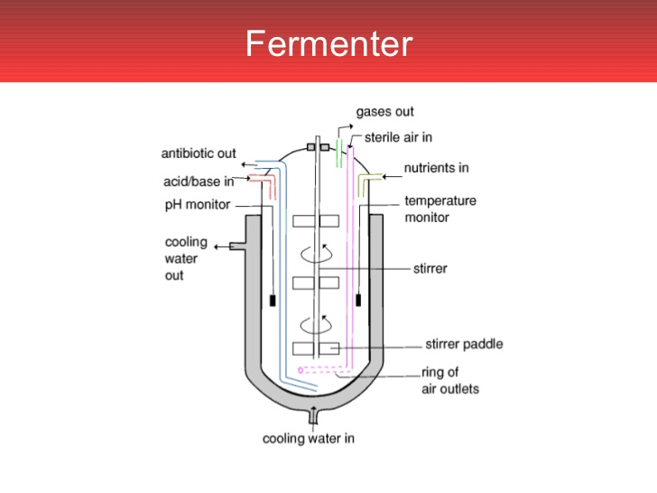
Medium and Inoculum Preparation: The inoculum is usually built up from lyophilized spores or a frozen culture and developed through vessels of increasing size to a final 5-10% of the fermentation tank. The fermenters vary from 38,000 to 380,000 liters in capacity and in modern establishments are worked by computerized automation, which monitor various parameters including oxygen content, Beta-lactam content, pH, temperature etc. The medium for penicillin production now usually has as carbohydrate source glucose, beet molasses or lactose. The nitrogen is supplied by corn steep liquor. Cotton seed, peanut, linseed or soybean meals have been used as alternate nitrogen sources. The nitrogen source is sometimes exhausted towards the end of the fermentation and it must then therefore be replenished. Calcium carbonate or phosphates may be added as buffer. Sulfur compounds are sometimes added for additional yields since penicillin contains sulfur. The practice nowadays is to add the carbohydrate source intermittently, i.e. using fed-batch fermentation. Lactose is more slowly utilized and need not be added intermittently. Glucose suppresses secondary metabolism and excess of it therefore limits penicillin production. The pH is maintained at between 6.8 and 7.4 by the automatic addition of H₂SO₄ or NaOH as necessary. Precursors of the appropriate side-chain are added to the fermentation. Thus if benzyl penicillin is desired, phenylacetic acid is added. Phenyl acetic acid is nowadays added continuously as too high an amount inhibits the development of the fungus. High yielding strains of P. chrysogenum resistant to the precursors have therefore been developed. Penicillin production is stimulated by the addition of surfactants in a yet unexplained mechanism. The temperature is maintained at about 25°C, but in recent times it has been found that yields were higher if adjusted according to the growth phase. Thus, 30-32°C was found suitable for the trophophase and 24°C for the idiophase. Aeration and agitation are vigorous in order to keep the components of the medium in suspension and to maintain yield in the highly aerobic fungus
Extraction of penicillin after fermentation: the separation of penicillin from culture is based on the solubility, adsorption and ionic properties of penicillin. Since penicillins are monobasic carboxylic acids they are easily separated by solvent extraction described next. The fermentation beer or broth is filtered with a rotary vacuum filter to remove mycelia and other solids and the resulting broth is adjusted to about pH 2 using a mineral acid. It is then extracted with a smaller volume of an organic solvent such as amyl acetate or butyl acetate. At the end of the fermentation the broth is transferred to a settling tank. Penicillin is highly reactive and is easily destroyed by alkali conditions (pH 7.5-8.0) or by enzymes. It is therefore cooled rapidly to 5-10°C. A reduction of the pH to 6 with mineral acids sometimes accompanied by cooling helps also to preserve the antibiotic. The fermentation broth contains a large number of other materials and the method used for keeping it at this very low pH for as short a time as possible. The aqueous phase is separated from the organic solvent usually by centrifugation using Podbielniak centrifugal countercurrent separator. The organic solvent containing the penicillin is then typically passed through charcoal to remove impurities, after which it is back-extracted with a 2% phosphate buffer at pH 7.5. The buffer solution containing the penicillin is then acidified once again with mineral acid (phosphoric acid) and the penicillin is again extracted into an organic solvent (e.g. amyl acetate). The product is transferred into smaller and smaller volumes of the organic solvent with each successive extraction process and in this way, penicillin becomes concentrated several times over, up to 80-100 times. When it is sufficiently concentrated the penicillin may be converted to a stable salt form in one of several ways which employ the fact that penicillin is an acid: (a) it can be reacted with a calcium carbonate slurry to give the calcium salt which may be filtered, lyophilized or spray dried. (b) it may be reacted with sodium or potassium buffers to give the salts of these metals which can also be freeze or spray dried; (c) it may be precipitated with an organic base such as triethylamine.
Administration; When benzyl penicillin is administered intramuscularly it is given either as the sodium (or potassium) salt or as procaine penicillin. The former gives high blood levels but it is quickly excreted. Procaine penicillin gives lower blood levels, but it lasts longer in the body because it is only slowly removed from the blood. It is produced by dissolving sodium or penicillin in procaine hydrochloride.
Antibiotic Modes of Action
1. Cell wall synthesis inhibitors generally inhibit some steps in the synthesis of bacterial peptidoglycan. Generally they exert their selective toxicity against eubacteria because human cells lack cell walls. Beta lactam antibiotics contain a 4-membered beta lactam ring. They are the products of two groups of fungi, Penicillium and Cephalosporium molds, and are correspondingly represented by the penicillins and cephalosporins. The beta-lactam antibiotics inhibit the last step in peptidoglycan synthesis, the final cross-linking between peptide side chains, mediated by bacterial carboxypeptidase and transpeptidase enzymes. Beta-lactam antibiotics are normally bactericidal and require that cells are actively growing in order to exert their toxicity. Examples of natural penicillins, such as Penicillin G or Penicillin V, are produced by fermentation of P. chrysogenum. They are effective against Streptococcus, Gonococcus and Staphylococcus species, except where resistance has developed. They are considered narrow spectrum Semisynthetic penicillins first appeared in 1959. A mold produces the main part of the molecule (6-aminopenicillanic acid) which can be modified chemically by the addition of side chains. Many of these compounds have been developed to have distinct benefits or advantages over penicillin G, such as increased spectrum of activity (effectiveness against Gram-negative rods), resistance to penicillinase, effectiveness when administered orally, etc. Amoxycillin and Ampicillin have broadened spectra against Gram-negatives and are effective orally; Methicillin is penicillinase-resistant.
Cephalolsporins are beta-lactam antibiotics with a similar mode of action to penicillins that are produced by species of Cephalosporium. They have a low toxicity and a somewhat broader spectrum than natural penicillins. They are often used as penicillin substitutes, against Gram-negative bacteria, and in surgical prophylaxis. They are subject to degradation by some bacterial beta-lactamases, but they tend to be resistant to beta-lactamases from Staphylococcus aureus.
2. Cell membrane inhibitors disorganize the structure or inhibit the function of bacterial membranes. The integrity of the cytoplasmic and outer membranes is vital to bacteria, and compounds that disorganize the membranes rapidly kill the cells. However, due to the similarities in phospholipids in eubacterial and eukaryotic membranes, this action is rarely specific enough to permit these compounds to be used systemically. The only antibacterial antibiotic of clinical importance that acts by this mechanism is Polymyxin, produced by Bacillus polymyxa. Polymyxin is effective mainly against Gram-negative bacteria and is usually limited to topical usage. Polymyxins bind to membrane phospholipids and thereby interfere with membrane function. Polymyxin is occasionally given for urinary tract infections caused by Pseudomonas species that are gentamicin, carbenicillin and tobramycin resistant.
3. Protein synthesis inhibitors attack always at one of the events occurring on the ribosome and rather than the stage of amino acid activation or attachment to a particular tRNA. Most have an affinity or specificity for 70S (as opposed to 80S in eukaryotes) ribosomes, and they achieve their selective toxicity in this manner. The most important antibiotics with this mode of action are the tetracyclines, chloramphenicol, the macrolides (e.g. erythromycin) and the aminoglycosides (e.g. streptomycin). The aminoglycosides are products of Streptomyces species and are represented by streptomycin, kanamycin, tobramycin and gentamicin. These antibiotics exert their activity by binding to bacterial ribosomes and preventing the initiation of protein synthesis. Aminoglycosides have been used against a wide variety of bacterial infections caused by Gram-positive and Gram-negative bacteria. Streptomycin has been used extensively as a primary drug in the treatment of tuberculosis. Gentamicin is active against many strains of Gram-positives and Gram negative bacteria, including some strains of Pseudomonas aeruginosa. Kanamycin (a complex of three antibiotics, A, B and C) is active at low concentrations against many Gram-positive bacteria, including penicillin-resistant staphylococci. Gentamicin and Tobramycin are mainstays for treatment of Pseudomonas infections. The tetracyclines consist of eight related antibiotics which are all natural products of Streptomyces, although some can now be produced semisynthetically. Tetracycline, chlortetracycline and doxycycline are the best known. The tetracyclines are broad-spectrum antibiotics with a wide range of activity against both Gram-positive and Gram-negative bacteria. The tetracyclines act by blocking the binding of aminoacyl tRNA to the A site on the ribosome. Tetracyclines inhibit protein synthesis on isolated 70S or 80S (eukaryotic) ribosomes, and in both cases, their effect is on the small ribosomal subunit. However, most bacteria possess an active transport system for tetracycline that will allow intracellular accumulation of the antibiotic at concentrations 50 times as great as that in the medium. This greatly enhances its antibacterial effectiveness and accounts for its specificity of action, since an effective concentration cannot be accumulated in animal cells. Thus a blood level of tetracycline which is harmless to animal tissues can halt protein synthesis in invading bacteria. The Macrolides are a family of antibiotics whose structures contain large lactone rings linked through glycoside bonds with amino sugars. The most important members of the group are erythromycin and oleandomycin. Erythromycin is active against most Gram-positive bacteria, Neisseria, Legionella and Haemophilus species, but not against the Enterobacteriaceae. Macrolides inhibit bacterial protein synthesis by binding to the 50S ribosomal subunit. Binding inhibits elongation of the protaein by peptidyl transferase or prevents translocation of the ribosome or both. Macrolides are bacteriostatic for most bacteria but are bacteriocidal for a few Gram-positive bacteria.
4. Effects on Nucleic Acids is seen in the synthesis of DNA or RNA, agents can bind to DNA or RNA so that their messages cannot be read. Either case, of course, can block the growth of cells. The majority of these drugs is unselective, however, and affects animal cells and bacterial cells alike and therefore has no selective therapeutic application. Two nucleic acid synthesis inhibitors which have selective activity against prokaryotes and some medical utility are nalidixic acid and rifamycins.
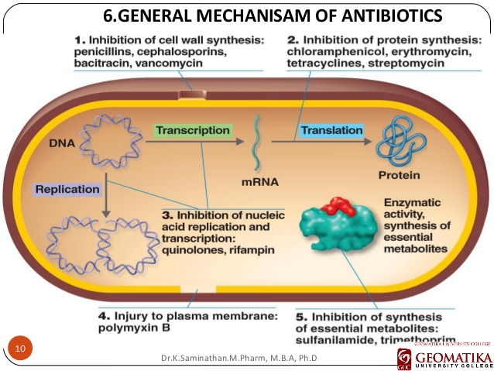
5. Competitive Inhibitors are mostly all synthetic chemotherapeutic agents. Most are “growth factor analogs” which are structurally similar to a bacterial growth factor but which do not fulfill its metabolic function in the cell. Some Sulfonamides were introduced as chemotherapeutic agents by Domagk in 1935, which showed that they are bacteriostatic and some are bactericidal. One of these compounds (prontosil) had the effect of curing mice with infections caused by beta-hemolytic streptococci. Chemical modifications of the compound sulfanilamide gave compounds with even higher and broader antibacterial activity. The resulting sulfonamides have broadly similar antibacterial activity, but differ widely in their pharmacological actions. Bacteria which are almost always sensitive to the sulfonamides include Streptococcus pneumoniae, beta-hemolytic streptococci and Escherichia coli. The sulfonamides have been extremely useful in the treatment of uncomplicated UTI caused by E. coli, and in the treatment of meningococcal meningitis (because they cross the blood-brain barrier).

