**(Viral) Effects on Cells**

Thomas Albrecht, Michael Fons, Istvan Boldogh, and Alan S. Rabson.

**General Concepts**

**Definitions**

Cells that support viral replication are called *permissive*. Infections of permissive cells are usually *productive* because infectious progeny virus is produced. Most productive infections are called cytocidal (cytolytic) because they kill the host cell. Infections of *non-permissive* cells yield no infectious progeny virus and are called *abortive*. When the complete repertoire of virus genes necessary for virus replication is not transcribed and translated into functional products the infection is referred to as *restrictive*. In persistent and in some transforming infections, viral nucleic acid may remain in specific host cells indefinitely; progeny virus may or may not be produced.

**Cytocidal Infections**

Infection by cytocidal viruses is usually associated with changes in cell morphology, in cell physiology and sequential biosynthetic events. Many of these changes are necessary for efficient virus replication.

*Morphologic Effects*: The changes in cell morphology caused by infecting virus are called cytopathic effects (CPE). Common examples are **rounding of the infected cell**, fusion with adjacent cells to form a **syncytium** (polykaryocytes), and the appearance of **nuclear or cytoplasmic inclusion bodies**. Inclusion bodies may represent either altered host cell structures or accumulations of viral components.

*Effects on Cell Physiology:* The interaction of virus with the cell membrane and/or subsequent events, (for example, *de novo* synthesized viral proteins) may change the physiological parameters of infected cells, including movement of ions, formation of secondary messengers, and activation cascades leading to altered cellular activities.

*Effects on Cell Biochemistry*: Many viruses inhibit the synthesis of host cell macromolecules, including DNA, RNA, and protein. Viruses may also change cellular transcriptional activity, and protein-protein interactions, promoting efficient production of progeny virus. For some viruses, specific cellular biochemical functions may be stimulated in order to enhance virus replication.

*Genotoxic Effects*: Following virus infection, breakage, fragmentation, rearrangement and/or changes in the number of chromosomes may occur.

*Biologic Effects*: Virus-specified proteins may alter the cell's antigenic or immune properties, shape, and growth characteristics.

**Persistent Infections**

Some viruses evolved the ability to remain in specific cells for long periods of time. These infections include: **latent**, **chronic**, and **slow virus infections**. The type of persistent infection usually influences the extent of cellular changes.

*Latent Infection*: Latent infections are characterized by restricted expression of the episomal or integrated virus genome. The viral genomic product(s) are associated with few, if any, changes in the latently infected cell.

*Chronic Infection*: The cellular effects of chronic infection are usually the same as those of acute cytocidal infections, except that production of progeny may be slower, intermittent or limited to a few cells. The long-term cellular changes may result in severe disease, immune suppression or may trigger immune responses to damaged or undamaged cells or tissues.

*Slow Infection*: This type of virus-cell interaction is characterized by a prolonged incubation period, without significant morphological and physiological changes of infected cells. A slow progression of cellular injury may take years and is followed by extensive cellular injury and disease.

**Transforming Infections**

DNA or RNA tumor viruses may mediate multiple changes that convert a normal cell into a malignant (CANCEROUS) one. RNA tumor viruses usually transform cells to a malignant phenotype by integrating their own genetic material into the cellular genome and may also produce infectious progeny. DNA tumor virus infections are often cytocidal; thus transformation is associated with abortive or restrictive infections in which few viral genes are expressed.

*Stages of Transformation*: Transformation involves at least two processes: **first**, the cell gains the capacity for unlimited cell division (immortalization), and **second**, the immortalized cells acquire additional heritable genetic changes by which the cell is able to produce a tumor in an appropriate host.

*Mechanisms of Oncogenic Transformation*: There are two general patterns by which cell transformation may be accomplished: 1) ***the tumor virus may introduce and express a so-called transforming gene in the cells*** or 2) ***the tumor virus may alter the expression and (or) coding capacity of preexisting cellular genes***. After development of a malignant phenotype the relevant segment(s) of the viral genome may or may not be retained in the transformed cells, depending on the mechanism of transformation. These mechanisms are not mutually exclusive, and both may occur in the same cell.

**Cytopathic Effects**

In most cases, the disturbances of bodily function that are manifested as the signs and symptoms of viral disease result from the direct effects of viruses on cells. Knowledge of the morphologic, physiologic, biochemical, and immunologic effects of viruses on cells is essential in understanding the pathophysiology of viral disease and in developing accurate diagnostic procedures and effective treatment.

Virus-host cell interactions ([Table 44-1](https://www.ncbi.nlm.nih.gov/books/NBK7979/table/A2360/?report=objectonly)) may produce either 1) cytocidal (cytolytic) infections, in which production of new infectious virus kills the cell; 2) persistent infections, in which the virus or its genome resides in some or all of the cells without killing most of them; or 3) transformation, in which the virus does not kill the cell, but produces genetic, biochemical, physiologic, and morphologic changes that may result in the acquisition of malignant properties. The type of virus infection and the virus-induced effects on cells are dependent on the virus, the cell type and species, and often the physiologic state of the cell.

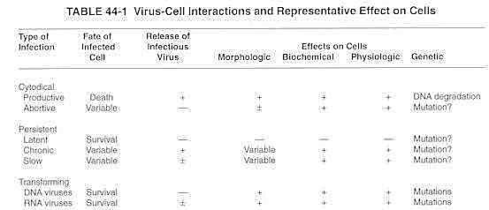

## Cytocidal Infections

### Morphologic and Structural Effects

Infection of permissive cells with virus leads to productive infection and often results in cell death (cytocidal, cytolytic infection). The first effects of the replication of cytocidal viruses to be described were the morphologic changes known as *cytopathic effects*. Cultured cells that are infected by most viruses undergo morphologic changes, which can be observed easily in unfixed, unstained cells by a light microscope. Some viruses cause characteristic cytopathic effects; thus, observation of the cytopathic effect is an important tool for virologists concerned with isolating and identifying viruses from infected animals or humans ([Fig. 44-1](https://www.ncbi.nlm.nih.gov/books/NBK7979/figure/A2363/?report=objectonly)).

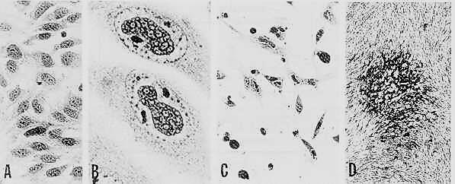

**Figure 44-1Development and progression of viral cytopathology**

Human embryo skin muscle cells were infected with human cytomegalovirus and stained at selected times to demonstrate (A) uninfected cells, (B) late virus cytopathic effects (nuclear inclusions, cell enlargement), (C) cell degeneration, and (D) a focus of infected cells in a cell monolayer (i.e., a plaque), hematoxylin and eosin stain. (A, × 255; B, × 900; C, × 225; D, × 20.)

Many types of cytopathic effects occur. Often the first sign of viral infections is **rounding of the cells**. In some diseased tissues, intracellular structures called **inclusion bodies** appear in the nucleus and/or cytoplasm of infected cells. Inclusion bodies were first identified by light microscopy in smears and stained sections of infected tissues. Their composition can often be clarified by electron microscopy. In an adenovirus infection, for example, crystalline arrays of adenovirus capsids accumulate in the nucleus to form an inclusion body.

Inclusions may alternatively be host cell structures altered by the virus. For example, in reovirus-infected cells, virions associate with the microtubules, giving rise to a crescent-shaped perinuclear inclusion. Infection of cells by other viruses causes specific alterations in the cytoskeleton of cells. For example, extensive changes in cellular intermediate filaments in relation to formation of viral inclusions may be observed after cytomegalovirus infection ([Fig. 44-4](https://www.ncbi.nlm.nih.gov/books/NBK7979/figure/A2364/?report=objectonly)).

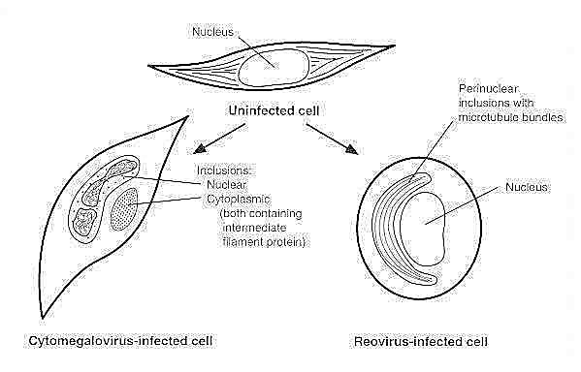

**Figure 44-4Alteration of cytoskeleton organization by virus infection**

Normal cells have networks of microtubules, and intermediate filaments throughout the cytoplasm. Infection with reovirus causes a perinuclear aggregation of microtubules, and infection with cytomegalovirus causes a modification of intermediate filaments proteins, including their relocation into the nuclear and cytoplasmic inclusion bodies.

A particularly striking cytopathic effect of some viral infections is the **formation of syncytia**, or polykaryocytes, which are large cytoplasmic masses that contain many nuclei (*poly,* many; *karyon*, nucleus) and are usually produced by fusion of infected cells ([Fig. 44-2](https://www.ncbi.nlm.nih.gov/books/NBK7979/figure/A2366/?report=objectonly)). The mechanism of cell fusion during viral infection probably results from the interaction between viral gene products and host cell membranes. Cell fusion may be a mechanism by which virus spreads from infected to uninfected cells.

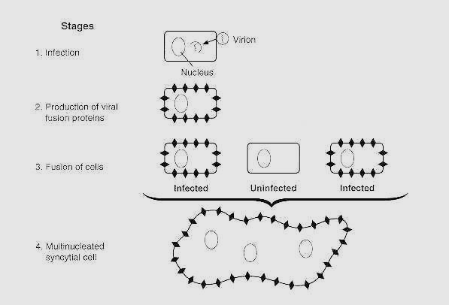

**Figure 44-2Formation of multinucleated cells**

The figure represents the cytopathology of measles virus-induced syncytia.