PHYLUM ANNELIDA
This phylum consists of earthworms, leeches, and various marine worms given many different names (e.g., sand worms, tube worms). There are about 12,000 - 15,000 species. Animals in this phylum are triploblastic, bilaterally symmetrical, segmented coelomates. They have a complete circulatory system, and a well-developed nervous system. Typically, each segment has paired epidermal "bristles" (setae or chaetae). Most are marine but they are successful occupants of almost anywhere sufficient water is available. They can be free living, parasitic, mutualistic, or commensalistic. Major advances of this phylum include the true coelom, segmentation, both longitudinal and circular muscles, a closed circulatory system and, for most, a more advanced excretory system (nephridia).
The coelom serves as a hydrostatic skeleton, permits development of complex organ systems, protects internal structures, and permits the internal organs to function separately from the body wall muscles. Segmentation also provided for the specialization of different body regions.

Annelids have a coelom partitioned by septa. The digestive tract, longitudinal blood vessels, and nerve cords penetrate the septa and extend the length of the animal.

Locomotion: Movement involves coordinating longitudinal and circular muscles in each segment with the fluid-filled coelom functioning as a hydrostatic skeleton. Circular muscle contraction makes each segment thinner and longer; longitudinal muscle contraction makes the segment shorter and thicker. Waves of alternating contractions pass down the body. Most aquatic annelids are bottom-dwellers that burrow, although some swim in pursuit of food. Coelom is filled with fluid (except leeches) which serves as hydrostatic skeleton. Annelids have 3 general types of movements:
1. burrowing: waves of peristaltic contractions sweep down body. 1st animal elongates- contraction of circular muscle
2nd animal shortens- contraction of longitudinal muscle
setae anchor hind end of body while front end pushes forward.
2. crawling: polychaetes use parapodia alternately to move across surface
3. swimming: mainly polychaetes and leeches undulating body movements parapodia help in polychaetes

Feeding and Digestion: The complete digestive system is divided into several parts, each specialized for a specific function in digestion: pharynx → esophagus → crop → gizzard → intestine. Complete digestive tract “tube within a tube” design muscle layers allow modification of tract into various structures:
Muscular pharynx- to take in food, often with
Eversible pharynx with jaws
Crop – food storage
Gizzard – food grinding
Intestine – digestion and absorption of nutrients
Anus – elimination of undigested wastes.

Circulatory System: Annelids have a closed circulatory system. Hemoglobin is present in blood cells. Dorsal and ventral longitudinal vessels are connected by segmental pairs of vessels. Important blood vessels within an annelid's body include the dorsal blood vessel, which runs from the hearts at the 'back', or dorsal, side of the body; and the ventral blood vessel, which runs from the hearts at the 'front', 'belly', or ventral, side of the body. Another important set of blood vessels are the lateral vessels that run along the intestines or gut tube of the annelid body structure. These blood vessels help bring nutrients away from the gut and out toward the rest of the body. Several pairs of aortic arches (=”hearts”) help to keep pressure up in ventral vessel blood:

Respiration: In some annelids, including earthworms, gaseous exchange takes place by diffusion over the general body surface, the necessary moisture being provided by exudations of the coelomic fluid through the dorsal pores, by the secretions of epidermal mucous glands, and by excretions from the nephridia. However, many polychaetes and some clitellates have gills associated with most segments, often as extensions of the parapodia in polychaetes. In tube-dwellers, the gills are usually more concentrated at the end that is exposed to stronger water currents.

Excretory System: An excretory system of paired metanephridia is found in each segment; each metanephridium has a nephrostome (which removes wastes from the coelomic fluid and blood) and exits the body through an exterior pore.
Nephric tubule:
Nephrostome = funnel like opening into previous segment coiled ciliated tubule surrounded by capillaries bladder like structure
Nephridipore = opening to outside

Nervous System: The annelid nervous system is composed of a pair of cerebral ganglia lying above and anterior to the pharynx. A nerve ring around the pharynx connects these ganglia to a subpharyngeal ganglion, from which a pair of fused nerve cords run posteriorly. Along the ventral nerve cords are fused segmental ganglia.

Reproduction: Annelids have both asexual and sexual reproduction which is quite variable within the phylum. Annelids are hermaphroditic but cross-fertilize during sexual reproduction. Asexual reproduction by fragmentation and budding off new individuals while the parent remains intact occurs in a few sedentary polychaetes. It is common in aquatic oligochaetes and sexual reproduction is virtually unknown in certain species. Some oligochaetes divide to form a chain of two or more individuals which break off as young worms. Some are also capable of self-fertilization and parthenogenesis (production of young without fertilization). Asexual reproduction in oligochaetes is always by dividing into two or more pieces, rather than by budding. Leeches have never been observed to reproduce asexually. Annelids are said to be highly organized animals with the power of complete regeneration. The power of regeneration is shown in the polychaetes and a few oligochaetes; leeches are incapable of regeneration. Annelids are either monoecious or dioecious. Most annelids are hermaphrodites and larva, if present is trochophore. Most polychaetes shed their gametes into the water. Various major body changes may precede the emission of gametes, the two most profound being epitoky (maturation into a modified, fertile form) and stolonization (the development of stem-like growths). At sexual maturity these polychaetes leave their burrows and swim in groups (swarming) before releasing gametes.

- Class Oligochaeta
The class Oligochaeta contains earthworms and a variety of aquatic species. The oligochaetes differ from the polychaetes in that most are terrestrial or freshwater. Earthworms ingest soil, extract nutrients in the digestive system and deposit undigested material (mixed with mucus from the digestive tract) as casts through the anus.
- Segmented externally and internally.
- Absence of parapodia but with setae/chaetae arranged singly, arising from the body wall.
- Head usually poorly developed (prostomium simple) and lacking appendages.
- Lack eyes - but have sensory systems that detect light, touch, and moisture.
- With a clitellum (which secretes cocoon) and a spacious coelom.
- Hermaphroditic.
- Most species are terrestrial or freshwater.
- Usually burrow in soil.
- Have fewer setae than polychaetes.
- Eat soil and organic debris.
- Castings are deposited at surface. Reproduction is by copulation and cross fertilization. Fertilization is internal.
- They lack suckers.
- E.g. Lumbricus terrestris, Tubifex tubifex, etc.

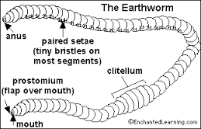

- Class Polychaeta. These are marine worms comprising worms that are commonly called fan worms, feather worms, tube worms, bristleworms, ragworms, sandworms,
etc. Each segment has a pair of parapodia which are highly vascularized paddle-like structures that function in gas exchange and locomotion. Traction for locomotion is proved by several chitinous setae present on each parapodium.
- The head proper is well-developed and made up of the prostomium and peristomium. The triangular prostomium projects above the mouth and bears one pair of tentacles, one pair of fleshy palps, and two pairs of eyes. The peristomium, surrounding the mouth, is the first true segment. It bears 4 pairs of peristomial tentacles.
- External and internal segmentation.
- Lateral biramous (two-branched) parapodia (fleshy paddlelike appendages) which carry many setae/chaetae (or bristles).
- The chaetae are chitinous (made up of chitin).
- Absence of a clitellum.
- Separate sexes (i.e. dioecious).
- Fertilization is external.
- An important link in marine food chains.
- Many live in association with sponges, molluscs, echinoderms, crustaceans.
- They have no suckers.
- The gonads are localized but extend throughout the body.
- E.g. Nereis, Sabella, Arenicola, Aphrodite, Eunice, Glycera, etc.

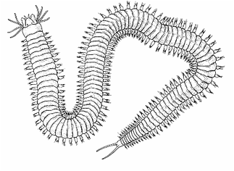

- Class Hirudinea
The class Hirudinea contains the leeches- mostly freshwater, some terrestrial and marine. They are mainly known for their ectoparasitic blood sucking habits, however many leeches are freshwater and marine predators. Many are carnivorous and feed on small invertebrates, while some attach temporarily to animals to feed on blood. Size ranges from 1 – 30 cm in length. Some blood-feeding forms have a pair of blade-like jaws that slit the host's skin while others secrete enzymes that digest a hole in the skin. An anesthetic is secreted by the leech to prevent detection of the incision by the host. Leeches also secrete hirudin which prevents blood coagulation during feeding. Leeches may ingest up to ten times their weight in blood at a single meal and may not feed again for several months. Leeches are currently used to treat bruised tissues and for stimulating circulation of blood to fingers and toes reattached after being severed in accidents.

- They are highly specialized annelids.
- Many are ectoparasites of vertebrates, while some are free-living predators or scavengers.
- They occur mostly in freshwater with a few on land and in the sea.
- They have anterior and posterior suckers.
- They lack a distinct head.
- Their body is somewhat shortened; all members of this class have 33/34 segments.
- They lack chaetae or parapodia or head appendages.
- They are hermaphrodites.
- Reproduction is by cross fertilization.
- Development is direct within cocoons secreted by the clitellum.
- E.g. Hirudo medicinalis etc.

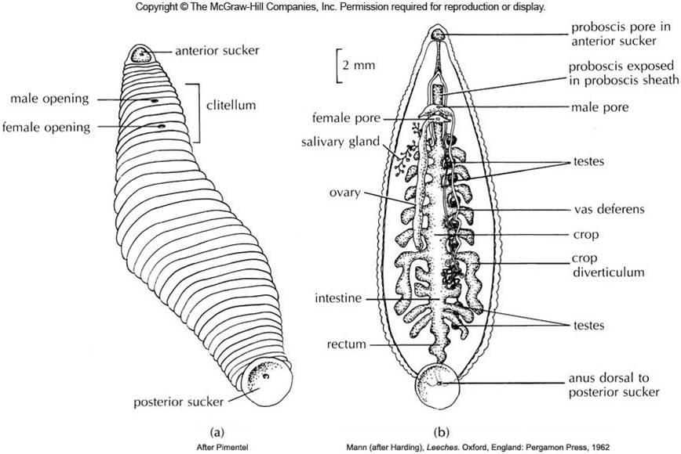

EARTHWORM: Earthworms are commonly found living in soil, feeding on live and dead organic matter. They are nocturnal and in day time they live in the burrows. During rainy season they come out and crawl on the ground. During dry season they close the burrows by leaves and debris. This is to warm the burrows. Their presence is marked by the occurrence of worm cast, the faecal deposit of earthworm. The body of the earthworm is segmented which looks like many little rings joined or fused together. The earthworm is made of about 100-150 segments. The segmented body parts provide important structural functions. Segmentation can help the earthworm move. Each segment or section has muscles and bristles called setae. The bristles or setae help anchor and control the worm when moving through soil. The bristles hold a section of the worm firmly into the ground while the other part of the bo dy protrudes forward. The earthworm uses segments to either contract or relax independently to cause the body to lengthen in one area or contract in other areas. Segmentation helps the worm to be flexible and strong in its movement. If each segment moved together without being independent, the earthworm would be stationary. The exterior of an individual segment is a thin cuticle over skin, commonly pigmented red to brown, which has specialized cells that secrete mucus over the cuticle to keep the body moist and ease movement through soil. Under the skin is a layer of nerve tissue, and two layers of muscles—a thin outer layer of circular muscle, and a much thicker inner layer of longitudinal muscle. An adult earthworm develops a belt-like glandular swelling, called the clitellum, which covers several segments toward the front part of the animal. This is part of the reproductive system and produces egg capsules. The ventral part is distinguished by the presence of genital openings.

Locomotion: Earthworms are invertebrates, which means they do not have a backbone. In fact, they don’t have any kind of bones, legs, eyes, or teeth. While earthworms do not have legs, they do have muscles. They have muscles that circle their body and muscles that go from one end to the other. The circular muscles allow the worm to make its body wider or narrower. The longitudinal muscles can shorten or lengthen the worm’s body. Using their muscles, earthworms crawl by lengthening its front part and pushing forward through the soil. The longitudinal muscles push the worm forward and the circular muscles squeeze the worm’s body inward. Working together, these different muscles move part of the worm forward. When this is happening, tiny bristles called setae on the underside of the worm hold the rear part of the worm in place. Once the front part has pushed forward, the front setae hold the worm in place and the rear setae turn loose. Now the worm is in position to pull its rear end forward.

Nutrition: Earthworms eat the soil which has organic matter such as decaying vegetation or leaves. Plants cannot use this organic matter directly. After organic matter is digested, the earthworm releases waste from their bodies called castings. Castings contain many nutrients that the plant can use. Some people even use earthworm castings as garden fertilizer. The digestive system is partitioned into many regions, each with a certain function. The digestive system consists of the pharynx, the esophagus, the crop, the intestine and the gizzard. Food such as soil enters the earthworm’s mouth where it is swallowed by the pharynx. Then the soil passes through the esophagus, which has calciferous glands that release calcium carbonate to rid the earthworm’s body of excess calcium. After it passes through the esophagus, the food moves into the crop where it is stored and then eventually moves into the gizzard. The gizzard uses stones that the earthworm eats to grind the food completely. The food moves into the intestines as gland cells in the intestine release fluids to aid in the digestive process. The intestinal wall contains blood vessels where the digested food is absorbed and transported to the rest of the body.

Respiration: Earthworms do not have lungs. They breathe through their skin. Oxygen and carbon dioxide pass through the earthworm’s skin by diffusion. For diffusion to occur, the earthworm’s skin must be kept moist. Body fluid and mucous is released to keep its skin moist. Earthworms therefore, need to be in damp or moist soil. This is one reason why they usually surface at night when it is possibly cooler and the “evaporating potential of the air is low.”

Circulatory system: Another important organ system is the circulatory system. The earthworm has a closed circulatory system. An earthworm circulates blood exclusively through vessels. There are three main vessels that supply the blood to organs within the earthworm. These vessels are the aortic arches, dorsal blood vessels, and ventral blood vessels. The aortic arches function like a human heart. There are five pairs of aortic arches, which have the responsibility of pumping blood into the dorsal and ventral blood vessels. The dorsal blood vessels are responsible for carrying blood to the front of the earthworm’s body. The ventral blood vessels are responsible for carrying blood to the back of the earthworm’s body.

Excretory system: The excretory system contains a pair of metanephridia in every segment, except for the first three and the last ones. The three types of metanephridia are: integumentary, septal, and pharyngeal. The waste in the coelom fluid from a forward segment is drawn in by the beating of cilia of the nephrostome. From there it is carried through the septum (wall) via a tube which forms a series of loops entwined by blood capillaries that also transfer waste into the tubule of the nephrostome. The excretory wastes are then finally discharged through a pore on the worm's side-nephridiopore.

Nervous system: The nervous system in earthworms and all annelids have a pair of cerebral ganglia. Posterior to the cerebral ganglia, ventral nerve cords run the length of the body and each body segment has its own pair of smaller ganglia.

Reproduction: Mating occurs on the surface, most often at night. Earthworms are hermaphrodites; that is, they have both male and female sexual organs. Copulation and reproduction are separate processes in earthworms. The mating pair overlap front ends ventrally and each exchanges sperm with the other. The clitellum becomes very reddish to pinkish in color. Sometime after copulation, long after the worms have separated, the clitellum (behind the spermathecae) secretes material which forms a ring around the worm. The worm then backs out of the ring, and as it does so, it injects its own eggs and the other worm's sperm into it. As the worm slips out of the ring, the ends of the cocoon seal to form a vaguely lemon-shaped incubator (cocoon) in which the embryonic worms develop. They emerge as small, but fully formed earthworms, but lack their sex structures, which develop in about 60 to 90 days.

Economic importance of annelids
- The casting and the open channels created by burrowing ease the downward growth of roots and enhance the fertility of the soil by increasing aeration and drainage.
- Thoroughly ground soil and secretions from the gizzard act as cement to hold soil particles together, improving soil structure and reducing erosion by compaction of soil.
- Leaves pulled into earthworms burrows are broken down by microorganisms, releasing nutrients such as nitrates, phosphates, potassium and magnesium that can be absorbed by plants.
- Earthworms and ragworms are used as fish bait.
- Ragworms are used as a food source in aquaculture.
- Some polychaetes are mollusk predators causing serious losses aquaculture and fisheries.
- The rear end of the Palolo worm (Eunice) that detaches for spawning is a Samoan delicacy.
- Aquatic oligochaetes are important food for fishes; a few are ectoparasites.
- Scientists study aquatic annelids to monitor the oxygen content, salinity and pollution levels in fresh and marine water.
- Burrowing species increase the penetration of water and oxygen and water into the seafloor sediment, which encourages the growth of populations of bacteria and small animals alongside their burrows.
- Earthworms are important prey for birds, and mammals, and in some cases conserving earthworms may be essential for conserving endangered birds.
- Some small tube-dwelling oligochetes transmit protozoan parasites that cause whirling disease in fish.
- Leeches can be used medically to bring circulation to areas of the body that have very poor circulation after an injury. Improved circulation prevents gangrene.
- The anticoagulant secreted by leeches keeps the circulation in injured limbs and digits from forming adhesions during the healing process.
- The anticoagulant and clot-digesting properties of substances secreted by leeches make them potentially useful as drugs for the treatment of cardiovascular diseases.
- Recently leeches have been used to assist in microsurgery, and their saliva has provided anti-inflammatory compounds and several important anticoagulants, one of which also prevents tumors from spreading.
- Leeches are vectors of fish trypanosomes (Sanguinicolidae).
- Ragworm jaws are made of unusual proteins that bind strongly to zinc and are strong but much lighter than the hard parts of many other organisms, which are biomineralized. This has attracted the attention of engineers.

