WHY HUMANS ARE UNABLE TO DIGEST CELLULOSE?
Humans do not produce and secrete $β$ (1-4) endoglucosidase in digestive juice. Therefore, they are unable to digest cellulose a polysaccharide of plant origin containing $β$ (1-4) glycosidic bonds between glucose residues. Undigested cellulose provide bulk or fibre (also called roughage) in the diet, fibre aids intestinal motility and act as a stool softer.
ABSORPTION OF CARBOHYDRATES
Carbohydrates (CHO) are absorbed as monosaccharides from the intestinal lumen through the mucosal epithelial cells into the blood stream of the portal venous system. Two (2) mechanisms are responsible for the absorption of monosaccharides:
1. Active transport against concentration gradient (uphill process)
The transport of glucose and galactose across the brush border membrane of mucosal cells occurs by an active transport, energy requiring process that requires a specific transport protein and the presence of sodium ions. glucose transporter.

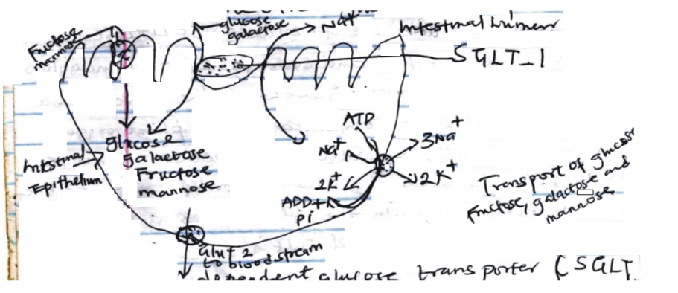
Figure 1: Transport of glucose, fructose, galactose and mannose

A sodium dependent glucose transport (SGLT-1) binds both glucose and sodium ions at separate sites and transport them both through the plasma membrane of the intestinal cells. The Na⁺ is transported down its concentration gradient (higher to lower concentration) and at the same time glucose is transported against its concentration gradient. This is called co-transporter or symport mechanisms.
The free energy required for this active transport is obtained from the hydrolysis of ATP linked to a sodium pump that expels Na⁺ from the cell in exchange of K⁺ . The molecular configuration that seems necessary for active transport are:
- The OH group on carbon 2 should have the same configuration as in glucose.
- A pyranose ring should be present
- A methyl or substituted methyl group should be present on carbon 5
The active transport of glucose is inhibited by cardiac glycoside ouabain; an inhibitor of Na pump and by phlorhizin an inhibitor of glucose reabsorption in the kidney tubule
2. Facilitative transport with the concentration gradient
Fructose and maltose are transported across the brush border by a Na⁺ independent facilitative diffusion process, involving another specific glucose transporter (GLUT 5). Movement of sugar in facilitative diffusion is strictly downhill, going from a higher concentration to a lower concentration unit its reaches an equilibrium. The same transport can also be used by glucose and galactose if the concentration gradient is favorable. The absorption of various monosaccharides from the intestinal lumen was found to have the following relative rate, based on glucose as 100:
- D-Galactose – 110
- D-Glucose - 100
- D-Fructose – 43
- D-Mannose - 19
- D-Xylose - 15
- D-Arabinose -09

TRANSPORT OF CARBOHYDRATE
The sodium independent transporter, (GLUT-2) that facilitate transport of sugars out of the mucosal cells, thereby entering the portal circulation and being transported to the liver. Several glucose transporter proteins have been described in various tissues. The role of these glucose transporter protein is shown in Table 1

Table 1: Glucose transporters
Transporters | Occurrence | Function
GLUT1 | Brain, kidney, colon, placenta and erythrocyte | Uptake of glucose
GLUT 2 | Liver, kidney, pancreatic beta cell, small intestine | Rapid uptake and release of glucose
GLUT3 | Brain, kidney, placenta | Uptake of glucose
GLUT4 | Heart, skeletal muscle, adipose tissue | Insulin stimulated uptake of glucose
GLUT 5 | Small intestine | Absorption of glucose
SGLT- 1 | Small intestine and kidney | Active uptake of glucose from lumen of intestine and reabsorption of glucose in proximal tubule of kidney against concentration gradient

DISORDERS OF DIGESTION AND ABSORPTION OF CHO
Any condition that result in impaired ability to digest and absorb CHO may result in bacterial fermentation in the large intestine with the production of hydrogen gas and CO₂ gases, and low molecular weight acid like acetic acid, propionic acid and butyric acid which are osmotically active.
Abdominal cramps and flatulence results from the accumulation of gases and the osmotically active product draw water from the intestinal cells into the lumen resulting in diarrhea and dehydration.
Examples include:
- Lactose intolerance
- Sucrose deficiency

