$$\frac{ε}{2}$$
$$\frac{ε}{2}$$
Pole Pitch ${180}^{0}$ Electrical
Fig 3: Short pitching

$$E_{v}$$
SLOT 1
E
SLOT 3
SLOT 2
E
E
(b)
$${}_{}{ K}_{d}= \frac{\sin{\frac{nℿσ}{2}}}{n\sin{\frac{σ}{2}}}……………………..(9$$

$${40}^{0}$$
$σ$ $={20}^{0}{ 20}^{0}$

$$σ$$
Pole Pitch ${180}^{0}$ Electrical
A
B
C
(a)
Fig 4: Phase Spread and Distribution Factor

The Hershey System  Power Quality  Power Quality Testimony  Energy Questionnaire  Equipment Photos  System Brochure  System Architecture  Employment Opportunities  Site Index | Harmonics  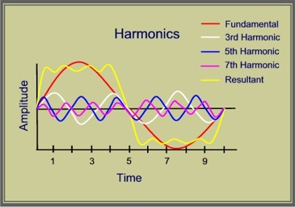  Harmonics: Harmonics by definition are a steady state distortion of the fundamental frequency (60 Hz). Harmonic distortion of current occurs when sinusoidal voltage is applied to a non-linear load (ex. electronic ballast, PLC, adjustable-speed drive, arc furnace, any ac/dc converter). The result is a distortion of the fundamental current waveform. This distortion occurs in integer multiples of the fundamental frequency (60 Hz). Hence, the 2nd Harmonic has a frequency = 2 x 60 = 120 Hz, the 3rd Harmonic = 180 Hz and so on. Voltage distortion, on the other hand, is generated indirectly as result of harmonic currents flowing through a distribution system.  It is important to note that the vast majority of harmonic currents found in a distribution system are odd-order harmonics (3rd, 5th, 7th, etc.). Secondly, more often than not, the sources of the harmonic currents in a distribution system are the loads in operation within that facility. Interestingly, these are frequently the types of loads that are the most sensitive to distortion in the current and/or voltage.  Triplen Harmonics – The triplen harmonics are defined as the odd multiples of the 3rd harmonic (ex. 3rd, 9th, 15th, 21st etc.). Triplen harmonics are of particular concern because they are zero sequence harmonics, unlike the fundamental, which is positive sequence. The consequence of this fact is that the magnitude of these currents on the 3 phases are additive in the neutral. This can lead to very large currents circulating in the neutral, and unless the neutral is sufficiently oversized this can present a fire hazard. These currents can also circulate in the transformer causing significant overheating there too. Single-phase power supplies for equipment such as electronic ballasts and PCs are the most significant source of Triplen harmonics.  5th and 11th Harmonics – The 5th and 11th harmonics are also of particular concern to industry today. Although the 5th harmonic is much more prevalent, both have a negative sequence. This means that when distorted voltage containing the 5th or 11th harmonic is applied to a 3-phase motor, it will attempt to drive the motor in reverse, creating a negative torque. In order to compensate for this negative torque, the motor must draw additional fundamental current. This, in turn, can cause overheating and/or the tripping of over-current protection devices. 6-Pulse adjustable speed drives are a major source of the 5th, 7th and 11th harmonics. 12-Pulse drives are significantly more expensive, and are a source of the 11th and 13th harmonics, but through their design are able to eliminate the 5th and 7th.  In general, harmonics present on a distribution system can have the following deleterious effects:  - Overheating of transformers & rotating equipment  - Increased Hysteresis losses  - Decreased kVA capacity  - Neutral overloading  - Unacceptable neutral-to-ground voltages  - Distorted voltage and current waveforms  - Failed capacitor banks  - Breakers and fuses tripping  - Interference on phone and communications systems  - Unreliable operation of electronic equipment  - Erroneous register of electric meters  - Wasted energy/hight electric bills - kW & kWh  - Wasted capacity - Inneficient distribution of power  - Increased maintenance of equipment and machinery  The Hershey Solution: The standard Hershey System will incorporate broadband harmonic filtering to mitigate the effects of harmonics in the system and render them to a harmless level, thereby helping to release kVA capacity in the transformer, while protecting conductors from overheating, improving the operation of plant equipment and reducing the losses caused by the harmonics.  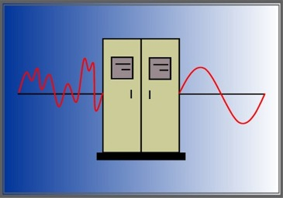  This is accomplished through the application of variable, non-saturable, zig-zag reactors both at the source of the harmonic currents (load) and at the transformer in the mainframe unit. Furthermore, if harmonics of excessive magnitude exist, optional specific harmonic filtering can be employed at the customer's request.
OCC
$$E_{a}$$

$$I_{f}$$

$k_{p}= \cos{\frac{nε}{2}}$

$$k_{d}= \frac{vector sum of emfs}{arithmetic sum}………………………………………………………\left(8\right)$$

