1.How is a synchronous motor used for power factor correction and How is it operated at max efficiency?
A Synchronous Machine when used for the purpose of reactive power control is called a Synchronous Compensator/Condenser/Capacitor. It is a Synchronous Motor, whose shaft spins freely without any torque on it except its weight.
A Synchronous Machine when used for power factor correction has two circuits, A Stator Circuit which is connected to the grid and a rotor circuit which is called Field winding/Excitation Winding. The field winding is controlled by a solid state voltage and frequency regulator.
Increasing the device's field winding excitation results in its furnishing reactive power (VARs) to the system and decreasing the field winding excitation causes absorption of reactive power from the system (VARs). Hence, it acts as a capacitor in over excited mode and an as inductor in under-excited mode.
The variations of I with excitation are known as V curves because of their shape.

A synchronous condenser operates at nearly zero real power as the machine passes from under-excited to overexcited, its stator current passes through a minimum.
ADVANTAGES
A synchronous condenser provides step-less automatic power factor correction with the ability to produce up to 150% additional vars. The system produces no switching transients and is not affected by system electrical harmonics (some harmonics can even be absorbed by synchronous condensers). They will not produce excessive voltage levels and are not susceptible to electrical resonances. Because of the rotating inertia of the synchronous condenser, it can provide real time voltage support during system short circuits.
HIGH TECH COMPENSATORS FOR MAXIMUM EFFICIENCY
The capacity of a synchronous condenser can be increased by replacing the copper wound iron field rotor with an iron less rotor of high temperature superconducting wire, which must be cooled to the liquid nitrogen boiling point of 77oK (-196 deg C). The superconducting wire carries 160 times the current of comparable copper wire, while producing a flux density of 3 Tesla or higher, an iron core would saturate at 2 Tesla in the rotor air gap. Such a machine is said to have considerable additional transient ability to supply reactive power to troublesome loads like metal melting arc furnaces. The manufacturers describe it as being a “reactive power shock absorber”. Such a synchronous condenser has a higher power density (smaller physically) than a switched capacitor bank. The ability to absorb or produce reactive power on a transient basis stabilizes the overall power grid against fault conditions.

Synchronous condenser installation at the substationin ABUAD.

INFINITE BUS
Definition: The bus whose voltage and frequency remains constant even after the variation in the load is known as the infinite bus. The alternators operating in parallel in a power system is the example of the infinite bus. The on and off of any of the alternator will not affect the working of the power system.
The capacity of a parallel operating system is enormous. Their voltage and frequency remain constant even after the disturbance of the load. The connection and disconnection of any of the machine will not affect the magnitude and phase of voltage and frequency of an infinite bus. In an infinite bus system
- The voltage and frequency always remain constant.
- The synchronous impedance of the bus is low because of parallel operations of the machine.

SYNCHRONOUS MACHINE ON INFINITE BUS
The performance of the synchronous machine varies on the infinite bus. When the synchronous machine operates independently, variation in their excitation causes the changes in their terminal voltage. The power factor of the synchronous machine depends only on their load. But when the synchronous machines are operating in parallel, the change in their excitation changes the power factor of the load.

OBTAINING AN INFINITE BUS
Consider generators G₁, G₂, G₃……G_{n} connected to an infinite bus as shown in the figure below.
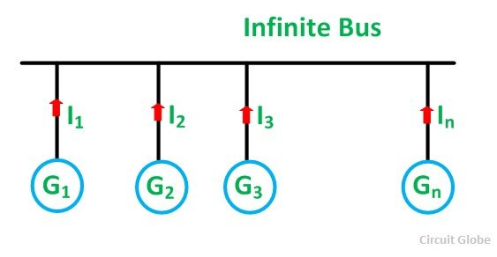Proof of Voltage Remaining Constant
Let,
- V be the terminal voltage of the bus
- E be the induced emf of each generator
- Z_{S} is the synchronous impedance of each generator
- n is the number of generators in parallel
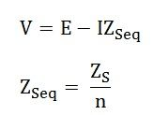
When n is very large Z_{Seq} → 0 and, therefore, I Z_{Seq} → 0
Therefore, V = E (constant)
If the number of alternators operating in parallel is infinite only then Z_{S} = 0
Proof of Frequency Remaining Constant
Let,
- J be the moment of inertia of each alternator
Total moment of inertia of all n alternators is given as
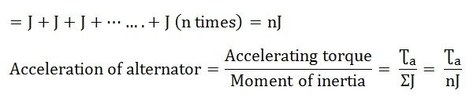If the value of n is very large, nJ is also very large.
Therefore, acceleration → 0 and the speed is constant.
The above equation shows that the constant voltage and frequency of the bus depend on the number of machines operating parallel.

What is synchronous impedance of an alternator?
1 Answer

A no load voltage is induced in the stator coils of alternator when rotor is rotated by a prime mover. When a balanced load is connected across stator winding a balanced set of 3 phase currents flow with a phase relation with no load voltage depending on nature of load. This set of currents produces a rotating magnetic field and has the same frequency as that of the no load voltage which is also the electrical frequency of the rotor.
Now this rotating magnetic field induces voltage in stator coils at the same electrical frequency as that of the rotor. Depending on nature of load, the no load voltage differs from terminal voltage.
The ratio of difference of no load voltage and actual terminal voltage to the current is the synchronous reactance of alternator.

PARALLEL OPERATION OF ALTERNATOR
Alternator is really an AC generator. In alternator, an EMF is induced in the stator (stationary wire) with the influence of rotating magnetic field (rotor) due to Faraday’s law of induction. Due to the synchronous speed of rotation of field poles, it is also known as synchronous generator.
Here, we can discuss about parallel operation of alternator. When the AC power systems are interconnected for efficiency, the alternators should also have to be connected in parallel. There will be more than two alternators connected in parallel in generating stations.

CONDITION FOR PARALLEL OPERATION OF ALTERNATOR
There are some conditions to be satisfied for parallel operation of the alternator. Before entering into that, we should understand some terms which are as follows.
- The process of connecting two alternators or an alternator and an infinite bus bar system in parallel is known as synchronizing.
- Running machine is the machine which carries the load.
- Incoming machine is the alternator or machine which has to be connected in parallel with the system.

The conditions to be satisfied are:
- The phase sequence of the incoming machine voltage and the bus bar voltage should be identical.
- The RMS line voltage (terminal voltage) of the bus bar or already running machine and the incoming machine should be the same.
- The phase angle of the two systems should be equal.
- The frequency of the two terminal voltages (incoming machine and the bus bar) should be nearly the same. Large power transients will occur when frequencies are not nearly equal.
Departure from the above conditions will result in the formation of power surges and current. It also results in unwanted electro-mechanical oscillation of rotor which leads to the damage of equipment.

GENERAL PROCEDURE FOR PARALLELING ALTERNATORS
The figure below shows an alternator (generator 2) being paralleled with a running power system (generator 1). These two machines are about to synchronize for supplying power to a load. Generator 2 is about to parallel with the help of a switch, S1. This switch should never be closed without satisfying the above conditions.
- To make the terminal voltages equal. This can be done by adjusting the terminal voltage of incoming machine by changing the field current and make it equal to the line voltage of running system using voltmeters.
- There are two methods to check the phase sequence of the machines. They are as follows
  - First one is using a Synchroscope. It is not actually check the phase sequence but it is used to measure the difference in phase angles.
  - Second method is three lamp method (Figure 2). Here we can see three light bulbs are connected to the terminals of the switch, S1. Bulbs become bright if the phase difference is large. Bulbs become dim if the phase difference is small. The bulbs will show dim and bright all together if phase sequence is the same. The bulbs will get bright in progression if the phase sequence is opposite. This phase sequence can be made equal by swapping the connections on any two phases on one of the generators.

- Next, we have to check and verify the incoming and running system frequency. It should be nearly the same. This can be done by inspecting the frequency of dimming and brightening of lamps.
- When the frequencies are nearly equal, the two voltages (incoming alternator and running system) will alter the phase gradually. These changes can be observed and the switch, S1 can be made closed when the phase angles are equal.

ADVANTAGES OF PARALLEL OPERATING ALTERNATORS
- When there is maintenance or an inspection, one machine can be taken out from service and the other alternators can keep up for the continuity of supply.
- Load supply can be increased.
- During light loads, more than one alternator can be shut down while the other will operate in nearly full load.
- High efficiency.
- The operating cost is reduced.
- Ensures the protection of supply and enables cost-effective generation.
- The generation cost is reduced.
- Breaking down of a generator does not cause any interruption in the supply.
- Reliability of the whole power system increases.

