What is Environmental Chemistry?
Environmental chemistry is the study of the sources, reactions, transport, and fates of chemical species involving all environmental spheres
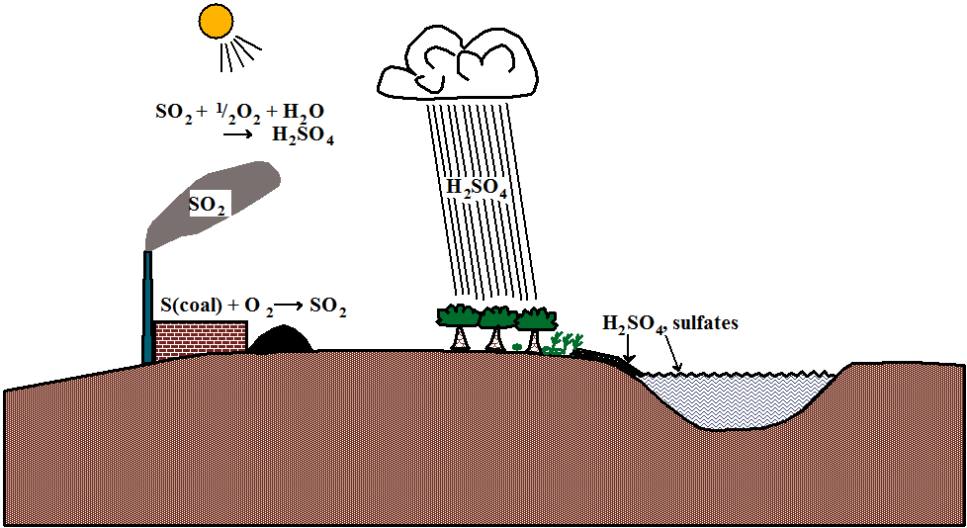

Aquatic Chemistry
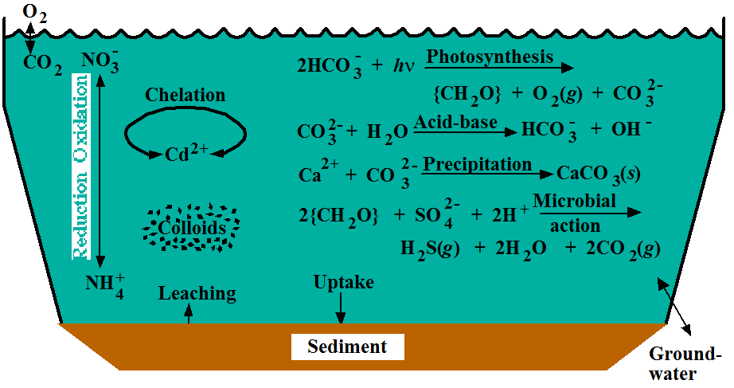

Atmospheric Chemistry
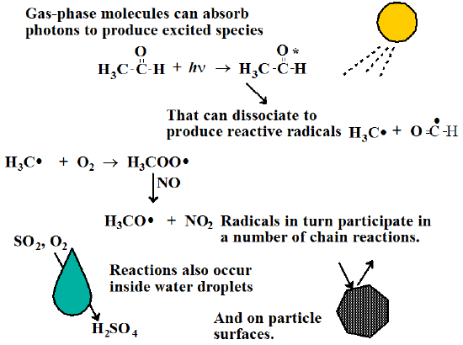

Chemistry of the Geosphere and Soil
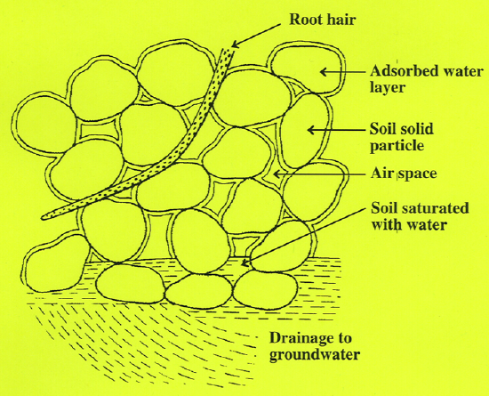

Chemistry of the Biosphere and Toxicological Chemistry
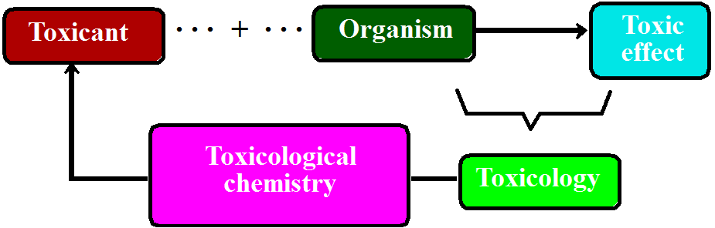

Chemistry of the Anthrosphere within a Framework of Industrial Ecology
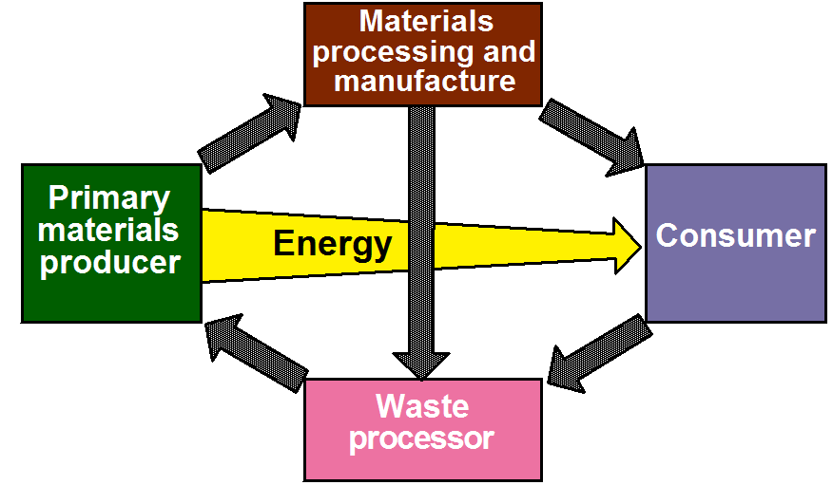

The Environment and the Five Environmental Spheres
‎Jun‎ ‎5‎, ‎2019
Donate
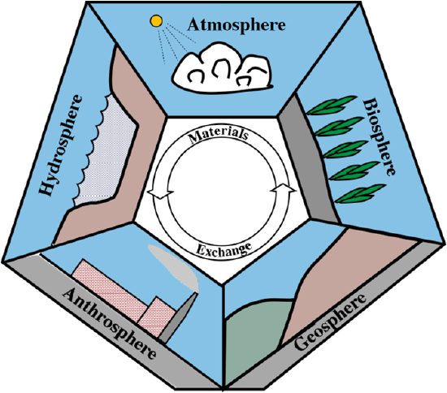

The Atmosphere
- Very thin, most within several kilometers of Earth’s surface
- Provides oxygen for animals and other organisms, carbon dioxide and nitrogen for plants
- Vital protective function
- Stratospheric ozone protects against harmful ultraviolet
- Stabilizes Earth’s temperature by re-absorbing outgoing heat as infrared radiation
- Conduit for fresh water by way of the hydrologic cycle

The Hydrosphere
- More than 97% in oceans
- Most of the remaining fresh water is ice and snow in polar ice caps and glaciers
- Small fraction of water in atmospheric water vapor
- Fresh water on the surface in lakes, reservoirs, and streams and as groundwater in underground aquifers

The Geosphere
- Includes all rocks and minerals
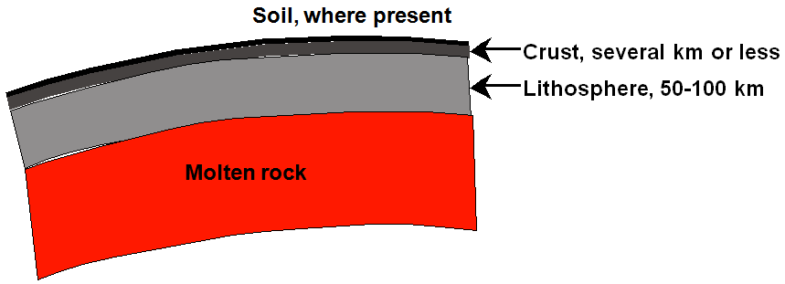
- The crust is the part of the geosphere that is available to interact with the other environmental spheres and that is accessible to humans

The Biosphere
- All living organisms
- Most found in a very thin layer at the interface of the geosphere and atmosphere and in the hydrosphere
- Involved with the geosphere, hydrosphere, atmosphere and even anthrosphere through biogeochemical cycles
- Biogeochemical cycles involve important life elements including carbon, nitrogen, and phosphorus

The Anthrosphere
- Strong interactions with other environmental spheres
- Cultivation of land modifies the geosphere
- Diversion and use of water affects the hydrosphere
- Emission of particles, acid gases, organics, greenhouse warming carbon dioxide
- Perturbation of biogeochemical cycles
- Entering anthropocene era

Environmental Pollution
Donate
Awareness from
- Silent Spring, Rachel Carson, 1962
- Approximately 10,000 deformed children from thalidomide
- Visible air pollution
- “Dead” bodies of water
- Love Canal around 1970

Command and Control Approach Emphasizing End-of-Pipe Treatment Measures

