ASSIGNMENT
SUBMIT TO THE Email : rominiyiol@abuad.edu.ng / engromslawani@yahoo.com
DEADLINE : 10 TH APRIL , 2020 ON OR BEFORE 12 MID NIGHT
NOTE : Any Assignment submitted after this given ultimatum will not be marked and graded. ( STAY SAFE)
QUESTION 1
(a)
- Give three conditions for coutte flow
- State four conditions that can be used to determine the nature of flow.
- In tabular form differentiate between aerofoil and hydrofoil.
(b)
A liquid of 0.9 Centipoise is filled between two horizontal plate of 10mm apart. If the upper plate moves at I m/s relative to the lower plate which is stationary and the pressure difference between the two sections 60 mmm apart is 60 kN/m² . Compute : (i) velocity distribution (ii) discharge per unit width
( iii) shear stress at the upper plate

QUESTION 2
Laminar flow of a liquid in fig2, whose viscosity is 0.9 Ns/m² and density of 1260 kg/m³ occurs between a pair of parallel plates of extensive width inclined at an angle 45⁰ to the horizontal. The upper plate moved with a velocity of 1.5 m/s relative to the lower plate in a direction opposite to the fluid flow . Pressure gauges mounted at two points 1m vertically apart on the upper plate records a pressure of 250 kN /m² and 80 kN /m² respectively.
Determine (a) Velocity and shear stress distribution between the plates
(b) maximum flow velocity
( c) Shear stress on the upper plate.
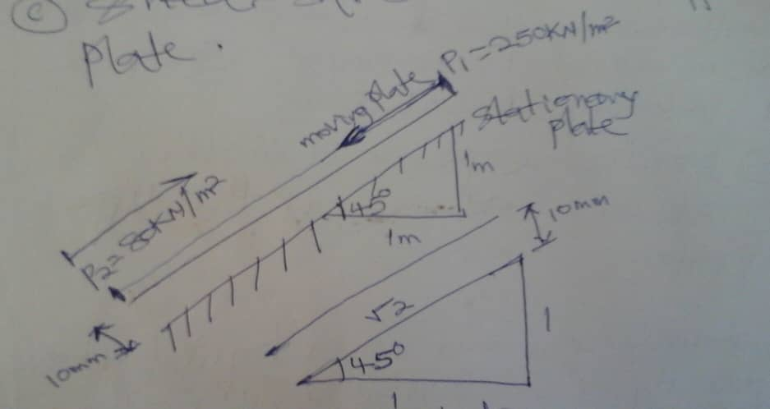
FIG2

Ans : (a) (i) Velocity distribution ; $u=566.4y-7.164 ×{10}^{-4} y^{2}$
(ii) Shear stress distribution $τ= .509.76-1.289 ×{10}^{5}y$
(b) u_{max} ( maximum velocity ) = 1.12 m/s , $τ @ y=3.9530 ×{10}^{-3} m=0.218 N/m^{2}$
( c) Shear stress at the upper plate : $τ \left(upper plate \right)$= - 0.78 N/m²

