

COLLEGE OF SOCIAL AND MANAGEMENT SCIENCES
DEPARTMENT OF TOURISM AND EVENTS MANAGEMENT
COURSE TITLE: THE EARTH SURFACE COURSE CODE: TEM 104

THE SOLAR SYSTEM

Introduction
The solar system comprises of the sun and other planets, essentially the sun is the principal element in the solar system. It is the major source of light and energy through which other planets received illumination.
This study session will help you to learn about the mechanisms and operation in the space particularly as it concerns solar system and its components.

The Solar System
To know exactly what we mean when we say "solar system" it is important to break it down into the two words that comprise the expression. Firstly, the term "solar" is simply a word that means "of the Sun." Secondly, a system is just a collection of objects that interact to form a whole. Thus, putting the two words together it can be referred to that the solar system is a group of objects that interact with one another, the fundamental interaction for each object being the one it has with the Sun. Our solar system has eight planets: Mercury, Venus, Earth, Mars, Jupiter, Saturn, Uranus and Neptune.
There are many different types of objects found in the solar system: a star, planets, moons, dwarf planets, comets, asteroids, gas, and dust. Figure 2.1 gives a clear understanding of some of the object found in the solar system. In terms of the numbers of each of these objects, our current knowledge is as follows:
- 1 star (The Sun)
- 8 planets (Mercury, Venus, Earth, Mars, Jupiter, Saturn, Uranus, and Neptune)
- 5 dwarf planets (Pluto, Ceres, Haumea, Makemake, and Eris)
- 181 moons
- 566,000 asteroids
- 3,100 comets
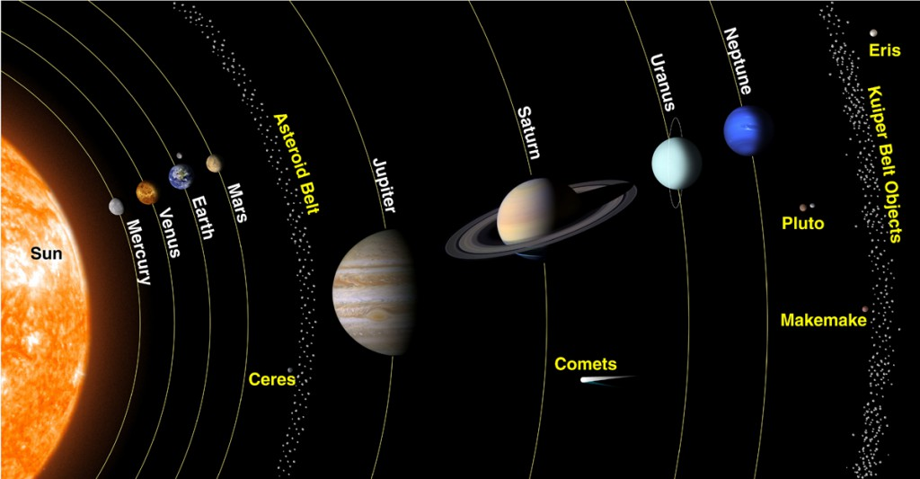
Fig. 2.1: The Planets, Dwarf Planets and other objects in our Solar System

The Formation of the Solar System
Although there is some debate as to the Solar System’s formation, the following outline is currently the best known explanation of how the Solar System developed.
- Approximately 4.6 billion years ago a large cloud of gas and dust was disturbed by some force. (Scientists have theorized that this force was a nearby supernova.)
- As a result of this disturbance and the energy introduced to the cloud, the cloud began to move.
- Once the movement began, the cloud started to collapse in on itself due to its own gravity.
- During the process of collapsing, the cloud began to rotate and heat up.
- As the cloud continued to collapse, the cloud’s temperature continued to rise and its rotation became faster and faster. As a result, the cloud eventually began to flatten out into a disk shape with most of the mass located at its center.
- At some point the pressure and temperature became so great at the cloud’s center that nuclear fusion began to take place. It was then that the Sun was born.
- After the Sun was born, the gases and dust further out from the disk’s center began to cool and condense into tiny particles.
- As more and more particles formed they began to collide with one another and stick together, thus creating particles as large as rocks and boulders.
- Like the smaller particles that collided, the boulder-sized particles began to impact and join together. These larger bodies are known as planetisimals.
- Eventually, enough planetisimals joined together to form planetary embryos. However, unlike the small particles, boulders, and planetisimals, planetary embryos were massive enough to exert significant gravitational force on surrounding objects. Hence, instead of random collisions between objects, planetary embryos pulled objects in the surrounding area to itself.
- Once all of the material in the area of each planetary embryo was pulled in, the planets were born.
- All other significant material in the solar system that did not join to form the Sun or the planets condensed to form the moons, asteroids, or comets.
- Over time, the orbits of the planets and other bodies stabilized into the solar system that we know today.

The Planet
The International Astronomical Union (IAU), the official governing body for matters concerning naming astronomical objects, came to a definition of the term “planet.” According to the IAU, a planet is a celestial body that meets the following criteria:
- Is in orbit around the Sun,
- Has sufficient mass for its self-gravity to overcome rigid body forces so that it assumes a hydrostatic equilibrium (nearly round) shape, and
- Has cleared the neighborhood around its orbit.

Thus, there exist Eight planets currently in the solar system which includes: Mercury, Venus, Earth, Mars, Jupiter, Saturn, Uranus, and Neptune. Pluto is no longer considered as a planet but a dwarf planet. Pluto which from its discovery in 1930 up until that year was considered the ninth planet in the Solar System, would now be stripped of that position and become a dwarf planet. The main reason that relegated Pluto to the dwarf planet status is that its orbit is riddled with other celestial objects that crisscross its path around the Sun.
Hence, each of these planets are distinguished from one another as a result of their unique attributes. With the exception of Uranus and Neptune, each of these planets can be seen unaided. All eight planets can be see through the use of an inexpensive amateur telescope or binoculars. figure 2.2 shows the order of the eight planets.
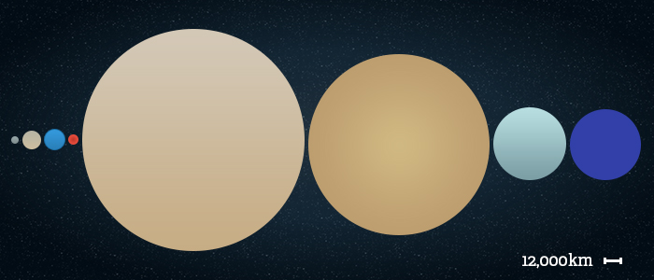
Fig.2.2: Order of the eight planets from left: Mercury, Venus, Earth, Mars, Jupiter, Saturn, Uranus and Neptune.
The order of planets from closest to farthest from the Sun are Mercury, Venus, Earth, Mars, Jupiter, Saturn, Uranus and Neptune. The largest planet is Jupiter, followed by Saturn, Uranus, Neptune, Earth, Venus, Mars and, the smallest planet, Mercury.
If you include dwarf planets as well, the planets in order becomes Mercury, Venus, Earth, Mars, Ceres, Jupiter, Saturn, Uranus, Neptune, Pluto, Haumea, Makemake and Eris being the furthest from the Sun.

Types of Planets
Generally, planets fall into two distinct categories based on their physical characteristics: the terrestrial planets and the gas giants.

1. Terrestrial Planets (Inner Planets)
There are four terrestrial planets: Mercury, Venus, Earth, and Mars. These planets are those closest to the Sun. They are characterized by their dense, rocky composition.

2. Gas Giants (Outer Planets)
There are also four gas giant planets: Jupiter, Saturn, Uranus, Neptune. These planets are found in the outer solar system. They are characterized by their massiveness and gaseous composition

The Sun and the Eight Other Planets
The Sun
The sun is the centre of the solar system, all objects (Planets) in the solar system orbit the sun; that is, they move around the sun in elliptical paths. Moreover, the orbits of these objects lie roughly in the same plane, called the ecliptic plane. The sun does not in itself move. It is stationary while all other planet moves or revolve around it. The sun is the largest star and has a surface temperature of 6000⁰C.
It is the ultimate source of light and energy to all the planets, other planet shine only through the reflected light from the sun. It is noteworthy that the sun which appear singly when viewed from the earth actually exist in groups or clusters which is better described as galaxies or nebulas.
The Eight Planets
Today we have eight planets that revolves around the sun, they include: Mercury, Venus, Earth, Mars, Jupiter, Saturn, Uranus and Neptune. The eight planets are discussed in the section below.
DISTANCE OF THE PLANETS FROM THE SUN
S/N | PLANET | DISTANCE FROM THE SUN | DIAMETER
1. | Mercury | 57,910,000 km (0.387 AU) | 4,879 km
2. | Venus | 108,200,000 km (0.723 AU) | 12,104 km
3. | Earth | 149,600,000 km (1.000 AU) | 12,756 km
4. | Mars | 227,940,000 km (1.524 AU) | 6,805 km
5. | Jupiter | 778,330,000 km (5.203 AU) | 142,984 km
6. | Saturn | 1,424,600,000 km (9.523 AU) | 120,536 km
7. | Uranus | 2,873,550,000 km (19.208 AU) | 51,118 km
8. | Neptune | 4,501,000,000 km (30.087 AU) | 49,528 km
9. | Pluto (Dwarf planet) | 5,945,900,000 km (39.746 AU) | 2,368 km (+- 20km)
Table 2.1: Distance of the Planets from the Sun
1. Mercury
Mercury is the closest planet to the Sun and is also the smallest of the eight planets in our solar system. It thus completes its orbit in a much shorter space of time than does by planet earth. A year in mercury is only 88 days, thus, it has the shortest orbit around the sun. It is the hottest of the entire planet since is the closest to the sun; therefore, mercury does not support the existence of any living organism (plant and animal) as a result of its attendant high temperature.
Mercury has a mass 330,104,000,000,000 billion kg (0.055 x Earth), an equatorial diameter of 4,879 km, polar diameter 4,879 km, equatorial circumference 15,329 km and no satellite or moon, its distance from the sun is 57,910,000 km, also, it is one of five planets that is visible to the naked eye.
MERCURY PROFILE
Mass: 330,104,000,000,000 billion kg (0.055 x Earth)
Equatorial Diameter: 4,879 km
Polar Diameter: 4,879 km
Equatorial Circumference: 15,329 km
Known Moons: None
Notable Moons: None
Orbit Distance: 57,909,227 km (0.39 AU)
Orbit Period: 87.97 Earth days
Surface Temperature: -173 to 427°C
First Record: 14th Century BC
Recorded by: Assyrian astronomers
2. Venus
Venus is the second planet from the Sun and the third brightest object in Earth's sky after the Sun and Moon. It is sometimes referred to as the sister planet to Earth, because their size and mass are so similar. Venus is also the closest planet to Earth. The surface of Venus is hidden by an opaque layer of clouds which are formed from sulphuric acid. The planet is named for Venus, the Roman goddess of love and beauty and is the second largest terrestrial planet.
The orbit of the planet takes 225 Earth-days making a year on Venus. Venus is sometimes called Earth’s sister planet. This is because their size is very similar (there is only a 638 km different in diameter) and Venus has around 81% of Earth’s mass. They are also similarly located with Venus being the closest planet to Earth. Both planets also have a central core, a molten mantle and a crust.
Venus has a mass of 4,867,320,000,000,000 billion kg, equatorial diameter 12,104 km, polar diameter 12,104 km, it has a distance of 108,209,475 km from the sun, it has no satellite or moon, it has an equatorial circumference of 38,025 km.

VENUS PROFILE
Mass: 4,867,320,000,000,000 billion kg (0.815 x Earth)
Equatorial Diameter: 12,104 km
Polar Diameter: 12,104 km
Equatorial Circumference: 38,025 km
Known Moons: None
Notable Moons: None
Orbit Distance: 108,209,475 km (0.73 AU)
Orbit Period: 224.70 Earth days
Surface Temperature: 462° C
First Record: 14th Century BC
Recorded by: Babylonian astronomers

3. Earth
Earth is the third planet from the Sun and largest of the terrestrial planets. Surprisingly, while it is only the fifth largest planet in terms of size and mass, it is the densest (5,513 kg/m3) of all the planets. The word “Earth” comes from the Old English word “ertha” meaning ground or land. Earth is the only planet not named for a mythological god or goddess. The other seven planets in the solar system were named after Roman gods or goddesses. Earth’s atmosphere is composed of 78% nitrogen, 21% oxygen, and trace amounts of other gases including argon and carbon dioxide.
The Earth which is the only planet that support and also conducive for the existence of both plant and animals; like many other planets, the earth has a natural satellite which is known as the moon which revolves eastward around the earth once twenty-seven days. It takes the earth 365^{1/4} days (a year) to complete a revolution around its orbit. It has a mass of 5,972,190,000,000,000 billion kg, equatorial diameter of 12,756 km, polar diameter of 12,714 km, and equatorial circumference of 40,030 km. The distance between the earth and the sun is 149,598,262 km also, also the distance between the earth and the moon is 384,629 km.
EARTH PROFILE
Mass: 5,972,190,000,000,000 billion kg
Equatorial Diameter: 12,756 km
Polar Diameter: 12,714 km
Equatorial Circumference: 40,030 km
Known Moons: 1
Notable Moons: The Moon
Orbit Distance: 149,598,262 km (1 AU)
Orbit Period: 365.26 Earth days
Surface Temperature: -88 to 58° C

4. Mars
Mars is the fourth planet from the Sun and last of the terrestrial planets. Like the rest of the planets in the solar system (except Earth), Mars is named after a mythological figure - the Roman god of war. In addition to its official name, Mars is sometimes called the Red Planet because of the brownish-red color of its surface. Mars is the second smallest planet in the solar system behind Mercury.
It takes Mars 687 Earth days to orbit the Sun with its orbit radius of 227,840,000 km. it has mass of 641,693,000,000,000 billion kg, equatorial diameter of 6,805 km, polar diameter 6,755 km, equatorial circumference 21,297 km, and has two moons. Much attention has been focused on mars to explore the possibilities of extending man’s influence to it.
MARS PROFILE
Mass: 641,693,000,000,000 billion kg (0.107 x Earth)
Equatorial Diameter: 6,805 km
Polar Diameter: 6,755 km
Equatorial Circumference: 21,297 km
Known Moons: 2
Notable Moons: Phobos & Deimos
Orbit Distance: 227,943,824 km (1.38 AU)
Orbit Period: 686.98 Earth days (1.88 Earth years)
Surface Temperature: -87 to -5 °C
First Record: 2nd Millenium BC

5. Jupiter
Jupiter is the largest and most massive planet in the Solar System. Jupiter has 67 confirmed moons orbiting the planet. These moons are separated into three groups: Inner moons; Galilean moons; and Outer moons. Jupiter has the shortest day of the eight planets. The planet rotates very quickly, turning on its axis once every 9 hours and 55 minutes. One orbit of the Sun takes Jupiter 11.86 Earth years. its surface is made up of many gases like hydrogen, helium and methane.
Also, it is distinguished from other planets by its circular light and dark bands. It has mass 1,898,130,000,000,000,000 billion kg, equatorial diameter 142,984 km, polar diameter 133,709 km, equatorial circumference 439,264 km, known Moons 67 and four rings.
JUPITER PROFILE
Mass: 1,898,130,000,000,000,000 billion kg (317.83 x Earth)
Equatorial Diameter: 142,984 km
Polar Diameter: 133,709 km
Equatorial Circumference: 439,264 km
Known Moons: 67
Notable Moons: Io, Europa, Ganymede, & Callisto
Known Rings: 4
Orbit Distance: 778,340,821 km (5.20 AU)
Orbit Period: 4,332.82 Earth days (11.86 Earth years)
Surface Temperature: -108°C
First Record: 7th or 8th Century BC
Recorded by: Babylonian astronomers
6. Saturn
Saturn is the sixth planet from the Sun and second largest planet of the Solar System in terms of diameter and mass. Saturn is known as a gas giant, but scientists believe it has a solid rocky core surrounded by hydrogen and helium. Saturn and Jupiter combined account for 92% of the entire planetary mass in the solar system. The interior of Saturn is very hot, reaching temperatures of up to 11,700°C (21,000 °F). Saturn is 1,426,666,422 km from the Sun. It is very far from the sun; hence it takes 29^{1/2} years to complete its orbit.
It has mass of 568,319,000,000,000,000 billion kg, equatorial diameter 120,536 km, polar diameter 108,728 km, equatorial circumference 365,882 km, and 62 moons. Saturn has three notable rings.

SATURN PROFILE
Mass: 568,319,000,000,000,000 billion kg (95.16 x Earth)
Equatorial Diameter: 120,536 km
Polar Diameter: 108,728 km
Equatorial Circumference: 365,882 km
Known Moons: 62
Notable Moons: Titan, Rhea & Enceladus
Known Rings: 30+ (7 Groups)
Orbit Distance: 1,426,666,422 km (9.58 AU)
Orbit Period: 10,755.70 Earth days (29.45 Earth years)
Surface Temperature: -139 °C
First Record: 8th Century BC
Recorded by: Assyrians

7. Uranus
Uranus, named after the father of the Roman god Saturn, is the seventh planet in the Solar System and third of the gas giants. It is the third largest planet by diameter, yet fourth most massive. Unlike others planets, Uranus orbits around the sun in a clockwise direction from east to west with five satellites revolving round it. Uranus is the coldest planet in the solar system. The minimum surface temperature on Uranus is -224°C – making it the coldest of the eight planets.
The mass of Uranus is 86,810,300,000,000,000 billion kg about 14.5 times the mass of Earth, making it the lightest of the four gas giants of the outer solar system. It takes Uranus 84 years to orbit the Sun. it has equatorial diameter of 51,118 km, polar diameter of 49,946 km, equatorial circumference of 159,354 km, and 27 moons.
URANUS PROFILE
Mass: 86,810,300,000,000,000 billion kg (14.536 x Earth)
Equatorial Diameter: 51,118 km
Polar Diameter: 49,946 km
Equatorial Circumference: 159,354 km
Known Moons: 27
Notable Moons: Oberon, Titania, Miranda, Ariel & Umbriel
Known Rings: 13
Orbit Distance: 2,870,658,186 km (19.22 AU)
Orbit Period: 30,687.15 Earth days (84.02 Earth years)
Surface Temperature: -197 °C
First Record: March 13th 1781
Recorded by: William Herschel

8. Neptune
Neptune is the eighth planet from the Sun and last of the known planets. While it is the third largest planet with respect to mass of 102,410,000,000,000,000 billion kg, it is only the fourth largest in terms of diameter. Due to its blue coloration, Neptune was named after the Roman god of the Sea.
It takes Neptune 164.8 Earth years to orbit the Sun. On 11 July 2011, Neptune completed its first full orbit since its discovery in 1846. Neptune has 14 known moons, Neptune has an average surface temperature of -214°C. Neptune has equatorial diameter of 49,528 km, polar diameter 48,682 km, equatorial circumference 155,600 km.
NEPTUNE PROFILE
Mass: 102,410,000,000,000,000 billion kg (17.15x Earth)
Equatorial Diameter: 49,528 km
Polar Diameter: 48,682 km
Equatorial Circumference: 155,600 km
Known Moons: 14
Notable Moons: Triton
Known Rings: 5
Orbit Distance: 4,498,396,441 km (30.10 AU)
Orbit Period: 60,190.03 Earth days (164.79 Earth years)
Surface Temperature: -201 °C
First Record: September 23rd 1846
Recorded by: Urbain Jean Joseph Le Verrier & Johann Galle

S/N | PLANET | NO OF MOONS | NO OF RINGS
1. | Mercury | None | None
2. | Venus | None | None
3. | Earth | 1 | None
4. | Mars | 2 | None
5. | Jupiter | 67 | 4
6. | Saturn | 62 | 30
7. | Uranus | 27 | 13
8. | Neptune | 14 | 5
Table 2. Distributions of Moons and Rings among Planets in the Solar System

