BFN 408 (Capital Market Operations
How to interpret stock market tables
Stock markets around the world are creators of wealth for investors. The stock market, like any market, has its own conventions and rules governing how trades are executed and recorded. It is important for any investor to understand how the stock market functions, specifically how to read the daily market tables and place orders with a stockbroker.
We will use the stock table below as a learning guide. Note that there is no accepted guideline on how the columns and data are presented.
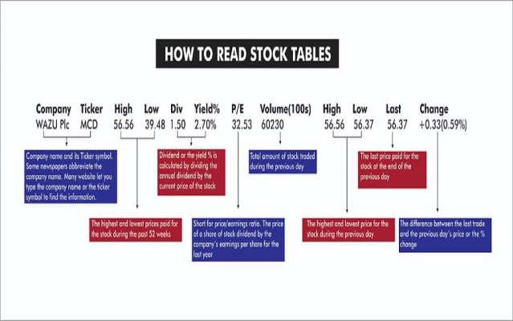

The first column
This is usually the name of the company and its trading symbol. When a company is listed, its name will be displayed digitally and on paper in the daily trading report of the Exchange. The stock symbol is a unique series of letters assigned to that stock for trading purposes, like a personalized license plate.

The high and low prices
These represent the highest prices paid in the last 52 weeks for each unit of that stock. This a quick way for the investor to visually determine how the current market price relates to the 52 weeks’ trend. This is simply a guide; it is important that the investor does not become “anchored” to any price but uses the price as a basis to ask questions, e.g. Why did prices drop this low? Was the demand weak for the stock? Etc.
Dividend and Dividend yield
These are very important data on the stock in question. A dividend is simply the return declared by the company to shareholders; for example, the company can declare a dividend of N10 per share, thus the dividend is N10. Dividend yield, however, is that N10 dividend expressed as a percentage of the price of the stock. If the price of the stock is N100 and the dividend is N10, then the dividend yield is N10/N100 or 10%. Again, the dividend yield should prompt questions: Is the yield high because the share price has fallen or because the dividend payout has increased? What is the trend of the yield- is it increasing or decreasing? What are other similar stocks in the same industry returning in terms of yield?
The main use of the dividend yield to the investor is to allow for an even comparison amongst asset classes. The investor should compare dividend yields of stocks to dividend yields of bonds, this will tell which asset class is returning more in terms of yield to the investor.
Keep in mind that dividend yield can change daily if prices also change; thus, dividends can be said to be tactical information.
Price Earnings Ratio
The PE ratio is simply the price of the stock divided by the earning per share of the stock. It’s a measure of how “expensive” the stock is; if the PE is 12, it means that an investor is paying N12 to receive N1.00 of earnings of the company. The PE of the stock, not the price of the stock tells more about how “expensive” the stock is.
If you take an inverse of the PE ratio, you get the earning yield of the stock. Just like the dividend yield, the earnings yield enables the investor to compare across other asset classes, i.e. compare the earning yield of a stock to earning yield of a bond.

Volume traded
Volume traded refers to how much of the stock changed hands between buyers and sellers on the market for that trading day. The importance of volume traded cannot be overstated.
Basic economics tells us that more demand equals higher prices and less demand equals falling prices, same for the stock market. If a stock is on “offer” (meaning there is more supply than demand) then the price of that stock will start to fall, as brokers will reduce prices to attract buyers. If demand is strong, then prices will rise, and brokers will offer higher prices to get that stock. If an investor wants to buy or sell, watching and tracking the volume traded will be beneficial.

Daily High and Low prices
Like the 52-week High and Low price, this data point simply indicates to the investor that the previous day closed on bid (to buy) or offer (to sell). However, the investor cannot reach a conclusion on just one day’s trading result but must seek to establish a trend. Why are others selling? What is the support level (price the stock won’t breach if it’s falling)? These questions give a bigger picture to investors and allow decision making to be data-driven.

The % Change
This shows the investor the % daily movement in prices. Most stock markets have a set predetermined % change before a bid/offer can translate to a price increase/decrease. Comparing the volume trades with % daily change can be a forward indicator of price movements.

Placing your trade order
With this understanding of how to read stock tables, how can an investor place trade?
For example, If you want to buy 100 units of MTN stock, you have many ways of placing that order to protect your portfolio from loss.
- Market Order: you can ask your broker to buy MTN at the best market price. This means that the broker will simply fill your order, based on the prevailing market price when the order was made. It can be higher or lower than when you gave that mandate to buy.
- Limit Order: A limit order places limits on a market order. For example, you can tell your stockbroker to “buy MTN shares at market price, but stop at N200.” This mandate allows your broker to fill your stock purchase mandate, but not to buy at a price above N200 per share. A limit order can also be on the sell-side. Thus, you can instruct your broker to “sell MTN share at best market but not less than N150.” This means your broker can sell but cannot sell if the stock falls below N150.
- Stop Orders: A stop order closes an open market order. When a market order is placed, you are telling your broker to fill that order at that market price, a stop order states when to terminate the market order. So you can tell your stock broker, “buy MTN units of MTN at a N200 limit, then stop at 100 units.”
- Bracketed Orders: if you trade, you may want to use a bracket order. A bracket order is a buy/stop order simultaneously accompanied by a sell/stop order, usually above the buy/stop order. For example, you tell your broker “Buy 100 MTN shares at stop order of N200, sell at the market limit of 250/150.” This means that your broker will only buy when the share price is at or below N200. Your broker will also sell once the stock bought has reached two-stop triggers, either at a price of N250 locking in profits of at 150 reducing a loss position. This kind of offer allows you to participate in price swing up and down.

