What Are the Different Types of Malaria Parasites?
- Plasmodium falciparum (or P. falciparum)
- Plasmodium malariae (or P. malariae)
- Plasmodium vivax (or P. vivax)
- Plasmodium ovale (or P. ovale)
- Plasmodium knowlesi (or P. knowlesi)

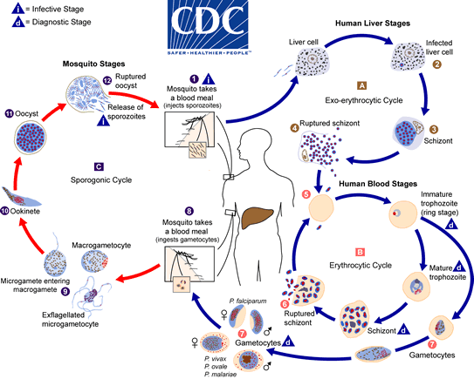
The malaria parasite life cycle involves two hosts. During a blood meal, a malaria-infected female Anopheles mosquito inoculates sporozoites into the human host . Sporozoites infect liver cells and mature into schizonts , which rupture and release merozoites . (Of note, in P. vivax and P. ovale a dormant stage [hypnozoites] can persist in the liver (if untreated) and cause relapses by invading the bloodstream weeks, or even years later.) After this initial replication in the liver (exo-erythrocytic schizogony ), the parasites undergo asexual multiplication in the erythrocytes (erythrocytic schizogony ). Merozoites infect red blood cells . The ring stage trophozoites mature into schizonts, which rupture releasing merozoites . Some parasites differentiate into sexual erythrocytic stages (gametocytes) . Blood stage parasites are responsible for the clinical manifestations of the disease. The gametocytes, male (microgametocytes) and female (macrogametocytes), are ingested by an Anopheles mosquito during a blood meal . The parasites’ multiplication in the mosquito is known as the sporogonic cycle . While in the mosquito’s stomach, the microgametes penetrate the macrogametes generating zygotes . The zygotes in turn become motile and elongated (ookinetes) which invade the midgut wall of the mosquito where they develop into oocysts . The oocysts grow, rupture, and release sporozoites, which make their way to the mosquito’s salivary glands. Inoculation of the sporozoites into a new human host perpetuates the malaria life cycle.
Comparative properties of antimalarial drugs
 |  | PRE | ERYTHRO | ERYTH |  | Phase | Hypnozoite | Gamete | Resistance | Toxicity Grading
S/N | DRUG | Fal | Viv | Activity | Onset | Duration
1 | Chloroquine | _ | - | + | Fast | Long | _ | - | Slow | +
2 | Mefloquine | _ | - | + | Int | Long | _ | - | Minor | ++
3 | Quinine | - | - | + | Int | Short | - | - | Minor | +++
4 | Proguanil | + | - | + | Int | Short | - | * | Rapid | ±
5 | .Pyrimethamine | _ | - | + | Slow | Long | _ | - | Rapid | +
6 | Primaquine | + | + | - | - | - | + | + | Minor | ++
7 | Sulfonamides | _ | - | ± | slow | Long | _ | - | Minor | +±
8 | Tetracyclines | _ | - | + | slow | Short | _ | - | Nil | +
9 | Clindamycin | _ | - | + | slow | Short | _ | - | Nil | +
10 | Artemisinin | _ | - | + | Fastest | Short | _ | + | Nil | +
11 | Lumefantrine | _ | - | + | Int | Long | _ | - | Nil | +

*Do not kill gametes but may inhibit their development in mosquito.
Pre-erythro. — Preerythrocytic stage; Fal. — P. falciparum; Viv — P. vivax; Int — Intermediate

