Actuation Systems
Introduction

Hydraulic and Pneumatic Systems

Mechanical Actuation Systems

Electrical Actuation Systems

INTRODUCTION
Mechatronic systems employ actuators or drives that are part of the physical process being monitored and controlled. Actuation is the result of a direct physical action upon the process, such as removing a workpiece from a conveyor system or the application of a force. It has a direct effect upon the process. Actuators take low power signals transmitted from the computer and produce high power signals which are applied as input to the process. Actuation systems are the elements of control systems which are responsible for transforming the output of a microcontrollers or microprocessor or control system into a controlling action on machine.
The controlled movement of parts or a controlled application of force is a common
requirement in the industries. These operations are performed mainly by using electrical
machines or diesel, petrol and steam engines as a prime mover. These prime movers can
provide various movements to the objects by using some mechanical attachments like
screw jack, lever, rack and pinions etc. However, these are not the only prime movers. An enclosed fluid like in (hydraulic and pneumatic system) can also function as prime mover. Actuating system can be classified into Pneumatic, hydraulic, mechanical, electrical and thermal actuating system.
Fig. 1 illustrate a typical mechatronic system of plant from the starting parameter measurement by sensor to the final stage of controlling the machine by actuator. The parameter or variable could be temperature, pressure, strain, position, proximity, motion parameter among others depending on the plant. For instance, for a conveyor system plant, the variable could be position. The sensor will be the corresponding sensor for the variable. The sensing signal from the sensor will be sent to the signal conditioning devices where it will be processed ( e.g filtering, amplification etc) to obtain the required signal which will be sent to the microprocessor. The microprocessor in which a control code is written. The code could be any programing language like (C++, Phyton, Matlab etc) processed the required signal to end a command signal to the actuator where action or motion take place.

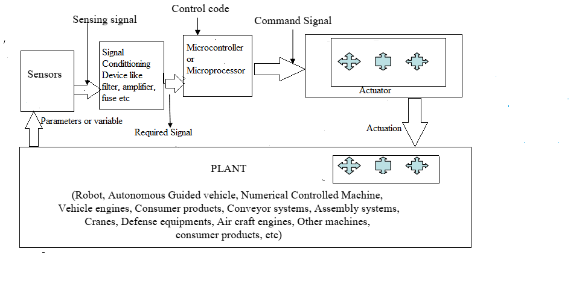
Fig. 1

Classification of Actuator
Actuator can be classified into Hydraulic, pneumatic, mechanical, Electrical and thermal actuator

HYDRAULIC SYTEM
The enclosed fluids (liquids and gases) can be used as prime movers to provide
controlled motion and force to the objects or substances. The specially designed enclosed
fluid systems can provide both linear as well as rotary motion. The high magnitude
controlled force can also be applied by using these systems. This kind of enclosed fluid
based systems using pressurized incompressible liquids as transmission media are called
as hydraulic systems.
The hydraulic system works on the principle of Pascal’s principle which
says that the pressure in an enclosed fluid is transformed uniformly in all the directions. The Pascal’s Pinciple is illustrated in figure 2. The force given by fluid is given by the multiplication of pressure and area of cross section. As the pressure is same in all the direction, the smaller
piston feels a smaller force and a large piston feels a large force. Therefore, a large force
can be generated with smaller force input by using hydraulic systems.

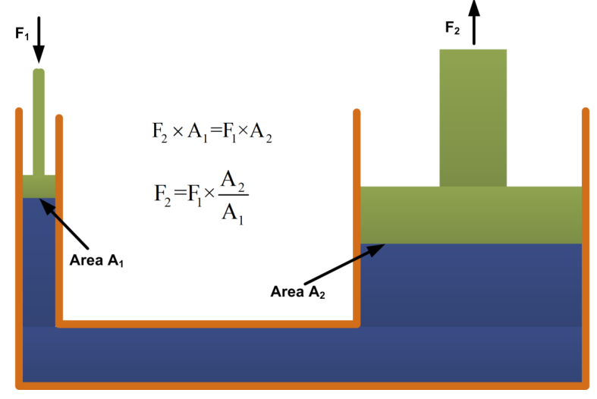
Figure 2 : Pascal Principle illustration
The hydraulic systems consists a number of parts for its proper functioning. These
include storage tank, filter, hydraulic pump, pressure regulator, control valve, hydraulic
cylinder, piston and leak proof fluid flow pipelines. The schematic of a simple hydraulic
system is shown in figure 3.
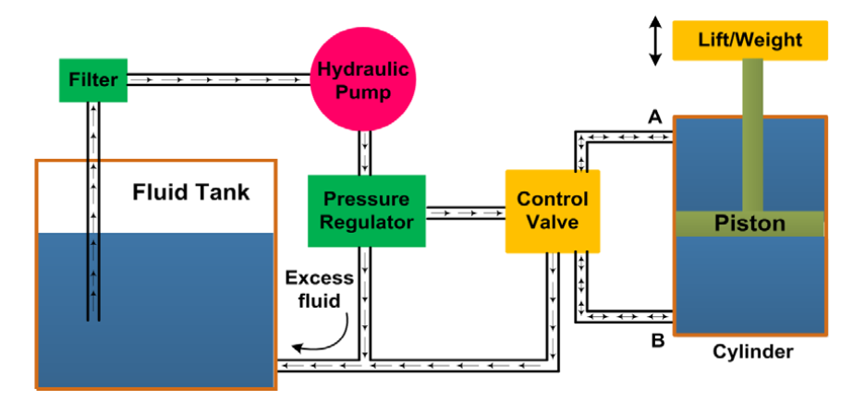
Figure 3 Schematic of hydraulic system

Functions of various components of Hydraulic systems
- The output shaft : It transfers the motion or force however all other parts help to control the system.
- The storage/fluid tank : It is a reservoir for the liquid used as a transmission media.
The liquid used is generally high density incompressible oil.
- Filter: It is used to remove dust or any other unwanted particles and then pumped by the hydraulic pump.
- Hydraulic Pump: These pumps generally deliver constant
volume in each revolution of the pump shaft. Therefore, the fluid pressure can increase
indefinitely at the dead end of the piston until the system fails. The capacity of pump depends on the hydraulic system design.
- Pressure regulator ; This is used to avoid such circumstances which redirect the excess fluid back to the storage tank. The movement of piston is controlled by changing liquid flow from port A and port B.
- Control valve: The cylinder movement is controlled by using control valve which directs the fluid flow. The fluid pressure line is connected to the port B to raise the piston and it is connected to port A to lower down the piston. The valve can also stop the fluid flow in any of the port.
- The leak proof piping is also important due to safety, environmental hazards and
economical aspects.
Some other components like flow control system, travel limit control,
electric motor starter and overload protection may also be used in the hydraulic systems
though not shown in figure 3.
APPLICATIONS OF HYDRAULIC SYSTEMS
The hydraulic systems are mainly used for precise control of larger forces. The main
applications of hydraulic system can be classified in five categories:
Industrial: Plastic processing machineries, steel making and primary metal
extraction applications, automated production lines, machine tool industries,
paper industries, loaders, crushes, textile machineries, R & D equipment and
robotic systems etc.
Mobile hydraulics: Tractors, irrigation system, earthmoving equipment, material handling equipment, commercial vehicles, tunnel boring equipment, rail
equipment, building and construction machineries and drilling rigs etc.
Automobiles: It is used in the systems like breaks, shock absorbers, steering
system, wind shield, lift and cleaning etc.
Marine applications: It mostly covers ocean going vessels, fishing boats and
navel equipment.
Aerospace equipment: There are equipment and systems used for rudder
control, landing gear, breaks, flight control and transmission etc. which are used
in airplanes, rockets and spaceships.

Worked Example
A hydraulic cylinder to be used to move a work piece in a manufacturing operation through a distance of 240 mm in 12s. if a force of 40 KN is required to move the work piece, what is the required working pressure and hydraulic liquid flow rate if a cylinder with a piston diameter of 120 mm is available.
Solution:
Area , A = $\frac{πd^{2}}{4}$ = $\frac{π{(0,12)}^{2}}{4}$ = $0.0113m^{2}$
- The working pressure, P = $\frac{F}{A}$ = $\frac{40000N}{0.0113m^{2}}$ = $3.54MPa$
- The speed of a hydraulic cylinder = flow rate of the
liquid through the cylinder
Flow rate, $Q = A.v= 0.0113m^{2}\left(\frac{0.24m}{12s} \right)$ = 2.26 $×$ ${10}^{-4}$ $m^{3}/s$
Pneumatic System :
Pneumatic systems use air as the medium which is available and can be exhausted into the atmosphere after completion of the task.
1. Basic Components of Pneumatic System
Important components of a pneumatic system are shown in fig.4

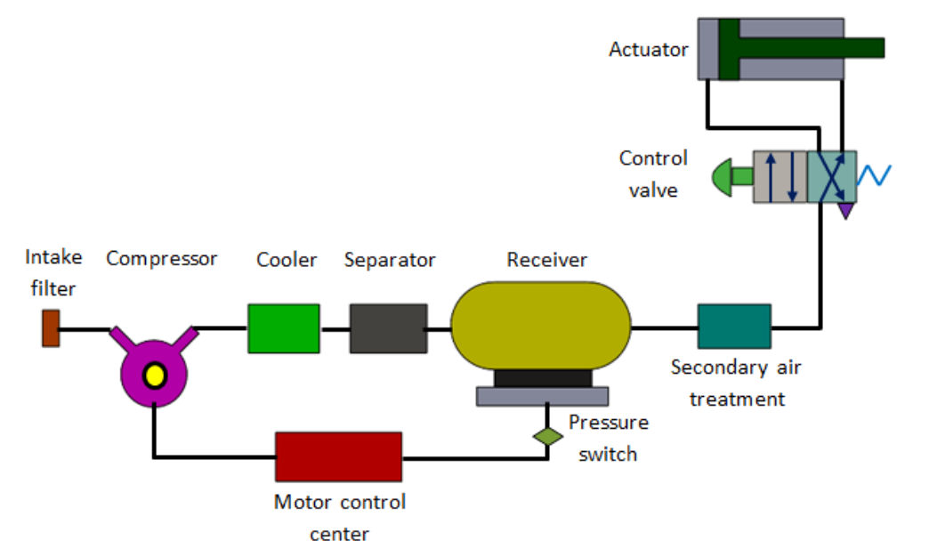
Functions of components of Pneumatic Components
a) Air filters: These are used to filter out the contaminants from the air.
b) Compressor: Compressed air is generated by using air compressors. Air
compressors are either diesel or electrically operated. Based on the
requirement of compressed air, suitable capacity compressors may be used.
c) Air cooler: During compression operation, air temperature increases.
Therefore coolers are used to reduce the temperature of the compressed air.
d) Dryer: The water vapor or moisture in the air is separated from the air by
using a dryer.
e) Control Valves: Control valves are used to regulate, control and monitor for
control of direction flow, pressure etc.
f) Air Actuator: Air cylinders and motors are used to obtain the required
movements of mechanical elements of pneumatic system.
g) Electric Motor: Transforms electrical energy into mechanical energy. It is
used to drive the compressor.
h) Receiver tank: The compressed air coming from the compressor is stored in
the air receiver.
Diffrerences Hydraulic and Pneumatic Systems
Hydraulic and pneumatic systems are similar except that a hydraulic
system uses an incompressible fluid as the working medium, while a pneumatic system
uses air, which is basically compressible. Advantages of using air as the working
medium are that it is readily available and no recycling is necessary. It is nonflammable so that leakage does not create a threat to safety. It has negligible
change in viscosity, which controls the system’s performance.
The major advantage of a hydraulic system is the incompressibility of the fluid helps in positive
action or motion, and faster response, unlike pneumatic systems where there are
longer time delays.

