MECHANICAL ACTUATING SYSTEM

INTRODUCTION
A Mechanical actuator functions to execute movement by converting one types of motion (e,g rotational motion) into another types (e.g translational motion). The operation of mechanical actuator is based on the combination of structural components such as gears and rails, or pulley and chains.
MECHANICAL ELEMENTS, MECHANISM AND MACHINE
Mechanical elements
Mechanical elements refers to the elementary components of a machine . They include the use of linkages, cams, gears, rack-and pinions, chains, belt drives, etc. For example, the rack-and-pinion can be used to convert rotational motion to linear motion.
Mechanisms
A mechanism is defined as a combination of rigid or resistant bodies, formed
and connected so that they move with definite relative motions with respect to
one another. Mechanisms are devices, which can be considered to be motion
converters because they transform motion from one form to some required
form. They might, for example, transform linear motion into rotational motion,
or motion in one direction into a motion in a direction at right angles. They
might transform a linear reciprocating motion into rotary motion, as in the
internal combustion engine where the reciprocating motion of the pistons is
converted into the rotation of the crank and hence drive shaft.
mechanisms being used to provide the following functions:
- Force amplification e.g. levers
- Change of speed e.g. gears
- Transfer of rotation about one axis to rotation about
another axis e.g. belt
- Change to a particular types of motion
Machines
A machine is an assemblage of parts that transmit forces, motion and energy in
a predetermined manner. A machine is a combination of rigid or resistant bodies,
formed and connected so that they move with definite relative motions and
transmit force from the source of power to the resistance to be overcome. A
machine has two functions: transmitting definite relative motion and transmitting
force. These functions require strength and rigidity to transmit the forces. Simple
machines include any of various elementary mechanisms having the elements of
which all machines are composed. Included in this category are the lever, the wheel
and axle, the pulley, the inclined plane, the wedge and the screw.
The similarity between machines and mechanisms is that:
they are both combinations of rigid bodies; the relative motion among the rigid bodies is definite.
The difference between machine and mechanism is that machines transform
energy to do work, while mechanisms do not necessarily perform this function.
but a mechanism is principally concerned with transformation of motion
while the term machine is used for a system that transmits or modifies the action of
a force or torque to do useful work.
A machine is thus defined as a system of elements which are arranged to transmit motion and energy from one form to some required form while a mechanism is defined as a system of elements which are arranged to transmit motion from one form to some required form. A mechanism can therefore be thought of as a machine, which is not required to transmit energy but merely to reproduce exactly the motions that take place in an
actual machine. The term machinery generally means machines and mechanisms.

Types of motion
A rigid body can have a very complex motion, which might seem difficult to describe. However, the motion of any rigid body can be considered to be a combination of translational and rotational motions. By considering the three dimensions of space, a translation motion can be considered to be a movement along one or more of the three axes. A rotation can be defined as a rotation about one or more of the axes.
Translation motion Rotational motion

Freedom and Constraints
An important aspect in the design of mechanical elements is the orientation and arrangement of the elements and parts. A body that is free in space can move in three, independent, perpendicular directions and rotate in three ways about those directions. It is said to have six degrees of freedom (number of components of motion that are required to generate motion).
6 - number of constraints = number of degrees of freedom - number of redundancies

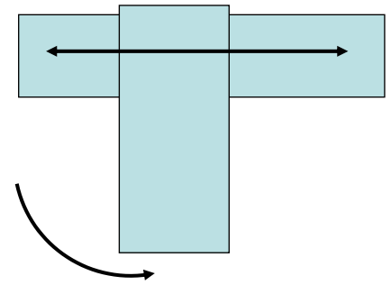
One degree of motion Two degree of motion

Cams
A cam is a body which rotates or oscillates and in doing so imparts a reciprocating or oscillatory motion to a second body called the follower, with which it is in
contact. As the cam rotates so the follower is made to rise, dwell, and fall. The length of times spent for the rotation is depending on the shape of the cam.

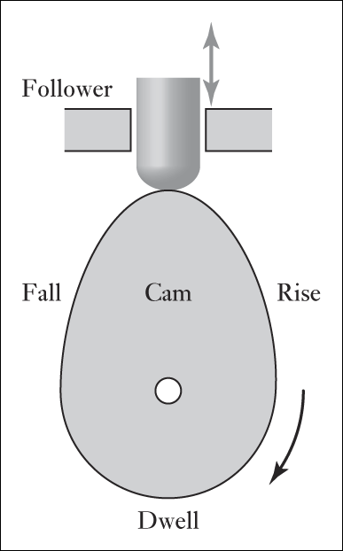
Fall : This is the Part that lowers the follower, its profile determining how quickly the cam follower will fall.
Rise : Part that drives the follower upwards, its profile determining how quickly the cam follower will lifted
Dwell : Part that allows the follower to remain at the same lever for a significant period of time and where its circular with a radius that does not change
Cam and follower mechanism are widely used for operating the inlet and oulet value of internal combustion Engine, feed mechanism of authomatic lathe , paper cutting machine, weaving textile machine among others.

Gear
Gear trains are mechanisms which are very widely used to transfer and transform rotational motion. They are used when a change in speed or torque of a rotating device is needed. For example, the car gearbox enables the driver to match the speed and torque requirements of the terrain with the engine power available.
Gear Ratio
Consider Two meshed gears A and Bas illustrated in figure 1

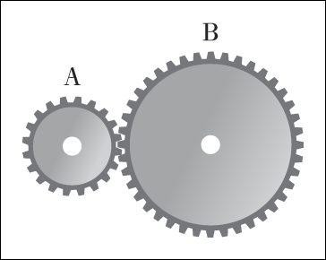
Fig. 1
The gear ratio is defined as
$$\frac{ω_{A}}{ω_{B}}= \frac{Number of teeth on B}{Number of teeth on A}= \frac{d_{B}}{d_{A}}$$
Where $ω$ is the angular velocity and d is the diameter of the corresponding gear

Gear Train : This is a series of intermeshed gear wheels. Gear train can be classified into simple and compound gear train
Simple Gear train : This is used for a system where each shaft carries only one gear wheel. (See Fig. 2)
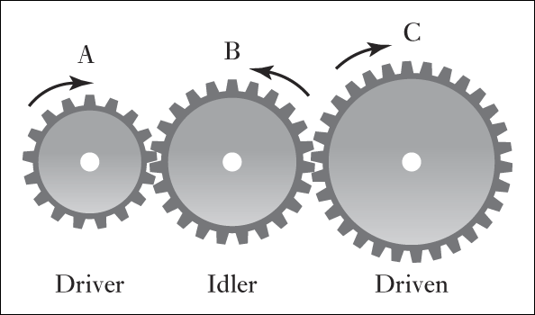
Fig 2. Simple gear wheel
Ratio of the angular velocities for simple gear train is given by ;

G = $\frac{ω_{A}}{ω_{C}}= \frac{ω_{A}}{ω_{B}}$ $× \frac{ω_{B}}{ω_{C}}$

Compound gears trains – In this case, two wheels are mounted on a common shaft. For instance, say wheel B and wheel C as illustrated in figure 3

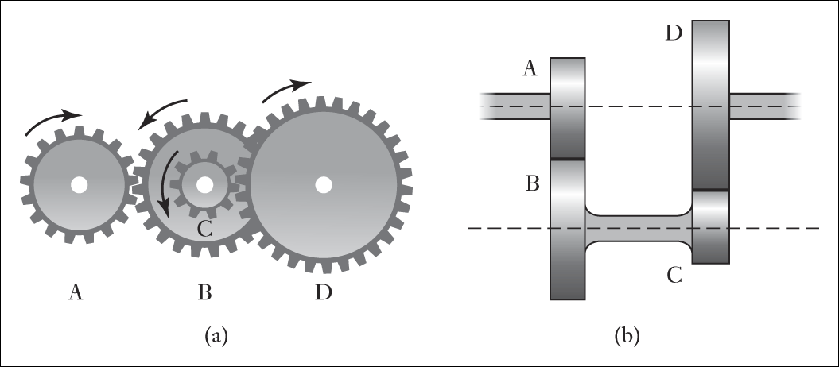
Fig 3 : Compound gear wheel
Ratio of the angular velocities,
G = $\frac{ω_{A}}{ω_{D}}= \frac{ω_{A}}{ω_{B}}$ $× \frac{ω_{B}}{ω_{C}}$ $× \frac{ω_{C}}{ω_{D}}$ = $\frac{ω_{A}}{ω_{B}}$ $×\frac{ω_{C}}{ω_{D}}$
(NOTE : Wheel B and C mounted on a common shaft will have the same angular velocity)

For the input and output shafts to be in line, we must also have for the radii of the gears
r_{A}+ r_{B} = r_{D} + r_{C}

WORKED EXAMPLE
if A has 15 teeth, B 30 teeth, C 18 teeth and D 36
Teeth. Find the angular speed of D if A speed is 160 rpm
Solution
Since the angular speed of a wheel is inversely proportional to the
number of teeth on the wheel, the overall gear ratio is
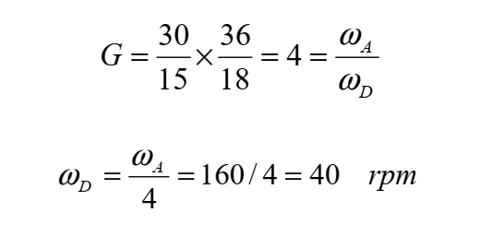
Rack and pinion : A rack and pinion is a type of linear actuator that comprises a pair
of gears which convert rotational motion into linear motion. A circular gear called "the pinion" engages teeth on a linear "gear" bar called "the rack“. Rotational motion applied
to the pinion causes the rack to move relative to the pinion, thereby translating the rotational motion of the pinion into linear motion.
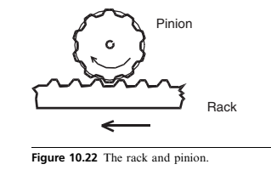
One of the most common application is the Rackand-pinion steering. It is the most common
type of steering on cars, small trucks and SUVs. When you turn the steering wheel, the gear
spins, moving the rack. The tie rod at each end of the rack connects to the steering arm on the spindle
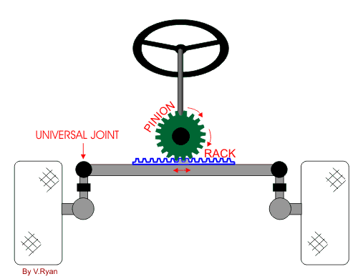
Part that drives the follower upwards, its profile determining how quickly the cam follower will lifted.
Belt Drives
This is essentially a pair of rolling cylinders with the motion of one cylinder being transferred to the other by a belt.
Belt drives use the motion that develops between the pulleys attached to the shafts and the belt around the arc of contact in order to transmit torque. Since the transfer
relies on motion forces, slip can occur. As a method of transmitting power between
two shafts, belt drives have the advantage that the length of the belt can easily
be adjusted to suit a wide range of shaft-to-shaft distances. In this case, the
system is automatically protected against overload because slipping occurs if the
loading exceeds the maximum tension that can be sustained by frictional forces.
If the distances between shafts are large, a belt drive is more suitable than gears,
but over small distances gears are to be preferred
The transmitted torque is due to differences in tension that occur in the belt during operation. This difference results in a tight side and slack side for the belt.
If the tension on the tight side is T₁ and that on the slack side is T₂ then:
Torque on A = (T₁-T₂)R_{A}
Torque on B = ( T₁-T₂)R_{B}
Where R_{A} and R_{B} are the radius of A and B

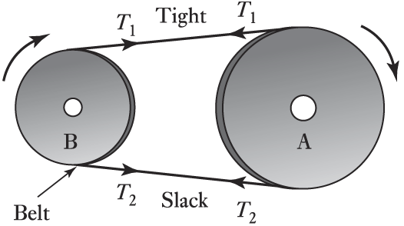
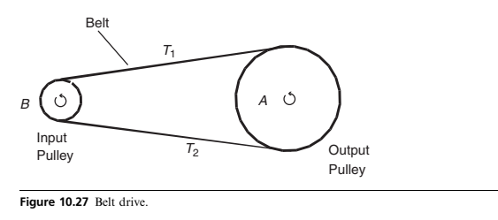

if belt speed is v then angular speed for A and B are:
$ω_{A}= \frac{V}{r_{A}}$
$$ω_{B}= \frac{V}{r_{B}}$$
Since the power transmitted is the produce of the torque and the angular velocity, and since the angular velocity is v/rA for pulley A and v/rB for pulley B, then for either pulley we have
Power on either pulley is given by : P = (${T_{1}-T}_{2}$) $v$
If distances between shafts are large then a belt drive is more suitable than gear

Chain drives
Slip can be prevented by the use of chains, which lock into teeth on the rotating cylinders to give the equivalent of a pair of intermeshing gear wheels. A chain
drive has the same gear ratio relationship as a simple gear train. The drive
mechanism used with a bicycle is an example of a chain drive

