ELECTRICAL ACTUATING SYSTEM

Introduction
Electrical actuators convert electrical command signals into mechanical motions. The actuators take low power signals transmitted from the computer and produce high power signals which are applied as input to the process. There are many types of electrical actuating devices, some of the most common ones include solenoids, electrohydraulic actuators, DC or AC motors, stepper motors, piezoelectric motors among others. Generally, electrical actuators can be classified into
- Solenoids and Relays
- Drive systems; this include all types of electric motor (A.C, D,C, Stepper among others)
- Switching devices : This include Mechanical switches , Solid-state switches.

Principle of Electrical Actuators
Electrical actuators rely on electromagnetic forces to create their action. According to electromagnetic principle, when a current carrying conductor is moved in a magnetic field, a force is produced in a direction perpendicular to the current and magnetic field directions. Lorentz’s force law, relates force on a conductor to the current in the conductor and the external magnetic field, in vector form as
$\overline{F}= \overline{I} × \overline{B}$ (8.1)
where $\overline{F}$ is the force vector (per unit length of conductor), $\overline{I}$ is the current vector,
and $\overline{B}$ is the magnetic field vector. The direction of these three parameters were described by Fleming Right hand rule which states that if your
right-hand index finger points in the direction of the current and your middle finger is aligned with the field direction, then your extended thumb (perpendicular to the index and middle fingers) will point in the direction of the force. This is illustrated in Fig. 8.1.

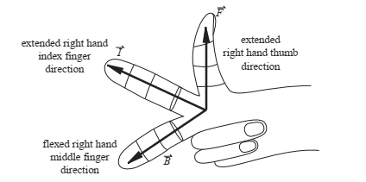
Figure 8.0 : Flemings Right hand rule
The flux density is the flux per unit area given by
$B = \frac{∅ }{A}$ (8.2)
where φ is the flux in weber and A is the cross sectional area of the flux path in m².
The force vector ($\overline{F})$ is the force per unit length (L) of conductor
$\overline{F} = \frac{F }{L}$ (8.3)
Substitute equation (8.3) into equation (8.1)
$F = BIL$ (8.4)
This force (F) acting at a radius produces the torque (T) to rotate the motor. This torque is directly proportional to magnetic flux ($∅)$and the current around in the conductor, (I)
T = $K∅I$ (8.5)
Where K is a constant depends on design parameters such as the number of poles ( in the magnetic field), number of conductors, and number of parallel paths.
Another electromagnetic effect important to actuator design is field intensification within a coil. The magnetic flux through a coil is proportional to the current through the coil and the number of windings. The proportionality constant is a function of the permeability of the material within the coil. The permeability of a material characterizes how easily magnetic flux penetrates the material. Iron has a permeability a few hundred times that of air; therefore, a coil wound around an iron core can produce a magnetic flux a few hundred times that of the same coil with no core. This is the principle employed in moving iron transducer which form the basis for electromagnets, solenoids, and relay.

Moving-iron Transducers
The simplest example of a moving-iron transducer is the electromagnet shown in Figure 8.2, which consists of a fixed U-shaped element and a movable iron bar.
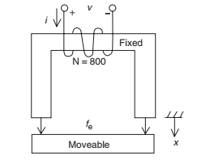
Figure 8.2 : Moving Iron Transducer
Given;
The magnetic force acting on the bar = $F_{e}$
The displacement of the iron bar = x,
The work due to the electromagnetic field = $W_{m}$
The force acting to pull the bar toward the electromagnet structure will be opposite relative to $F_{e}=F$
Therefore, F = $-F_{e}=$ $-\frac{dW_{m}}{dx}$ (8.6)
The energy stored in a magnetic structure is given by : w = $-\frac{{∅ }^{2}R(x)}{2}$ (8.7)
Where :
$∅$ is the magnetic flux
$R$ is the reluctance (equivalent of electrical resistance in electric field)
Subt equation (8.7) into eqnation (8.6)
F = $-F_{e}=$ $-\frac{dW_{m}}{dx}=$ $\frac{{∅ }^{2}}{2} × \frac{dR(x)}{dx}$ (8.8)
This is the equation (equation 8,8) for the magnetic force acting on moving iron and is the basis for the operation of solenoids and relays. However, the magnetic flux ($∅ )$through a coil is proportional to the current through the coil and the number of windings

Solenoids and Relays
As illustrated in Figure 8.2 , a solenoid consists of a coil and a movable iron core
called the armature. When the coil is energized with current, the core moves to
increase the flux linkage by closing the air gap between the cores. The movable core is usually spring-loaded to allow the core to retract when the current is switched off. The force generated is approximately proportional to the square of the current and inversely proportional to the square of the width of the air gap. Solenoids are primarily used in on-off applications such as latching, locking, and triggering application. They are also used in home appliances like washing machine valves and factory automation
Another electromechanical device that finds common industrial actuating applications is the relay (Figure 9.3). The relay is an electromechanical switch
that permits the opening and closing of electrical contacts by means of an
electromagnetic structure similar to the moving-iron transducer. When the push button is pressed, an electric current flows through the coil and generates a field in the magnetic structure. The resulting force draws the moveable part toward the fixed part, thereby causing an electric contact. Applications of relay include power switches and electromechanical control elements. A relay performs a function similar to a power transistor switch circuit but has the capability to switch much larger currents.
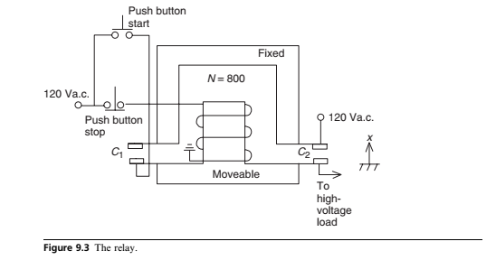
Figure 8.2 : The relay

Drive System: Electric Motor
Drive actuators are essentially electric motor; they are used to efficiently convert electrical energy into mechanical energy. They use permanent magnets and/or electromagnets, and exploit the electromagnetic induction phenomenon in order to produce the actuation. Electric motor are DC, AC and stepper motors.

Working Principle of Electric Motors
When an electric current flows through a coil, it generates a magnetic field around the coil. Similarly, by placing a charged coil of wire in an existing magnetic field (say, between two magnets), the coil will be attracted to one magnet and repelled by the other, or vice versa, depending on the current flow. The higher the current, the greater the magnetic field generated; thus, the greater the attraction or repulsion.
In an electric motor, a coil is mounted on a spinning shaft in the middle of the motor. As one magnet alternately attracts the coil and the other repulses the coil (as a result of input current) , it spins from one magnet to the other resulting in circular motion thus producing torque. The torque is produced due to input current. In reverse situation, the torque, which is equivalent to mechanical energy, can produce current that is equivalent to electrical energy. This current comes back in the
reverse direction of the input current to spin the motor. It is called
blowback, or back voltage . This reverse process is utilized for the design of DC generator.
Generally, electric motors have a variety of Speed–Torque and Speed–Current, characteristics during steady state and transient operations. For a given drive application, engineers initially selected motors with characteristics matching the needed operation. However, due to advances in power electronic devices and circuits, such stringent restrictions has been abandoned. The characteristics of most motors can now be altered to match the desired performance when external power converters are used and advanced control strategies are employed.

Direct Current motors
The Direct Current (DC.) motor is the simplest of electric motors. It works on exactly the principle discussed in sub-section 8.4.1. The desirable features of DC motors are their high torque value, ease of speed control over a wide range, and speed-torque characteristics. D C motors are well suited for many applications including manufacturing equipment, computer numerically controlled systems, servo valve actuators, industrial robots among others.
Figure 9.6 shows the main components of the D.C machine: it consists of field circuit, armature circuit, commutator, and brushes. The field is normally a magnet powered by a d.c. source. The armature circuit is composed of the windings, commutator, and brushes. The windings and the commutator are mounted on the rotor shaft. The brushes are mounted on the stator and are stationary, but in contact with the rotating commutator segments. The rotor windings are composed of several coils; each has two terminals connected to the commutator segments on opposite sides. The commutator segments are electrically isolated from one another. The segments are exposed, and the brushes touch two opposing segments. The brushes allow the commutator segments to be connected to an external d.c. source.
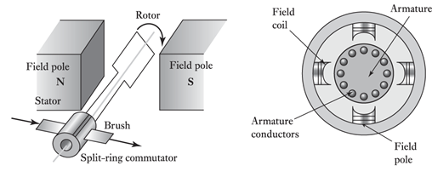
Figure 8.3 : Main components of the D.C machine
A D.C motor has two terminals, and when current flows in one terminal (the other being grounded), the motor spins in one direction. When current flows in the other terminal (and the first is grounded), the motor spins in the opposite direction. That is, by switching
the polarity of the terminals, the direction of the motor is reversed. This produces torque. Thus, the torque produce is a function of applied current. The motor’s speed is controlled by varying the current supplied. Analysis of variation of torque with speed as well as the speed with current under steady and transient working operation is called Torque-Speed, and Speed - Current characteristics, respectively.
Direct current motors can be classified into four groups based on the
arrangement of their field windings. Motors in each group exhibit distinct speed–
torque characteristics and are controlled by different means. These four groups are:
- Separately excited machines: The field winding is composed of a large
number of turns with small cross section wire. This type of field winding is
designed to withstand the rated voltage of the motor. The field and
armature circuits are excited by separate sources.
- Shunt machine: The field circuit is the same as that for separately excited
machines, but the field winding is connected in parallel with the armature
circuit. A common source is used for the field and armature windings.
- Series machines: The field winding is composed of a small number of turns
with a large cross section wire. This type is designed to carry large currents
and is connected in series with the armature winding.
- Compound machines: This type uses the shunt and series windings.
Electric motors have a variety of speed–torque and speed-current characteristics during steady state and transient operation. For a given drive application, in the past, engineers often selected motors with characteristics matching the needed operation. Because of advances in power electronic devices and circuits, such stringent restrictions no longer exist. The characteristics of most motors can now be altered to match the
desired performance when external power converters are used and advanced
control strategies are employed.

8.5.1 Separately Excited Motors
The equivalent circuit (consists of the field and the armature circuit) of a separately excited motor is shown in Figure 9.8.

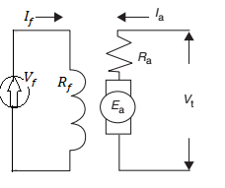

Figure 8.4 : The equivalent circuit of a separately excited motor
The field circuit is mounted on the stator of the motor and is energized by a separate d.c. voltage source,$V_{f}$ The field has a resistance, $R_{f}$and a high inductance$L_{f}$. The field inductance has no impact in the steady-state analysis, since the source is a d.c. type. The field current $I_{f}$ (according to Ohms’ law hold ) is given by ;
$I_{f}$ = $\frac{V_{f}}{R_{f}}$ (8.8)
The armature circuit is mounted on the rotor, is composed of a rotor winding
and commutator segments. An external voltage source, $V_{t}$, is connected across the
armature to drive the load. relative to the field circuit, the armature carries a much higher current. Therefore, the wire cross section of the armature winding is much larger than that for the field circuit, thus the armature resistance, $R_{a}$ is, smaller
than the field resistance, $R_{f}$. These differences is in such a way to ensure that the field voltage,$V_{f}$ is usually in the same order of magnitude as the armature voltage. The armature voltage is the difference between the external voltage source, $V_{t}$ and the back electromotive force ($E_{a}$) produced by the developed torque (see sub-section 8.4.1)
Also, based on Ohms’ law. the armature current $I_{a}$ can then be expressed by
$I_{a}$ = $\frac{V_{t}-E_{a}}{R_{a} }$ (8.8)
The product of armature current and back emf ( $I_{a}E_{a})$ is the developed power, $P_{d}$. In mechanical term, the developed power is the product of the developed torque
and the angular speed
$P_{d}$ $=$ $I_{a}E_{a}=$ $ωT_{d}$ (8.9)
where $ω$ is the angular speed in radians per second. $P_{d}$ is the output power consumed by the mechanical and the rotational losses due to frictional force. Similarly, the developed torque, $T_{d}$, is the sum of the load torque and the rotational torque.
Applying Faraday’s law for the induced emf (E) and the Lorentz law for the force (F) acting at a radius that produces the torque (T) to rotate the motor. The two equation is given by;
$E= Blv$ (8.10)$F = Bli$ (8.11)
From Section 8.1, the torque (T) produced by the force, F, in an electric motor is given by T = $K∅I$ (8.5)
Therefore, $T_{d}$ = K$φ$Ia, (8.12)
where $φ$ is the flux, which is almost proportional to $I_{f}$ for separately excited motors. The constant K is dependent on design parameters such as the number of poles, number of conductors, and number of parallel paths.
From eqn (8.9); $E_{a}=ω$ $\frac{T_{d}}{I_{a}}$ (8.13)
Substitute equation (8.12) into equation (8.13)
$E_{a}=$ K$φω$ (8.13)
The speed–torque equation can be obtained by first substituting armature current $I_{a}$ in equation 8.8 into Equation 8.12.
$T_{d} = Kφ\frac{V_{t}-E_{a}}{R_{a}}$ (8.14)
Then Subt equation (8.13) into (8.14)

$$T_{d} = Kφ\frac{V_{t}-Kφω}{R_{a}}$$
$ω= \frac{V_{t}}{Kφ}- \frac{R_{a}}{{Kφ}^{2}}T_{d}$ (8.15)
This equation 8.15 is called the Speed-Torque characteristic of a Separately Excited D.C Motor
To obtain the speed–current characteristic equation; eliminate the torque from equation (8.15) by subt, equation 8.12 ( $T_{d}$ = K$φI_{a}$)
$ω= \frac{V_{t}}{Kφ}- \frac{R_{a}I_{a}}{Kφ}$ (8.16)
This equation 8.16 is the speed-current relationship of a Separately Excited D.C Motor

Zero Load And Steady Operation Parameters
The speed, torque, and current of a separately excited motors at zero load and during steady operation can be determined by applying the valid conditions to the speed-current and speed-torque characteristic equations.
The speed of the motor at zero load ($ω_{o})$is obtain by setting $I_{a}=0$ to the speed-torque characteristics equation
Therefore, $ω_{o}= \frac{V_{t}}{Kφ}$ (8.17)
This equation is the approximate value of zero load speed; though the real value is slightly lower. This is due to the mass of the drive system and the rotational losses
In the steady state, the speed of the motor ( $ω )$drops by an amount $∆ ω$ ;
$∆ ω= ω_{o}- ω$ (8.18)
Subt equation (8.16) and (8.17) into (8.18),
$∆ ω=\frac{R_{a}I_{a}}{Kφ}$ (8.18)
Also, to express $∆ ω$, as a function of torque,
Subt, Ia = $\frac{T_{d} }{ Kφ}$ from equation 8.12 ( $T_{d}$ = K$φI_{a}$)
$∆ ω= \frac{R_{a}}{{Kφ}^{2}}T_{d}$ (8.19)
Also, the developed torque at starting, $T_{st}$, can be calculated from the speed-torque Equation by setting the steady speed, $ω=0$
$T_{st} = Kφ\frac{V_{t}}{R_{a}}$ (8.20)
The armature starting current,$I_{st}$ can be calculated from speed- current equation by setting the steady speed, $ω=0$
$I_{st} =( \frac{Vt}{R_{a}})$ (8.21)
The starting equations provide important information about the starting
behavior of the d.c. separately excited motor
Figures 9.9 and 9.10, show the speed–torque and speed–current characteristics
when the field and armature voltages are kept constant
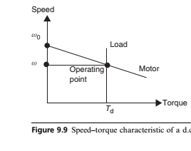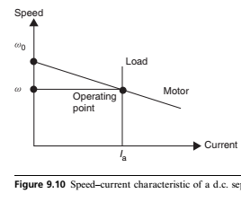

Shunt Motors
A shunt motor has its field winding connected across the same voltage source used
for the armature circuit, as shown in Figure 9.13. The source current, I, is equal to
the sum of the armature current, Ia, and the field current, If. The shunt motor
exhibits characteristics identical to those of the separately excited motor.
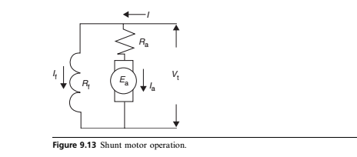

WORKED EXAMPLES
- A d.c. motor has the following specification:
k$φ=$6.0volt second
$V_{t}$= 10:0 V
$R_{a}$ = 1.5:00
$I_{a}$ = = 4:0 A (armature current at full load). Determine
- the rated torque,
- the starting torque;
- the starting current at full voltage;
- the starting speed;
- and the speed at the rated torque condition.
For
- Seperately excited motor
- Shunt motor

SOLUTION

  - Series motors
The field winding of a series motor is connected in series with the armature circuit,
as shown in Figure 9.14.
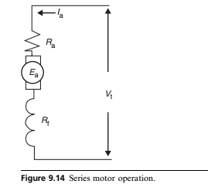
The field winding of a series motor is different from that of a shunt machine The major differences are
- The series field winding is composed of a smaller number of turns than the shunt field winding
- The series field winding carries a much larger current
than the shunt field winding.
- The field current of the shunt machine is constant regardless of loading
conditions (armature current). The series machine, on the other hand, has a
field current varying with the loading of the motor: the heavier the load, the
stronger the field. At light or no-load conditions, the field of the series
motor is very small
The armature current ($I_{a})$ is calculated by : $I_{a}= \frac{V_{t}-E_{a}}{R_{a}+ R_{f}}$ (8.22)
Subt. equation (8.22) into equation (8.12 ($T_{d}=$ K$φI_{a}$) to determine the torque $T_{d}$
$T_{d}$ = K$φ$($\frac{V_{t}-E_{a}}{R_{a}+ R_{f}})$ (8.23)
Also, $E_{a}=$ K$φω$ (8.13)
Subt eqution 8.13 into
$T_{d}$ = K$φ$($\frac{V_{t}-Kφω}{R_{a}+ R_{f}})$

Control of D.C. Motors
The Speed-Torque characteristic and the speed–current characteristic equation of a separately excited (or shunt) motor are given by eqn 8.15 and 8.16 respectively.

$ω= \frac{V_{t}}{Kφ}- \frac{R_{a}}{{Kφ}^{2}}T_{d}$ $= ω_{o}- ∆ ω$ (8.15)

$ω= \frac{V_{t}}{Kφ}- \frac{R_{a}I_{a}}{Kφ}$ $= ω_{o}- ∆ ω$ (8.16)
Therefore, for a given torque, the motor speed ($ω)$ depend on the three quantities:
- Resistance in armature circuit ($R_{a})$: When a resistance is inserted in the armature circuit, the motor speed ($ω$) decreases while $∆ ω$ increases . ( from equation 8.15)
- Terminal voltage (armature voltage): increasing the armature voltage, $V_{t}$, of
the motor increases the motor speed ($ω$)
- Field flux : Reducing the field flux, ($φ)$ will increase the motor speed

  - Advantages and limitations of D.C motor
Direct current motors have several special properties that makes widely used in applications such as actuation, manipulation, and traction. Some of the advantages of the D.c Motor include
- the ease by which they can be controlled,
- their ability to deliver high starting torque, and
- their near linear performance.
However, D.C motor also has some limitation or drawbacks that may
restrict their use in some applications. These include
- They are high maintenance motors due to their commutator mechanisms
- They are large and relatively expensive compared to other motors
- They may not be suitable for high-speed applications due to the presence of the commutator and brushes.
- because of the electrical discharging between the commutator
segments and brushes, d.c. machines cannot be used in explosive
environments
However,. Newer designs of d.c. motors have emerged that eliminate the mechanical commutator. thereby eliminating the mechanical switching of the conventional d.c. motor.

