Modeling and Simulation
One of the key tasks faced by systems engineers is the description of some system attribute such as the system structure, the way it works, or its condition or performance in the past, at the current time, or at some specified future time. Engineers typically use tools including statistical and modeling tools for analysis and evaluation at any phase. Examples of models in civil engineering include a model to predict the future need (demand) for urban transit, a model that describes the magnitude and direction of factors that enhance remediation of contaminated soil, a model that predicts the cost of reconstructing a levee 20 years from now, a model that describes the rate of corrosion in a structural steel member, and a model that describes the factors influencing the effectiveness of a building insulation system.
Statistical regression models are specific type of analytic models. The best model is often obtained after several trials.
Steps in Modeling
Step 1 Definition of Objective
This step will help avoid any communication problems between the data collectors and the modeler and will also help the modeler to establish any a priori expectations of the model outcomes and capabilities.
Step 2 Sampling/Data Collection
it is prudent to use data from a sample of the population instead of the entire population, due to problems that include the lack of time and money for sampling an entire population and the inaccessibility of certain systems or their components. The sample must be not only random (to avoid bias) but, also a close replica of the population, so that any inferences made from the data is applicable to the population.
Step 3 Specify the Response Variable
The response variable should reflect the objective of the modeling process.
Step 4 Selection of the Explanatory Variables
The explanatory variables are those characteristics of the system or its environment that influence the response we are trying to describe using the statistical model. In establishing the independent variables for the model, the systems engineer needs to think about which characteristics of the system or its environment are likely to influence the response variable.
Step 5 Carry Out Preliminary Analysis of the Data
The purpose of this step is to identify interesting trends or relationships between the dependent (Y) and independent (X) variables. The tools used in this step, some of which are described in Chapter 6, include scatter diagrams (simple plots of Y versus each X separately), box plots, stem-and-leaf plots, pie charts, analysis of variance (ANOVA), pairwise t tests, etc. If ordinary least squares (OLS) technique is being used for the modeling, there is a key assumption about the variance of the residuals: If a plot of the variance of the residuals indicates nonconstancy, then the variance of the residuals is termed heteroscedastic. A number of graphical and nongraphical tests are available to detect heteroscedasticity. One nongraphical method is the Durbin Watson Statistic (D value). D values ranging from 0 to 4 indicate homoscedastic variance (a value of 2 indicates perfect homoscedasticity). A normality test, which can be performed graphically or nongraphically, is used to ascertain whether a sample or any group of data fit a standard normal distribution.
Step 6 Model Specification
For discrete response variables, such as a bridge sufficiency rating, a logit or probit functional form could be more appropriate for the model. For continuous response variables, such as system service life or percentage of corrosion, regression or survivor models may be used. The mathematical form for the latter can range from linear to a variety of nonlinear forms: polynomial (including quadratic and cubic), exponential, logarithmic, power, and modified exponential. To ascertain which mathematical form is most appropriate for a given set of data, the raw data must be plotted; and the resulting scatter diagram could be compared with standard curve sketches and any resemblance could be identified for further scrutiny.
Step 7 Final Selection of Independent Variables
In cases where there is an excessive number of independent variables, it may be necessary to drop some of them to simplify the analysis. To know which ones to drop, the analyst may find that certain independent variables have little or no impact on the dependent variable and thus could be dropped without jeopardizing the efficacy of the model from the step 6 above.
Step 8 Separate Your Data Set into Two
As recommended in most statistical texts, it is often prudent to break up the original modeling data set into two sets: one for the model calibration (80–90% of the original data set) and a smaller portion (10–20%) for the model validation.
Step 9 Model Calibration
“Calibration” simply means determining the best function passing through the points (i.e., for the linear functional form, for example, determining the values of the parameters a and b of the functional form). Mathematically, a “best function” could mean an equation that passes through the points such that the sum of the vertical deviations of various points from the regression line is minimized. Regression analysis establishes an empirical relationship between two or more variables. The simplest form is linear regression between one dependent and one independent variable. In more complex forms, the regression model is nonlinear and there are several independent variables. The model is not expected to be a perfect representation of the underlying phenomenon we are trying to describe.
Step 10 Model Evaluation
To ascertain how good the developed model is, the following tests could be used: the coefficient of determination (R²), the level of significance, the standard error (or t-statistics or p values) of the estimate, the heteroscedasticity of variance, and normality tests. The coefficient of determination, the most common statistic used to evaluate how well the model fits the data, assesses the closeness of the observed data to the model functional form under consideration. The coefficient of determination R2 is a measure of the fraction of variability in a data set that is explained by the statistical model and shows how well future outcomes (or outcomes for observations outside the modeling data set) are likely to be predicted or estimated by the model. In linear regression, R2 is the square of the sample correlation coefficient between the actual values of the response variable and their predicted values, which varies from 0 (good fit) to 1 (perfect fit). The standard error of the estimate is a measure of how accurate the predictions are made with the regression model. The regression line or model seeks to minimize the sum of the squared errors of the predictions from the true observed values. The best regression model is that with the least value of the standard error of estimate. The statistical significance of any variable can be ascertained on the basis of the given level of confidence. The sign of the t statistic indicates the direction of the relationship between the X variable in question and the response variable Y∶ a negative sign suggests that an increase in the value of the X variable is associated with a decrease in the value of the Y variable; and a positive sign suggests that an increase in the value of the X variable is associated with an increase in the value of the Y variable. If these signs are consistent with expectation or engineering judgement, then the model results are considered intuitive.
Step 11 Model Validation
The purpose of all models is to increase our understanding of the civil engineering system. A common validation technique is to substitute the values of the independent variables from a validation data set (a set of observations that is external to the calibration data set in time or space) into the calibrated model and determine the corresponding predictions of the response variable—this yields Y_{EST}. Then these values are compared with the actual observed values of the response for those independent variables (denoted by Y_{OBS}). Root mean square error
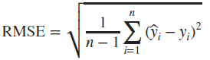
Alternatively, the percentage of deviations (PD) of the estimated responses from the observed (actual) values of the response variable can be calculated as follows:
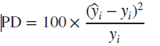
Sources of Error in Systems Modeling and Suggested Precautions
Errors occur due to uncertainties in the civil engineering systems management environment, such as material imperfections, variability in workmanship (often surrogated by contractor class), climate/weather variations, economic uncertainties, equipment error, and human error or incompetence. Model error could also be caused by misspecifications for example, omitting some key factors. A model may not be truly complete until it adequately incorporates all relevant factors as well as the interactions between/among them. An overzealous modeler may be tempted to include a large number of parameters in a bid to develop a comprehensive model.
Simulation is a process that mimics the structural behavior, condition, or performance of a system over a period of time. Simulation is one of the several modeling tools used to describe these attributes of a system. In carrying out simulation for a civil engineering system, it is implicitly acknowledged that the behavior of the system and its interactions with the environment is dictated by factors that are not constant but rather exhibit a great deal of variability. In other words, while the overall system behavior may be roughly predicted, there seems to be some variability that cannot be predicted using the classical laws of mechanics or other laws that govern a system’s behavior. There are certain conditions under which simulation is typically carried out. They are when: (a) the system is too large to be studied; (b) it is too expensive or impractical to carry out scenarios; (c) the real-life system is inaccessible; (d) it is dangerous, unethical, or unacceptable to use the real-life system; or (e) the real-life system does not yet exist. Simulation may be graphical or nongraphical, and the simulation subject may be a real object or a process. Monte Carlo simulation is used in predicting the variability in outcomes of some system attribute in response to the variability in the input factors that influence that attribute. Simulation is a useful tool for systems description and analysis.

Civil Engineering Systems and their Attributes
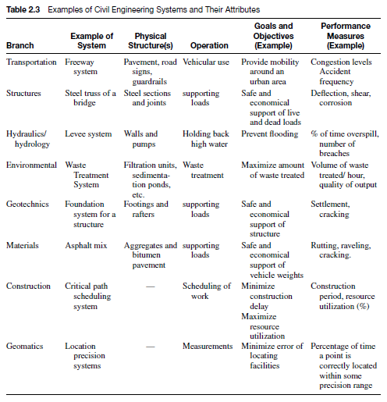

Phases of civil systems development and typical tasks at each phase
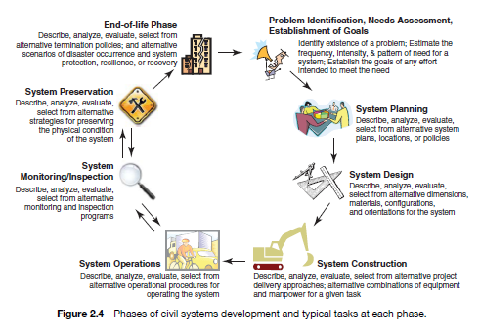
The development of a civil engineering system follows a sequence that begins with an assessment of the need for the system, planning and designing the system, system construction or implementation, operating the system while monitoring its use, inspecting its condition, carrying out maintenance as and when needed, and, finally, and system end of life.

TRADITIONAL TASKS OF ANALYZING SYSTEMS IN CIVIL ENGINEERING
Ironical as it may be, the “analysis of a system” could have a different meaning compared to “system analysis.” The former is associated with or requires the domain (traditional) skills and concepts that are specific to a specific branch of civil engineering (these skills are used to analyze systems in those disciplines; for example, statics in structures, fluid mechanics in hydraulics, soil mechanics in geotechnical, and traffic capacity theory in transportation). The latter is associated with systems engineering and is more consistent with the scope of this text. As stated in the introductory chapters, we do not attempt, within the limited confines of this text, to address all of the concepts that equip an engineer to complete the task of analyzing the system in question. Tools and techniques for carrying out traditional analysis of these systems require domain knowledge and are found in the various texts for each discipline. This text focuses instead on the systems concepts that could complement these analyses. Nevertheless, the sections below identify, for some civil engineering branches, a number of traditional tasks related to domain knowledge areas at that phase and could benefit from the incorporation of system analysis tools.

Construction Engineering
Construction engineers and managers analyze strategies for construction planning and scheduling, equipment and labor utilization, maintenance scheduling for construction equipment, project formwork management, and project monitoring. In analyzing an existing construction plan or scheduling strategy, key considerations include the duration, earliest start time, and the latest end time of each activity. In analyzing plans for equipment utilization, issues include whether the right equipment types/sizes are being used, the project type, the soil/water conditions, the vegetal cover type and extent, the topography, the local regulations, and the project specifications. The analysis often addresses the right mix of labor or equipment to be used; and the considerations may include labor or equipment productivity and cost, job size, and work schedule. In analyzing an existing formwork configuration for its appropriateness, cost, and cost-effectiveness, the key considerations may include the sizes and shapes of the concrete elements, the position of the concrete element, the desired quality of the concrete finish, the weight of the concrete, worker safety, the possibility of formwork recycling, and the strength and cost of form material. Construction engineers also carry out analysis related to project control, construction planning, scheduling and control, and site planning and management. All these traditional tasks could be carried out more efficiently when they are complemented with systems analysis tasks including description, evaluation, and so on. 4.2.2 Environmental Engineering Environmental engineers carry out a wide range of analysis in various areas of environmental engineering and at various phases of environmental system life cycles. In analyzing wastewater and water treatment plants, demand and supply are analyzed to ensure appropriate levels of service and to avoid wastage. Considerations in demand analysis include the initial demand, and the pattern of demand growth (linear, quadratic, exponential, etc.); and the outputs of demand analysis include the expected loads. From the supply perspective, considerations in the analysis may include the size (capacity) of the system (plant) and its constituent subsystems (units) and the costs of expansion and operations. Physical treatment operations that may be analyzed include screening, mixing, sedimentation, filtering, odor control, and aeration. Chemical treatment operations to be analyzed may include those associated with the processes of coagulation, softening, stabilization, demineralization, chemical oxidation, and disinfection. Existing biological treatment operations that could be analyzed include aerobic fixed-film processes, treatment wetland bioremediation, and composting, as well as sludge stabilization subsystems. In the context of solid waste management, the engineer may be required to analyze existing systems for incineration and landfilling. The environmental engineer’s tasks include the analysis and modeling of environmental systems and processes including environmental remediation, fate and transport of contaminants in the environment, and physical chemical processes for water quality control. Accompanying these traditional tasks are the tasks of system description, evaluation of alternatives, and so on.

Geotechnical Engineering
In geotechnics, engineers analyze the engineering behavior of earth materials and thus analyze
geotechnical structures, materials, and processes. This includes tasks such as investigating existing subsurface conditions and materials in order to assess the suitability of materials or soil formations for ground support and to assess the risk to humans and the environment posed by site conditions and/or natural hazards including earthquakes, soil liquefaction, landslides, sinkholes, and rock avalanches. For example, engineers analyze slope stability to determine whether soil covered slopes are likely to undergo movement. Also, in designing earthwork systems (tunnels, embankments, dikes, levees, channels, and earth reservoirs), lateral earth support structural systems (cantilever wall, gravity wall, and excavation shoring), and gravity and structure foundations (willow and deep foundations), geotechnical engineers analyze the stresses from current or expected loading and strains in soil materials. Another important aspect of geotechnical systems analysis at the design phase involves the assessment of the impact (in terms of structural stability, cost, and other performance criteria) of different foundation design types and configurations. At the systems operations and preservation phase, geotechnical analysis may involve investigating the sustained ground stability of structures using data obtained from monitoring equipment. In conducting these traditional tasks, geotechnical engineers also carry out the description, evaluation and selection of alternative geotechnical designs and processes.
Hydraulic and Hydrologic Engineering
Hydraulic and hydrologic engineers are tasked with analyzing existing or proposed hydraulic systems such as urban surface drainage systems and sewerage network systems, water distribution networks, and hydraulic systems, including culverts, dams and spillways, levees, hydraulic outlets, and energy-dissipating water structures. They analyze flows in water distribution networks and wastewater collection networks for purposes of storm water drainage management. Hydraulic and hydrologic engineers also carry out other tasks related to catchment flood modeling and management, coastal protection, shoreline management, flood alleviation and estuarine protection planning.
The task of analyzing hydraulic systems often involves the control and conveyance of water flow and includes design and evaluation of flow measurement devices, fluid supply, and distribution systems and facilities including pumps and turbines. Clearly, the branch of hydraulic and hydrologic engineering is replete with instances where systems analysis tasks are carried out in conjunction with the traditional tasks discussed above.
Civil Materials Engineering
The tasks of materials engineers include the investigation of the suitability of individual ingredients as well as mixed materials, such as Portland cement or asphaltic concrete mixes, metals, composite materials, and other traditional and nontraditional materials for buildings, highway pavements, and other civil engineering structures. In carrying out this work, analysis considerations include loading, climate and weather, aggregate quality, and desired concrete durability. In recent years, materials engineers analyze the nanoscale properties of steel, concrete and other construction materials in order to detect changes in these materials as a result of cracking, corrosion, or other modes of deterioration.
The traditional tasks of materials engineers also include analysis associated with material properties, including thermodynamics, failure analysis and forensics, mechanical properties, and materials characterization.
Structural Engineering
Structural engineers analyze a wide range of structures and structural configurations. They are tasked with analyzing steel structural systems including trusses and frames and structural concrete elements including beams, columns, and shells. In the course of their tasks, structural engineers consider live loads (traffic, pedestrians, occupants, wind), dead loads, failure mechanisms (bending, shear, torsion, etc.), strength of the materials, and the joint design and vulnerabilities. Most of structural engineering tasks are found in the domain knowledge areas in structural analysis including mechanics of materials, stress analysis, structural mechanics, structural analysis, and steel and concrete design. In recent years, structural engineers are increasingly carrying out systems analysis tasks in addition to their traditional tasks.
Transportation Engineering
The main task faced by transportation engineers involves the analysis of the operations of transportation systems and the physical planning and design of such systems. For example, airport engineers analyze airport location, runway configuration, terminal and passenger flow design; in carrying out these tasks, they consider the type of surrounding land use (for noise impact evaluation), wind direction, types and sizes of expected aircraft, and the passenger demand. In analyzing pavement structures for highways and airports, considerations include traffic loading types and levels, subgrade quality, strength of available base materials, weather effects, desired serviceability (performance), and variability of input parameters. Highway engineers analyze the geometric features of existing highway systems, such as vertical and horizontal curve design, grades, radii, superelevation, lanes, shoulders, curbs, median, climbing lanes, and escape ramps, and intersection layouts. In carrying out this task, they consider stopping and passing sight distances, design speeds, vehicle sizes, safety, human reaction time, and the like. Various initiatives for intelligent transportation systems (ITS) that are typically analyzed include advanced traveler information systems, advanced vehicle control systems, advanced traffic management systems, advanced public transportation systems, commercial vehicle operations, and electronic toll collection systems. Considerations for these analyses include the desired composition of traffic stream, design speeds, vehicle sizes, safety, human reaction time, and productivity of the ITS resources. Operations research related tasks and other systems analysis tasks typically complement the traditional tasks of the transportation engineer.

Phases of Developments in Civil Engineering facilities
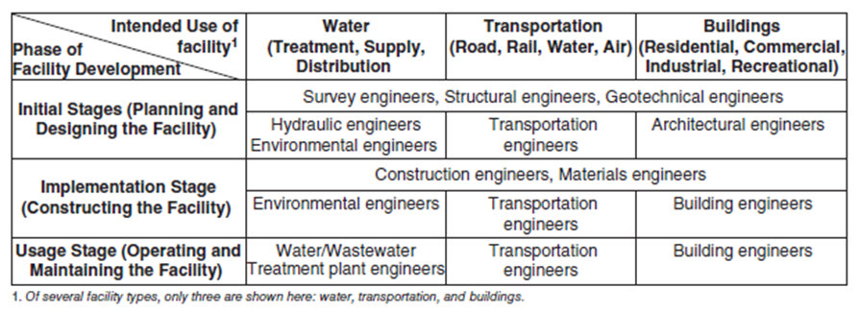

Civil Engineering Facilities

