PROGRAMMABLE LOGIC CONTROLLER (PLC)
If you are thinking of working in the automation industry, then you have to get familiar with PLCs and how to program them. Industrial automation plays a very important role in manufacturing and processing industries and Programmable Logic Controller (PLC) is extensively used for automation and process control systems.

What is PLC – Is it a Computer?
A PLC is similar to a computer as it has a central processing unit and generates outputs on the basis of some inputs. The logic or sequence of operation for a process is executed as per a control logic program or software. A PLC is a microprocessor based programming unit used to perform several functions in industrial processes. But it differs in some ways from a computer. Unlike desktop computers, PLCs have multiple inputs and outputs, and are designed for the rugged operation under extreme industrial conditions. They operate under extended temperature ranges, have immunity to electrical noise, and have resistance to vibration and impact.
A PLC may be seen as a digital industrial computer control system mainly used for automation of industrial processes, like controlling machinery or factory assembly lines. It continuously monitors the state of input devices, such as sensors, pressure switch, level switch, on/off switch, and makes decisions based upon a custom program or logic to control the state of the output devices like actuators, motors, relays or solenoids, and analog devices. It can also measure analog process variables, such as temperature and pressure and values from positioning and vision systems. The programs that are required to control the operation are usually stored in battery-backed or non-volatile memory.

Basic Components
A PLC is composed of a few basic parts. These include a power supply; a central processing unit, or CPU; input/output cards; and a backplane, carrier, or rack that these parts are placed into. The backplane, as shown in Figure 2, creates an electrical connection between all of the separate components, giving the PLC its modular design. This electrical connection includes both power and communication signals. Many PLC manufacturers use proprietary communication protocols on the backplane so that I/O can securely talk to the CPU.
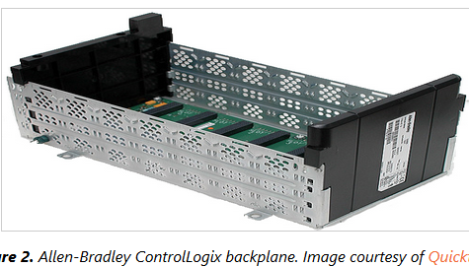

The Power Supply
The power supply provides either 125VAC or 24VDC depending on the application and the circumstances of the installation. As mentioned above, this voltage is bussed down the backplane providing power for the CPU and I/O modules, which come in the form of “cards”. These cards can quickly be added or removed from their slot in the carrier.

The Programming Device and Human-Machine Interface
Outside of the PLC itself are two very important components: the programming device and the human-machine interface (HMI). The programming device can be a desktop computer, laptop, or hand-held instrument from the same manufacturer. There are also fixed I/O PLCs with built-in displays and buttons that allow programs to be written directly on the PLC.
While the programming device allows the user to view and modify the code running on the PLC, the HMI provides a higher level of abstraction, modeling the control system as a whole. Figure 3 shows an integrated touchscreen that can be used in the control room or out in the “field” closer to the process. These types of interactive displays are very common and will often be mounted directly on the PLC enclosure or nearby for operator use.
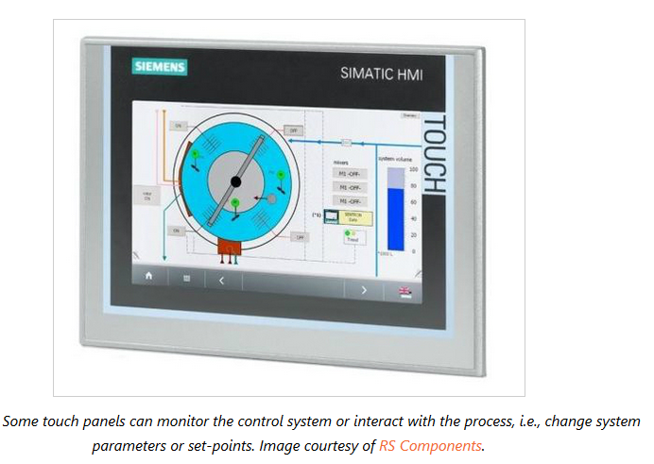
The “field” is the area of the plant or factory where the actual control is done. This is where you would find pumps, motors, valves, temperature and pressure sensors, heat exchangers, mass flow meters, robotic arms, and raw materials.

In today's large, complex industries, the HMI has become a critical feature in the implementation and deployment of a control system. As its name implies, the human-machine interface is a user's window into the control scheme or process. It allows the user to monitor, interact with, and, if necessary, shut down the control system.
Before modern HMIs, plant operators relied on walls of analog gauges and light bulbs to understand the state of their processes. Opening a valve to let off pressure in a pipe or ramping a temperature control loop down could not be done from a computer mouse or capacitive touchscreen, but had to be radioed to an outside operator who performed the action manually. Figure 4 compares the control rooms of old against a modern control room, equipped with HMIs and advanced graphics.
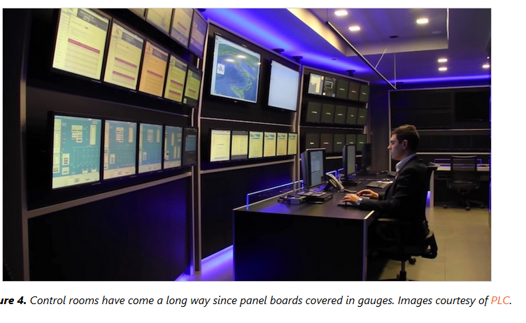
This high-level view of the PLC is the domain of automation and control engineers. These engineers understand control systems, control algorithms, and configuration. They model the process and determine the size and scale of the system needed. From there, the PLC and all of its components are purchased. This could be a single rack with eight I/O cards, or twenty racks all communicating over an industrial network with thousands of I/Os. The key takeaway here is that all of the control is done by a single CPU.

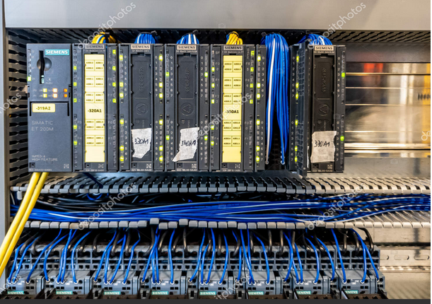
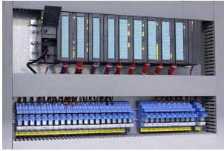
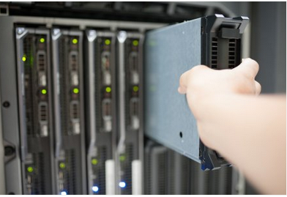

The main units of a PLC are:
- CPU (Central processing unit)
- Input modules
- Output modules
- Power supply unit or module
- Programming device
The Central Processing Unit (CPU) is the heart of the PLC system. The CPU reads input data from various sensing devices, executes the user program from memory and sends appropriate output commands to control devices. It communicates with the Input, Output devices through the Input, Output modules and also performs diagnostics tasks.

Applications of PLCs in Industrial Automation
PLCs are indispensable parts of industrial automation. PLCs were invented as replacements for automated systems that would use hundreds or thousands of relays, cam timers, and drum sequencers. Often, a single PLC can be programmed to replace thousands of relays. The biggest advantage of using programmable controllers is that they can replace the complications of rewiring the hard-wired control panels with simple software revisions when there is change in process, product model or sequence of operation. Expanding and contracting a process becomes much easier with a PLC based automation system.
Complicated wiring and need of hardware like timers, and relays can be reduced by using a PLC and writing software program to execute the control logic. This results in smaller and simpler control panels which occupy lesser space. Another advantage of a PLC system is that it is modular. That is, you can mix and match the types of Input and Output devices to suit your application.

What Language Is Used To Program PLCs?
The earlier PLCs used simple ladder logic, similar to electrical schematic diagrams, for setting up the logic and sequence. The electricians were able to trace out circuit problems with schematic diagrams using ladder logic. This program notation was chosen to reduce training demands for the existing technicians. While Ladder Logic is the most commonly used PLC programming language, it is not the only one. The following are some of the commonly used languages used to program a PLC:
- Ladder Diagram (LD): The traditional ladder logic is a graphical programming language. Though initially it used simple contacts that simulated the opening and closing of relays, later it expanded to include counters, timers, shift registers, and math operations.
- Statement List (STL): A high level text language that uses structured programming. It follows a structured syntax and supports a wide range of standard functions and operators.

Examples in STL
PLCs use the bit logic instructions of a binary system, which interpret signal states of 1 and 0 and combine them according to Boolean logic. These combinations produce a result of 1 or 0 called the ”result of logic operation” (RLO).
Boolean bit logic applies to the following basic instructions:
In STL, the following instructions are used to perform Boolean bit logic operations:
• A And
• AN And Not
• O Or
• ON Or Not
• X Exclusive Or
• XN Exclusive Or Not
• O And before Or
Inserting a ‘(‘ after each instruction can be used for performing nesting expressions.
You can terminate a Boolean bit logic string by using one of the following instructions:
• = Assign
• R Reset
• S Set

Example 1
If the circuit for energizing the output (Q 4.0) which is the coil of a contactor, has one NO (Normally Open, I 1.0) ‘ON’ switch in series with a NC (Normally Close, I 1.1) ‘OFF’ switch then the statement for the same in STL can be written as:
A I 1.0
AN I 1.1
= Q 4.0

Example 2
If the circuit for energizing the output (Q 4.0) which is the coil of a contactor, has one NO (Normally Open, I 1.0) ‘ON’ switch in parallel with a NO (Normally Open, I 1.1) ‘TEST’ switch, then the statement for the same in STL can be written as:
O I 1.0
O I 1.1
= Q 4.0
Timers and counters can be also programmed and instructions can be written to set and reset their values.
Several companies like Allen Bradley, Delta, Siemens, and Schneider have their own set of PLC products and also their own proprietary software programming language. Once you understand the basic concepts about PLC programming, it will easy for you to learn the programming methods of any of the companies. Along with the programming knowledge it is also important to understand the wiring and installation processes involved with PLCs.

Are you curious for knowing the difference between PLC and computer (PC)? Now you’re hoped to see clearer about their detailed explanation for each digital computer. Basically, the differences among both Programmable Logic Controller (PLC) and Personal Computer (PC) are relied on their applications. Somehow, they have their own functions to the users while in the same time they have different level of users. The more information about PLC and PC will guide you to better understanding and you won’t be confused anymore of their differences. Most people have their or PC while PLC is mostly used by industrial and machineries companies. Therefore, both items have their own purposes for assisting people’s activities. Reading these explanations, you’re pleased to understand completely about the difference between PLC and computer (PC).
Difference between PLC and Computer in their processors
When someone’s asking you about the difference between PLC and computer (PC), you’ve to understand more that PLC and PC is designed for different purposes. PLC is using microcontroller and it’s initially designed for machineries and industrial companies as well as one of essential automated equipment for assisting process in larger activities technically. This PLC is completed by single chip of its controller and provided by both digital and analog I/Os. Therefore, PLC is somehow stronger than PC for its ability to do heavy things. In some extent, PC is designed for personal activities and doesn’t related to heavy industrial things so it’s merely owned by microprocessor that consist of RAM, CPU, as well as EPROM. That’s why PC is only running OS (Operating System). Another difference between PLC and computer (PC) is about PLC’s ability to work around its clock while in the same time it has minimum downtime. Because of its microcontroller, PLC’ program applies ladder logic while PC doesn’t. PC isn’t also running in loop which enable the program is executing from first to last ways. Through those specific applications, it can be understood better about the difference between PLC and computer (PC).
Difference between PLC and Computer for their functions
Difference between PLC and computer (PC) obviously creates different functions for each application. Meaning to say, both PLC and PC have their own roles for people’s activities. PLC is mostly used for industrial companies which require the users to create their own application. Besides, PLC is also using multi axis and communicating while PC isn’t. PC is usually applied for people who wish to have computer access of personal activities. The more you understand about both functions, the more advance you can summarize difference between PLC and computer (PC).

In summary, So exactly what is a PLC?
A PLC is a digital computer used to control electromechanical processes, usually in an industrial environment. It performs both discrete and continuous control functions and differs from a typical computer in several important ways:
- It has Physical I/O; electrical inputs and outputs bring real world information into the system and control real world devices based on that information. If you were a PLC, your inputs can be thought of as “senses” like vision and touch, while your outputs could be thought of as your arms and legs.
- It is Deterministic; it processes information and reacts to it within defined time limits. PLCs operate on a timescale of milliseconds or even microseconds
- It is often Modular; it can have I/O modules, communication modules or other special purpose modules added to it for expansion. PLCs may also take the form of a computer or a small single module.
- It is programmed using several defined Languages. Some languages allow the program to be changed while the machine or system being controlled is still running.
- Software and Hardware are Platform Specific; components and programming software usually can’t be used between different manufacturers. But there are exceptions…
- It is Rugged and designed for use in industrial environments.
Unlike computers, PLCs are made to run 24 hours a day, 7 days a week and are able to resist harsh physical and electrical environments.
Where are PLCs used? PLCs are used for many different kinds of applications and industries. In a 2012 Control Engineering magazine poll, 87% of machine control applications used a PLC as the control platform. This includes assembly, packaging and other manufacturing operations. 58% of process control applications used PLCs, in such industries as chemical processing and the oil and gas industry. Power plants and wastewater treatment also fall into this category. 40% of motion control and robotics, 26% of batch control and 18% of diagnostic or testing applications used PLCs. Many applications are a combination of these.
PLCs are used anywhere, and everywhere!

