The Cell: The Basic Unit of Life
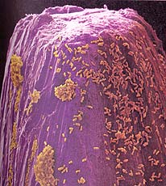
The above photograph demonstrates the size of bacterial cells in relation to a pinpoint.
The cell is the basic unit of life - the smallest structure capable of basic life processes, such as taking in nutrients, getting rid of waste, and reproducing. All living things are made of cells.

Cell Components
Cells are made up of molecules - nonliving structures formed by the joining of atoms. Small molecules serve as building blocks for larger molecules.
The four major molecules that underlie cell structure and participate in cell functions are:
- Proteins
- Nucleic acids
  - DNA - contains the hereditary information for cells.
  - RNA - works with DNA to build the thousands of proteins the cell needs.
- Carbohydrates
- Lipids (include fats and oils)
All cells have at least three things in common:
- Cell membrane
- Cytoplasm
- Genetic Material

Prokaryotes and Eukaryotes
There are two general classes of cells, both of which clearly affect human health and are essential for maintaining life as we know it:
Prokaryotes and Eukaryotes

Prokaryotes and Eukaryotes: Key Differences
The most important difference between prokaryotes and eukaryotes is that eukaryotes have:
- A true nucleus
- Membrane-bound organelles

Prokaryotes and Eukaryotes: Additional Differences
Additional differences between prokaryotes and eukaryotes include:
- Size
- DNA composition and length
- Cell Wall
Usually smaller | Usually larger
More simple | More complex
Either unicellular or colonia | Exist in multicellular forms
Lack tru nucleus | Has membrane bound nucleus
Lacks organelles | Has organelles
Has a cell wall made of peptidoglycan

Pathogenic Microorganisms
Not all microorganisms are pathogenic or capable of causing diseases or infections. There are 5 microbial groups that are of concern to the public health worker:
- Bacteria
- Fungi
- Protozoa
- Helminths (Worms)
- Viruses

Pathogenic Microorganisms: Structural Classification
Below is a structural classification chart of the microbial groups:
Microorganism | Prokaryote | Eukaryote | Acellular
Bacteria | ***
Fungi |  | ***
Protozoa |  | ***
Helminths |  | ***
Virus |  |  | ***
- Notice there is only one prokaryote: bacteria
- Notice that a virus is not a cell

PROKARYOTES
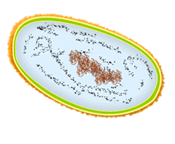

Characteristics of a Prokaryote
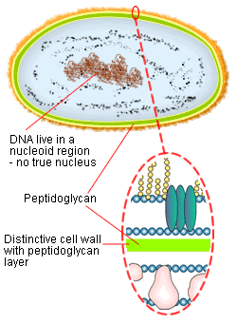

Prokaryotes have the following characteristics:
- No true nucleus - instead of a nucleus, they have a nucleoid region to organize DNA
- Distinct cell walls that contain a peptidoglycan layer (some exceptions)
- No organelles with internal membranes
- Single-celled organisms
- Cells are smaller
- Simpler structure

Prokaryotes and Public Health
In public health, we are only concerned with bacteria.

Bacteria
Did you know that bacteria cause the following threats to public health?
- Anthrax (Bacillus anthracis)
- Syphillis (Treponema pallidum)
- Strep throat (Streptococcus)
- Botulism (Clostridium botulinum)
- Skin boils (Staphyloccus)

Bacteria: The Basics
Bacteria are prokaryotic cells, the simplest of microbial cells. In essence, they consist of cell protoplasm contained within a retaining structure or cell envelope.

Basic Characteristics:
- Prokaryotic
- Simplest of all microbial cells
- Single-celled organisms
- Distinctive cell walls, or unique cell envelopes, which contain a peptidoglycan layer
- Tiny; measured in units called micrometers (µm)
- Lack a true nucleus; instead, have a region called the ‘nucleoid region' (i.e., DNA)
- DNA is free floating
- May have additional DNA which is not associated with this nucleoid region (called a plasmid)

Other Characteristics:
- Rapid growth and cell division (binary fission) under favorable conditions
- Mutants that arise from bacteria can become extremely resilient organisms because bacteria can:
  - Grow and reproduce cells quickly
  - Adapt quickly to changing environments
- Plasmids impart additional resistant characteristics to bacteria via cell-to-cell transfer of this extra DNA material
- Capable of colonizing in almost any environment
- Extremely diverse and numerous in soils or waters

Basic Bacteria
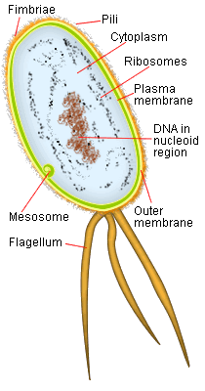
Constituents of bacterial cell components
Cell Appendages | Cell Envelope | Cell Protoplasm  (Plasma membrane)
Flagella | Glycocalyx | Ribosomes
Pili | Cell wall | Mesosomes
Fimbriae | Cell membrane | Granules
 |  | Nucleoid

All bacterial cells have a: | Not all bacterial cells have:
- Cell envelope  - Protoplasm that contains:  - Cell membrane  - Cytoplasm (cell pool)  - Ribosomes  - Nucleoid | - Cell wall (most have them)  - Flagella  - Pili

Classifying Bacteria
Understanding this simple classification method can lead to a better comprehension of the Bergey's Manual.
We can classify bacteria according to:
- Shape
- Cell wall structure and the Gram Stain
- Cellular respiration
- Growth factors: Energy Source and Nutrient Source

Classifying Bacteria by Shape
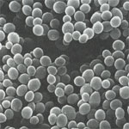
Coccus
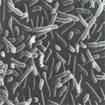
Bacilli (rods)
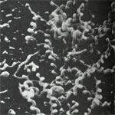
Spirillum
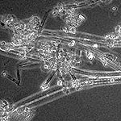
Filamentous

Bacteria cells vary in shape:
- Cocci – spherical
- Bacilli – rods, or cylindrical
- Spirillum – spiral, or helical
- Filamentous – complex forms, like ‘jellybeans in a straw'
The shape of a cell affects its survival and activity in the environment. For example, cocci have less surface area per volume than bacilli or spirillum, and thus can survive more severe desiccation or dehydration. Bacilli, however, have a greater surface area to volume ratio and can take up nutrients from dilute solutions more efficiently. Shape also affects motility. For instance, spirillum are spiral cells, move with a corkscrew motion, and meet less resistance from surrounding water.

Examples of Bacteria Classified by Shape:
- Cocci:
  - Streptococcus
  - Staphylococcus
- Bacilli:
  - Bacillus anthracis
  - Clostridium
- Spirillum:
  - Treponema pallidum
- Filamentous:
  - Leptothrix, Crenothrix

Classifying Bacteria by Cell Wall Structure: The Gram Stain
Another way to classify bacteria is based on differences in the composition of cell walls. The difference becomes clear by means of a technique called the Gram stain, which identifies bacteria as either Gram positive or Gram negative. After staining, Gram positive bacteria hold the dye and appear purple, while Gram negative bacteria release the first dye used and appear red from the second (counter) dye. Gram positive bacteria have thicker cell walls than Gram negative bacteria. Knowing whether a disease-causing bacterium is Gram positive or Gram negative helps a physician to prescribe the appropriate antibiotic. The stain is named for H. C. J. Gram, a Danish physician who invented it in 1884.
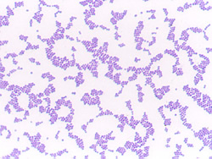
Gram stain of Gram positive Staphylococcus cell
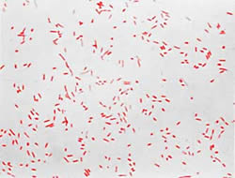
Gram stain of Gram negative E. coli cell

Distinctive Cell Walls: Peptidoglycan
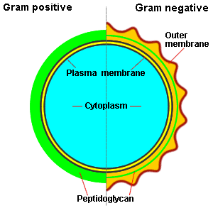
Both Gram positive and Gram negative organisms have more than one layer protecting their cytoplasm and nucleus from the outer environment. This is different from animal cells, which have only a single cytoplasmic membrane, made of a phospholipid bilayer. The layer just outside the bacterial cytoplasmic or plasma membrane is called the peptidoglycan layer. The peptidoglycan is what gives both cell wall types their rigid and protective qualities.

Gram Positives and Gram Negatives: Key Differences
Gram positive bacteria have simpler, but thicker walls, with a relatively large amount of peptidoglycan. The walls of Gram negative bacteria are thinner and have less peptidoglycan but are more complex in structure. An outer membrane on the Gram negative cell wall contains lipopolysaccharides (LPS.) These are toxic substances responsible for making Gram negative organisms more threatening than Gram positives. Even the LPS of dead organisms are a potential threat.

Gram Positives
The Gram positive cell envelope has two layers:
An outer cell wall – thick peptidoglycan layer, composed of complex cross-linked peptidoglycan, teichoic acid, polysaccharides and other proteins
Cytoplasmic membrane - contains proteins that span the lipid bilayer

Special Components of Gram Positive Bacteria
The special components of Gram positives are:
- Teichoic Acids
- Polysaccharides
The teichoic acids anchor the outer cell wall to the cytoplasmic membrane by attaching to glycolipids. Teichoic acids also act as antigenic determinants, so they are important for the serologic identification of many Gram positive organisms.
Examples of Gram positive Bacteria:
- Streptococcus pyogenes - causes strep throat
- Staphylococcus aureus - causes skin infections and may be responsible for boils

Gram Negatives
The Gram negative cell envelope has 3 layers (not including the periplasmic space):
- A unique outer membrane
- A thin peptidoglycan layer
- Cytoplasmic membrane

Special Components of Gram negative Bacteria
The special components of Gram negatives are:
- Outer membrane
- Murein lipoprotein
- Lipopolysaccharide (LPS) – has toxic properties
Unlike Gram positives, Gram negative cell envelopes have a complex outer membrane, which likely explains the resulting difference in the gram-stain process. Unlike Gram positives, the thin peptidoglycan layer does not contain a teichoic acid, but it does have a small, helical lipoprotein called murein lipoprotein . This lipoprotein is important because it starts in the peptidoglycan layer and extends outward to bind the unique third outer membrane. Another factor that adds to the complexity of the outer membrane is the presence of lipopolysaccharides (LPS). Lipopolysaccharides are the major toxins of pathogenic Gram negative bacteria. When the cell dies, LPS are released and can cause problems with organs or tissues.
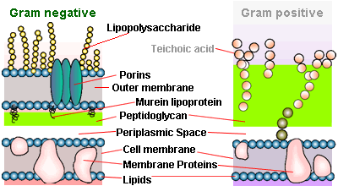

Examples of Gram Negative Bacteria:
- Treponema pallidum - causes syphilis
- Escherichia coli - may cause severe gastrointestinal problems

Classifying Bacteria by Cellular Respiration
We can also classify bacteria according to whether or not they need oxygen to survive.
- Aerobic bacteria, or strict aerobes - require oxygen
- Anaerobic bacteria, or strict anaerobes - cannot tolerate oxygen
- Facultative anaerobics – are generally aerobes, but have the capacity to grow in the absence of oxygen

Examples of Bacteria Classified by Cellular Respiration:
- Aerobic:
  - Bacillus cereus
- Anaerobic:
  - Clostridium spp. ( botulism, tetanus)
- Facultative anaerobes:
  - Staphylococcus spp.

Classifying Bacteria by Growth Factors
Bacteria can further be classified according to how they grow and metabolize. Under this scheme, they are generally classified according to:
- Energy source
- Nutrient source

Energy Source
- Chemotroph – chemical compounds as an energy source (most pathogenic bacteria are chemotrophs.)
- Phototroph - light as energy source

Nutrient Source
- Heterotroph – derive carbon from preformed organic nutrients such as sugar (most pathogenic bacteria are heterotrophs.)
- Autotroph – derive carbon from inorganic sources such as carbon dioxide

Eukaryotic:

Characteristics of a Eukaryote
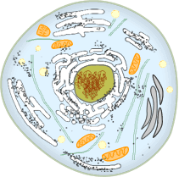
Eukaryotes are complex organisms whose cells contain a membrane-bound nucleus holding hereditary materials or DNA. The presence of a nucleus distinguishes eukaryotes from prokaryotes. The organelles of eukaryotes allow them to exhibit much higher levels of intracellular division of labor than is possible in prokaryotic cells.
Eukaryotes have the following characteristics:
- Complex structure
- May be unicellular or multicellular
- May or may not have cell walls
- Extensive membrane-bound organelles
- Membrane-bound nucleus to organize DNA
- Cells are larger

Pathogenic Eukaryotes
There are three types of pathogenic microorganism groups that are classified as eukaryotes:
- Fungi
- Protozoa
- Helminths (Worms)
FUNGI:
Did you know that fungi causes the following threats to public health?
- Aspergillosis (Aspergillus fumigatus)
- Meningoencephalitis (Cryptococcus neoformans)
- Oral Thrush (Candida albicans)
- Mold (Stachybotrys)

Fungi: The Basics
Fungi are eukaryotic cells that are widespread in the environment and critically affect human health and welfare.

Basic Characteristics:
- Eukaryotic
- Non-vascular organisms
- Reproduce by means of spores, usually wind-spread
- Both sexual (meiotic) and asexual (mitotic) spores may be produced, depending on the species and conditions
- Typically not capable of movement
- Like plants, fungi have an alternation of generations

Other Characteristics
- Vegetative body may be unicellular (yeasts) or composed of microscopic threads called hyphae
- Cell walls similar in structure to plants but differ in chemical composition; fungi cell walls are composed mostly of chitin; plant cell walls are composed mostly of cellulose (plus lignin in secondary walls)
- Cytoplasmic ultra-structure is broadly similar to plants cells, but differs significantly in kinds of organelles and structures

Fungal Forms

Some fungi can grow into two major fungal forms:
- Yeasts – primarily unicellular growth form of fungi; reproduce asexually through budding
- Molds or Mycelia – characterized by having long, filamentous structures known as hyphae (long threadlike structures that entwine together into a mass known as a mycelium)

Other fungal forms are:
- Spores – reproducing bodies of molds
- Dimorphic Fungi – fungi that can grow as either yeast or mold depending on environmental conditions and temperatures; Blastomyces dermatitidis is an example of a dimorphic fungi (mycelial forms at 25°C, and grow into yeast form at 37°C).

Classifying Fungi
The formal classification scheme for fungi is not essential for the scope of this course. Briefly, fungi are formally classified according to their growth and reproduction process. The three groups or divisions are:
- Zygomycota
- Ascomycetes
- Basidiomycetes

Pathogenic Fungi
Fungal pathogens adversely affect human health. Fungal infections develop slowly but recur more frequently than bacterial infections and do not produce a lasting immunity in the body. Infections can be generalized in one of two groups, depending on the part of the body that is infected.
- Dermatomycosis - infecting the skin, hair, or nails
- Systemic mycosis - infecting the entire body
Fungal infections are typically spread by spores that enter the body through breathing or through an opening in the skin. Some infections are passed from animals to humans or between humans.

Pathogenic Fungi: Examples of Pathogenic Fungi

Examples of Pathogenic Fungi
- Aspergillus fumigatus
- Blastomyces dermatitidis
- Stachybotrys atra
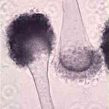
Aspergillus fumigatus
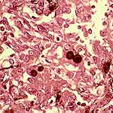
Blastomyces dermatitidis
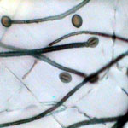
Stachybotrys atra

Pathogenic Fungi: Examples of Pathogenic Yeasts

Examples of Pathogenic Yeasts
- Candida albicans
- Cryptococcus neoformans
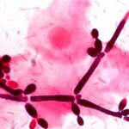
Candida albicans
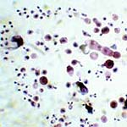
Cryptococcus neoformans

Protozoa
Did you know that protozoa causes the following threats to public health?
- Cryptosporidiosis (Cryptosporidium)
- Giardiasis (Giardia lamblia)
- Encephalitis

Protozoa: The Basics
Protozoa are unicellular eukaryotes, meaning that they have characteristic organelles. They are relatively large and some are visible with the naked eye. They occupy a vast array of habitats and niches and have organelles similar to those found in other eukaryotic cells as well as specialized organelles. Protozoa usually reproduce asexually by binary fission.
- Eukaryotic
- Can be both free-living (can live outside of a host) or parasitic (colonize host cell tissues)
- Usually single-celled organisms
- Divided into seven phyla
- Large - some are visible with the naked eye
- May have one or more nuclei
- Typically lack cell walls
- Complex life cycles and diverse. There are approximately 65,000 known protozoa. By way of comparison, only about 4,500 bacteria are known.
- May have both sexual and asexual reproductive phases
- Found in nearly all terrestrial and aquatic or moist environments and are thought to play a valuable role in ecological cycles
- Many are able to exist in extreme environments, from polar regions to hot springs and desert soils
- Giardia, Cryptosporidium and Microsporidium have become major concerns in the drinking water industry

The traditional four phyla classification, based largely on movement, includes the following groups:
- Flagellates – use flagella
- Amoebae – uses pseudopodial structures, flowing cytoplasm
- Sporozoans – bending, creeping or gliding
- Ciliates – use cilia

Oocysts
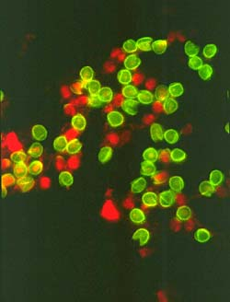
Oocysts of Cryptosporidium parvum
Oocysts are encapsulated zygotes of sporozoan protozoa, occurring as a life-cycle stage. Further development in an oocyst stage produces small individual infective organisms called sporozoites.
Sporozoites, products of meiotic division of zygotes in parasitic protozoa, are infective cells that invade the host and undergo asexual reproduction.

Pathogenic Protozoa
Not all protozoa are of concern to public health. Within the seven-phyla classification, there are only four that are pathogens:
Phylum | Pathogenic
Apicomplexa | Yes
Sarcomastigophora | Yes
Microspora | Yes
Ciliophora | Yes
Acetospora | No
Myxospora | No
Labyrinthomorpha | No
We will briefly discuss each of the pathogenic protozoa in the next few pages.

Apicomplexa
Apicomplexa are characterized by the presence of complex apical organelles generally consisting of a conoid that aids in penetrating host cells, rhoptries that possibly secrete a proteolytic enzyme, andsubpellicular microtubules that may be related to motility.
- All species parasitic
- No organelles for movement
- Characteristic apical complex
- Reproduction by spores and cysts
Examples:
- Toxoplasma
- Cryptosporidium
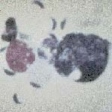
Toxoplasma
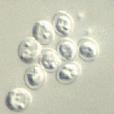
Cryptosporidium

Apicomplexa: Coccidians
The coccidia are classified as members of the phylum Apicomplexa, class Sporozoae, and subclass coccidia.
Six genera of coccidia infect humans:
- Toxoplasma
- Isospora
- Cryptosporidium
- Cyclospora
- Sarcocystis
- Plasmodium
The six coccidians have some features in common, but also differ markedly. The infective stage for all coccidia is a sporozoite, which is very similar in form and function among all coccidians. All produce an oocyst stage following the sexual cycle, and this environmentally hardy oocyst stage is excreted in the stool.

Important Coccidians: Cyclospora
Cyclospora can cause watery diarrhea, nausea, vomiting, and fever. Cyclospora is spread by ingestion of water or food that was contaminated with infected stool. For example, outbreaks of cyclosporiasis have been linked to various types of fresh produce. Cyclospora needs time (days or weeks) after being passed in a bowel movement to become infectious. Therefore, it is unlikely that Cyclospora is passed directly from one person to another. It is unknown whether animals can be infected and pass infection to people.
Cyclospora is ingested as an oocyst that contains two sporocysts with two sporozoites.
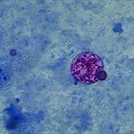
Modified acid-fast smears - oocysts stain from a light pink to a deep red
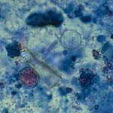
There are two oocysts ofCyclospora in this field, one shows the typical acid fast reaction and the other is a ghost

Important Coccidians: Isospora
Isospora belli (I. Belli) causes human coccidiosis or isosporiasis and is one of the four intestinal coccidia that parasitize humans. It is spread by the fecal-oral route. Isospora belli infects the mucosal epithelium of the small intestine and can cause diarrhea that may last for only a few days or a chronic infection that may persist for months. It can be life threatening to patients with weak immune systems. Although infection with I. Belli occurs worldwide, it tends to be a very uncommon infection.
Isospora is ingested as a mature oocyst that contains two sporocysts each with four nucleated sporozoites.
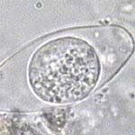
Immature Isospora oocyst with one sporocyst
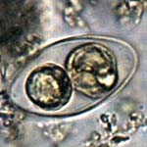
Infective stage - matureIsospora oocyst with 2 sporocysts

Sarcomastigophora
Sarcomastigophora is characterized by a single-type nucleus and movement by flagella, pseudopodia, or both. It comprises the subphyla mastigophora, opalinata, and sarcodina.
- Locomotory organelles are pseudopodia and flagella
- Only one type of nucleus

Examples:
- Giardia
- Cryptobia spp.
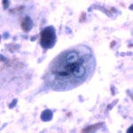
Giardia
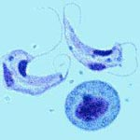
Cryptobia spp

Ciliophora
Ciliophora is characterized by the presence of cilia at some time during the life cycle.
Examples:
- Paramecium
- Tetrahymena
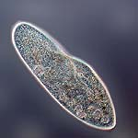
Paramecium
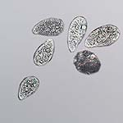
Tetrahymena

Virus
Did you know that viruses cause the following threats to public health?
- Herpes
- Chickenpox
- Influenza
- HIV
- SARS

Virus: The Basics
Viruses are small, obligate, intracellular parasites, meaning that they require a host cell for their growth and replication. They take over, or invade, their host's cell machinery to produce copies of their genetic material or produce their progeny. They can also survive outside a host, but cannot grow or replicate without one. They are generally species specific, infecting bacteria, plants or animals.

Viruses have these unique characteristics:
- Unlike prokaryotic and eukaryotic cells, they are energy-less. They float around until they come in contact with an appropriate cell
- They are basic life forms composed of a protein coat, called a capsid, that surrounds and protects the genetic material.
- Viruses do not have organelles or ribosomes.
- Some viruses are further enclosed by an external lipid bilayer membrane, or envelope, that surrounds the capsid and may contain glycoproteins. Some viruses also carry some structural proteins and enzymes inside their capsid.
- The genetic material is either DNA or RNA – never both. The nucleic acid may be single- or double-stranded. The genetic material contains instructions to make millions of clones of the original virus.
- Replication of the genetic material occurs when the virus takes control of the host cell's synthetic machinery to produce their progeny. Viruses contain all of the genetic information, but not the enzymes, needed to build millions of the original virus.

Capsids
The virus capsid is the term for the protein coat. Capsomers consist of one or more polypeptide chains that are organized into a protein subunit. Capsids are composed of capsomers held together by noncovalent bonds, surrounding the nucleic acid molecule. Capsids range in size from 18µm to several hundred nanometers. This outer coat protects and shields the viral nucleic acid and harbors specific receptor sites for host attachment.

Classifying Virus

Viruses can be classified according to:
- Type of nucleic acid
- Capsid symmetry
- Site of capsid assembly
- Envelope
- Size and number of capsomers

Classifying Virus by Type of Nucleic Acid
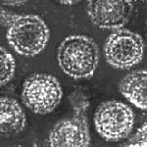
Example of a DNA virus (Hepadnaviridae)
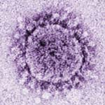
Example of an RNA virus (Coronaviridae)
Viruses are classified by the type of nucleic acid. They are either:
- DNA virus
- RNA virus
The nucleic acid strands can be single-stranded, double-stranded, linear, or looped, in separate segments or one continuous strand. The nucleic acid sequences can encode a simple message or encode hundreds of enzymes and structural proteins.

Classification by Nucleic Acid: RNA Viruses
Coronaviridae - positive-stranded RNA virus
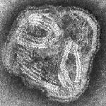
Paramyxoviridae - negative-stranded RNA virus
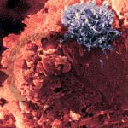
Retroviridae - RNA virus that carry unique enzymes called reverse transcriptase

Classification by Nucleic Acid: DNA Viruses
Unlike RNA, DNA cannot be translated directly into proteins. It must first be transcribed into mRNA, with subsequent translation of the mRNA into structural proteins and enzymes.
- Every DNA virus has both a negative and a positive strand. However, only the positive is read; the negative is ignored.
- Some carry enzymes for DNA repair.

Hepadnaviridae
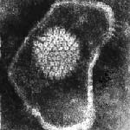
Herpesviridae
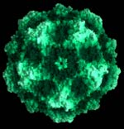
Parvoviridae

