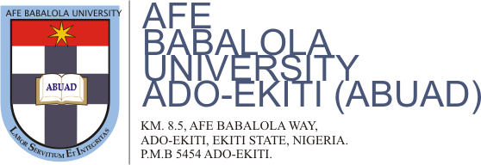
COURSE CODE: CVE 504
COURSE TITLE: Structural Engineering II
SEMESTER: Second
SESSION: 2019/2020
ASSIGNMENT ONE
The class has been grouped into three. Please, following the initial grouping as GP1, GP2 & GP3 respectively.
GR1- Design and analysis of a reinforce concrete continuous beam using the BS code.

GR2- Design of a simply supported steel bridge

GR3- Design of a cantilever retailing wall

Note: Ignore if questions were already give to you before the lockdown.
BE GUIDED, BE HOME, STAY SAFE & POSITIVE TOO

