The success of any business largely depends on sales, and sales depend on market demand behaviour. Market demand analysis is one of the crucial requirements for the existence of any business enterprise. Analysis of market demand for the product is necessary for the management in order to take decisions regarding production, cost allocation, product pricing, advertising, inventory holdings, etc. How much the firm must endeavour to produce depends mainly upon the demand for its product. If demand falls short of production, the two must be balanced by creating a new demand through more and better advertisements. If there is no demand for the product, its production is unwarranted. If the future demand for the product is likely to be more, the more the inventories that the firm should hold. If the demand for the product is large, a higher price can be charged, with other things remaining the same.
Market demand analysis helps the manager to make decisions regarding: (a) sales forecasting with a sound basis and greater accuracy: (b) guidelines for demand manipulation through advertising and sales promotion programmes; (c) production planning and product improvement: (d) pricing policy; (e) determination of sales quotas and performance appraisal of personnel in the sales department; and (f) size of market for a given product and corresponding market share.
What is demand?
By demand we mean the various quantities of a given commodity or service which consumers would buy in one market in a given period of time at various prices, or at various incomes, or at various prices of related goods.
Therefore, the demand for a good is made up of the following three things:
1. the desires to acquire it
2. the willingness to pay for it, and
3. the ability to pay for it. In other words.
Demand = Desire to acquire + Willingness to pay + Ability to pay
In absence of any of these three characteristics, there is no demand. For example, a teacher may possess both the willingness to pay as well as the ability to pay for a liquor bottle, yet he does not have demand for it. This is because he does not desire to have an alcoholic drink. Similarly, a trader might have the desire to have a TV, he might be rich enough to be able to pay for it, but if he is not willing to pay for the TV, he does not have demand for this product. Also, a worker might possess both the desire for a scooter as well as the willingness to pay for it, but if he does not possess enough money to pay for it, he does not have demand for the scooter. In contrast to these three situations, a lawyer, who has the desire for a car, as well as both the will and ability to pay for it, has demand for the car. Thus, demand in economics means effective demand, i.e., one which meets all its three characteristics—desire, willingness and ability to pay. On the other hand, demand means desire backed by willingness and ability to pay.

Besides, demand also signifies a price and a period of time in which the demand is to be fulfilled. Demand is the quantity of a specific good that people are willing and able to buy during a specific period, given the choices available.
To sum up. we can say that the demand for a product is the desire for that product backed by willingness as well as ability to pay for it. It is always defined with reference to a particular time, place, price and given values of other variables on which it depends.

Law of Demand
Law of Demand states that people will buy more at lower prices and buy less at higher prices, if other things remaining the same
Characteristics of law of demand
- Inverse relationship between price and demand.
- Price is independent variable
- Demand is dependent variable on price of goods.
Exceptions to law of demand
Generally, the amount demanded of good increases with a decrease in price of the good and vice versa. In some cases, however, this may not be true. Such situations are explained below.
1. Giffen goods: these are those inferior goods on which the consumer spends a large part of his income and the demand for which falls with a fall in their price. The demand curve for these has a positive slope. The consumers of such goods are mostly the poor. a rise in their price drains their resources and the poor have to shift their consumption from the more expensive goods to the giffen goods, while a fall in the price would spare the household some money for more expensive goods. which still remain cheaper. These goods have no closely related substitutes; hence income effect is higher than substitution effect.
2. Commodities which are used as status symbols: Some expensive commodities like diamonds, air conditioned cars, etc., are used as status symbols to display one’s wealth. The more expensive these commodities become, the higher their value as a status symbol and hence, the greater the demand for them. The amount demanded of these commodities increase with an increase in their price and decrease with a decrease in their price. Also known as a Veblen good. (In economics, Veblen goods are a group of commodities for which people's preference for buying them increases as their price increases, as greater price confers greater status, instead of decreasing according to the law of demand.)
3. Expectations regarding future prices: If the price of a commodity is rising and is expected to rise in future the demand for the commodity will increase.
4. Emergency: At times of war, famine etc. consumers have an abnormal behaviour. If they expect shortage in goods they would buy and hoard goods even at higher prices. In depression they will buy less at even low prices.
5. Quality-price relationship: some people assume that expensive goods are of a higher quality then the low priced goods. In this case more goods are demanded at higher prices.
CLASSIFICATION OF DEMAND
1. Individual demand:-
A commodity or good demanded by a single person is called individual demand.
Individual Demand Schedule
Price | Individual Quantity Demanded
1 | 4
2 | 3
3 | 2
4 | 1

Application: when the price is very high, a low-income buyer may not buy anything, though a high-income buyer may buy something. In such a case, we may distinguish between the demand of an individual buyer and that of the market which is the aggregate of individuals.

2. Market Demand
A demand for a particular product by all customers and added, is called market demand. (Total all individual demand is called as the market demand)
Table is the market demand schedule. This schedule, from the angle of simplification, is based on the assumption that there are two buyers, A and B for X commodity. By adding up their individual demand, the market demand schedule has been estimated:

Market demand Schedule
Price of Commodity X (Rs.) | Demand of person A | Demand of person B | Market Demand  Person (A+B+……= market demand)
1 | 4 | 5 | 4 + 5= | 9
2 | 3 | 4 | 3 + 4 = | 7
3 | 2 | 3 | 2 + 3 = | 5
4 | 1 | 2 | 1 + 2 = | 3

Factors affecting market demand

Market or aggregate demand is the summation of individual demand curves. In addition to the factors which can affect individual demand there are three factors that can affect market demand (cause the market demand curve to shift):
a change in the number of consumers,
a change in the distribution of tastes among consumers,
a change in the distribution of income among consumers with different tastes

3. Derived demand
The increase in demand for one particular good causes increase in the demand for other good is called derived demand. Complementary goods are those goods which are jointly used to satisfy a want. In other words, complementary goods are those which are incomplete without each other.
These are things that go together, often used simultaneously. For example, pen and ink, Tennis rackets and tennis balls, cameras and film, etc.
For example, demand for coal leads to derived demand for mining, as coal must be mined for coal to be consumed.
examples:
- Increasing demand for use computers in various fields will cause increase in demand for the operating systems like Microsoft windows products.
- Increase in the demand for automobiles like bikes, cars and large & heavy vehicle will cause increase in the demand for the fuel like petrol and diesel.
- Increase in the demand for the cellular phone will cause increase in the demand for the memory cards for the multimedia purpose.
- Increase in the demand for the education will cause increase in the demand for the text books for the various subjects.
4. Cross Demand: When the demand of one commodity is related with the price of other commodity is called cross demand. The commodity may be substitute or complementary. Substitute goods are those goods which can be used in case of each other. For example, tea and coffee, Coca-cola and Pepsi. In such case demand and price are positively related. This means if the price of one increased then the demand for other also increases and vise versa.
Cross elasticity demand:
There is a mutual relationship between change in price and quantity demanded of two related goods. Change in the price of one goods can cause change in the demand for the related good. For example, change in the price of tea ordinarily causes change in demand for coffee. Likewise, change in the price of cars causes change in demand for petrol. Mutual relationship between quantity demanded of a good due to change in the price of another goods can be measured by cross elasticity of demand.
Change in the Price of a particular good effect the demand for the other good. For example, 10% increase in the price of fuel, that causes 20% decrease in the demand for new cars which are not giving mileage,This measures the % change in QD for a good after the change in price of another.

Types of Cost

Fixed Cost
The much we produce the goods, fixed cost will not change, it will be constant (not change). If we close the production also fixed cost must be faced by the firm.
eg: (Rent, salaries, Interest on capital) these are to paid by the firm, if there is production are not.
Illustration:-
Cost schedule table
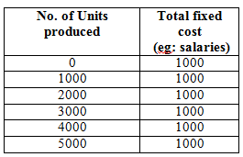
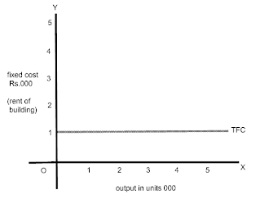

Average fixed cost
Fixed cost spends towards single unit of output or production is called Average fixed cost.
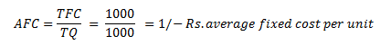
Total fixed cost (Rent) TFC = 1000/-
No. of units produced TQ = 1000
The more he produces, per unit cost will be decreased {per unit cost of fixed cost is average fixed cost}
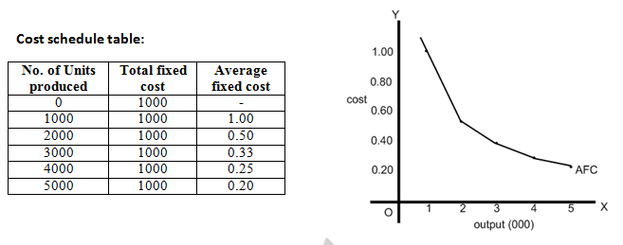

Variable Cost
The cost which rises with increase in production and decreases with fall in production is called variable cost. Variable cost incur for total goods produced is called total variable cost.
Eg: Raw materials, power, fuel and labour. The more the firm produces the goods the firm should incur more.

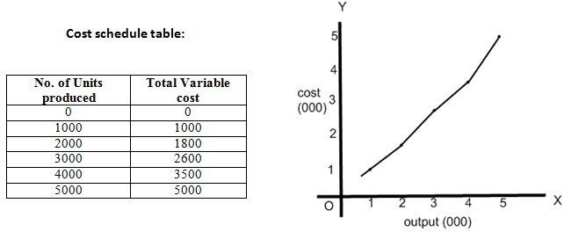

Total Cost
Total cost includes {Total Cost = total fixed cost + Total Variable cost}
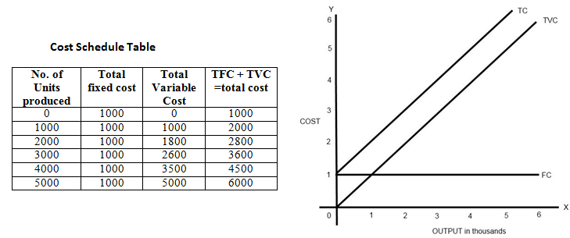

PRODUCTION ANALYSIS
In the ordinary language, the term "production" means rising of crops or making of a physical goods in factories. For example, if you make ice cream, you will say that you have produced ice- cream (goods). But from the point of view of Economics, you have not produced any new thing in the form of ice-cream; rather, you have changed the form of milk, sugar, cream, etc, and thus, have created the utility. Marshall is right to say, "Man does not produce physical (material) goods; but when it is said that he produces material goods, in fact, he only creates the utility. Even the scientists also agree that "Matter can neither be created nor destroyed." Thus, in Economics, the word "production” is used to imply creation or increasing the utility of a good so that its value is increased.
Definitions
"Production may be defined as the creation of utilities. Anatol Murad
"Production is the process that creates utility in goods. A.H. Smith
"Production is the creation of value in a commodity."- Thomas
"Production is the creation of economic utility "- Ely
"Production means an increase in the value of a commodity."- Nicholson
"Production is any activity which adds to the value of a nation's supply of goods and services.” -M.J.UImer
"Production may be defined as the process by which inputs may be transformed into output" - Robert Awh

Difference between Consumption and Production
Generally, production and consumption are considered to be altogether contrary and different activities.
Consumption is the use of utility whereas production is creation of utility. In fact, their difference is not so fundamental. Both these are two different aspects of the same activity. For example, when a carpenter makes a chair, he performs an act of production by increasing the utility of log of wood. But at the same time, he has also consumed the log of wood by using its utility.
Thus, two aspects of the same activity are production and consumption. According to Prof. Mehta., "When the utility of a good is used for the direct satisfaction of want, it is called consumption, and its use for the indirect satisfactions of want is called production."
Methods of Creation of Utility
Production or creation of utility can be made by the following methods:
1) Form Utility: If by changing the form of a good, capacity to satisfy wants is created in it, it is called the form utility. Changing of wheat in the form of biscuit, changing of wood into furniture are the examples of the form utility. Dalmia Biscuit Company or Godrej Steel Furniture Company or factories changing the raw materials into goods create the form utility.
2) Place Utility: Utility is also created by changing the place of goods. It is called place utility. Collecting of the sand from the river-bank and transporting it to the construction site or transporting the coal to different parts of the country from the coal-mines are the examples of place utility. A transporter, railways, shipping companies, and airways create place utility. So, the function of transporting companies is called production.
3) Time Utility: If by an act of storage of a good for some time its utility increases, it is called time utility. Storing oranges, apples and other fruits in the cold storages until their crop season is over and their prices increase, is the example of time utility. Thus the activities of traders, who make the stock of a commodity, can also be called production.
4) Service Utility: If the service of a man satisfies our want, it is called service utility. A professor's teaching in a class, a lawyer's pleading a case, a tailor's stitching a shirt, are the examples of the creation of service utility. Therefore, a professor, lawyer or a tailor are also the producers.
5) Possession Utility: If the change of possession of a good increases its utility, it is called the possession utility. The utility of a sewing machine is not so great for a dealer in sewing machines as it is for a tailor. The utility of the machine increases by this change of possession. It will be called possession utility. Since traders or retailers are the creators of this utility, their activity is also called production.
6) Knowledge Utility: When the utility of a good increase by increasing people's knowledge about that goods, it is called knowledge utility. For example, we come to know about the qualities of LG washing machine, Lux soap or Forhans tooth paste through advertisements. We make greater demand for these goods. Thus, advertisers also help production by creating knowledge utility.

Thus, in order to know whether a man is a producer or not, it is to ensure whether an increase in utility or value is made by the work done by that man or not. It is essential that the work-done by anyone must create or increase utility.
Factors of Production
You want to produce wheat. For the production of wheat, you require land, workers, tractor, tube well, seeds, pesticides, favourable climatic conditions and fertilizer, etc. All these are called the means of production or inputs. With the help of these, we get the output or production.
"The sources of services which enter into the process of production are called factors of production. The factors are broadly classified as land, labour, capital, organisation and enterprise .M.J. Ulmer
According to Dr. Marshall, "In a sense, only nature and man are the two sources of production-" Benham has rightly remarked, "Factors of production are neither two nor four but millions." But according to modem economists and for the sake of simplicity, there are four factors of production namely: (i) land (ii) labour (iii) capital (iv) organisation and enterprise. Modem economists call all these factors as Input or resources, as under;
1. Land: Land is that factor of production which is freely available from nature. In it, not only on the surface of soil is included, but also all other free gifts of the nature below the surface and above the surface are included; for example, forests, minerals, fertility of soil, water, etc. According to Marshall, "Land means the material and the forces which nature gives freely for man's aid, in land and water, in air, light and heat." Land is also called a natural resource.
2. Labour: Labour is a human factor of production. In it all those mental and physical activities of man are included which are performed in order to earn money. The services of a carpenter, black-smith, weaver, teacher, lawyer and doctor, etc., are called labour.
3. Capital: Capital is that man-made factor of production which is used for more production. Factors like machines, tools, raw materials, buildings, railways, factories, etc., are called capital. The saving of a man when invested to earn will also be called capital.

