Machine Cycle:
The process of a CPU that executes an instruction is referred as a machine cycle. The machine cycle is repeated each time the computer executes an instruction. Examples of the steps of the cycle are as followed:
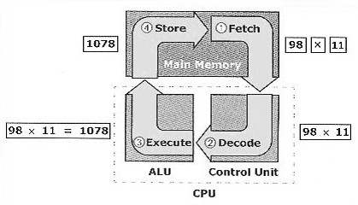

Operation | Description | Example
1. Fetching an instruction | Obtaining a program instruction or data item from memory
2. Decoding the instruction | Translating the instruction into commands the computer understand | 98×11
3. Executing the instruction | Carry out the commands | 98×11=1078
4. Storing the result | Writing the result of memory | 1078

The CPU performance depends on the following terms:
1. Clock Rate
Clock Rate is the speed at which the CPU can execute an instruction. Its unit is Hertz (Hz). A higher clock rate means the CPU can process more instructions per second.

2. Word Size
Word Size is the number of bits that the CPU can manipulate at one time. A CPU with a larger word size can handle more data with each operation and therefore has higher performance.

3. Cache Memory
Cache Memory is the memory that is placed inside the CPU. Cache memory is random access memory (RAM) that a computer microprocessor can access more quickly than it can access main memory. It acts as an intermediate between registers and the main memory. Increasing the size of the cache memory will greatly improve the overall performance of the computer system.

D. Main Memory

The main memory is the storage media installed on the motherboard. It is used to store data and instruction to be executed by the CPU. Main memory is classified into ROM, RAM and CMOS.

1. Read-Only Memory (ROM)

ROM is non-volatile, which is a memory chip made for storing instructions and data permanently. Data in ROM can be read but cannot be changed. It is also known as firmware. In computer, a ROM chip is used to store instructions and tells the computer how to load the operating system when booting up. These instruction sets is called the Basic Input/Output System (BIOS).

However, there are ways to change the content inside a specific kind of ROM. An EEPROM (Electrically Erasable Programmable Read-Only Memory) is a user-modifiable ROM that can be erased and reprogrammed (written to) repeatedly through the application of higher than normal electrical voltage. Nowadays, BIOS are stored in EEPROM so that the BIOS can be updated if needed.

2. Random Access Memory (RAM)

RAM is volatile, which means data and instructions stored in it are lost when the power to the computer is turned off. The instructions and data for the job performing are written to RAM and read from it as needed.
There are two operations: Loading and Saving.
1. Loading means copying data from the secondary storage to the main memory
2. Saving means copying data from RAM to the non-volatile secondary storage.

3. Complementary Metal-Oxide Semiconductor Memory (CMOS)

CMOS have the characteristics of both ROM and RAM, ie: it is non-volatile and we can change the information in CMOS. In computer, CMOS stores the configuration information about a computer like capacity of the hard disk and the current time and date. However, CMOS does not store any program.

