3. Semi-conducting Media

It is sometimes called flash memory, where it uses semi-conductor chips to store data. When transferring data, there is no mechanical movement involved so it is quiet in operation and not easy to be damaged. The size is small so it is used in some portable devices such as PDA, MP3 player and digital camera.

Type | Photo | Note
Smart Media (SM Card) | 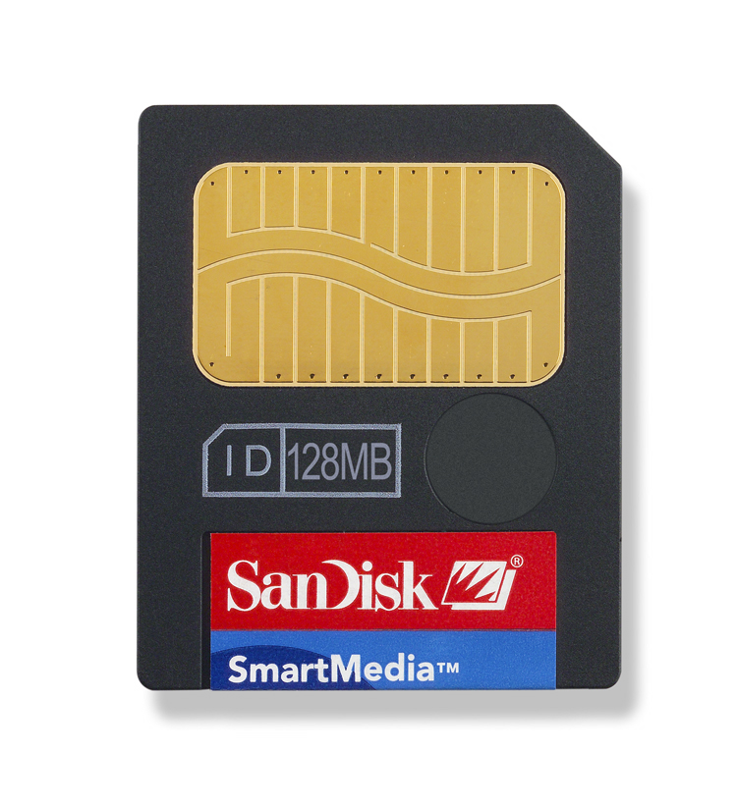 | - Relatively expensive  - Old type of memory card
Compact Flash (CF Card) | 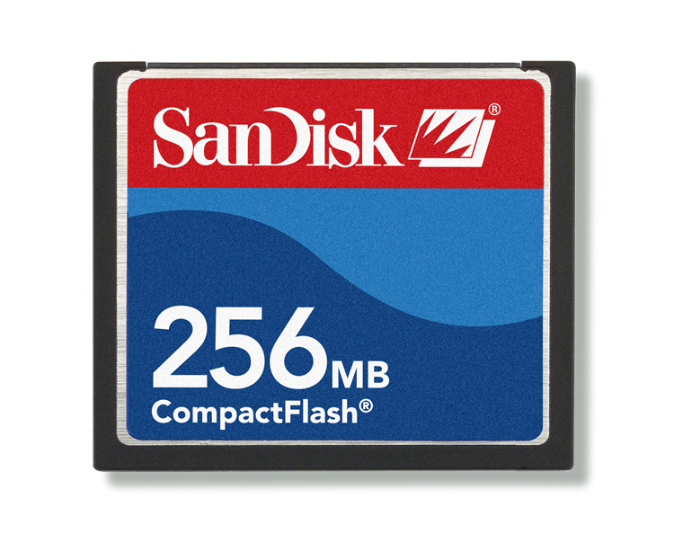 | - Size relatively large and thick  - Hard shield  - Relatively cheap
Microdrive  (MD) | 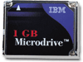 | - Same size as CF card  - Capacity much larger than CF card, maximum 4GB  - Most MD card can be read by a CF card reader
Multimedia Card (MMC) | 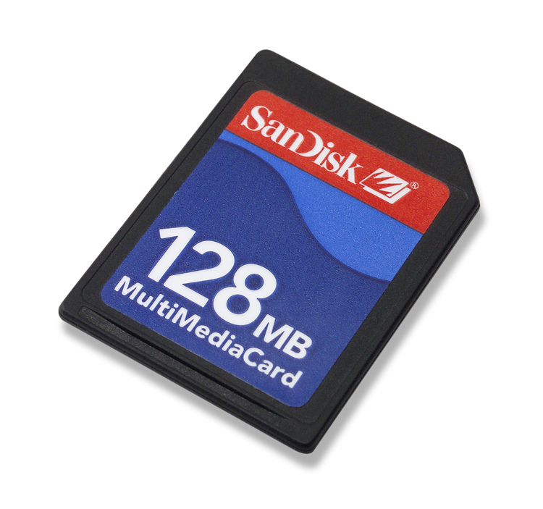 | - Relatively expensive  - Old type of memory card
Secure Digital (SD Card) | 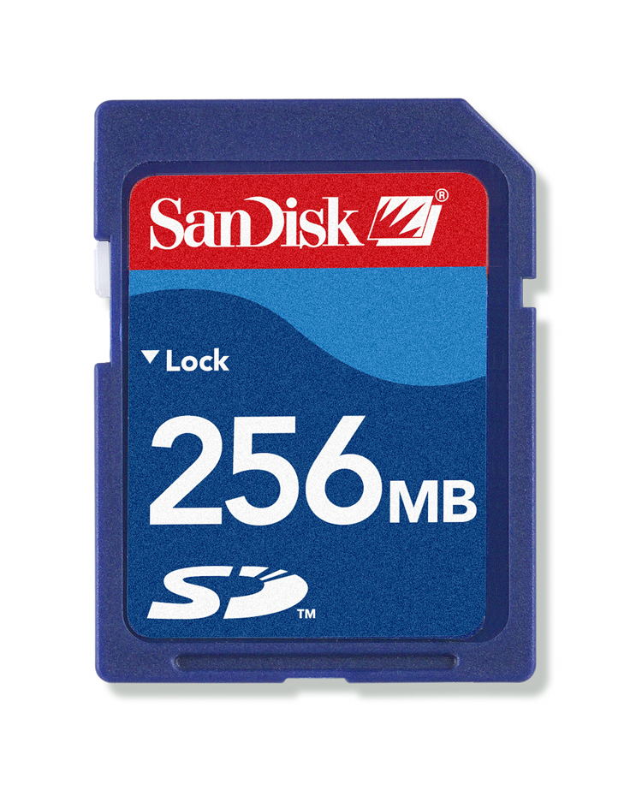 | - Size relatively small and thin  - Relatively expensive
xD Card | 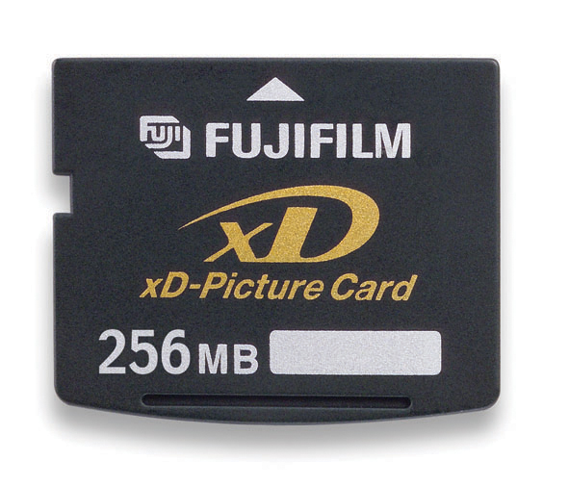 | - Size relatively small and thin  - Relatively expensive
Memory Stick, (MS), MS Pro, MS Pro Duo | 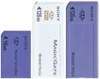 | - Rectangular in size  - All Sony products use it  - Relatively expensive
Flash Thumb Drive | 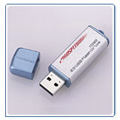 | - NOT used for devices like MP3 player and digital camera  - For portable storage of computer file  - USB connection

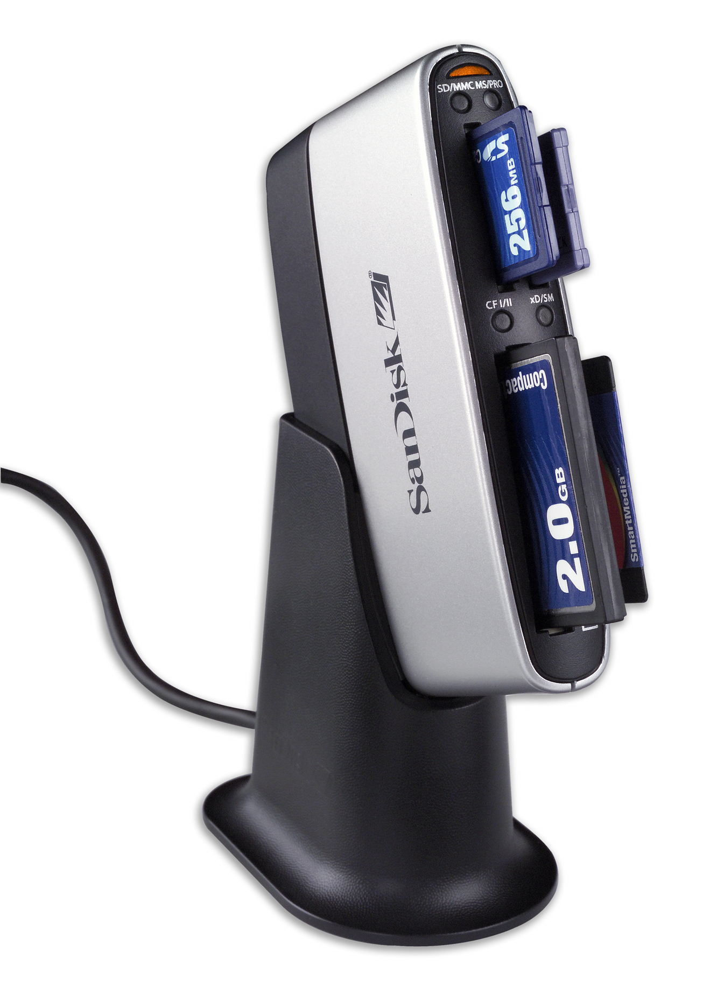
Except the flash thumb drive, all the above
memory card can be accessed by a card
reader, which is connected to the computer
by USB cable.

Comparison of different kind of memory:
(more expensive)
(fast)
Memory in CPU | Register | (less expensive)  Speed  (slow) | Expensive  (Cost per byte)
Memory in CPU | Cache | (less expensive)  Speed  (slow) | Expensive  (Cost per byte)
Main Memory | RAM | (less expensive)  Speed  (slow) | Expensive  (Cost per byte)
Secondary Storage | Flash card | (less expensive)  Speed  (slow) | Expensive  (Cost per byte)
Secondary Storage | Hard disk | (less expensive)  Speed  (slow) | Expensive  (Cost per byte)
Secondary Storage | CD / DVD | (less expensive)  Speed  (slow) | Expensive  (Cost per byte)
Secondary Storage | Floppy Disk | (less expensive)  Speed  (slow) | Expensive  (Cost per byte)
Secondary Storage | Magnetic Tape | (less expensive)  Speed  (slow) | Expensive  (Cost per byte)

