ONE SAMPLE t-TEST
The One Sample t Test determines whether the sample mean is statistically different from a known or hypothesized population mean. The One Sample t Test is a parametric test.
This test is also known as:
- Single Sample t Test
The variable used in this test is known as:
- Test variable
In a One Sample t Test, the test variable is compared against a "test value", which is a known or hypothesized value of the mean in the population.

Common Uses
The One Sample t Test is commonly used to test the following:
- Statistical difference between a sample mean and a known or hypothesized value of the mean in the population.
- Statistical difference between the sample mean and the sample midpoint of the test variable.
- Statistical difference between the sample mean of the test variable and chance.
  - This approach involves first calculating the chance level on the test variable. The chance level is then used as the test value against which the sample mean of the test variable is compared.
- Statistical difference between a change score and zero.
  - This approach involves creating a change score from two variables, and then comparing the mean change score to zero, which will indicate whether any change occurred between the two time points for the original measures. If the mean change score is not significantly different from zero, no significant change occurred.
Note: The One Sample t Test can only compare a single sample mean to a specified constant. It can not compare sample means between two or more groups. If you wish to compare the means of multiple groups to each other, you will likely want to run an Independent Samples t Test (to compare the means of two groups) or a One-Way ANOVA (to compare the means of two or more groups).

Data Requirements
Your data must meet the following requirements:
- Test variable that is continuous (i.e., interval or ratio level)
- Scores on the test variable are independent (i.e., independence of observations)
  - There is no relationship between scores on the test variable
  - Violation of this assumption will yield an inaccurate p value
- Random sample of data from the population
- Normal distribution (approximately) of the sample and population on the test variable
  - Non-normal population distributions, especially those that are thick-tailed or heavily skewed, considerably reduce the power of the test
  - Among moderate or large samples, a violation of normality may still yield accurate p values
- Homogeneity of variances (i.e., variances approximately equal in both the sample and population)
- No outliers

Hypotheses
The null hypothesis (H₀) and (two-tailed) alternative hypothesis (H₁) of the one sample T test can be expressed as:
H₀: µ = x ("the sample mean is equal to the [proposed] population mean")
H₁: µ ≠ x ("the sample mean is not equal to the [proposed] population mean")
where µ is a constant proposed for the population mean and x is the sample mean.

Test Statistic
The test statistic for a One Sample t Test is denoted t, which is calculated using the following formula:
t = x̅ - μ
S _{x̅}

Where: S _{x̅ =} S
√n
Where:
μ = Proposed constant for the population mean
x̅ = Sample mean
n = Sample size (i.e., number of observations)
s = Sample standard deviation
S _{x̅} = Estimated standard error of the mean (s/sqrt(n)
The calculated t value is then compared to the critical t value from the t distribution table with degrees of freedom df = n - 1 and chosen confidence level. If the calculated t value > critical t value, then we reject the null hypothesis.

Data Set-Up
Your data should include one continuous, numeric variable (represented in a column) that will be used in the analysis. The variable's measurement level should be defined as Scale in the Variable View window.

Run a One Sample t Test
To run a One Sample t Test in SPSS, click Analyze > Compare Means > One-Sample T Test.
The One-Sample T Test window opens where you will specify the variables to be used in the analysis. All of the variables in your dataset appear in the list on the left side. Move variables to the Test Variable(s) area by selecting them in the list and clicking the arrow button.
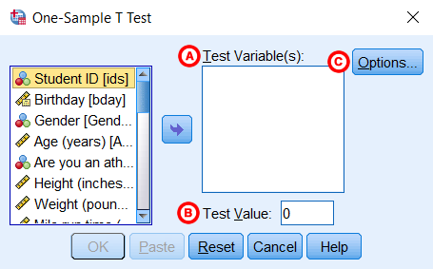
A Test Variable(s): The variable whose mean will be compared to the hypothesized population mean (i.e., Test Value). You may run multiple One Sample t Tests simultaneously by selecting more than one test variable. Each variable will be compared to the same Test Value.
B Test Value: The hypothesized population mean against which your test variable(s) will be compared.
C Options: Clicking Options will open a window where you can specify the Confidence Interval Percentage and how the analysis will address Missing Values (i.e., Exclude cases analysis by analysis or Exclude cases listwise). Click Continue when you are finished making specifications.
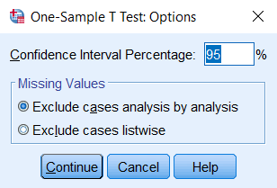
Click OK to run the One Sample t Test.

Example

PROBLEM STATEMENT
According to the CDC, the mean height of adults ages 20 and older is about 66.5 inches (69.3 inches for males, 63.8 inches for females). Let's test if the mean height of our sample data is significantly different than 66.5 inches using a one-sample t test. The null and alternative hypotheses of this test will be:
H₀: 66.5 = µ_{Height} ("the mean height of the sample is equal to 66.5")
H₁: 66.5 ≠ µ_{Height} ("the mean height of the sample is not equal to 66.5")
where 66.5 is the CDC's estimate of average height for adults, and x_{Height} is the mean height of the sample.

BEFORE THE TEST
In the sample data, we will use the variable Height, which a continuous variable representing each respondent’s height in inches. The heights exhibit a range of values from 55.00 to 88.41 (Analyze > Descriptive Statistics > Descriptives).
Let's create a histogram of the data to get an idea of the distribution, and to see if our hypothesized mean is near our sample mean. Click Graphs > Legacy Dialogs > Histogram. Move variable Height to the Variable box, then click OK.
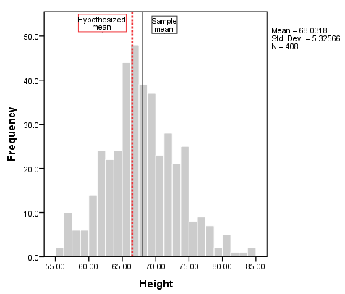
To add vertical reference lines at the mean (or another location), double-click on the plot to open the Chart Editor, then click Options > X Axis Reference Line. In the Properties window, you can enter a specific location on the x-axis for the vertical line, or you can choose to have the reference line at the mean or median of the sample data (using the sample data). Click Apply to make sure your new line is added to the chart. Here, we have added two reference lines: one at the sample mean (the solid black line), and the other at 66.5 (the dashed red line).
From the histogram, we can see that height is relatively symmetrically distributed about the mean, though there is a slightly longer right tail. The reference lines indicate that sample mean is slightly greater than the hypothesized mean, but not by a huge amount. It's possible that our test result could come back significant.

RUNNING THE TEST
To run the One Sample t Test, click Analyze > Compare Means > One-Sample T Test. Move the variable Height to the Test Variable(s) area. In the Test Value field, enter 66.5, which is the CDC's estimation of the average height of adults over 20.
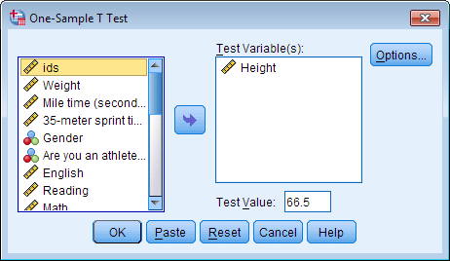
Click OK to run the One Sample t Test.

SYNTAX
T-TEST
/TESTVAL=66.5
/MISSING=ANALYSIS
/VARIABLES=Height
/CRITERIA=CI(.95).

OUTPUT

TABLES
Two sections (boxes) appear in the output: One-Sample Statistics and One-Sample Test. The first section, One-Sample Statistics, provides basic information about the selected variable, Height, including the valid (nonmissing) sample size (n), mean, standard deviation, and standard error. In this example, the mean height of the sample is 68.03 inches, which is based on 408 nonmissing observations.
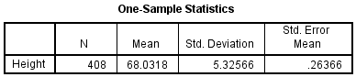
The second section, One-Sample Test, displays the results most relevant to the One Sample t Test.
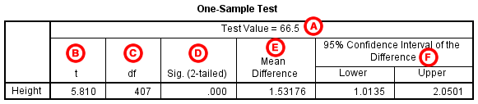
A Test Value: The number we entered as the test value in the One-Sample T Test window.
B t Statistic: The test statistic of the one-sample t test, denoted t. In this example, t = 5.810. Note that t is calculated by dividing the mean difference (E) by the standard error mean (from the One-Sample Statistics box).
C df: The degrees of freedom for the test. For a one-sample t test, df = n - 1; so here, df = 408 - 1 = 407.
D Sig. (2-tailed): The two-tailed p-value corresponding to the test statistic.
E Mean Difference: The difference between the "observed" sample mean (from the One Sample Statistics box) and the "expected" mean (the specified test value (A)). The sign of the mean difference corresponds to the sign of the t value (B). The positive t value in this example indicates that the mean height of the sample is greater than the hypothesized value (66.5).
F Confidence Interval for the Difference: The confidence interval for the difference between the specified test value and the sample mean.

DECISION AND CONCLUSIONS
Since p < 0.001, we reject the null hypothesis that the sample mean is equal to the hypothesized population mean and conclude that the mean height of the sample is significantly different than the average height of the overall adult population.
Based on the results, we can state the following:
- There is a significant difference in mean height between the sample and the overall adult population (p < .001).
- The average height of the sample is about 1.5 inches taller than the overall adult population average
PAIRED SAMPLE t-TEST
The Paired Samples t Test compares two means that are from the same individual, object, or related units. The two means can represent things like:
- A measurement taken at two different times (e.g., pre-test and post-test with an intervention administered between the two time points)
- A measurement taken under two different conditions (e.g., completing a test under a "control" condition and an "experimental" condition)
- Measurements taken from two halves or sides of a subject or experimental unit (e.g., measuring hearing loss in a subject's left and right ears).
The purpose of the test is to determine whether there is statistical evidence that the mean difference between paired observations on a particular outcome is significantly different from zero. The Paired Samples t Test is a parametric test.
This test is also known as:
- Dependent t Test
- Paired t Test
- Repeated Measures t Test
The variable used in this test is known as:
- Dependent variable, or test variable (continuous), measured at two different times or for two related conditions or units

Common Uses
The Paired Samples t Test is commonly used to test the following:
- Statistical difference between two time points
- Statistical difference between two conditions
- Statistical difference between two measurements
- Statistical difference between a matched pair
Note: The Paired Samples t Test can only compare the means for two (and only two) related (paired) units on a continuous outcome that is normally distributed. The Paired Samples t Test is not appropriate for analyses involving the following: 1) unpaired data; 2) comparisons between more than two units/groups; 3) a continuous outcome that is not normally distributed; and 4) an ordinal/ranked outcome.
- To compare unpaired means between two groups on a continuous outcome that is normally distributed, choose the Independent Samples t Test.
- To compare unpaired means between more than two groups on a continuous outcome that is normally distributed, choose ANOVA.
- To compare paired means for continuous data that are not normally distributed, choose the nonparametric Wilcoxon Signed-Ranks Test.
- To compare paired means for ranked data, choose the nonparametric Wilcoxon Signed-Ranks Test.

Data Requirements
Your data must meet the following requirements:
- Dependent variable that is continuous (i.e., interval or ratio level)
  - Note: The paired measurements must be recorded in two separate variables.
- Related samples/groups (i.e., dependent observations)
  - The subjects in each sample, or group, are the same. This means that the subjects in the first group are also in the second group.
- Random sample of data from the population
- Normal distribution (approximately) of the difference between the paired values
- No outliers in the difference between the two related groups
Note: When testing assumptions related to normality and outliers, you must use a variable that represents the difference between the paired values - not the original variables themselves.
Note: When one or more of the assumptions for the Paired Samples t Test are not met, you may want to run the nonparametric Wilcoxon Signed-Ranks Test instead.

Hypotheses
The hypotheses can be expressed in two different ways that express the same idea and are mathematically equivalent:
H₀: µ₁ = µ₂ ("the paired population means are equal")
H₁: µ₁ ≠ µ₂ ("the paired population means are not equal")
OR
H₀: µ₁ - µ₂ = 0 ("the difference between the paired population means is equal to 0")
H₁: µ₁ - µ₂ ≠ 0 ("the difference between the paired population means is not 0")
where
- µ₁ is the population mean of variable 1, and
- µ₂ is the population mean of variable 2.

Test Statistic
The test statistic for the Paired Samples t Test, denoted t, follows the same formula as the one sample t test.

t = x̅_{diff}- 0
S _{x̅}
Where: S _{x̅ =} S_{diff}
√n
x̅_{diff} = Sample mean of the difference
n =Sample size (i.e number of observation)
S_{diff} = Sample standard deviation of the difference
S_{x̅} = Estimated standard error of the mean

The calculated t value is then compared to the critical t value with df = n - 1 from the t distribution table for a chosen confidence level. If the calculated t value is greater than the critical t value, then we reject the null hypothesis (and conclude that the means are significantly different).

Data Set-Up
Your data should include two continuous numeric variables (represented in columns) that will be used in the analysis. The two variables should represent the paired variables for each subject (row). If your data are arranged differently (e.g., cases represent repeated units/subjects), simply restructure the data to reflect this format.

Run a Paired Samples t Test
To run a Paired Samples t Test in SPSS, click Analyze > Compare Means > Paired-Samples T Test.
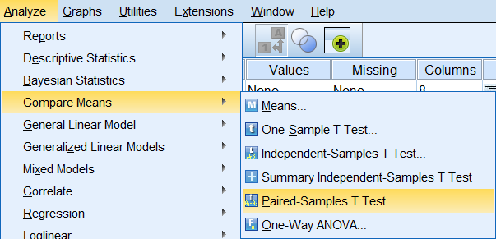
The Paired-Samples T Test window opens where you will specify the variables to be used in the analysis. All of the variables in your dataset appear in the list on the left side. Move variables to the right by selecting them in the list and clicking the blue arrow buttons. You will specify the paired variables in the Paired Variables area.
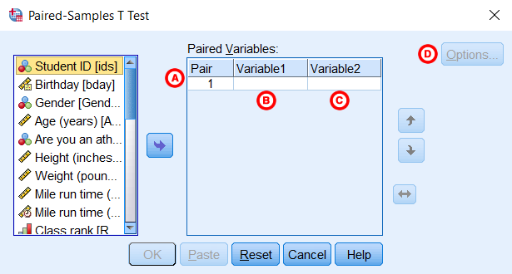
A Pair: The “Pair” column represents the number of Paired Samples t Tests to run. You may choose to run multiple Paired Samples t Tests simultaneously by selecting multiple sets of matched variables. Each new pair will appear on a new line.
B Variable1: The first variable, representing the first group of matched values. Move the variable that represents the first group to the right where it will be listed beneath the “Variable1” column.
C Variable2: The second variable, representing the second group of matched values. Move the variable that represents the second group to the right where it will be listed beneath the “Variable2” column.
D Options: Clicking Options will open a window where you can specify the Confidence Interval Percentage and how the analysis will address Missing Values (i.e., Exclude cases analysis by analysis or Exclude cases listwise). Click Continue when you are finished making specifications.
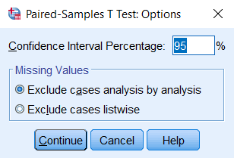
Click OK to run the Paired Samples t Test.

Example

PROBLEM STATEMENT
The sample dataset has placement test scores (out of 100 points) for four subject areas: English, Reading, Math, and Writing. Suppose we are particularly interested in the English and Math sections, and want to determine whether English or Math had higher test scores on average. We could use a paired t test to test if there was a significant difference in the average of the two tests.

BEFORE THE TEST
Variable English has a high of 101.95 and a low of 59.83, while variable Math has a high of 93.78 and a low of 35.32 (Analyze > Descriptive Statistics > Descriptives). The mean English score is much higher than the mean Math score (82.79 versus 65.47). Additionally, there were 409 cases with non-missing English scores, and 422 cases with non-missing Math scores, but only 398 cases with non-missing observations for both variables. (Recall that the sample dataset has 435 cases in all.)
Let's create a comparative boxplot of these variables to help visualize these numbers. Click Analyze > Descriptive Statistics > Explore. Add English and Math to the Dependents box; then, change the Display option to Plots. We'll also need to tell SPSS to put these two variables on the same chart. Click the Plots button, and in the Boxplots area, change the selection to Dependents Together. You can also uncheck Stem-and-leaf. Click Continue. Then click OK to run the procedure.
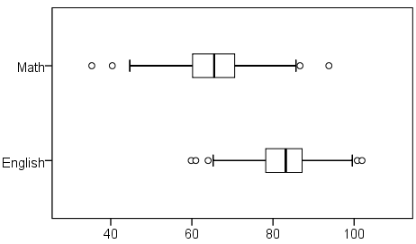
We can see from the boxplot that the center of the English scores is much higher than the center of the Math scores, and that there is slightly more spread in the Math scores than in the English scores. Both variables appear to be symmetrically distributed. It's quite possible that the paired samples t test could come back significant.

RUNNING THE TEST
- Click Analyze > Compare Means > Paired-Samples T Test.
- Select the variable English and move it to the Variable1 slot in the Paired Variables box. Then select the variable Math and move it to the Variable2 slot in the Paired Variables box.
- Click OK.

SYNTAX
T-TEST PAIRS=English WITH Math (PAIRED)
/CRITERIA=CI(.9500)
/MISSING=ANALYSIS.

OUTPUT

TABLES
There are three tables: Paired Samples Statistics, Paired Samples Correlations, and Paired Samples Test. Paired Samples Statistics gives univariate descriptive statistics (mean, sample size, standard deviation, and standard error) for each variable entered. Notice that the sample size here is 398; this is because the paired t-test can only use cases that have non-missing values for both variables. Paired Samples Correlations shows the bivariate Pearson correlation coefficient (with a two-tailed test of significance) for each pair of variables entered. Paired Samples Test gives the hypothesis test results.
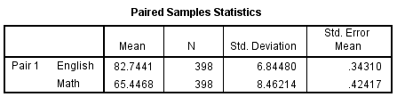
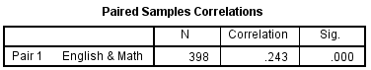
The Paired Samples Statistics output repeats what we examined before we ran the test. The Paired Samples Correlation table adds the information that English and Math scores are significantly positively correlated (r = .243).
Why does SPSS report the correlation between the two variables when you run a Paired t Test? Although our primary interest when we run a Paired t Test is finding out if the means of the two variables are significantly different, it's also important to consider how strongly the two variables are associated with one another, especially when the variables being compared are pre-test/post-test measures.
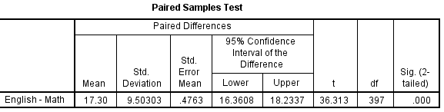
Reading from left to right:
- First column: The pair of variables being tested, and the order the subtraction was carried out. (If you have specified more than one variable pair, this table will have multiple rows.)
- Mean: The average difference between the two variables.
- Standard deviation: The standard deviation of the difference scores.
- Standard error mean: The standard error (standard deviation divided by the square root of the sample size). Used in computing both the test statistic and the upper and lower bounds of the confidence interval.
- t: The test statistic (denoted t) for the paired T test.
- df: The degrees of freedom for this test.
- Sig. (2-tailed): The p-value corresponding to the given test statistic t with degrees of freedom df.

DECISION AND CONCLUSIONS
From the results, we can say that:
- English and Math scores were weakly and positively correlated (r = 0.243, p < 0.001).
- There was a significant average difference between English and Math scores (t₃₉₇ = 36.313, p < 0.001).
- On average, English scores were 17.3 points higher than Math scores (95% CI [16.36, 18.23]).

INDEPENDENT SAMPLE T- TEST
The Independent Samples t Test compares the means of two independent groups in order to determine whether there is statistical evidence that the associated population means are significantly different. The Independent Samples t Test is a parametric test.
This test is also known as:
- Independent t Test
- Independent Measures t Test
- Independent Two-sample t Test
- Student t Test
- Two-Sample t Test
- Uncorrelated Scores t Test
- Unpaired t Test
- Unrelated t Test
The variables used in this test are known as:
- Dependent variable, or test variable
- Independent variable, or grouping variable

Common Uses
The Independent Samples t Test is commonly used to test the following:
- Statistical differences between the means of two groups
- Statistical differences between the means of two interventions
- Statistical differences between the means of two change scores
Note: The Independent Samples t Test can only compare the means for two (and only two) groups. It cannot make comparisons among more than two groups. If you wish to compare the means across more than two groups, you will likely want to run an ANOVA.

Data Requirements
Your data must meet the following requirements:
- Dependent variable that is continuous (i.e., interval or ratio level)
- Independent variable that is categorical (i.e., two or more groups)
- Cases that have values on both the dependent and independent variables
- Independent samples/groups (i.e., independence of observations)
  - There is no relationship between the subjects in each sample. This means that:
    - Subjects in the first group cannot also be in the second group
    - No subject in either group can influence subjects in the other group
    - No group can influence the other group
  - Violation of this assumption will yield an inaccurate p value
- Random sample of data from the population
- Normal distribution (approximately) of the dependent variable for each group
  - Non-normal population distributions, especially those that are thick-tailed or heavily skewed, considerably reduce the power of the test
  - Among moderate or large samples, a violation of normality may still yield accurate p values
- Homogeneity of variances (i.e., variances approximately equal across groups)
  - When this assumption is violated and the sample sizes for each group differ, the p value is not trustworthy. However, the Independent Samples t Test output also includes an approximate t statistic that is not based on assuming equal population variances. This alternative statistic, called the Welch t Test statistic¹, may be used when equal variances among populations cannot be assumed. The Welch t Test is also known an Unequal Variance t Test or Separate Variances t Test.
- No outliers
Note: When one or more of the assumptions for the Independent Samples t Test are not met, you may want to run the nonparametric Mann-Whitney U Test instead.
Researchers often follow several rules of thumb:
- Each group should have at least 6 subjects, ideally more. Inferences for the population will be more tenuous with too few subjects.
- A balanced design (i.e., same number of subjects in each group) is ideal. Extremely unbalanced designs increase the possibility that violating any of the requirements/assumptions will threaten the validity of the Independent Samples t Test.

¹ Welch, B. L. (1947). The generalization of "Student's" problem when several different population variances are involved. Biometrika, 34(1–2), 28–35.

Hypotheses
The null hypothesis (H₀) and alternative hypothesis (H₁) of the Independent Samples t Test can be expressed in two different but equivalent ways:
H₀: µ₁ = µ₂ ("the two population means are equal")
H₁: µ₁ ≠ µ₂ ("the two population means are not equal")
OR
H₀: µ₁ - µ₂ = 0 ("the difference between the two population means is equal to 0")
H₁: µ₁ - µ₂ ≠ 0 ("the difference between the two population means is not 0")
where µ₁ and µ₂ are the population means for group 1 and group 2, respectively. Notice that the second set of hypotheses can be derived from the first set by simply subtracting µ₂ from both sides of the equation.

Levene’s Test for Equality of Variances
Recall that the Independent Samples t Test requires the assumption of homogeneity of variance -- i.e., both groups have the same variance. SPSS conveniently includes a test for the homogeneity of variance, called Levene's Test, whenever you run an independent samples t test.
The hypotheses for Levene’s test are:
H₀: σ₁² - σ₂² = 0 ("the population variances of group 1 and 2 are equal")
H₁: σ₁² - σ₂² ≠ 0 ("the population variances of group 1 and 2 are not equal")
This implies that if we reject the null hypothesis of Levene's Test, it suggests that the variances of the two groups are not equal; i.e., that the homogeneity of variances assumption is violated.
The output in the Independent Samples Test table includes two rows: Equal variances assumed and Equal variances not assumed. If Levene’s test indicates that the variances are equal across the two groups (i.e., p-value large), you will rely on the first row of output, Equal variances assumed, when you look at the results for the actual Independent Samples t Test (under the heading t-test for Equality of Means). If Levene’s test indicates that the variances are not equal across the two groups (i.e., p-value small), you will need to rely on the second row of output, Equal variances not assumed, when you look at the results of the Independent Samples t Test (under the heading t-test for Equality of Means).
The difference between these two rows of output lies in the way the independent samples t test statistic is calculated. When equal variances are assumed, the calculation uses pooled variances; when equal variances cannot be assumed, the calculation utilizes un-pooled variances and a correction to the degrees of freedom.

Test Statistic
The test statistic for an Independent Samples t Test is denoted t. There are actually two forms of the test statistic for this test, depending on whether or not equal variances are assumed. SPSS produces both forms of the test, so both forms of the test are described here. Note that the null and alternative hypotheses are identical for both forms of the test statistic.

EQUAL VARIANCES ASSUMED
When the two independent samples are assumed to be drawn from populations with identical population variances (i.e., σ₁² = σ₂²) , the test statistic t is computed as:
$$t=\frac{ \overline{x}1-\overline{x}2 }{\frac{SP\sqrt{1}}{n1}-} - 0+…$$
t=x¯¯¯1−x¯¯¯2sp1n1+1n2−−−−−−√t=x¯1−x¯2sp1n1+1n2
with
sp=(n1−1)s21+(n2−1)s22n1+n2−2−−−−−−−−−−−−−−−−−−−√sp=(n1−1)s12+(n2−1)s22n1+n2−2
Where
x¯1x¯1 = Mean of first sample
x¯2x¯2 = Mean of second sample
n1n1 = Sample size (i.e., number of observations) of first sample
n2n2 = Sample size (i.e., number of observations) of second sample
s1s1 = Standard deviation of first sample
s2s2 = Standard deviation of second sample
PLEASE IGNORE THE FORMULAR
The calculated t value is then compared to the critical t value from the t distribution table with degrees of freedom df = n₁ + n₂ - 2 and chosen confidence level. If the calculated t value is greater than the critical t value, then we reject the null hypothesis.
Note that this form of the independent samples t test statistic assumes equal variances.
Because we assume equal population variances, it is OK to "pool" the sample variances (s_{p}). However, if this assumption is violated, the pooled variance estimate may not be accurate, which would affect the accuracy of our test statistic (and hence, the p-value).

EQUAL VARIANCES NOT ASSUMED
When the two independent samples are assumed to be drawn from populations with unequal variances (i.e., σ₁² ≠ σ₂²), the test statistic t is computed as:
t=x¯¯¯1−x¯¯¯2s21n1+s22n2−−−−−−√t=x¯1−x¯2s12n1+s22n2
where
x¯1x¯1 = Mean of first sample
x¯2x¯2 = Mean of second sample
n1n1 = Sample size (i.e., number of observations) of first sample
n2n2 = Sample size (i.e., number of observations) of second sample
s1s1 = Standard deviation of first sample
s2s2 = Standard deviation of second sample
The calculated t value is then compared to the critical t value from the t distribution table with degrees of freedom
df=(s21n1+s22n2)21n1−1(s21n1)2+1n2−1(s22n2)2df=(s12n1+s22n2)21n1−1(s12n1)2+1n2−1(s22n2)2
and chosen confidence level. If the calculated t value > critical t value, then we reject the null hypothesis.
Note that this form of the independent samples t test statistic does not assume equal variances. This is why both the denominator of the test statistic and the degrees of freedom of the critical value of t are different than the equal variances form of the test statistic.

Data Set-Up
Your data should include two variables (represented in columns) that will be used in the analysis. The independent variable should be categorical and include exactly two groups. (Note that SPSS restricts categorical indicators to numeric or short string values only.) The dependent variable should be continuous (i.e., interval or ratio).
SPSS can only make use of cases that have nonmissing values for the independent and the dependent variables, so if a case has a missing value for either variable, it cannot be included in the test.

Run an Independent Samples t Test
To run an Independent Samples t Test in SPSS, click Analyze > Compare Means > Independent-Samples T Test.
The Independent-Samples T Test window opens where you will specify the variables to be used in the analysis. All of the variables in your dataset appear in the list on the left side. Move variables to the right by selecting them in the list and clicking the blue arrow buttons. You can move a variable(s) to either of two areas: Grouping Variable or Test Variable(s).
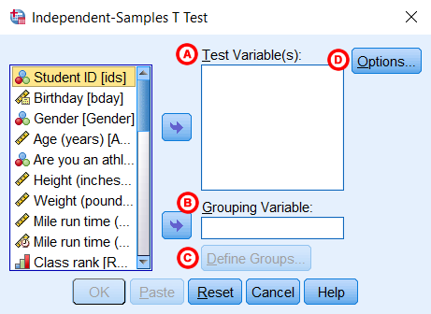
A Test Variable(s): The dependent variable(s). This is the continuous variable whose means will be compared between the two groups. You may run multiple t tests simultaneously by selecting more than one test variable.
B Grouping Variable: The independent variable. The categories (or groups) of the independent variable will define which samples will be compared in the t test. The grouping variable must have at least two categories (groups); it may have more than two categories but a t test can only compare two groups, so you will need to specify which two groups to compare. You can also use a continuous variable by specifying a cut point to create two groups (i.e., values at or above the cut point and values below the cut point).
C Define Groups: Click Define Groups to define the category indicators (groups) to use in the t test. If the button is not active, make sure that you have already moved your independent variable to the right in the Grouping Variable field. You must define the categories of your grouping variable before you can run the Independent Samples t Test procedure.
D Options: The Options section is where you can set your desired confidence level for the confidence interval for the mean difference, and specify how SPSS should handle missing values.
When finished, click OK to run the Independent Samples t Test, or click Paste to have the syntax corresponding to your specified settings written to an open syntax window. (If you do not have a syntax window open, a new window will open for you.)

DEFINE GROUPS
Clicking the Define Groups button (C) opens the Define Groups window:
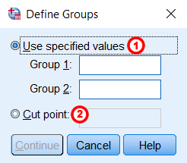
1 Use specified values: If your grouping variable is categorical, select Use specified values. Enter the values for the categories you wish to compare in the Group 1 and Group 2 fields. If your categories are numerically coded, you will enter the numeric codes. If your group variable is string, you will enter the exact text strings representing the two categories. If your grouping variable has more than two categories (e.g., takes on values of 1, 2, 3, 4), you can specify two of the categories to be compared (SPSS will disregard the other categories in this case).
Note that when computing the test statistic, SPSS will subtract the mean of the Group 2 from the mean of Group 1. Changing the order of the subtraction affects the sign of the results, but does not affect the magnitude of the results.
2 Cut point: If your grouping variable is numeric and continuous, you can designate a cut point for dichotomizing the variable. This will separate the cases into two categories based on the cut point. Specifically, for a given cut point x, the new categories will be:
- Group 1: All cases where grouping variable > x
- Group 2: All cases where grouping variable < x
Note that this implies that cases where the grouping variable is equal to the cut point itself will be included in the "greater than or equal to" category. (If you want your cut point to be included in a "less than or equal to" group, then you will need to use Recode into Different Variables or use DO IF syntax to create this grouping variable yourself.) Also note that while you can use cut points on any variable that has a numeric type, it may not make practical sense depending on the actual measurement level of the variable (e.g., nominal categorical variables coded numerically). Additionally, using a dichotomized variable created via a cut point generally reduces the power of the test compared to using a non-dichotomized variable.

OPTIONS
Clicking the Options button (D) opens the Options window:
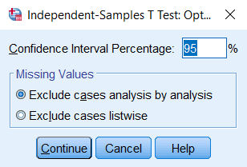
The Confidence Interval Percentage box allows you to specify the confidence level for a confidence interval. Note that this setting does NOT affect the test statistic or p-value or standard error; it only affects the computed upper and lower bounds of the confidence interval. You can enter any value between 1 and 99 in this box (although in practice, it only makes sense to enter numbers between 90 and 99).
The Missing Values section allows you to choose if cases should be excluded "analysis by analysis" (i.e. pairwise deletion) or excluded listwise. This setting is not relevant if you have only specified one dependent variable; it only matters if you are entering more than one dependent (continuous numeric) variable. In that case, excluding "analysis by analysis" will use all nonmissing values for a given variable. If you exclude "listwise", it will only use the cases with nonmissing values for all of the variables entered. Depending on the amount of missing data you have, listwise deletion could greatly reduce your sample size.

Example: Independent samples T test when variances are not equal

PROBLEM STATEMENT
In our sample dataset, students reported their typical time to run a mile, and whether or not they were an athlete. Suppose we want to know if the average time to run a mile is different for athletes versus non-athletes. This involves testing whether the sample means for mile time among athletes and non-athletes in your sample are statistically different (and by extension, inferring whether the means for mile times in the population are significantly different between these two groups). You can use an Independent Samples t Test to compare the mean mile time for athletes and non-athletes.
The hypotheses for this example can be expressed as:
H₀: µ_{non-athlete} - µ_{athlete} = 0 ("the difference of the means is equal to zero")
H₁: µ_{non-athlete} - µ_{athlete} ≠ 0 ("the difference of the means is not equal to zero")
where µ_{athlete} and µ_{non-athlete} are the population means for athletes and non-athletes, respectively.
In the sample data, we will use two variables: Athlete and MileMinDur. The variable Athlete has values of either “0” (non-athlete) or "1" (athlete). It will function as the independent variable in this T test. The variable MileMinDur is a numeric duration variable (h:mm:ss), and it will function as the dependent variable. In SPSS, the first few rows of data look like this:
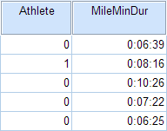

BEFORE THE TEST
Before running the Independent Samples t Test, it is a good idea to look at descriptive statistics and graphs to get an idea of what to expect. Running Compare Means (Analyze > Compare Means > Means) to get descriptive statistics by group tells us that the standard deviation in mile time for non-athletes is about 2 minutes; for athletes, it is about 49 seconds. This corresponds to a variance of 14803 seconds for non-athletes, and a variance of 2447 seconds for athletes¹. Running the Explore procedure (Analyze > Descriptives > Explore) to obtain a comparative boxplot yields the following graph:
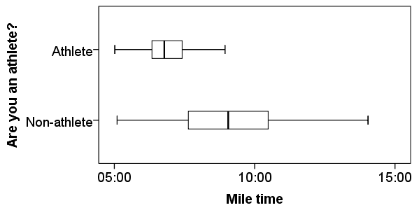
If the variances were indeed equal, we would expect the total length of the boxplots to be about the same for both groups. However, from this boxplot, it is clear that the spread of observations for non-athletes is much greater than the spread of observations for athletes. Already, we can estimate that the variances for these two groups are quite different. It should not come as a surprise if we run the Independent Samples t Test and see that Levene's Test is significant.
Additionally, we should also decide on a significance level (typically denoted using the Greek letter alpha, α) before we perform our hypothesis tests. The significance level is the threshold we use to decide whether a test result is significant. For this example, let's use α = 0.05.
¹When computing the variance of a duration variable (formatted as hh:mm:ss or mm:ss or mm:ss.s), SPSS converts the standard deviation value to seconds before squaring.

RUNNING THE TEST
To run the Independent Samples t Test:
- Click Analyze > Compare Means > Independent-Samples T Test.
- Move the variable Athlete to the Grouping Variable field, and move the variable MileMinDur to the Test Variable(s) area. Now Athlete is defined as the independent variable and MileMinDur is defined as the dependent variable.
- Click Define Groups, which opens a new window. Use specified values is selected by default. Since our grouping variable is numerically coded (0 = "Non-athlete", 1 = "Athlete"), type “0” in the first text box, and “1” in the second text box. This indicates that we will compare groups 0 and 1, which correspond to non-athletes and athletes, respectively. Click Continue when finished.
- Click OK to run the Independent Samples t Test. Output for the analysis will display in the Output Viewer window.

SYNTAX
T-TEST GROUPS=Athlete(0 1)
/MISSING=ANALYSIS
/VARIABLES=MileMinDur
/CRITERIA=CI(.95).

OUTPUT

TABLES
Two sections (boxes) appear in the output: Group Statistics and Independent Samples Test. The first section, Group Statistics, provides basic information about the group comparisons, including the sample size (n), mean, standard deviation, and standard error for mile times by group. In this example, there are 166 athletes and 226 non-athletes. The mean mile time for athletes is 6 minutes 51 seconds, and the mean mile time for non-athletes is 9 minutes 6 seconds.
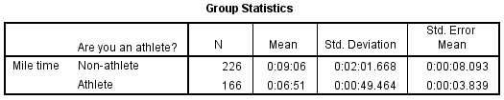
The second section, Independent Samples Test, displays the results most relevant to the Independent Samples t Test. There are two parts that provide different pieces of information: (A) Levene’s Test for Equality of Variances and (B) t-test for Equality of Means.
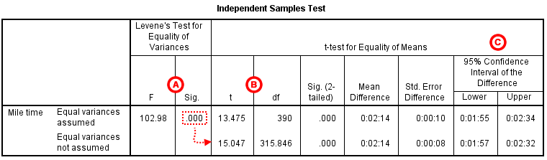
A Levene's Test for Equality of of Variances: This section has the test results for Levene's Test. From left to right:
- F is the test statistic of Levene's test
- Sig. is the p-value corresponding to this test statistic.
The p-value of Levene's test is printed as ".000" (but should be read as p < 0.001 -- i.e., p very small), so we we reject the null of Levene's test and conclude that the variance in mile time of athletes is significantly different than that of non-athletes. This tells us that we should look at the "Equal variances not assumed" row for the t test (and corresponding confidence interval) results. (If this test result had not been significant -- that is, if we had observed p > α -- then we would have used the "Equal variances assumed" output.)
B t-test for Equality of Means provides the results for the actual Independent Samples t Test. From left to right:
- t is the computed test statistic
- df is the degrees of freedom
- Sig (2-tailed) is the p-value corresponding to the given test statistic and degrees of freedom
- Mean Difference is the difference between the sample means; it also corresponds to the numerator of the test statistic
- Std. Error Difference is the standard error; it also corresponds to the denominator of the test statistic
Note that the mean difference is calculated by subtracting the mean of the second group from the mean of the first group. In this example, the mean mile time for athletes was subtracted from the mean mile time for non-athletes (9:06 minus 6:51 = 02:14). The sign of the mean difference corresponds to the sign of the t value. The positive t value in this example indicates that the mean mile time for the first group, non-athletes, is significantly greater than the mean for the second group, athletes.
The associated p value is printed as ".000"; double-clicking on the p-value will reveal the un-rounded number. SPSS rounds p-values to three decimal places, so any p-value too small to round up to .001 will print as .000. (In this particular example, the p-values are on the order of 10⁻⁴⁰.)
C Confidence Interval of the Difference: This part of the t-test output complements the significance test results. Typically, if the CI for the mean difference contains 0, the results are not significant at the chosen significance level. In this example, the 95% CI is [01:57, 02:32], which does not contain zero; this agrees with the small p-value of the significance test.

DECISION AND CONCLUSIONS
Since p < .001 is less than our chosen significance level α = 0.05, we can reject the null hypothesis, and conclude that the that the mean mile time for athletes and non-athletes is significantly different.
Based on the results, we can state the following:
- There was a significant difference in mean mile time between non-athletes and athletes (t_{315.846} = 15.047, p < .001).
- The average mile time for athletes was 2 minutes and 14 seconds faster than the average mile time for non-athletes.
ONE WAY ANOVA
One-Way ANOVA ("analysis of variance") compares the means of two or more independent groups in order to determine whether there is statistical evidence that the associated population means are significantly different. One-Way ANOVA is a parametric test.
This test is also known as:
- One-Factor ANOVA
- One-Way Analysis of Variance
- Between Subjects ANOVA
The variables used in this test are known as:
- Dependent variable
- Independent variable (also known as the grouping variable, or factor)
  - This variable divides cases into two or more mutually exclusive levels, or groups

Common Uses
The One-Way ANOVA is often used to analyze data from the following types of studies:
- Field studies
- Experiments
- Quasi-experiments
The One-Way ANOVA is commonly used to test the following:
- Statistical differences among the means of two or more groups
- Statistical differences among the means of two or more interventions
- Statistical differences among the means of two or more change scores
Note: Both the One-Way ANOVA and the Independent Samples t Test can compare the means for two groups. However, only the One-Way ANOVA can compare the means across three or more groups.
Note: If the grouping variable has only two groups, then the results of a one-way ANOVA and the independent samples t test will be equivalent. In fact, if you run both an independent samples t test and a one-way ANOVA in this situation, you should be able to confirm that t²=F.

Data Requirements
Your data must meet the following requirements:
- Dependent variable that is continuous (i.e., interval or ratio level)
- Independent variable that is categorical (i.e., two or more groups)
- Cases that have values on both the dependent and independent variables
- Independent samples/groups (i.e., independence of observations)
  - There is no relationship between the subjects in each sample. This means that:
    - subjects in the first group cannot also be in the second group
    - no subject in either group can influence subjects in the other group
    - no group can influence the other group
- Random sample of data from the population
- Normal distribution (approximately) of the dependent variable for each group (i.e., for each level of the factor)
  - Non-normal population distributions, especially those that are thick-tailed or heavily skewed, considerably reduce the power of the test
  - Among moderate or large samples, a violation of normality may yield fairly accurate p values
- Homogeneity of variances (i.e., variances approximately equal across groups)
  - When this assumption is violated and the sample sizes differ among groups, the p value for the overall F test is not trustworthy. These conditions warrant using alternative statistics that do not assume equal variances among populations, such as the Browne-Forsythe or Welch statistics (available via Options in the One-Way ANOVA dialog box).
  - When this assumption is violated, regardless of whether the group sample sizes are fairly equal, the results may not be trustworthy for post hoc tests. When variances are unequal, post hoc tests that do not assume equal variances should be used (e.g., Dunnett’s C).
- No outliers
Note: When the normality, homogeneity of variances, or outliers assumptions for One-Way ANOVA are not met, you may want to run the nonparametric Kruskal-Wallis test instead.
Researchers often follow several rules of thumb for one-way ANOVA:
- Each group should have at least 6 subjects (ideally more; inferences for the population will be more tenuous with too few subjects)
- Balanced designs (i.e., same number of subjects in each group) are ideal; extremely unbalanced designs increase the possibility that violating any of the requirements/assumptions will threaten the validity of the ANOVA F test

Hypotheses
The null and alternative hypotheses of one-way ANOVA can be expressed as:
H₀: µ₁ = µ₂ = µ₃ = ... = µ_{k} ("all k population means are equal")
H₁: At least one µ_{i} different ("at least one of the k population means is not equal to the others")
where
- µ_{i} is the population mean of the i^{th} group (i = 1, 2, ..., k)
Note: The One-Way ANOVA is considered an omnibus (Latin for “all”) test because the F test indicates whether the model is significant overall—i.e., whether or not there are any significant differences in the means between any of the groups. (Stated another way, this says that at least one of the means is different from the others.) However, it does not indicate which mean is different. Determining which specific pairs of means are significantly different requires either contrasts or post hoc (Latin for “after this”) tests.

Test Statistic
The test statistic for a One-Way ANOVA is denoted as F. For an independent variable with k groups, the F statistic evaluates whether the group means are significantly different. Because the computation of the F statistic is slightly more involved than computing the paired or independent samples t test statistics, it's extremely common for all of the F statistic components to be depicted in a table like the following:
 | Sum of Squares | df | Mean Square | F
Treatment | SSR | df_{r} | MSR | MSR/MSE
Error | SSE | df_{e} | MSE
Total | SST | df_{T}
where
SSR = the regression sum of squares
SSE = the error sum of squares
SST = the total sum of squares (SST = SSR + SSE)
df_{r} = the model degrees of freedom (equal to df_{r} = k - 1)
df_{e} = the error degrees of freedom (equal to df_{e} = n - k - 1)
k = the total number of groups (levels of the independent variable)
n = the total number of valid observations
df_{T} = the total degrees of freedom (equal to df_{T} = df_{r} + df_{e} = n - 1)
MSR = SSR/df_{r} = the regression mean square
MSE = SSE/df_{e} = the mean square error
Then the F statistic itself is computed as
F=MSRMSEF=MSRMSE

Note: In some texts you may see the notation df₁ or ν₁ for the regression degrees of freedom, and df₂ or ν₂ for the error degrees of freedom. The latter notation uses the Greek letter nu (ν) for the degrees of freedom.
Some texts may use "SSTr" (Tr = "treatment") instead of SSR (R = "regression"), and may use SSTo (To = "total") instead of SST.
The terms Treatment (or Model) and Error are the terms most commonly used in natural sciences and in traditional experimental design texts. In the social sciences, it is more common to see the terms Between groups instead of "Treatment", and Within groups instead of "Error". The between/within terminology is what SPSS uses in the one-way ANOVA procedure.

Data Set-Up
Your data should include at least two variables (represented in columns) that will be used in the analysis. The independent variable should be categorical (nominal or ordinal) and include at least two groups, and the dependent variable should be continuous (i.e., interval or ratio). Each row of the dataset should represent a unique subject or experimental unit.
Note: SPSS restricts categorical indicators to numeric or short string values only.

Run a One-Way ANOVA
The following steps reflect SPSS’s dedicated One-Way ANOVA procedure. However, since the One-Way ANOVA is also part of the General Linear Model (GLM) family of statistical tests, it can also be conducted via the Univariate GLM procedure (“univariate” refers to one dependent variable). This latter method may be beneficial if your analysis goes beyond the simple One-Way ANOVA and involves multiple independent variables, fixed and random factors, and/or weighting variables and covariates (e.g., One-Way ANCOVA). We proceed by explaining how to run a One-Way ANOVA using SPSS’s dedicated procedure.
To run a One-Way ANOVA in SPSS, click Analyze > Compare Means > One-Way ANOVA.
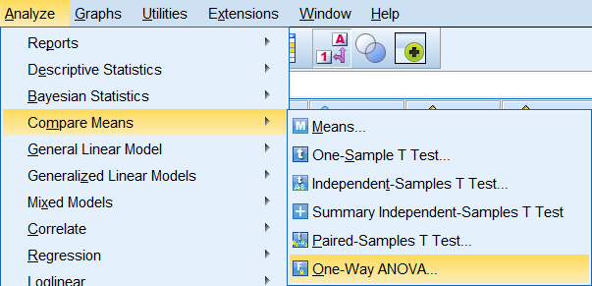
The One-Way ANOVA window opens, where you will specify the variables to be used in the analysis. All of the variables in your dataset appear in the list on the left side. Move variables to the right by selecting them in the list and clicking the blue arrow buttons. You can move a variable(s) to either of two areas: Dependent List or Factor.
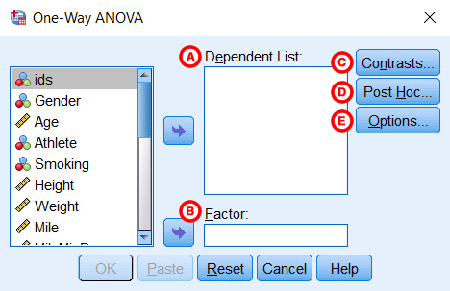
A Dependent List: The dependent variable(s). This is the variable whose means will be compared between the samples (groups). You may run multiple means comparisons simultaneously by selecting more than one dependent variable.
B Factor: The independent variable. The categories (or groups) of the independent variable will define which samples will be compared. The independent variable must have at least two categories (groups), but usually has three or more groups when used in a One-Way ANOVA.

C Contrasts: (Optional) Specify contrasts, or planned comparisons, to be conducted after the overall ANOVA test.
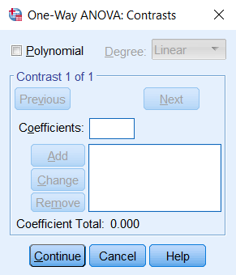
When the initial F test indicates that significant differences exist between group means, contrasts are useful for determining which specific means are significantly different when you have specific hypotheses that you wish to test. Contrasts are decided before analyzing the data (i.e., a priori). Contrasts break down the variance into component parts. They may involve using weights, non-orthogonal comparisons, standard contrasts, and polynomial contrasts (trend analysis).
Many online and print resources detail the distinctions among these options and will help users select appropriate contrasts. For more information about contrasts, you can open the IBM SPSS help manual from within SPSS by clicking the "Help" button at the bottom of the One-Way ANOVA dialog window.

D Post Hoc: (Optional) Request post hoc (also known as multiple comparisons) tests. Specific post hoc tests can be selected by checking the associated boxes.
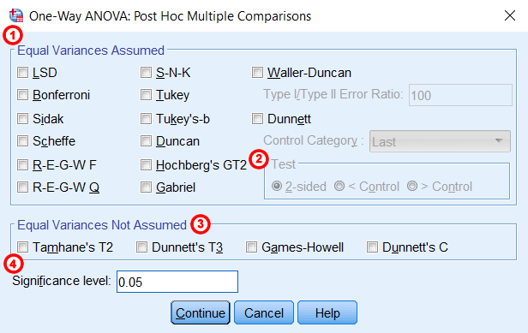
1 Equal Variances Assumed: Multiple comparisons options that assume homogeneity of variance (each group has equal variance). For detailed information about the specific comparison methods, click the Help button in this window.
2 Test: By default, a 2-sided hypothesis test is selected. Alternatively, a directional, one-sided hypothesis test can be specified if you choose to use a Dunnett post hoc test. Click the box next to Dunnett and then specify whether the Control Category is the Last or First group, numerically, of your grouping variable. In the Test area, click either < Control or > Control. The one-tailed options require that you specify whether you predict that the mean for the specified control group will be less than (> Control) or greater than (< Control) another group.
3 Equal Variances Not Assumed: Multiple comparisons options that do not assume equal variances. For detailed information about the specific comparison methods, click the Help button in this window.
4 Significance level: The desired cutoff for statistical significance. By default, significance is set to 0.05.
When the initial F test indicates that significant differences exist between group means, post hoc tests are useful for determining which specific means are significantly different when you do not have specific hypotheses that you wish to test. Post hoc tests compare each pair of means (like t-tests), but unlike t-tests, they correct the significance estimate to account for the multiple comparisons.

E Options: Clicking Options will produce a window where you can specify which Statistics to include in the output (Descriptive, Fixed and random effects, Homogeneity of variance test, Brown-Forsythe, Welch), whether to include a Means plot, and how the analysis will address Missing Values (i.e., Exclude cases analysis by analysis or Exclude cases listwise). Click Continue when you are finished making specifications.
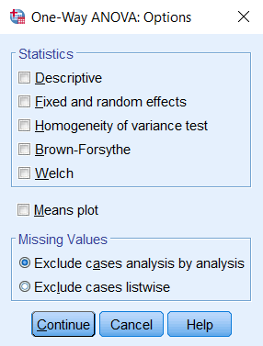
Click OK to run the One-Way ANOVA.

Example
To introduce one-way ANOVA, let's use an example with a relatively obvious conclusion. The goal here is to show the thought process behind a one-way ANOVA.

PROBLEM STATEMENT
In the sample dataset, the variable Sprint is the respondent's time (in seconds) to sprint a given distance, and Smoking is an indicator about whether or not the respondent smokes (0 = Nonsmoker, 1 = Past smoker, 2 = Current smoker). Let's use ANOVA to test if there is a statistically significant difference in sprint time with respect to smoking status. Sprint time will serve as the dependent variable, and smoking status will act as the independent variable.

BEFORE THE TEST
Just like we did with the paired t test and the independent samples t test, we'll want to look at descriptive statistics and graphs to get picture of the data before we run any inferential statistics.
The sprint times are a continuous measure of time to sprint a given distance in seconds. From the Descriptives procedure (Analyze > Descriptive Statistics > Descriptives), we see that the times exhibit a range of 4.5 to 9.6 seconds, with a mean of 6.6 seconds (based on n=374 valid cases). From the Compare Means procedure (Analyze > Compare Means > Means), we see these statistics with respect to the groups of interest:
 | N | Mean | Std. Deviation
Nonsmoker | 261 | 6.411 | 1.252
Past smoker | 33 | 6.835 | 1.024
Current smoker | 59 | 7.121 | 1.084
Total | 353 | 6.569 | 1.234
Notice that, according to the Compare Means procedure, the valid sample size is actually n=353. This is because Compare Means (and additionally, the one-way ANOVA procedure itself) requires there to be nonmissing values for both the sprint time and the smoking indicator.
Lastly, we'll also want to look at a comparative boxplot to get an idea of the distribution of the data with respect to the groups:
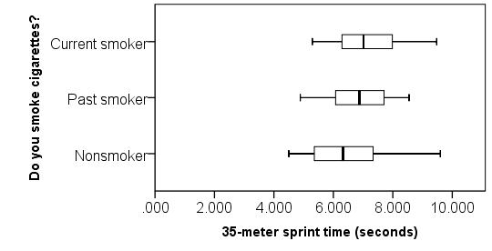
From the boxplots, we see that there are no outliers; that the distributions are roughly symmetric; and that the center of the distributions don't appear to be hugely different. The median sprint time for the nonsmokers is slightly faster than the median sprint time of the past and current smokers.

RUNNING THE PROCEDURE
- Click Analyze > Compare Means > One-Way ANOVA.
- Add the variable Sprint to the Dependent List box, and add the variable Smoking to the Factor box.
- Click Options. Check the box for Means plot, then click Continue.
- Click OK when finished.
Output for the analysis will display in the Output Viewer window.

SYNTAX
ONEWAY Sprint BY Smoking
/PLOT MEANS
/MISSING ANALYSIS.

OUTPUT
The output displays a table entitled ANOVA.
 | Sum of Squares | df | Mean Square | F | Sig.
Between Groups | 26.788 | 2 | 13.394 | 9.209 | .000
Within Groups | 509.082 | 350 | 1.455
Total | 535.870 | 352
After any table output, the Means plot is displayed.
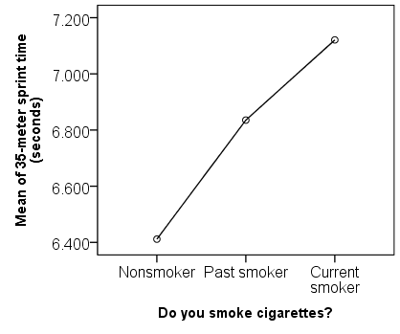
The Means plot is a visual representation of what we saw in the Compare Means output. The points on the chart are the average of each group. It's much easier to see from this graph that the current smokers had the slowest mean sprint time, while the nonsmokers had the fastest mean sprint time.

DISCUSSION AND CONCLUSIONS
We conclude that the mean sprint time is significantly different for at least one of the smoking groups (F_{2, 350} = 9.209, p < 0.001). Note that the ANOVA alone does not tell us specifically which means were different from one another. To determine that, we would need to follow up with multiple comparisons (or post-hoc) tests.

